**Use case 01: Implementing Medallion Architecture with Data Factory in Microsoft Fabric for Scalable Data Processing**

**Introduction:**

Modern organizations generate large volumes of data from diverse sources. Effectively organizing, processing, and transforming this data is critical to enable reliable analytics and data-driven decisions. Microsoft Fabric's Medallion Architecture provides a robust, scalable solution by layering data across Bronze (raw), Silver (transformed), and Gold (curated) stages. This use case explores how to implement a complete data lifecycle using Microsoft Fabric's capabilities-Data Pipelines, Lakehouses, Warehouses, and Dataflows-within the Medallion framework.

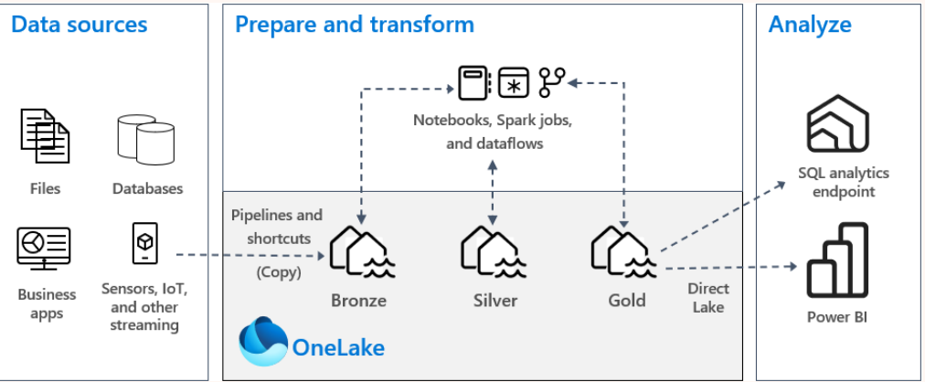

**Objective:**

* Setting up a Fabric workspace and Medallion task flow.
* Ingesting raw data into the Bronze layer.
* Transforming and enriching data in the Silver layer.
* Curating refined data for analytics in the Gold layer.
* Automating orchestration using pipelines and dynamic expressions.
* Demonstrating end-to-end integration of Power BI and T-SQL with Direct Lake mode.

Exercise 1: Setting Up a Medallion Architecture for Scalable Data Processing

This exercise focuses on creating a project task flow and understanding the basics of Data Factory experiences. It provides hands-on guidance for building and managing solutions using Microsoft Fabric. By the end of the exercise, a foundational understanding of key concepts and tools essential for efficient data management and transformation will be established.

The first step involves creating a medallion architecture task flow within a workspace. The medallion architecture is a design pattern that organizes data into layered stages-bronze, silver, and gold-to enhance data quality and accessibility. This task flow demonstrates how to structure and manage data effectively.

Next, a lakehouse item is created for data storage. A lakehouse combines the strengths of data lakes and data warehouses, offering a unified platform for storing and analyzing large volumes of data. This step is crucial for establishing a scalable and efficient data solution that supports diverse data processing and analytics needs.

Finally, a data pipeline is built to ingest sample data using the copy activity. Data pipelines automate the movement and transformation of data from various sources to destinations. The copy activity enables efficient data transfer between storage systems, ensuring data remains current and ready for analysis.

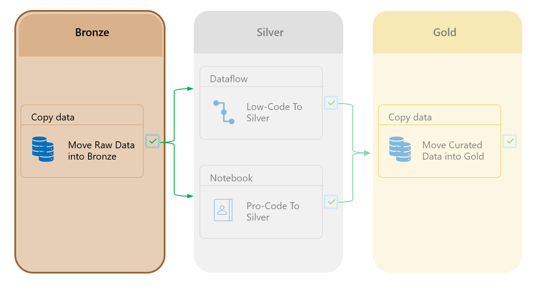

**Task 1: Create a Fabric workspace**

In this task, you create a Fabric workspace. The workspace contains all the items needed for this lakehouse tutorial, which includes lakehouse, dataflows, Data Factory pipelines, the notebooks, Power BI datasets, and reports.

1. Open your browser, navigate to the address bar, and type or paste the following URL: https://app.fabric.microsoft.com/ then press the **Enter** button.
2. In the **Home** page click on **+ New Workspaces** as shown in the below image.

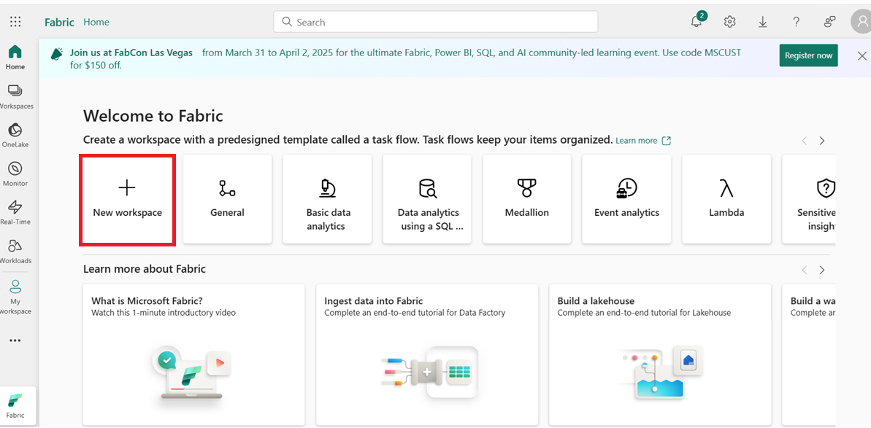

1. In the **Create a workspace** pane that appears on the right side, enter the following details, and click on the **Apply** button.

|  |  |
| --- | --- |
| Name | **Data Factory-MedallionXX** (XX can be a unique number) |
| Advanced | Under License mode, select **Trial** |
| Default | storage format Small dataset storage format |

1. 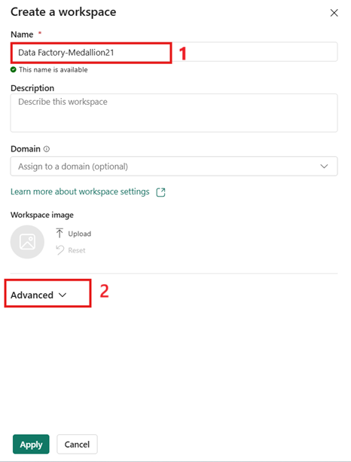
2. 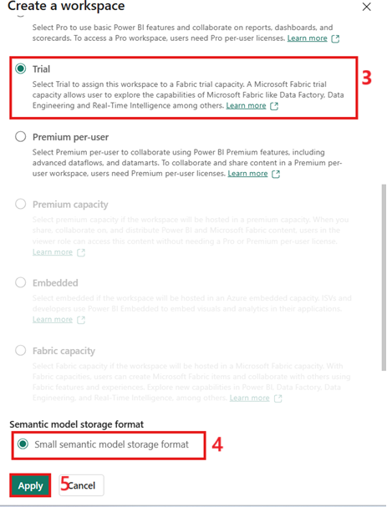
3. 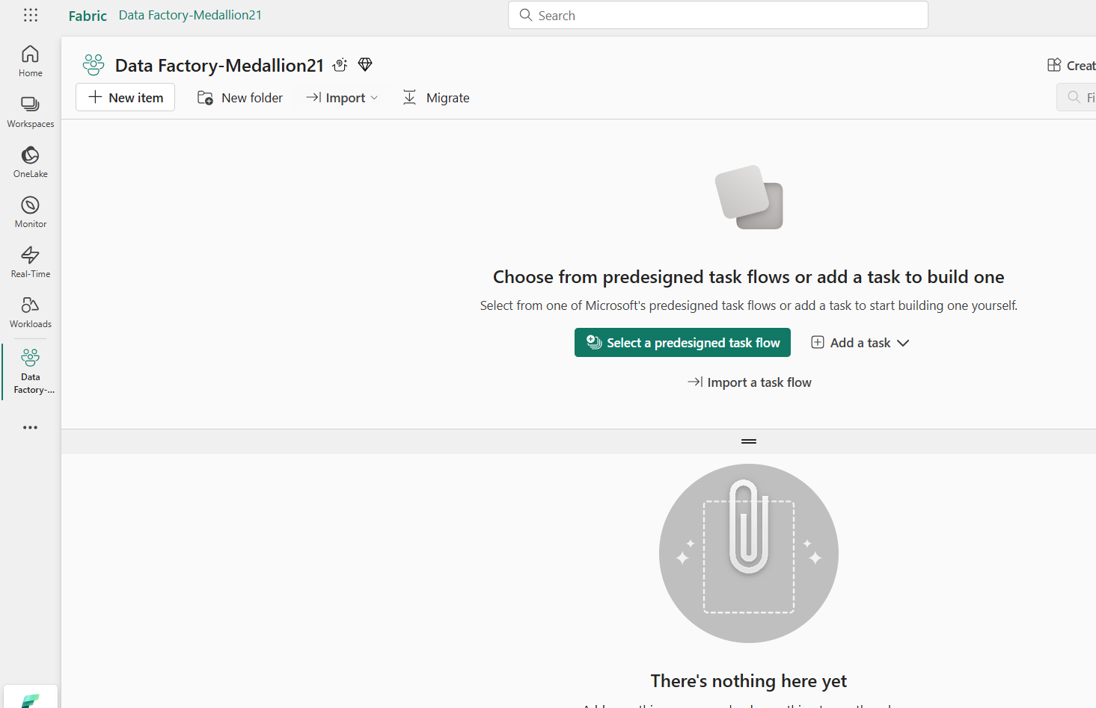

Task 2: Medallion task flow

1. From the empty workspace, select the option **Select a predefined task flow** to choose one of Microsoft's task flows. These predesigned task flows provide a structured approach to managing data projects

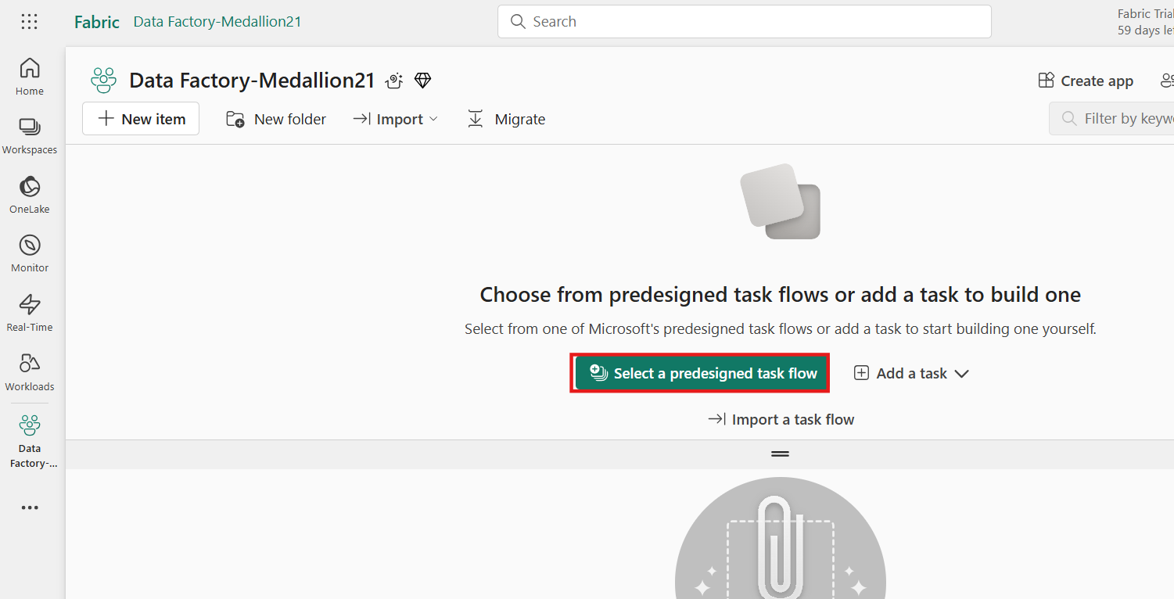

1. From the **Select a task flow** window, choose the **Medallion** option.
2. This option includes the description "Organize and improve data progressively as it moves through each layer," which is crucial for data projects. The medallion architecture helps in structuring data into different layers, such as bronze, silver, and gold, to enhance data quality and accessibility.
3. Select the **Select** option to continue.

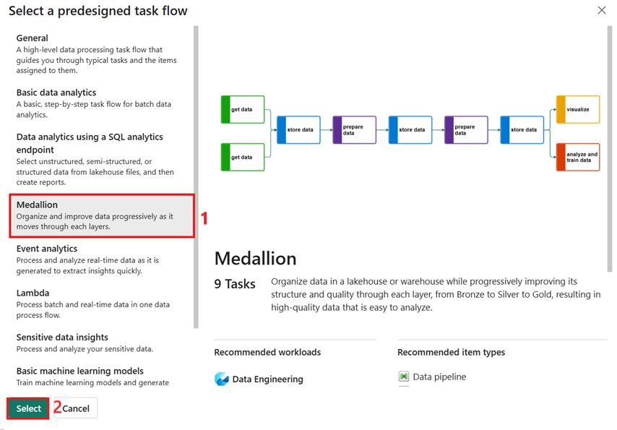

1. A task flow has now been created within your workspace, which can be considered an architectural template. This template provides a structured framework for your data project.

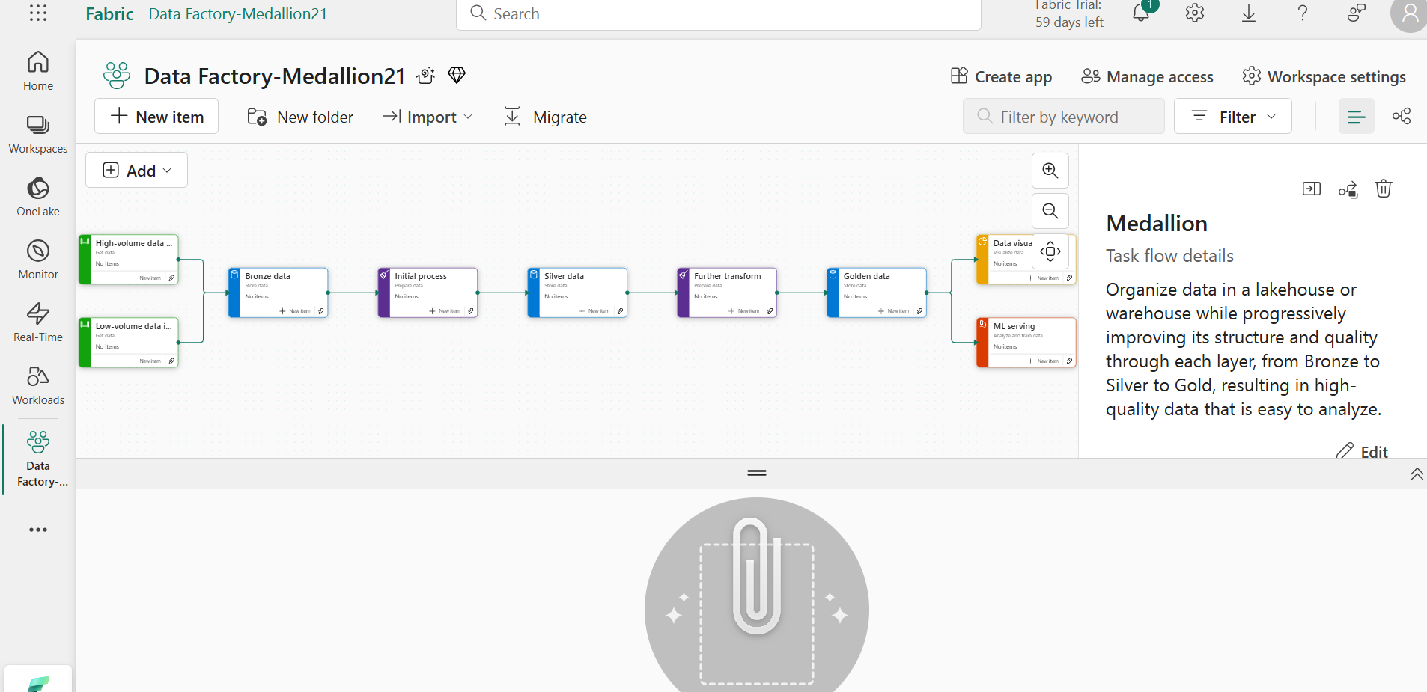

1. Select the **New item** option on the **Bronze data** task to start adding items to task flow.

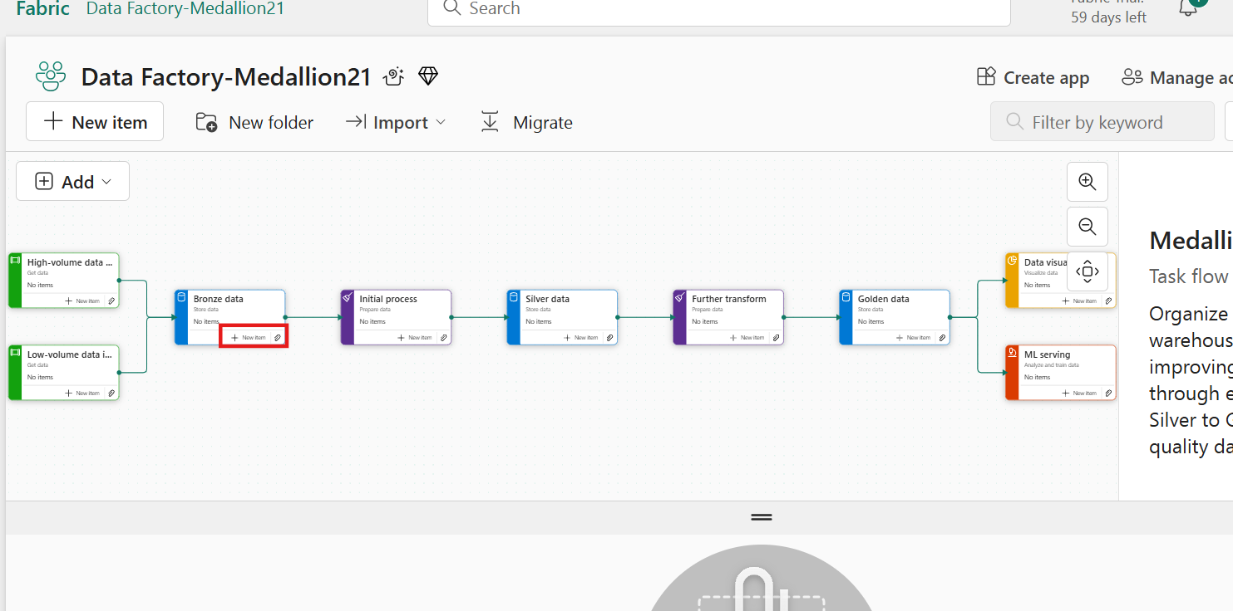

1. In the Create an item window, the available options within Microsoft Fabric have been filtered down to **Recommended items**. This filtering is helpful for choosing the correct items for project.
2. Select the **Lakehouse** item for data storage.

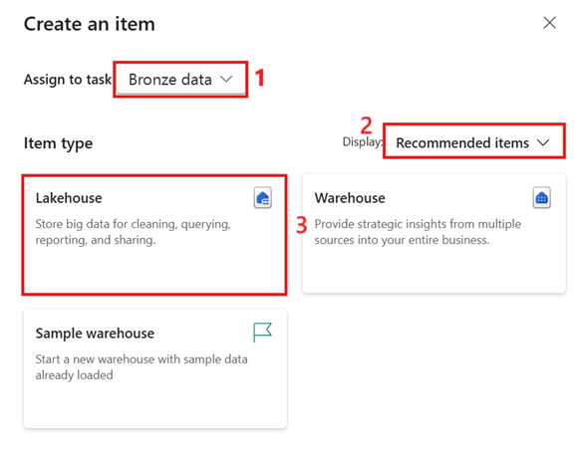

1. In the New lakehouse window, set the lakehouse name to **bronze_Lakehouse** and then select **Create**.

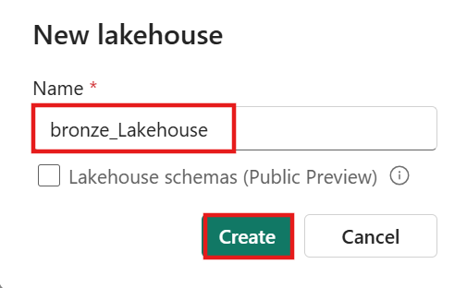

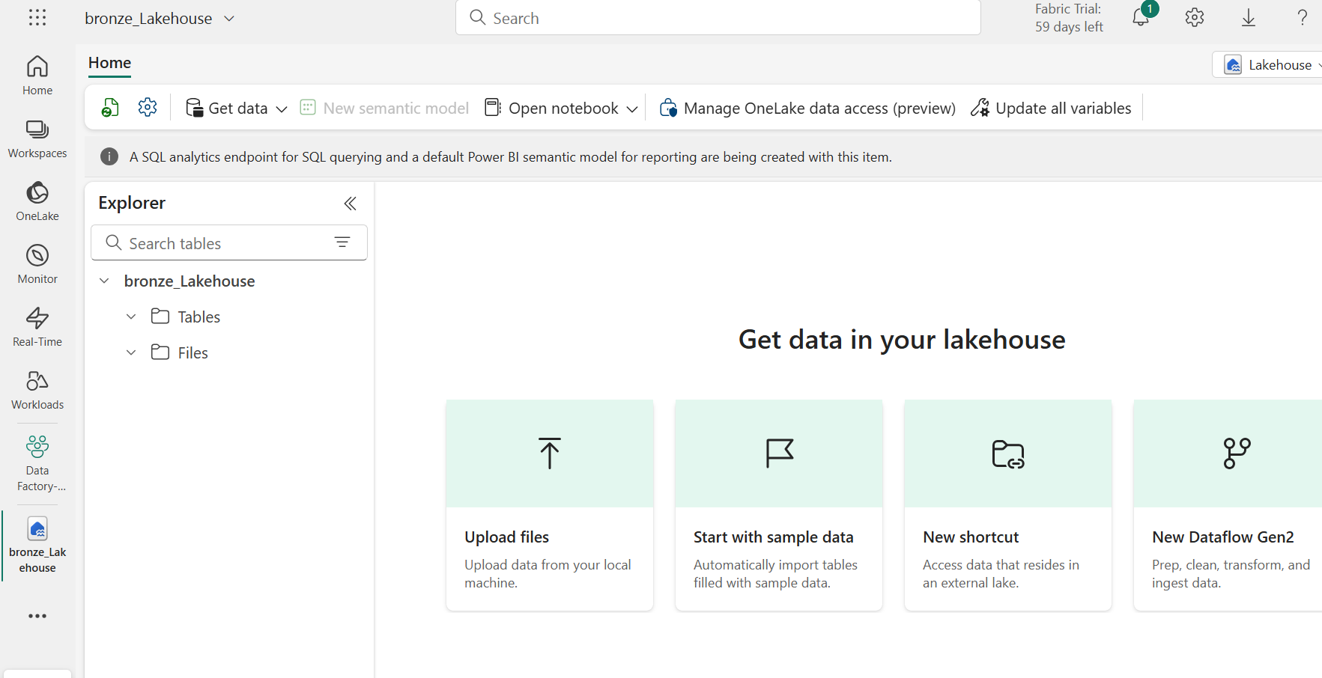

1. In the left-sided navigation menu, navigate and click on ***Data Factory-MedallionXX***, as shown in the below image.

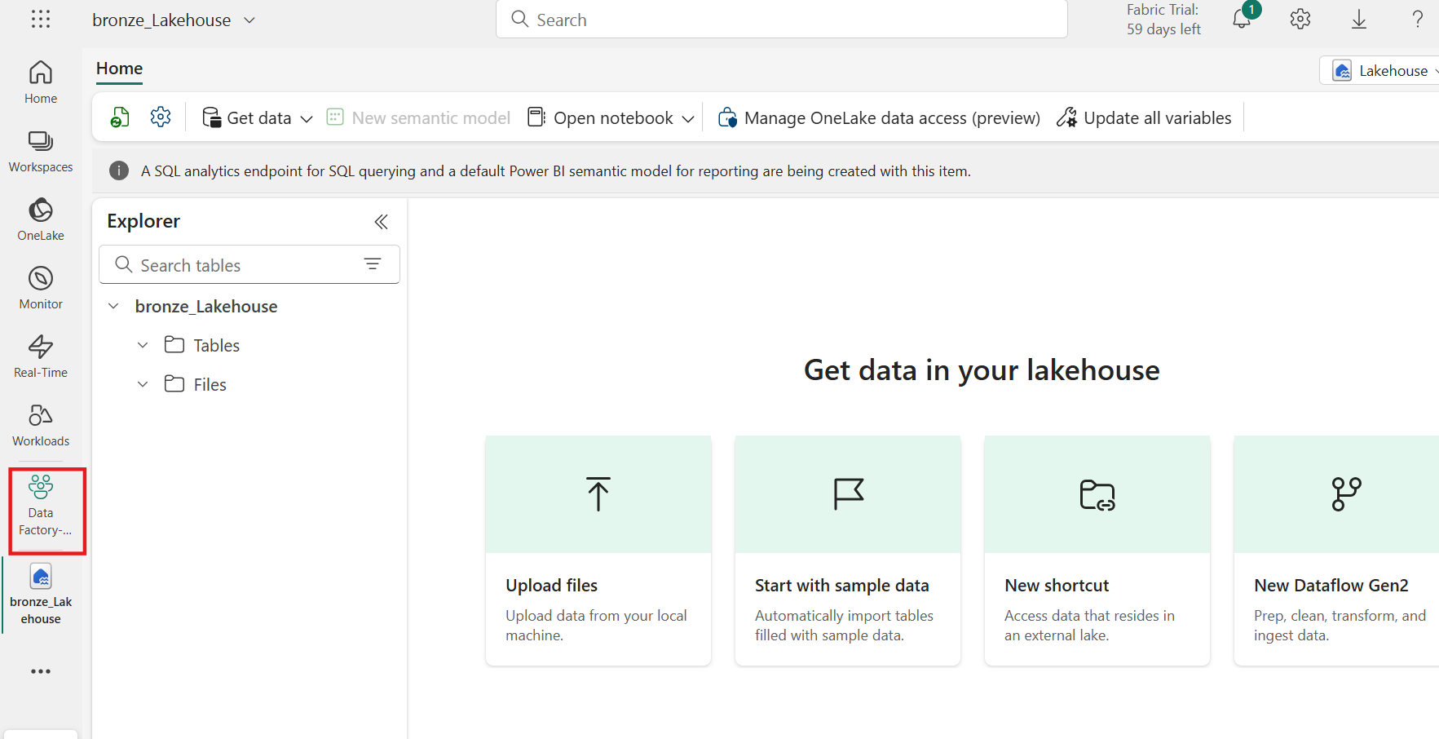

1. Within the workspace, you will notice that three items have now been created and are associated with your lakehouse. These items include the lakehouse (storage), SQL analytics endpoint, and a default Semantic model.

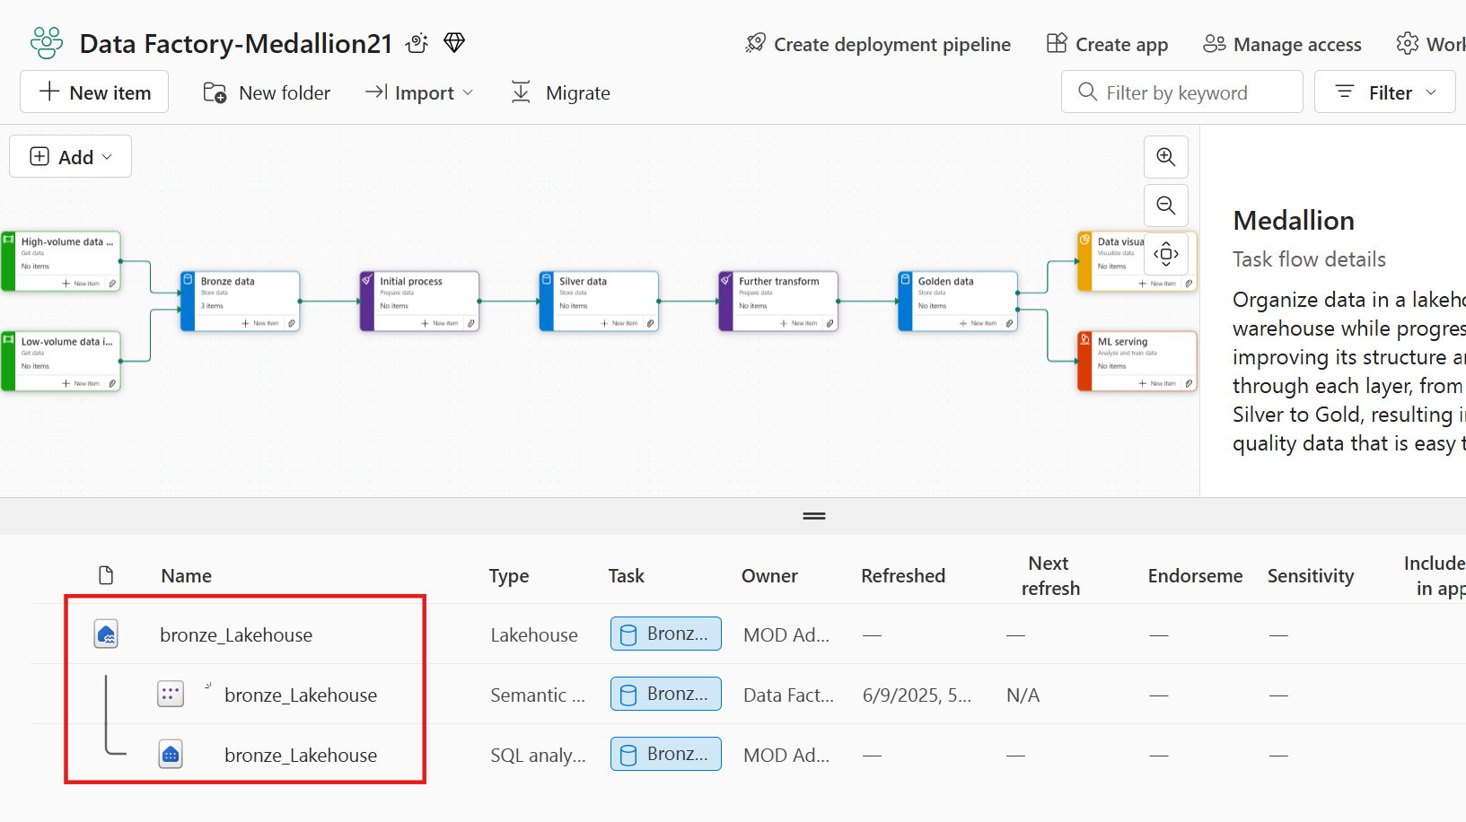

1. Select **New item** from the **High-volume data ingest** task. This task is crucial for handling large volumes of data efficiently, ensuring that your data ingestion processes are scalable and robust.

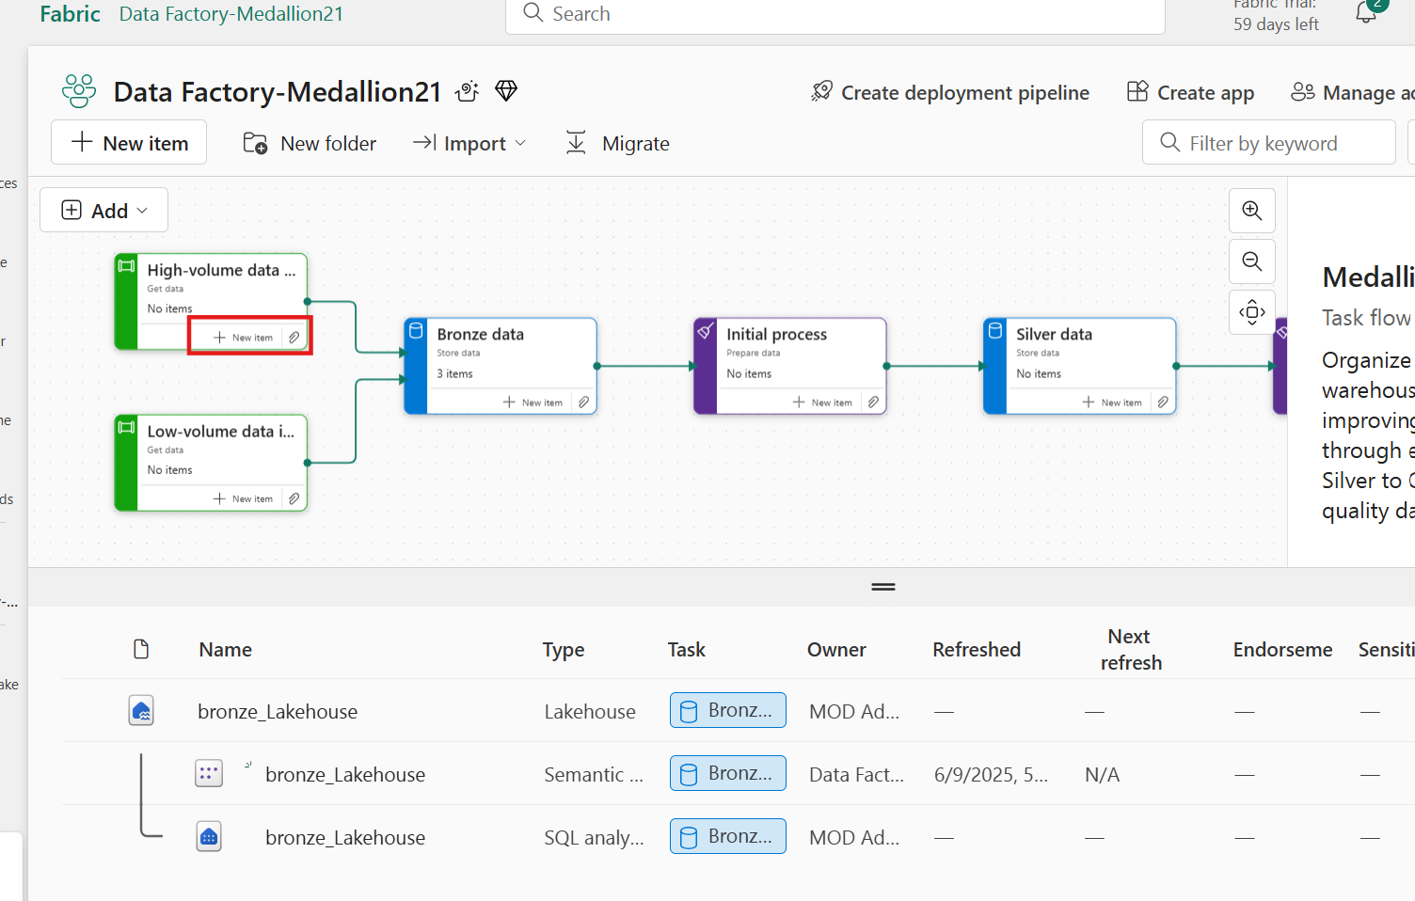

1. In the **Create an item** window, the available options within Microsoft Fabric have been filtered down to **Recommended items**. Select the **Data pipeline** item which is essential for automating the movement and transformation of data from various sources to destinations.

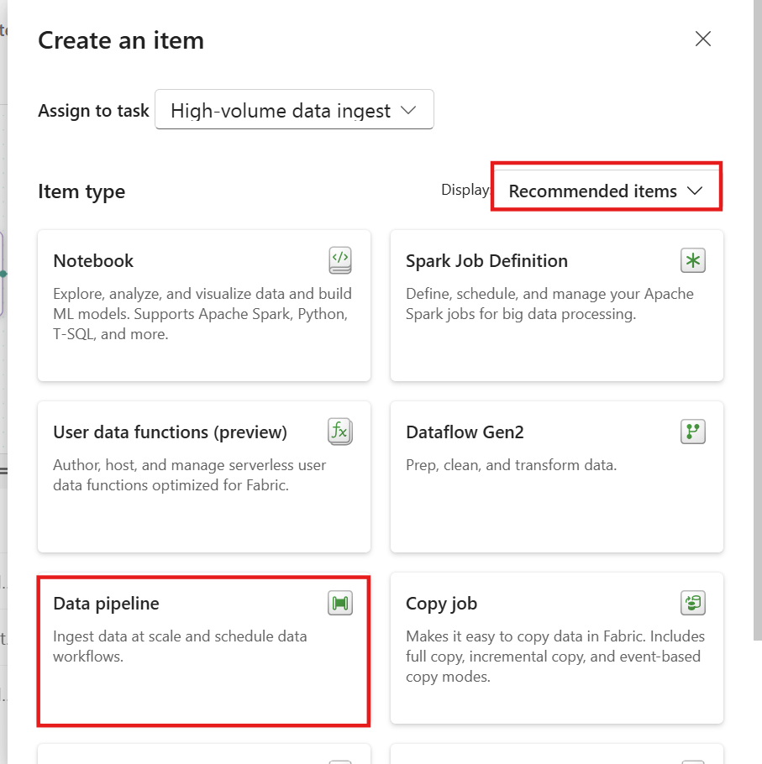

1. In the New pipeline window, set the data pipeline name to **samplePipeline** and then select **Create**.

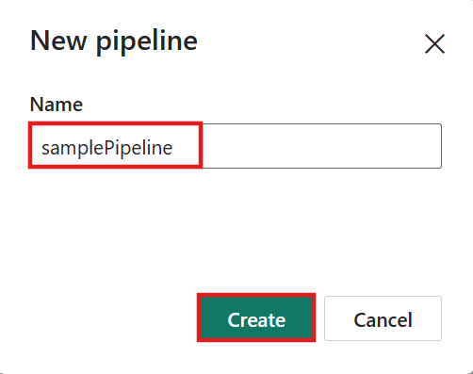

Task 3: Copy activity

1. From the data pipeline page, select the **Copy data assistant.**

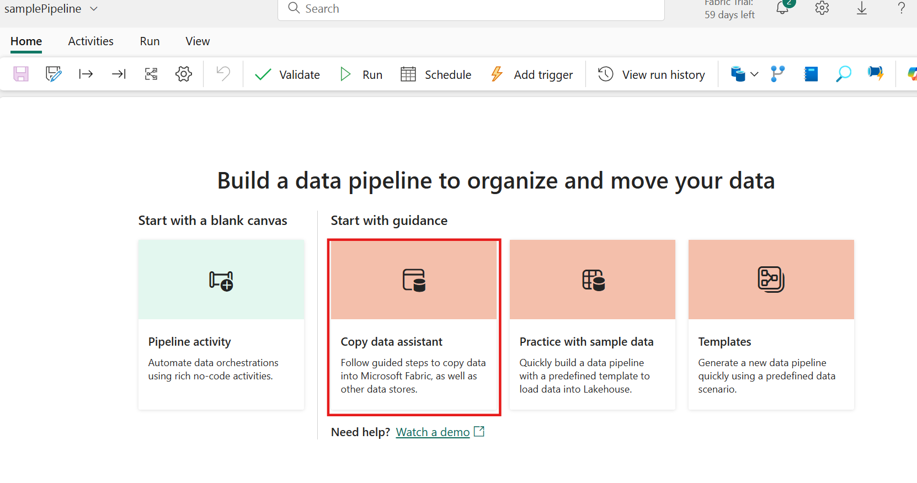

1. The **Copy data** dialog is displayed with the first step, **Choose data source**, highlighted. Select **Sample data** section, and select the **Public Holidays** data source type.

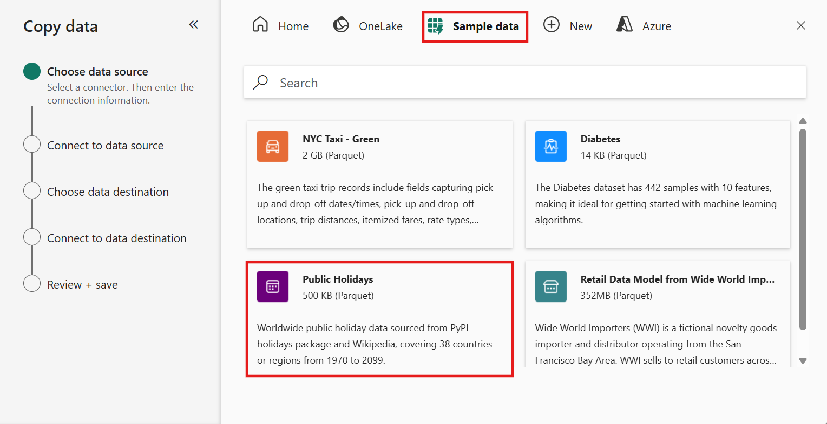

1. A preview of the data source will now be displayed to verify the correct selection and understand the data structure. After reviewing the preview, select **Next** to proceed.

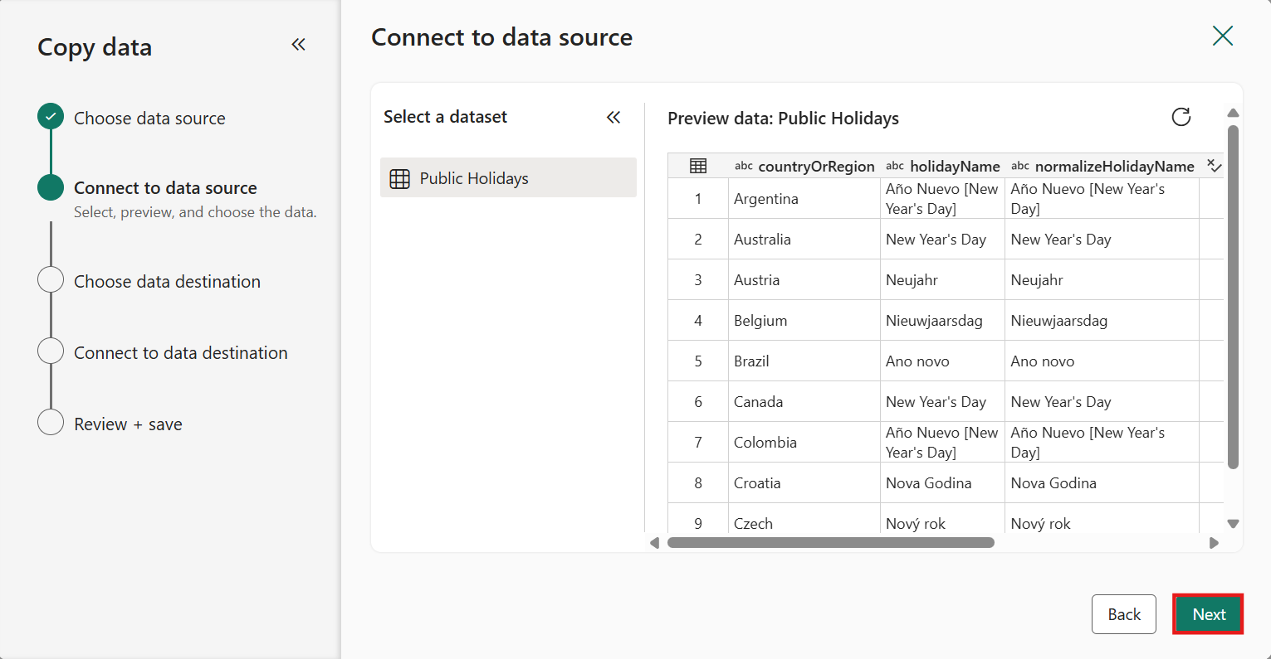

1. Select the **bronze_Lakehouse** lakehouse item as the data destination from the **OneLake catalog list**. It determines the storage location for the data.

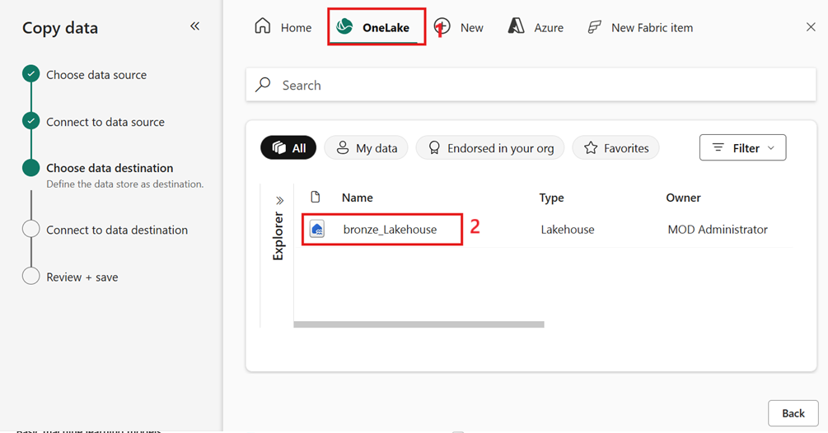

1. Within the data destination configuration, select the **Files** option and set the File name to **Holidays.csv**. Set the Copy behavior to **Merge files** before selecting **Next**.

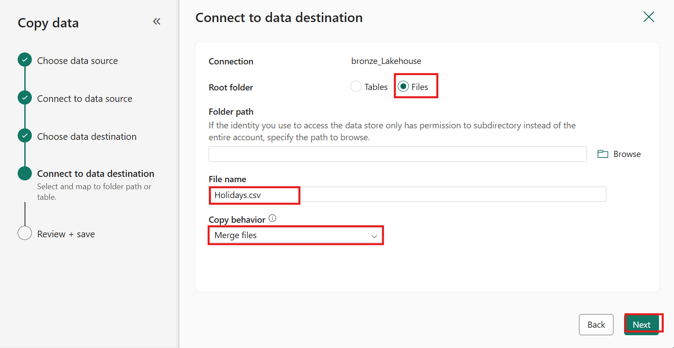

1. Set the Compression type to **None**. This setting is important for determining how your data will be stored and accessed. In this case, no compression is applied, which can be useful for maintaining the original data format.

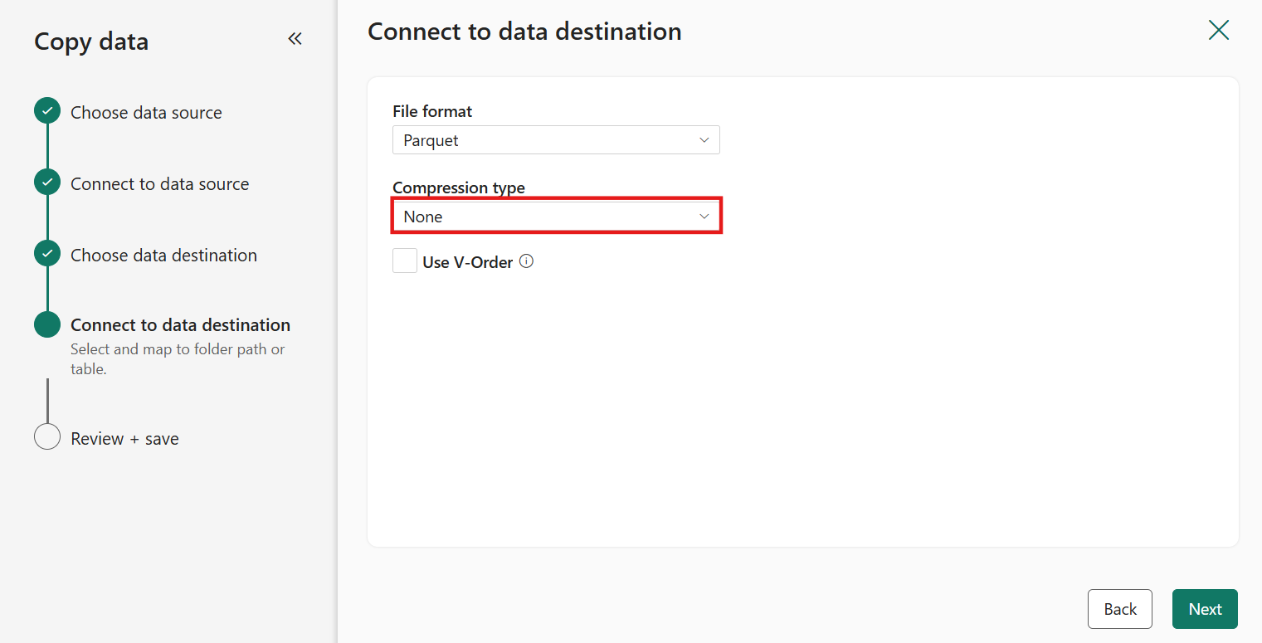

1. Set the **File format** to **DelimitedText** and then select **Next**. This format is commonly used for storing tabular data, making it easy to import and export data between different systems.

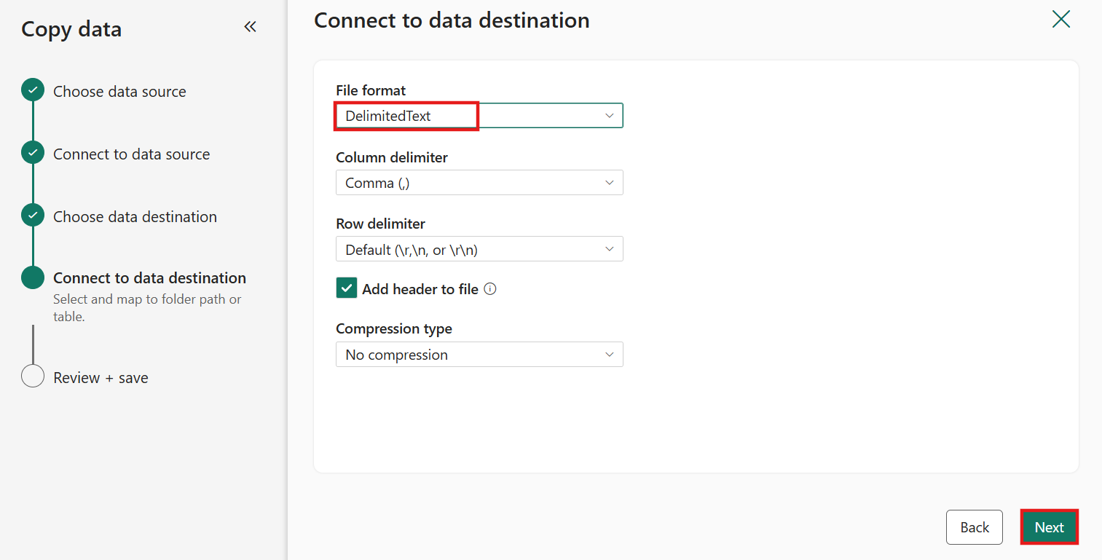

1. Within the **Review + save** window, disable the **Start data transfer immediately** option and then select **OK** to review the configured copy activity within the data pipeline canvas.

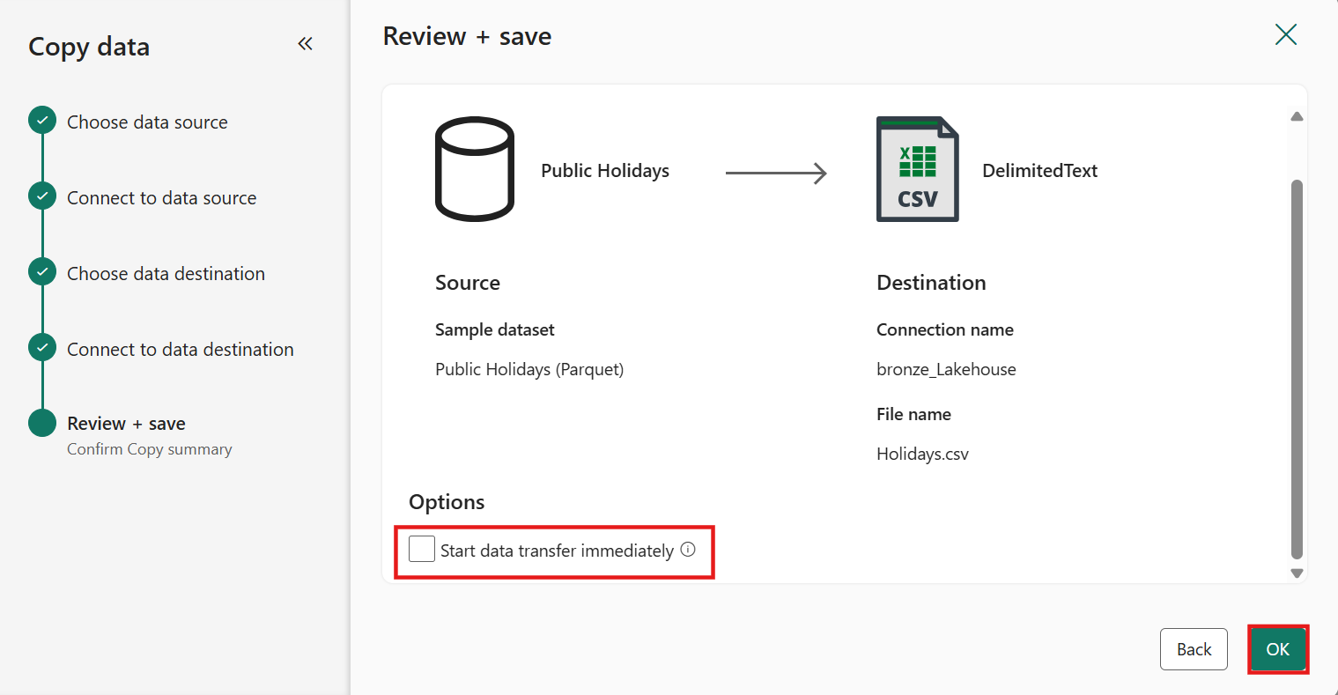

Task 4: Authoring canvas

1. Within the authoring canvas, select the **Copy data activity**.

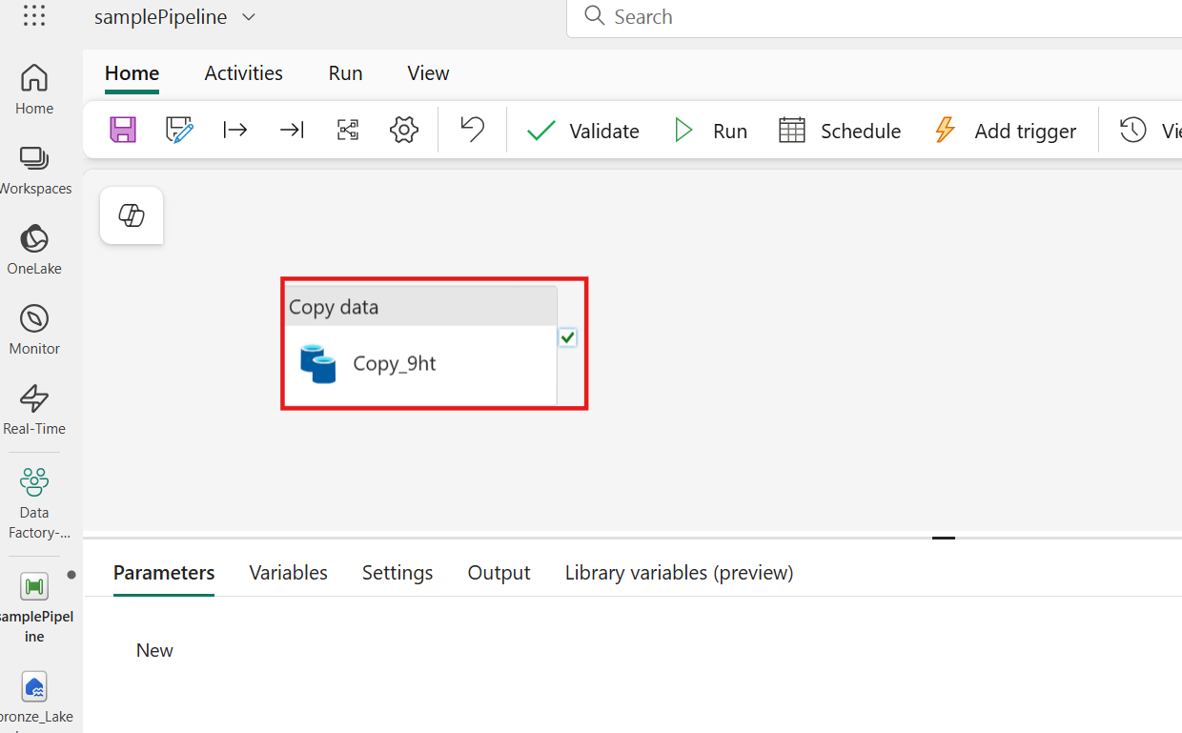

1. The properties section below provides access to configurations for Source, Destination, Settings, and more. These configurations can be edited directly to ensure the data copy activity is correctly set up and aligned with specific requirements.

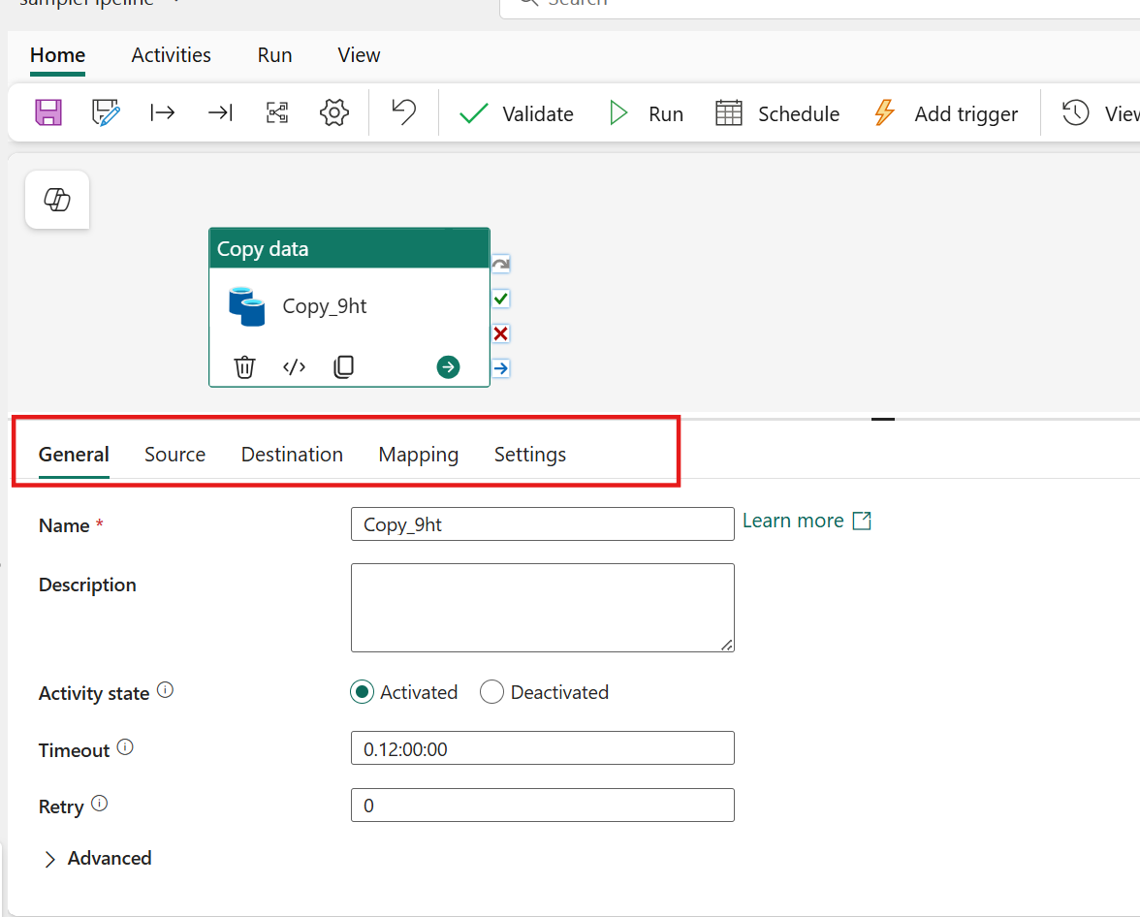

1. Next, from the **Home** tab on the ribbon, select the **Validate** option.

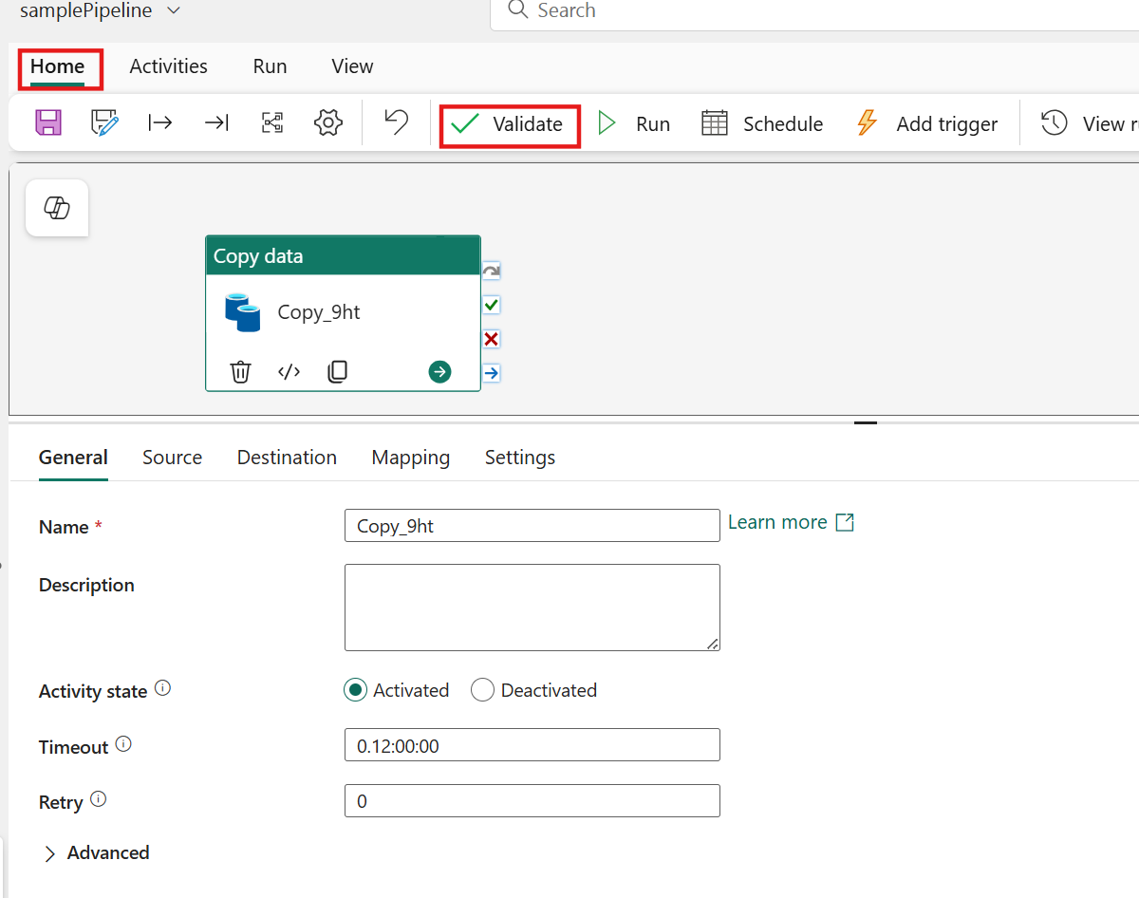

This step is important to ensure that the entire pipeline (in this sample, just the Copy activity) is valid. In the Pipeline validation output window, a confirmation message stating 'The pipeline has been validated. No errors were found.' should appear. This validation step helps identify any potential issues before executing the pipeline

1. Select the **Run** option to start the pipeline and begin your data ingestion process. Running the pipeline initiates the data transfer from the source to the destination.

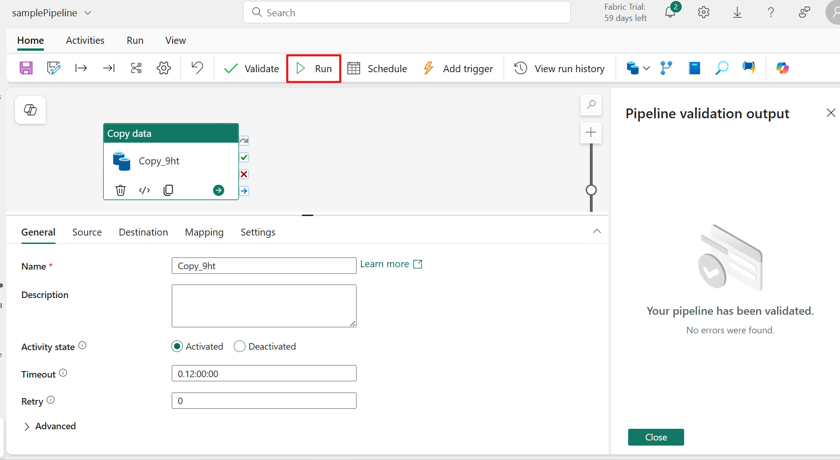

1. In the **Save and run?** dialog box, click on **Save and run** button to execute these activities. This activity will take around less than 1 min.

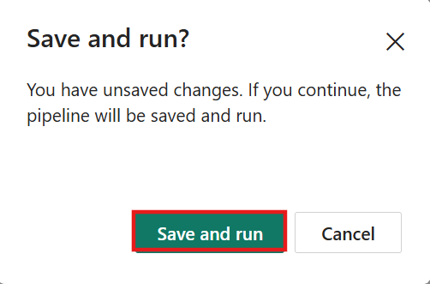

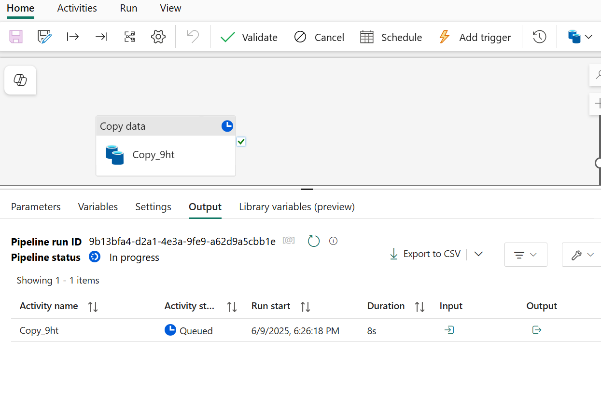

1. The global properties and **Output** view will then become visible. After starting the run of your pipeline, both the **Pipeline status** and the **Activity status** should show a **Succeeded** status. This indicates that everything ran as intended, confirming that your data ingestion process was successful.

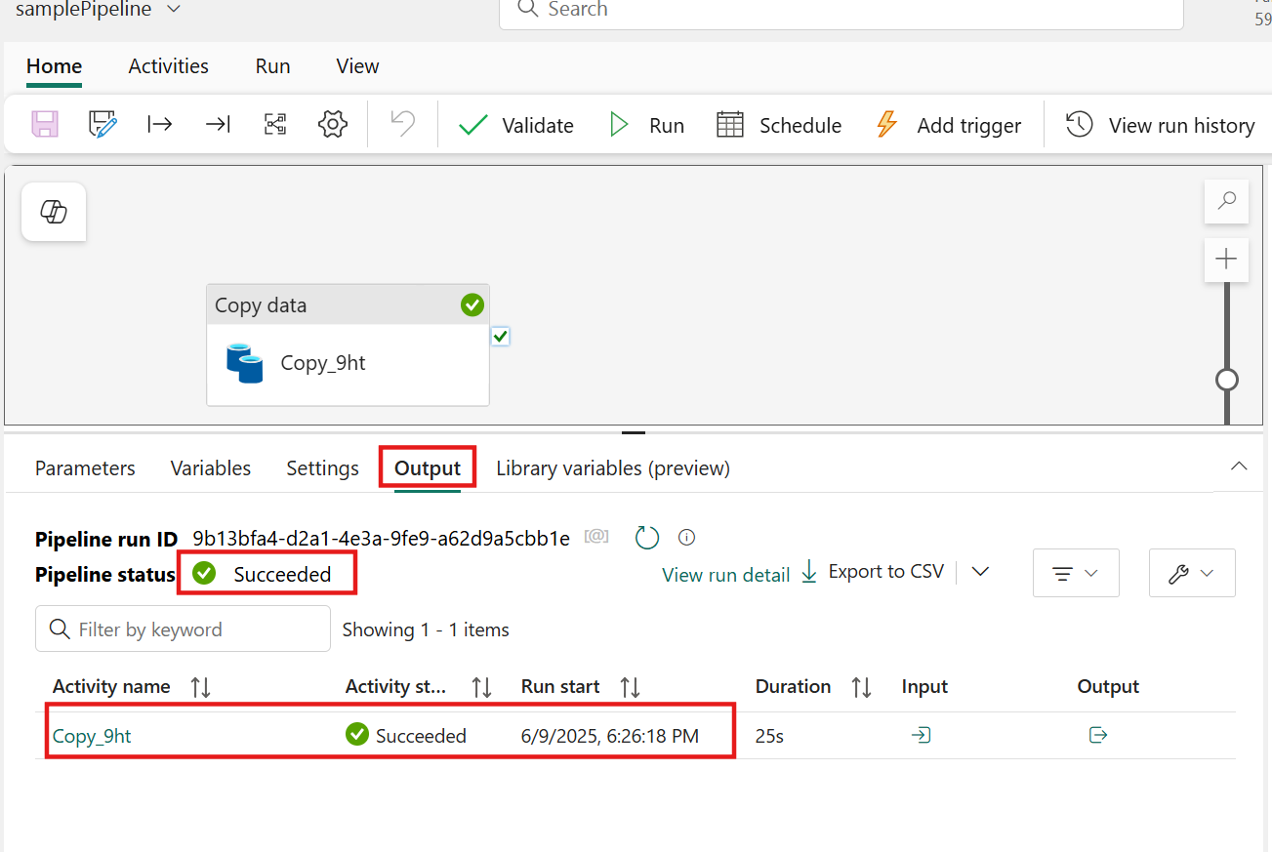

1. In the left-sided navigation menu, navigate and click on **bronze_Lakehouse lakehouse** created in the previous task.

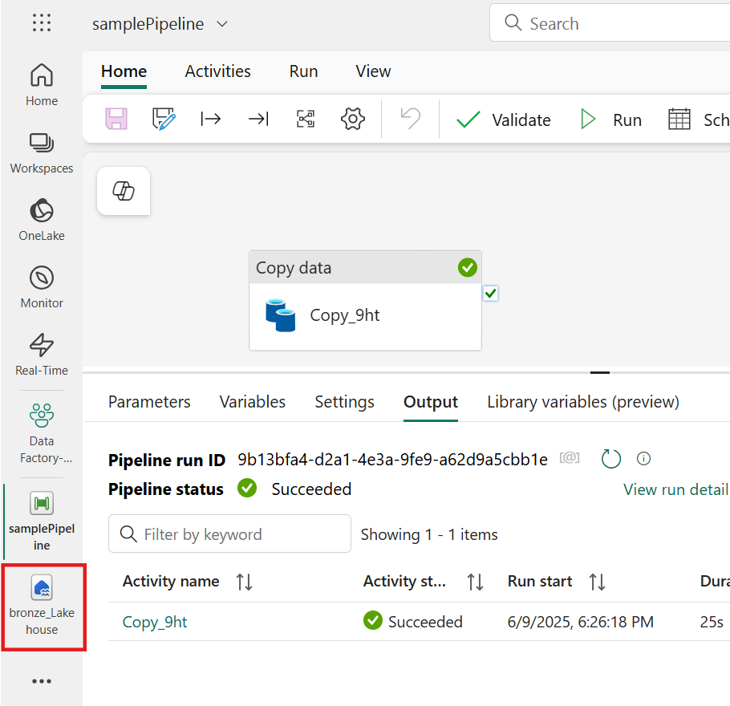

1. The **Holidays.csv** file has been successfully added to the **Files** section. Selecting the file provides a preview of the data, helping confirm that the ingestion process was completed correctly.

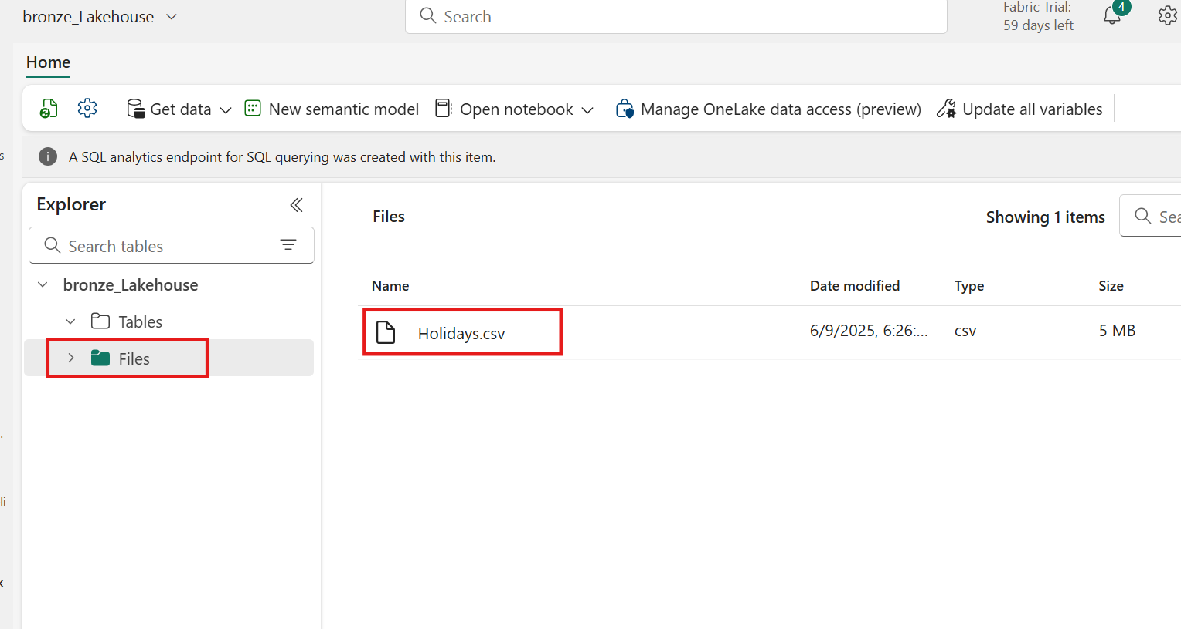

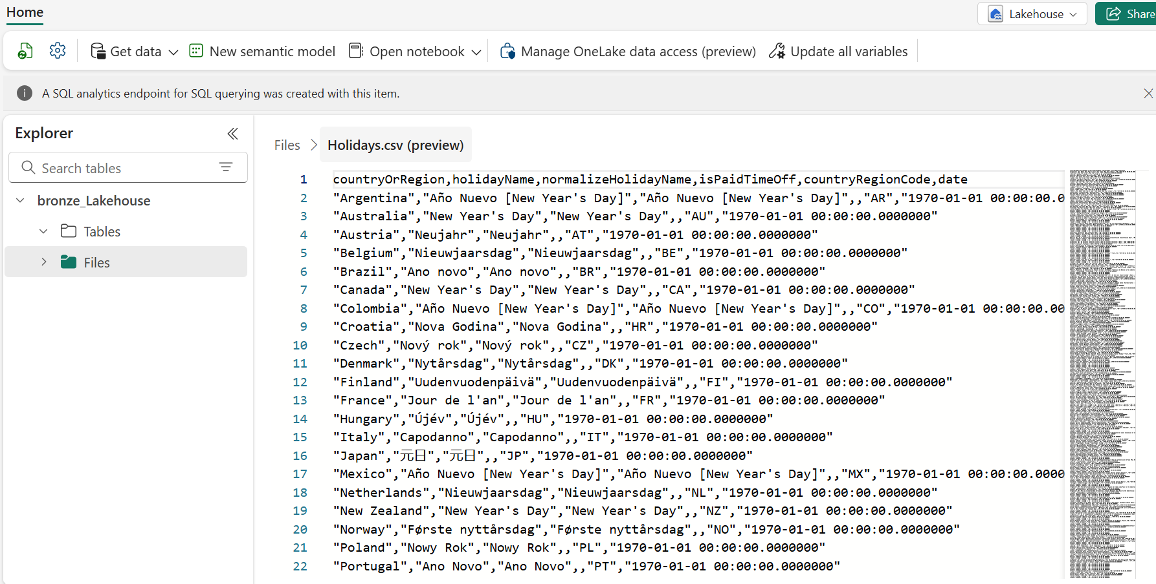

Task 5: Pipeline expression builder

1. Delete the existing **Holidays.csv** file from our lakehouse by selecting the ellipses (**…**) and then the **Delete** option.

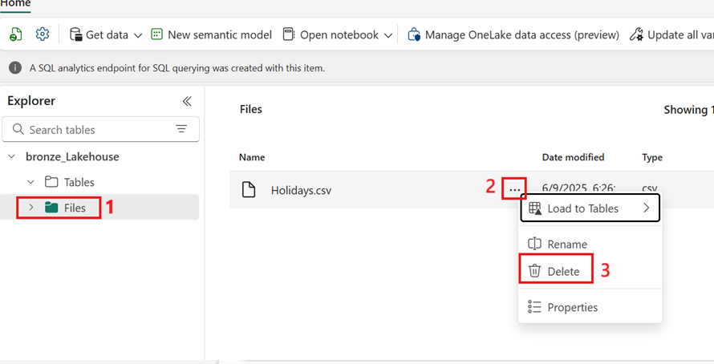

1. A confirmation window will be displayed. Select **Delete** to confirm the removal of the file.

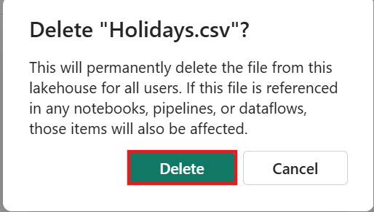

1. In the left-sided navigation menu, navigate and click on **samplePipeline** 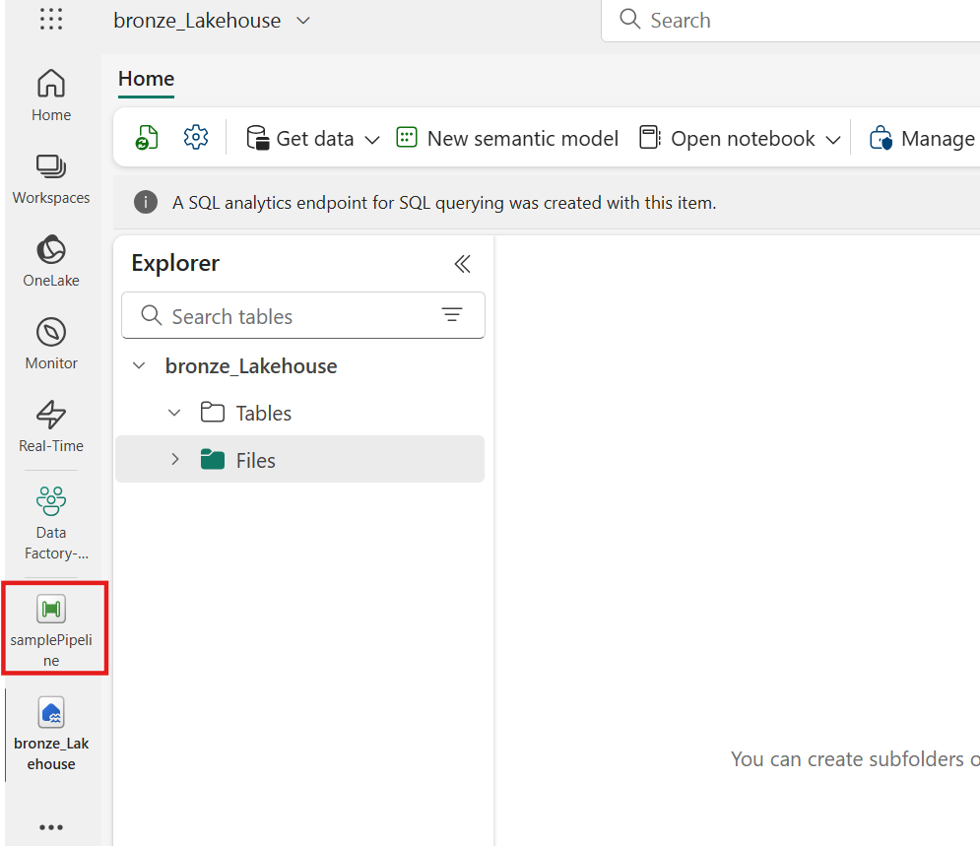
2. Select the **Copy data** activity and then go to the **Destination** tab.

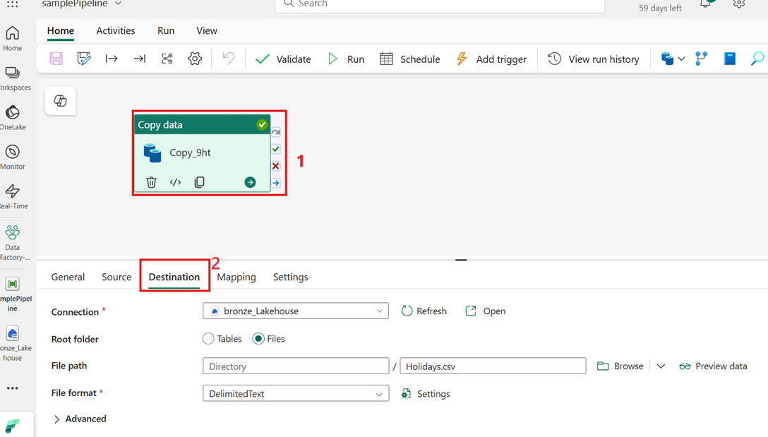

1. Select the text box input for the **File path**, where after selection you will see the text **Add dynamic content [Alt+Shift+D]**. Select this text to open the pipeline expression builder.

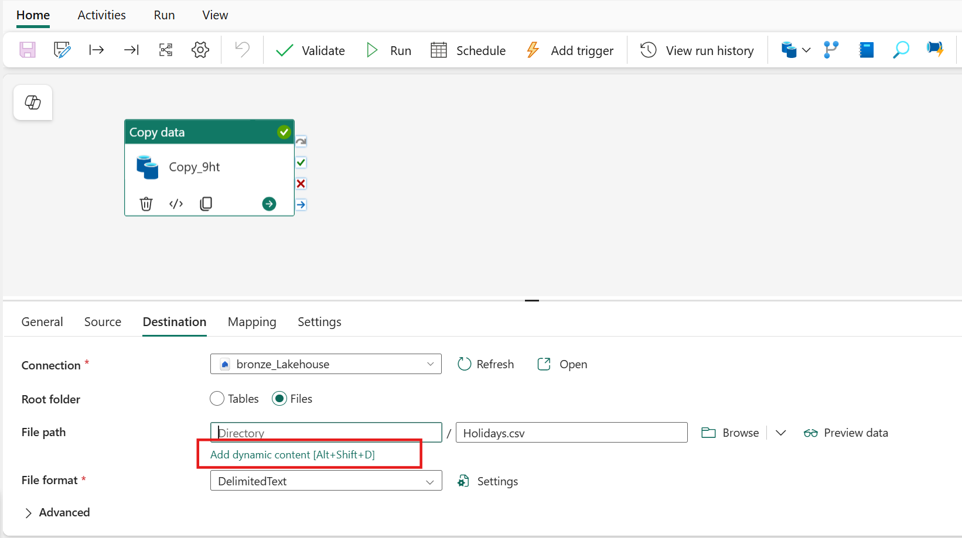

1. Within the Pipeline expression builder window, select the **Functions** tab. Here, you can explore various functions that exist within the expression library. These functions provide powerful tools for creating dynamic expressions. When you're ready, copy and paste the code block below into the expression input box. Press **Ok** when complete.
2. @formatDateTime(
3. convertFromUtc(
4. utcnow(), 'Central Standard Time'
5. ),
6. 'yyyy/MM/dd'

)

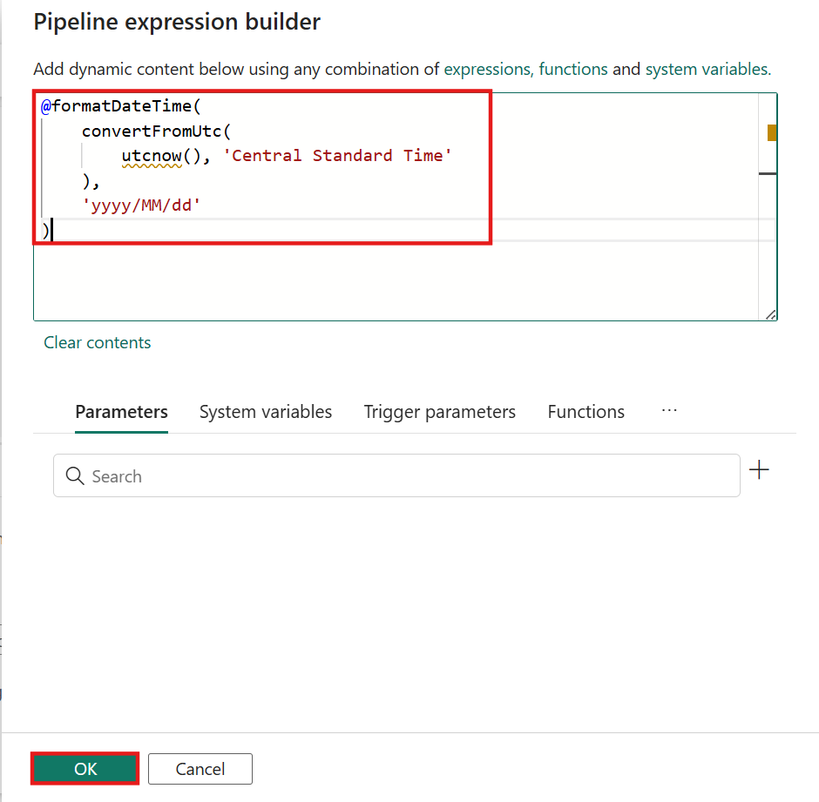

**Note:** This expression will be used to create a folder structure within your pipeline that writes the file to nested folders based on the current year, the current month, and the current date of the run time. The forward slash "**/**" character is how the folder structure is defined. This dynamic folder structure helps in organizing your data based on the date, making it easier to manage and retrieve.

1. From the **Home** tab on the ribbon, select the **Validate** option once again.

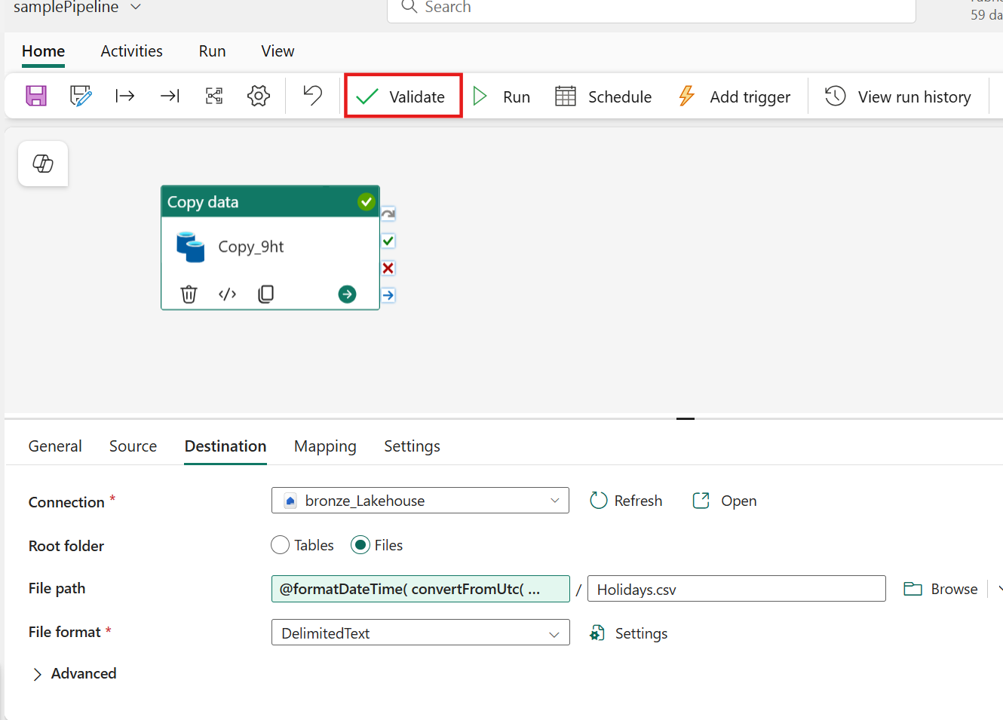

1. Select the **Run** option to start the pipeline and begin data ingestion process. Running the pipeline initiates the data transfer from the source to the updated destination folder path.

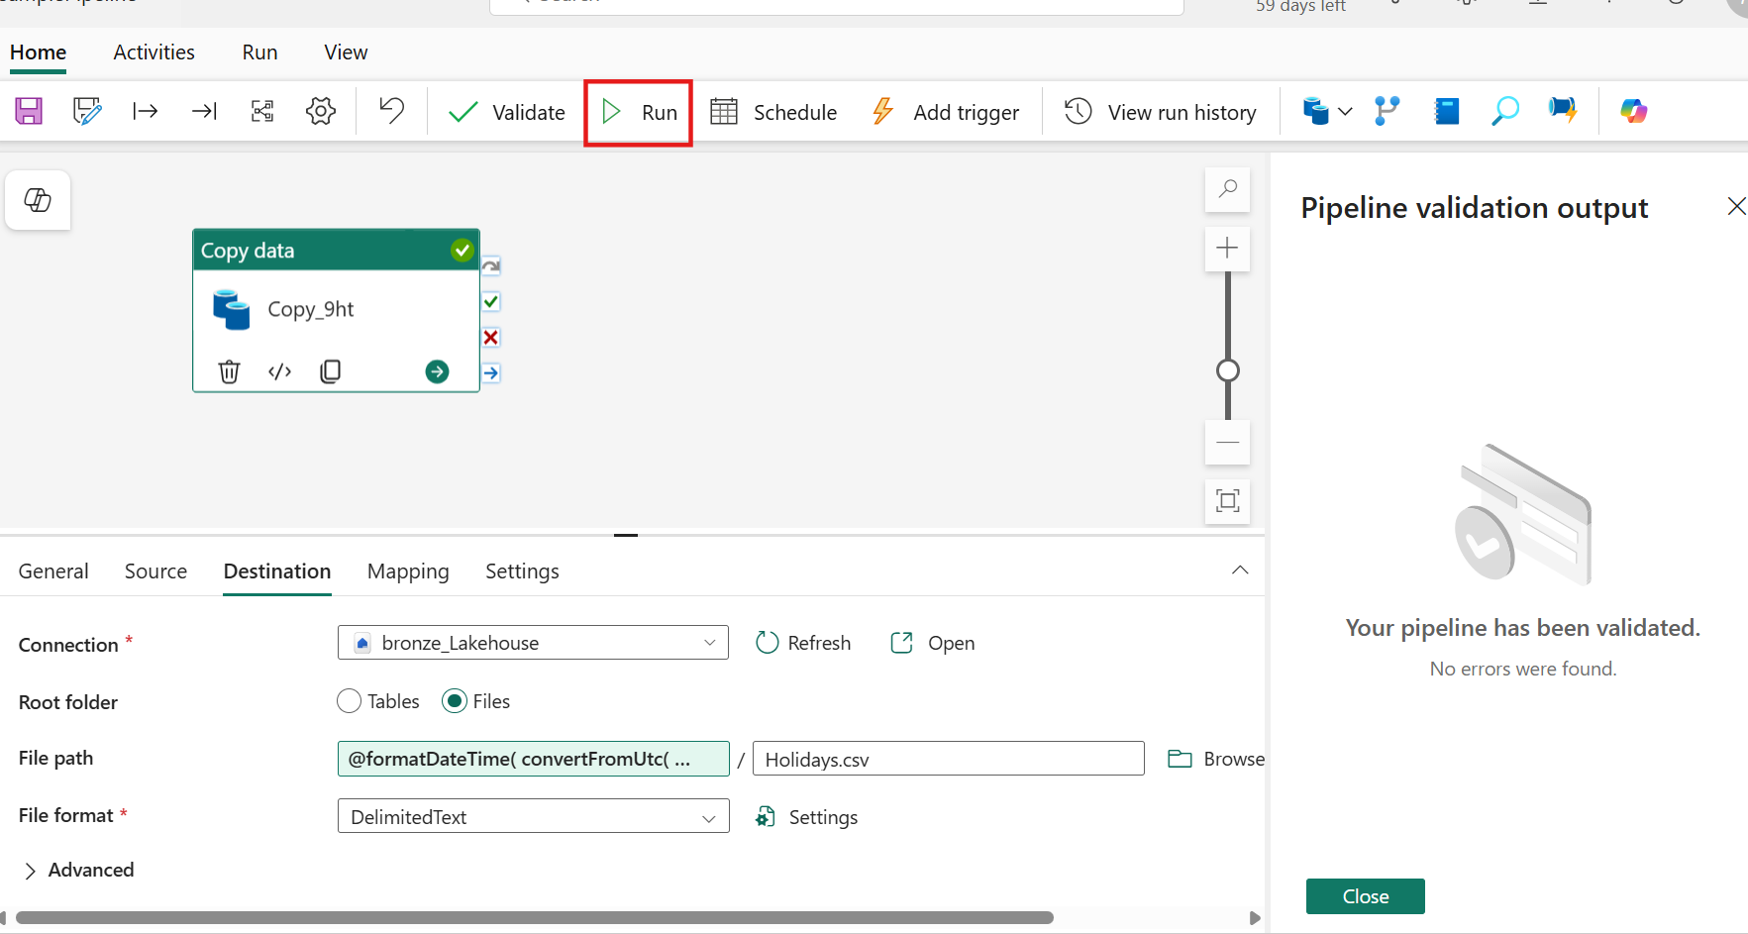

1. In the **Save and run?** dialog box, click on **Save and run** button to execute these activities. This activity will take around less than 1 min.

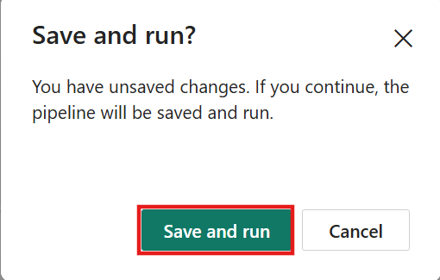

1. The global properties and **Output** view will then become visible. After starting the run of your pipeline, both the **Pipeline status** and the **Activity status** should show a **Succeeded** status. This indicates that everything ran as intended, confirming that your data ingestion process was successful.

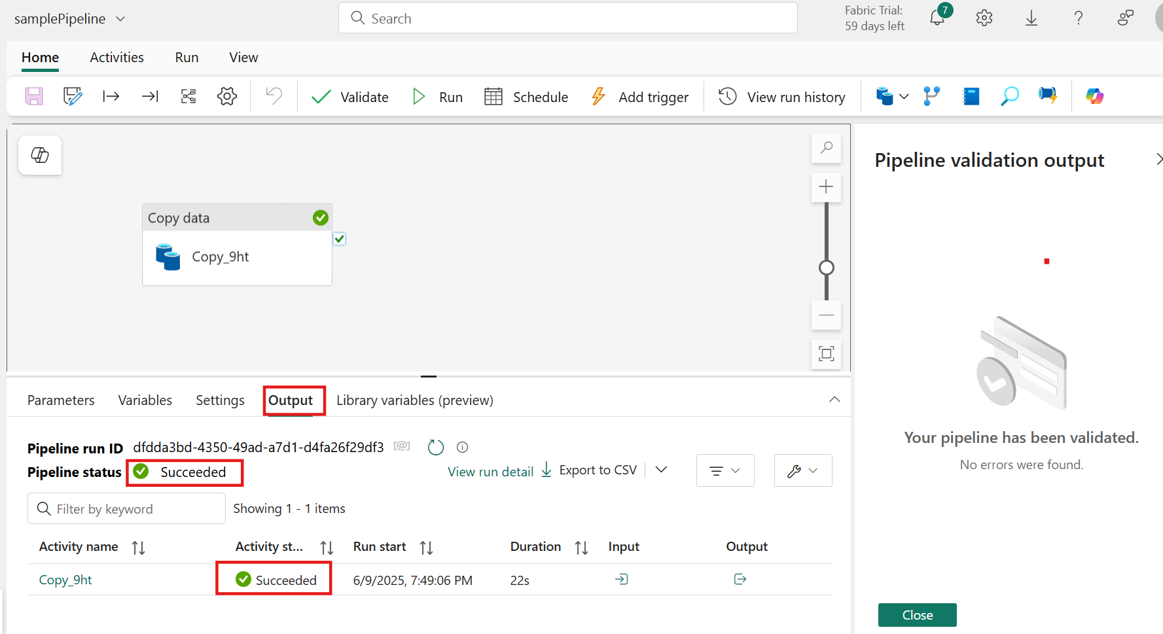

1. In the left-sided navigation menu, navigate and click on **bronze_Lakehouse lakehouse** created in the previous task.

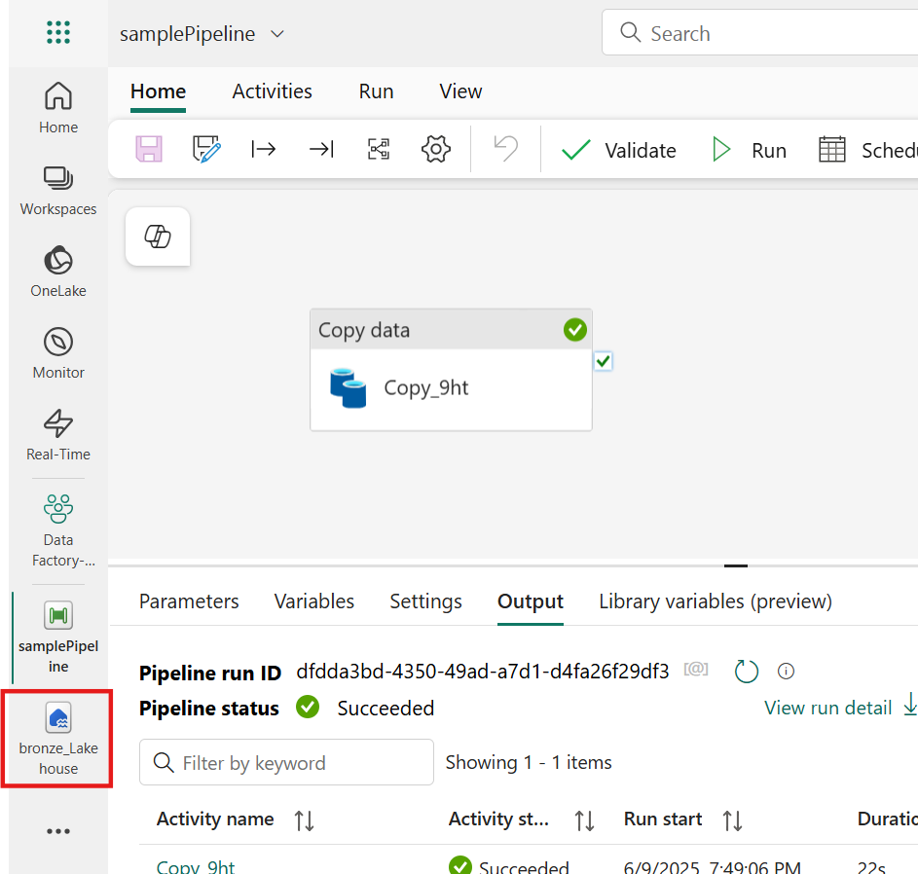

1. The **Holidays.csv** file has been successfully added to the **Files** section, organized within a nested folder structure based on the **year, month, and date** of execution. This confirms that the dynamic file output is functioning correctly and that the data is being structured as intended.

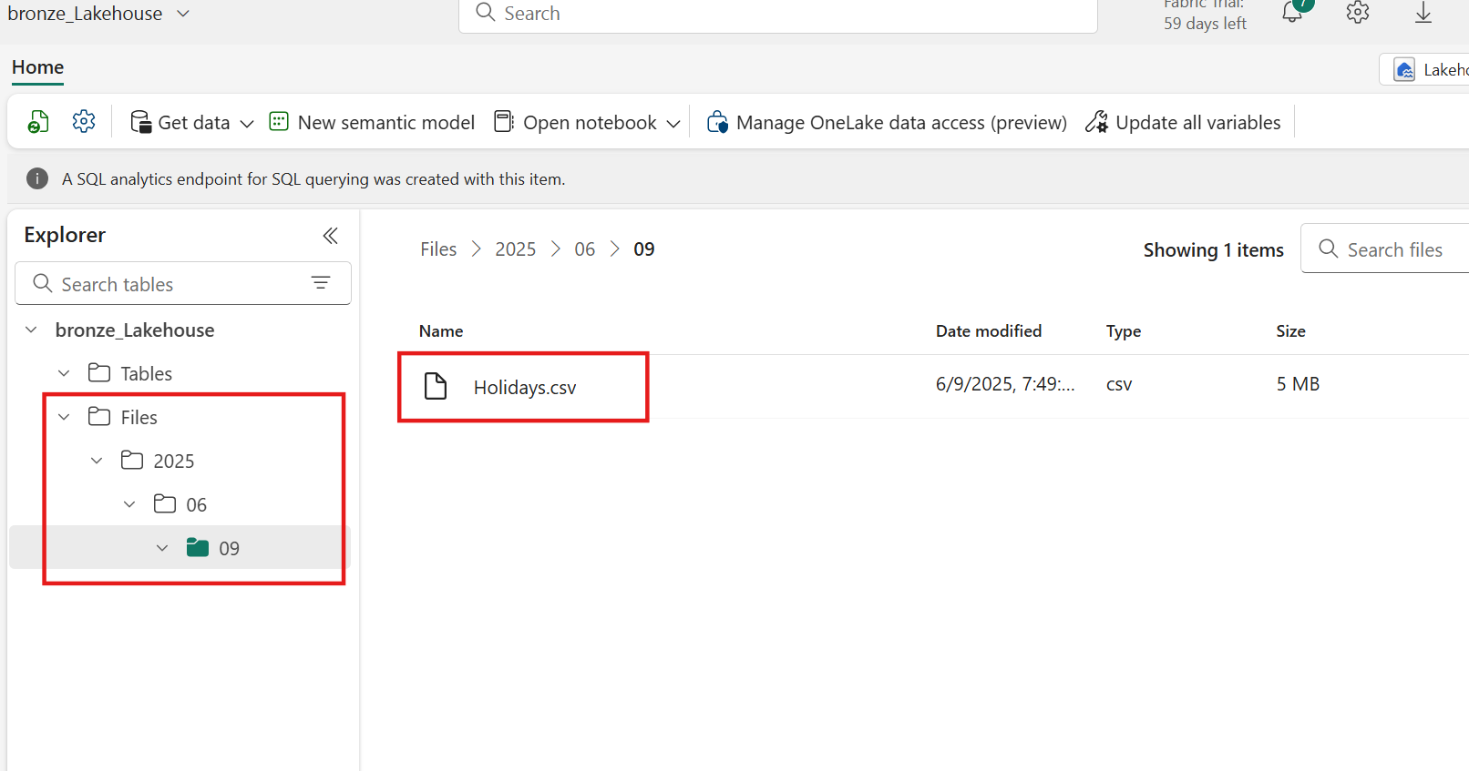

**Note:** If the contents are not yet visible, navigate to the Home tab and select the Refresh icon to start the metadata sync process and update the lakehouse viewer content.

1. Select the **ellipses (…)** next to the top level year folder and then the **Delete** option to remove the **sample data**

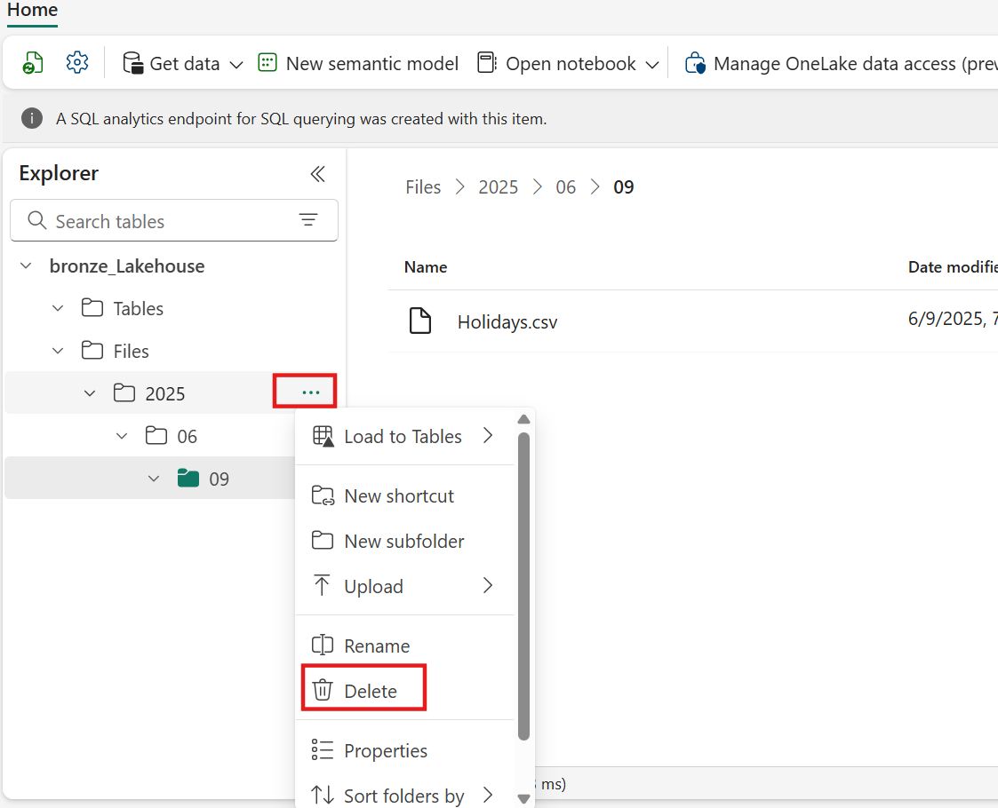

1. A confirmation window will appear, select **Delete** to proceed with removing the contents.

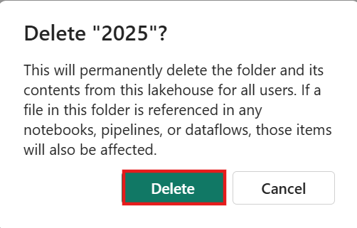

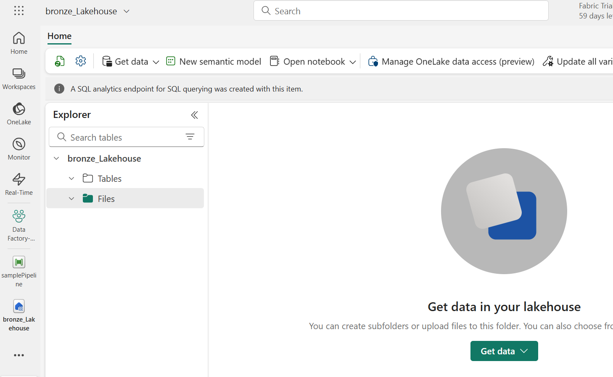

Exercise 2: Orchestrating data movement

This exercise focuses on orchestrating data movement using Data Factory experiences, including the creation of dynamic expressions and conditional paths. It provides practical guidance for building flexible and efficient data workflows.

The first step involves creating a dynamic pipeline using variables to manage and copy data efficiently through reusable components. This approach enhances modularity and simplifies pipeline maintenance.

Next, conditional paths are set up to handle different scenarios and ensure a logical flow within the pipeline. These paths enable decision-making capabilities that adapt to varying data conditions and processing requirements.

Finally, data is moved between medallion layers-specifically from the bronze to the silver layer-to optimize data storage and retrieval for analytical purposes. This structured movement supports improved data quality and accessibility across the data lifecycle.

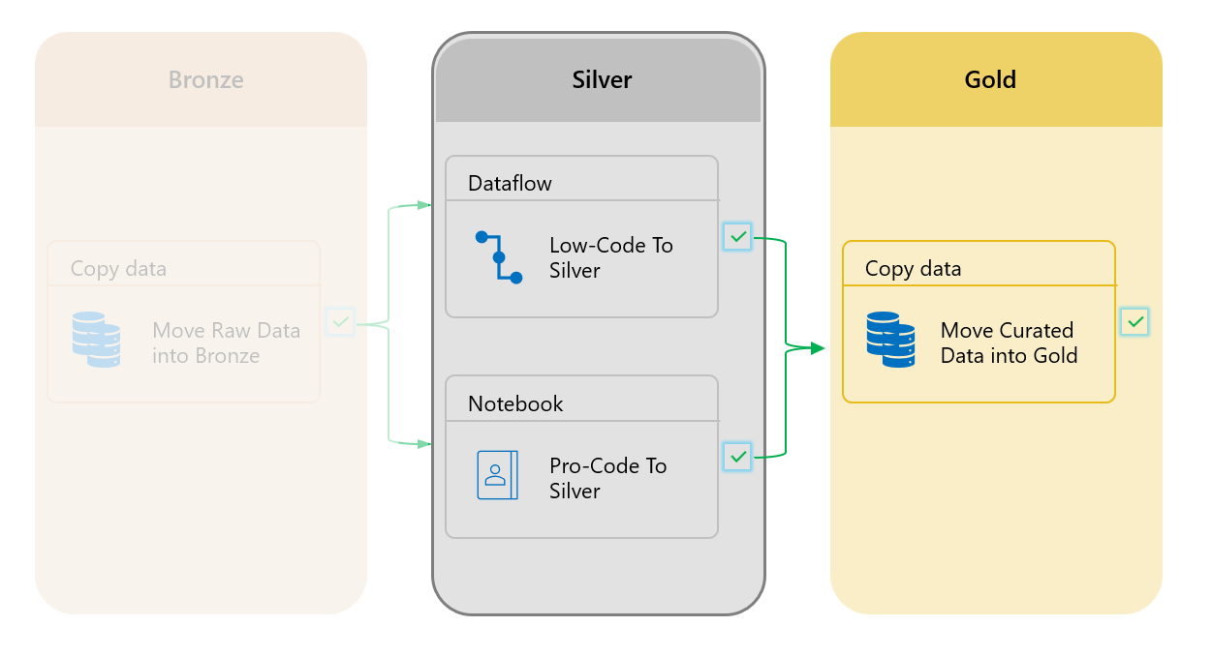

Task 1: Create a data pipeline

1. In the left-sided navigation menu, navigate and click on **Data Factory-MedallionXX**, as shown in the below image.

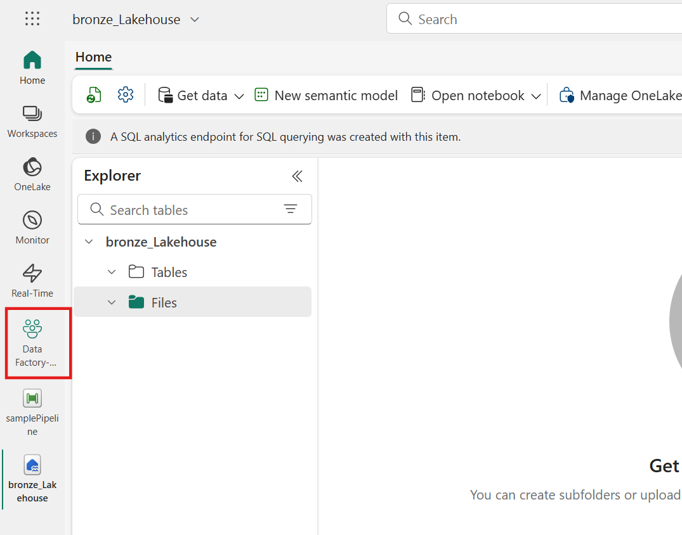

1. Now proceed to select and add a **New item** from the **High-volume data ingest** task.

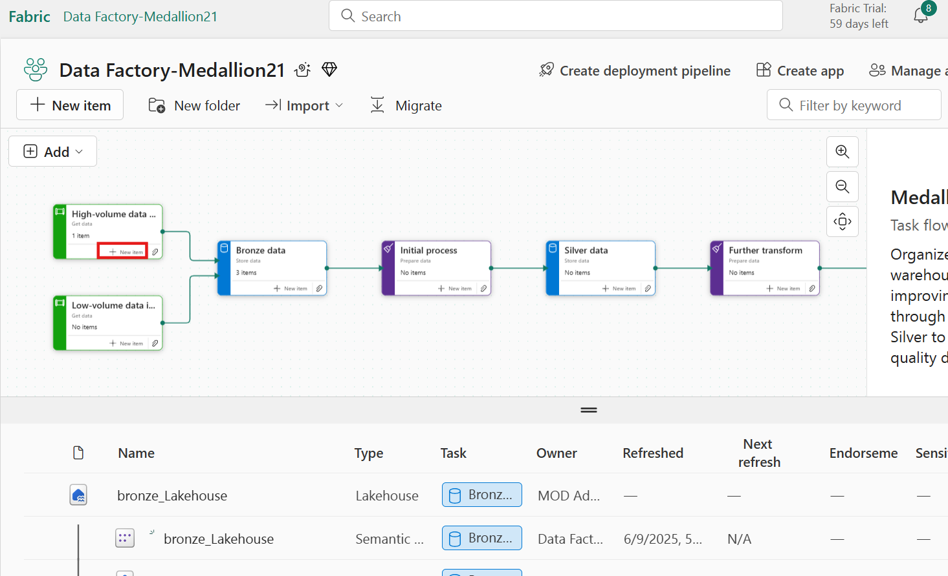

1. Within the Create an item window, the available options within Microsoft Fabric have been filtered down to **Recommended items** only again. Select the **Data pipeline** item.

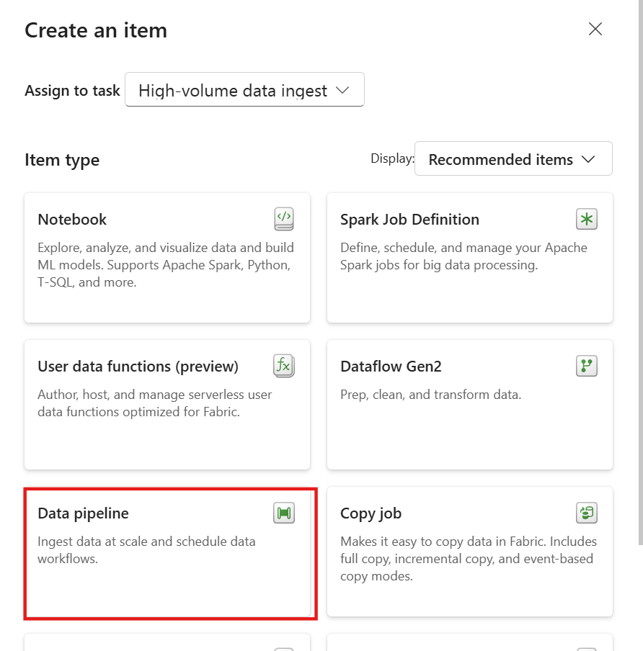

1. In the New pipeline window, set the data pipeline name to **getContosoSample** and then select **Create**.

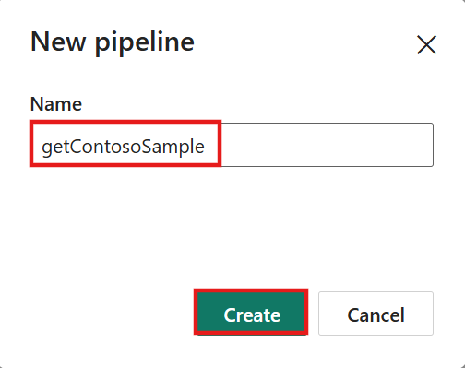

Task 2: Creating a data connection

1. From the new and empty data pipeline, select the **Pipeline activity** watermark option and then choose **Copy data** to add this activity to the authoring canvas.

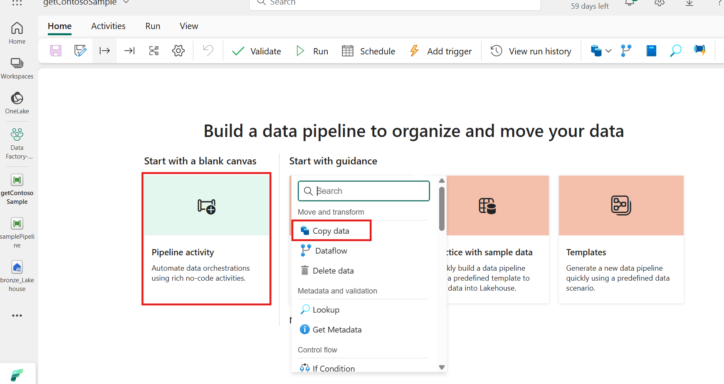

1. With the **Copy data** activity selected, navigate to the **Source** tab. Within the **Connection** drop-down menu, select the **More** option to launch the Get data navigator.

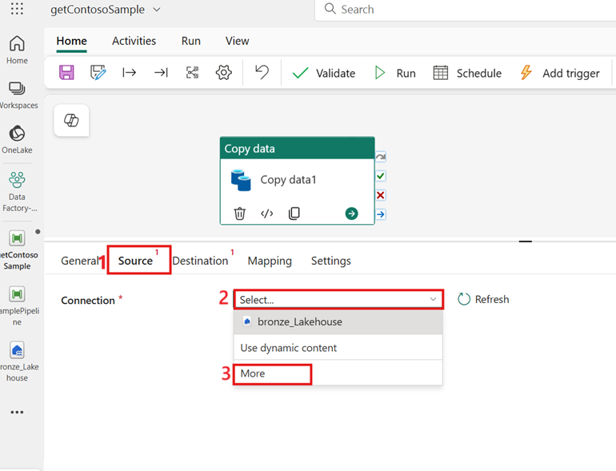

This navigator provides a comprehensive interface for connecting to various data sources, ensuring that you can easily integrate different data streams into pipeline.

1. From the Get data navigator, select **Add** from the left side-rail.

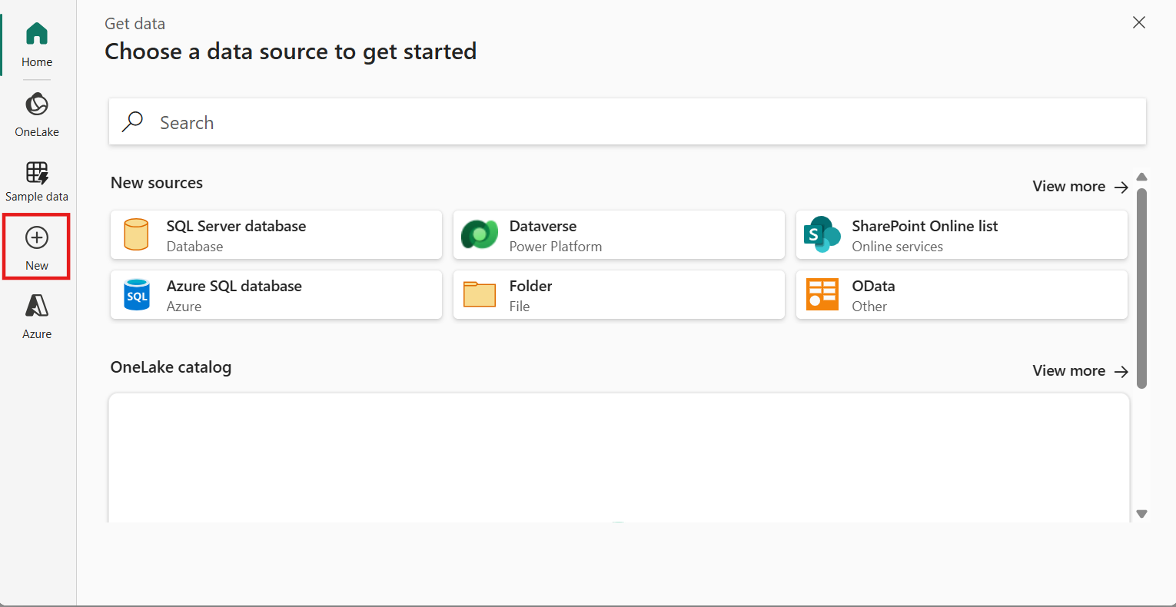

1. From the list of **New sources**, select **View more**, search for **Http** and select it. The Http connector allows you to connect to web-based data sources, providing flexibility in accessing data from various online resources.

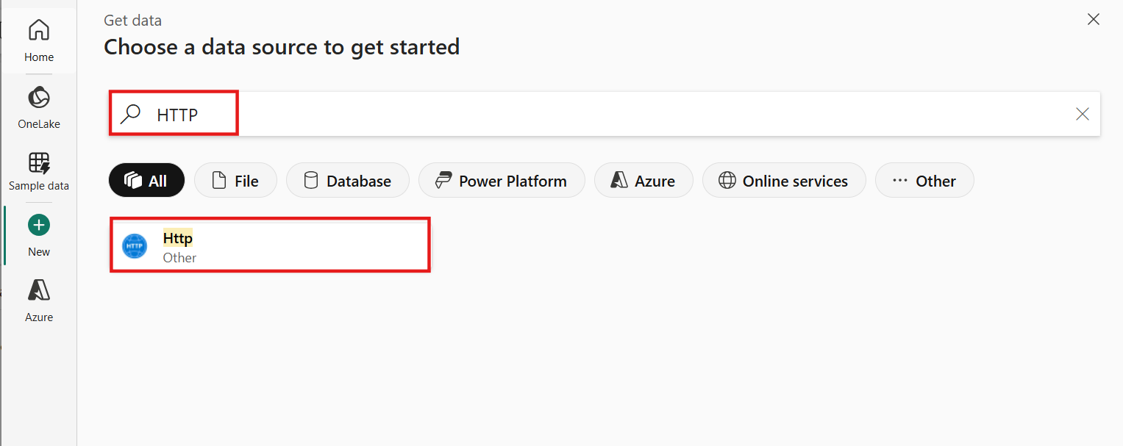

1. n the **Connect to data source** window, enter the details from the table below and select **Connect**.

|  |  |
| --- | --- |
| Property | Value |
| URL | **https://github.com/microsoft/pbiworkshops/raw/main/Day%20After%20Dashboard%20in%20a%20Day/Source_Files/ContosoSales.zip** |
| Connection | Create a new connection |
| Connection name | **ContosoSample** |
| Data gateway | None |
| Authentication kind | Anonymous |

1. 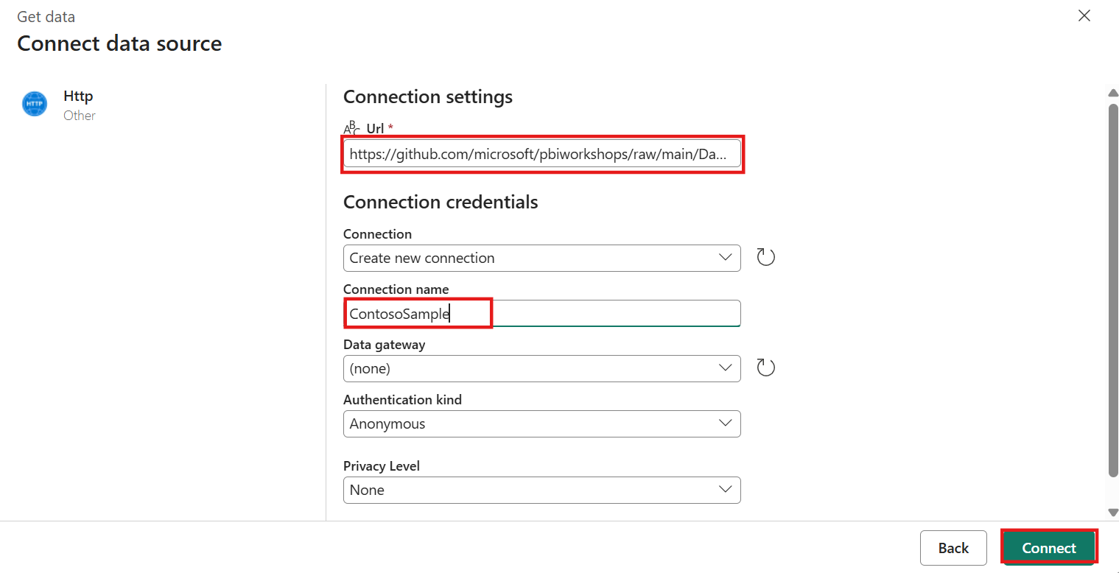
2. 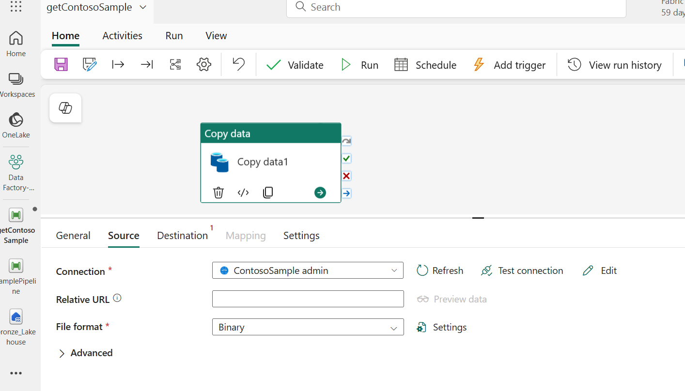

Task 3: Copy activity settings

1. In the **Copy data** activity selected and the **Source** tab displayed, select the **Settings** option next to the File format field

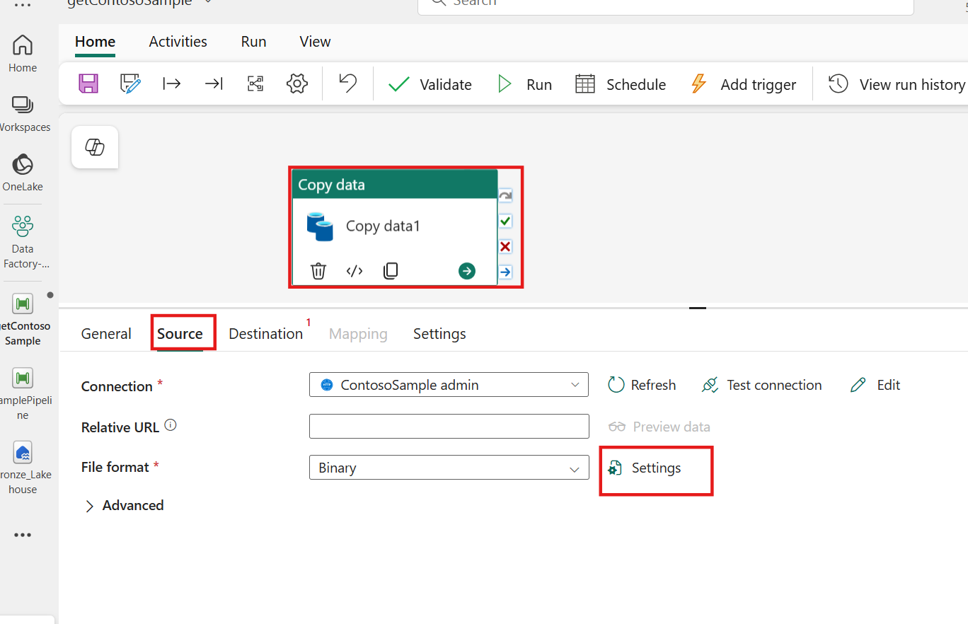

1. In the **Compression type** setting, choose **ZipDeflate (.zip)** and select **OK** to complete.

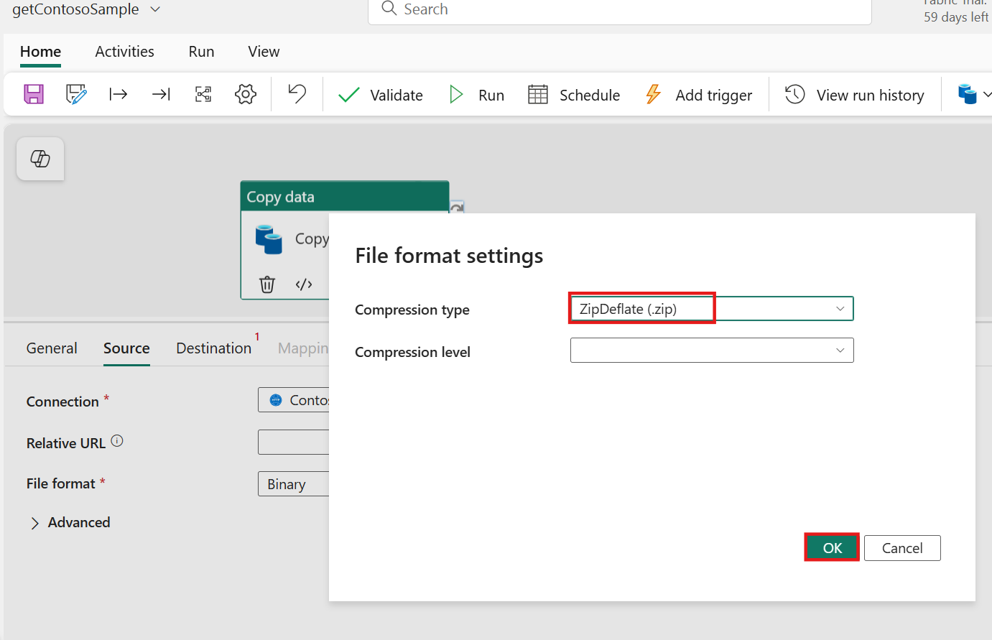

1. In the Source tab, expand the **Advanced** section. Deselect the option to **Preserve zip file name as folder**. This allows you to customize the folder name for your zip contents, providing more flexibility in organizing data.

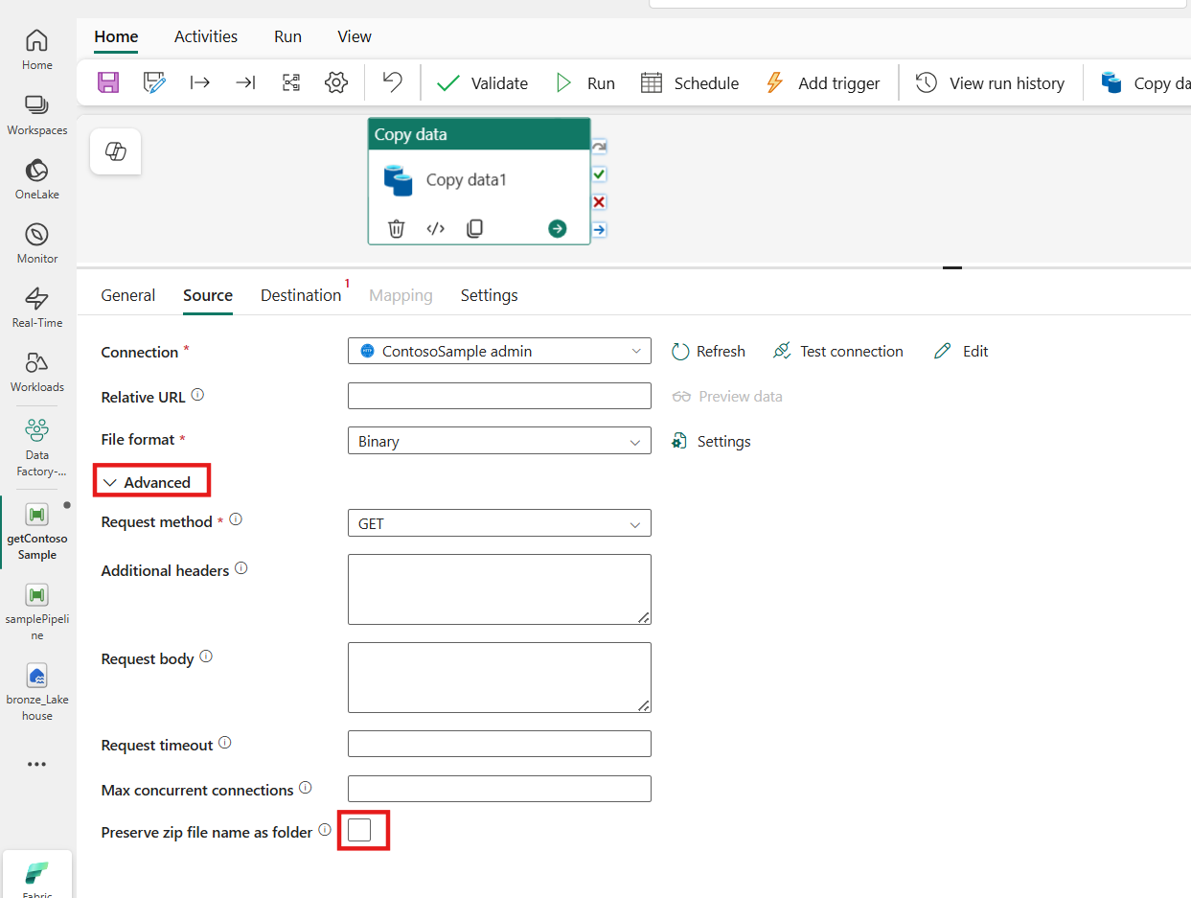

1. In the Copy data activity, navigate to the **Destination** tab.

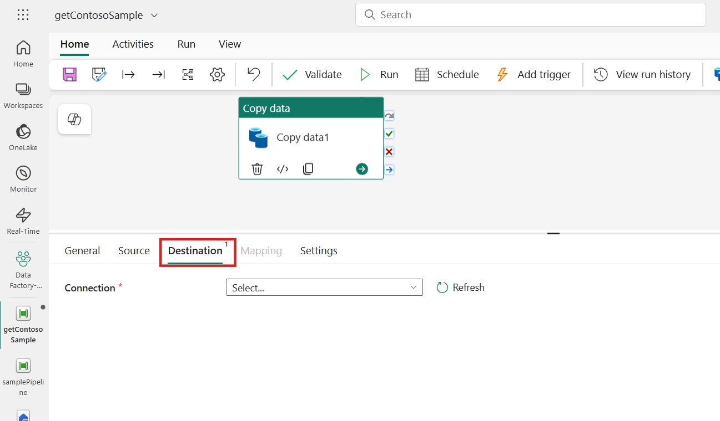

1. From the list of connections, select the configured lakehouse **bronze_Lakehouse**.

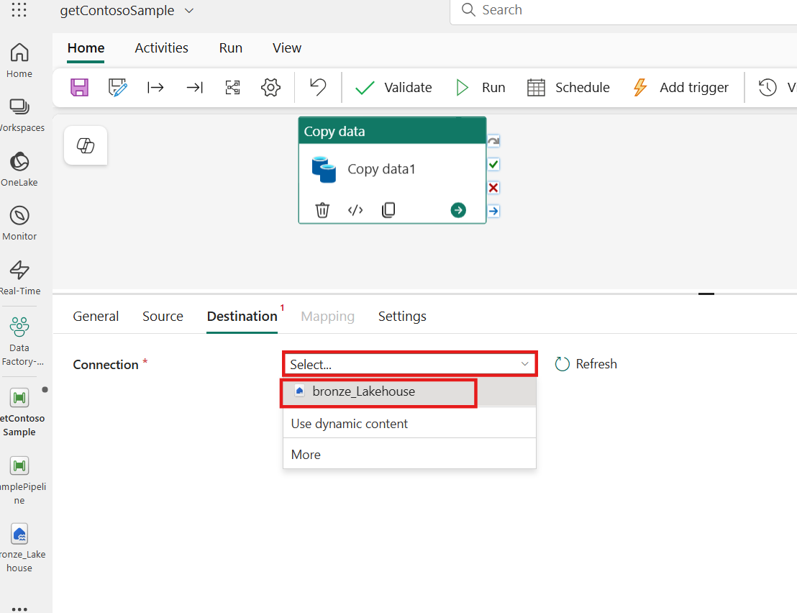

This step ensures that the data is being copied to the correct destination, which is essential for maintaining data integrity and organization.

1. Within the Destination settings, select the **Files** option and then the **Directory** file path text input box. This will display the **Add dynamic content [Alt+Shift+D]** property.

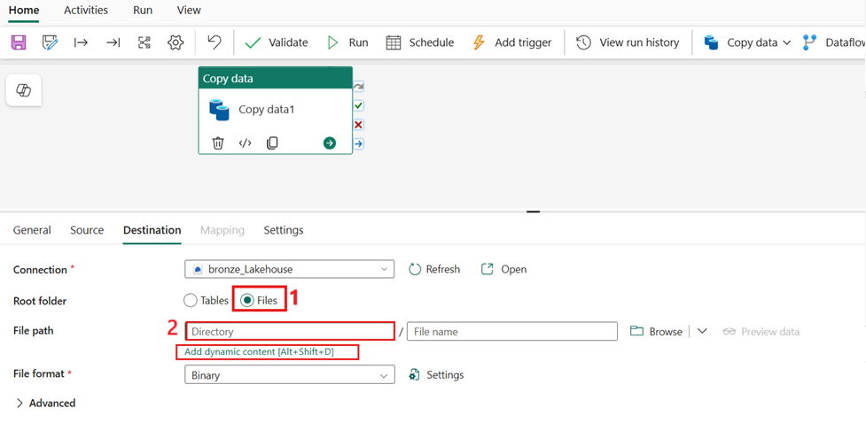

1. Select this text to open the pipeline expression builder. The expression builder allows us to create dynamic file paths, which can be customized based on various dynamic parameters such as date and time or static text values.

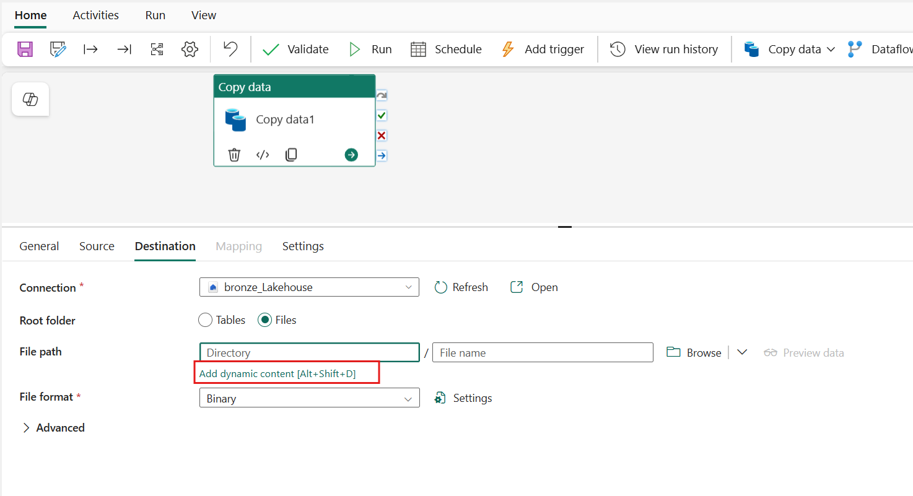

1. In the Pipeline expression builder window, select the **Functions** tab. Here, you can explore various functions that exist within the expression library, in this example we'll use both date and string functions to create a dynamic folder path. Copy and paste the code block below into the expression input box. Press **Ok** when complete.
2. @concat(
3. 'ContosoSales\',
4. formatDateTime(
5. convertFromUtc(
6. utcnow(), 'Central Standard Time'
7. ),
8. 'yyyy/MM/dd'
9. )

)

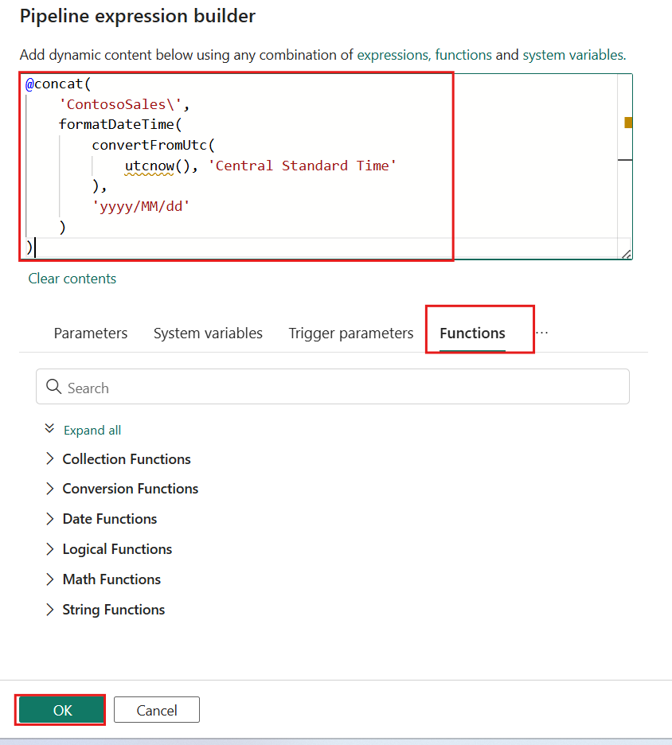

1. With the Copy data activity and Destination settings still selected, expand the **Advanced** section, select the drop-down for the **Copy behavior** and then choose the **Preserve hierarchy** option.
2. This option maintains the original file names as they are within the zip file, ensuring that the file structure is preserved during the copy process.

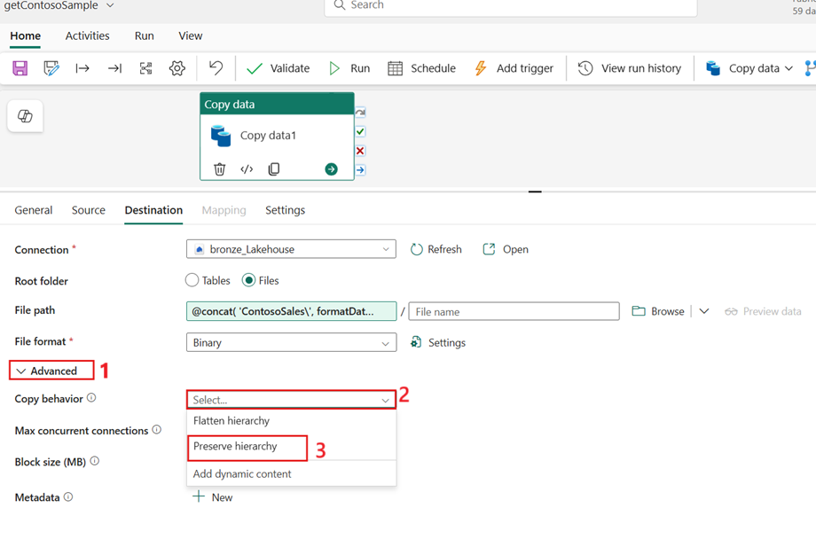

1. Navigate to the **General** tab with the Copy data activity selected. Update the **Name** and **Description** fields with the appropriate text. This step helps in identifying and managing the activity within your pipeline, making it easier to understand its purpose and functionality.

| **Property** | **Text** |
| --- | --- |
| Name | **Get and Unzip files** |
| Description | Copies sample data from GitHub and stores raw content in lakehouse files |

1. 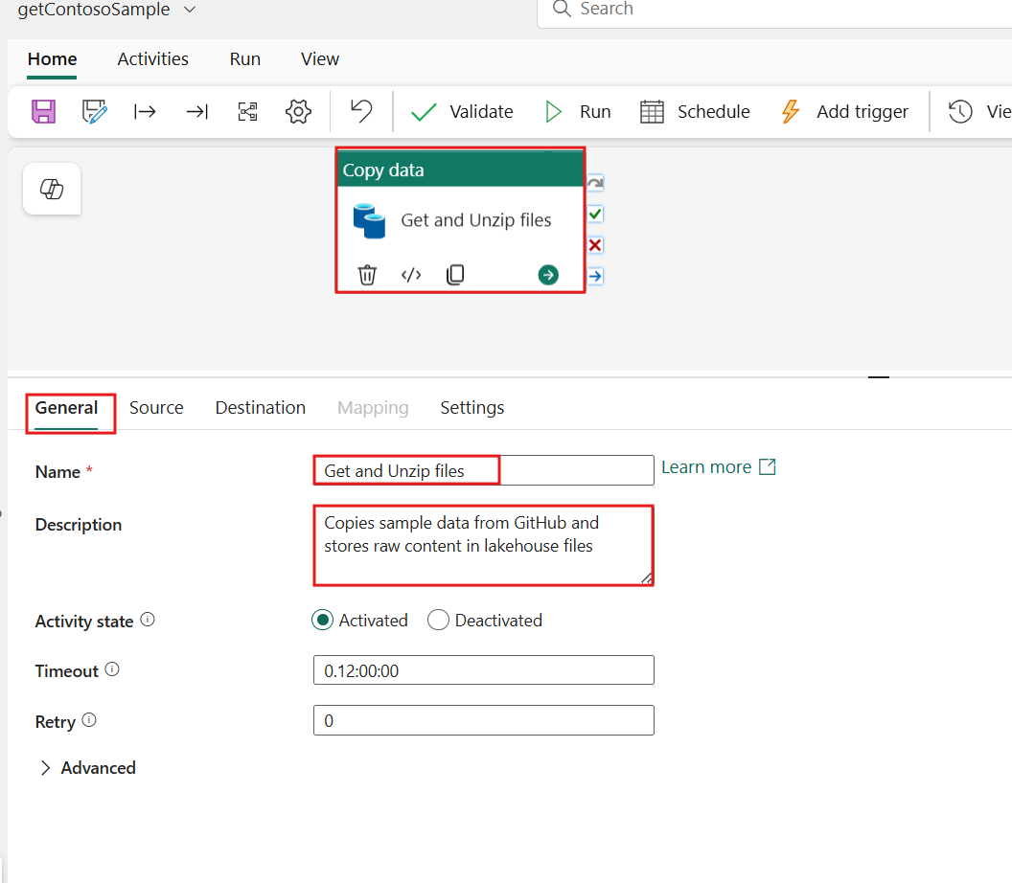
2. From the **Home** tab, select the **Validate** option to first confirm that there are no issues with your pipeline. This validation step helps in identifying any errors to be fixed before running the pipeline.

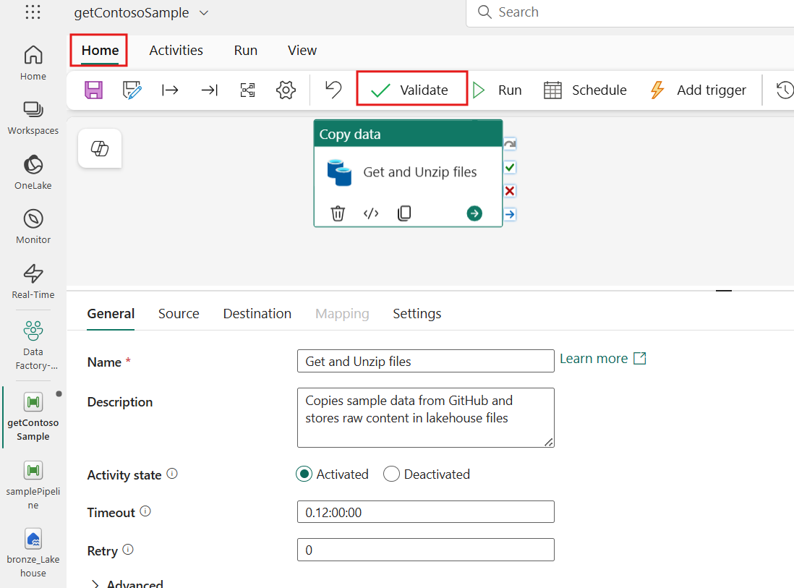

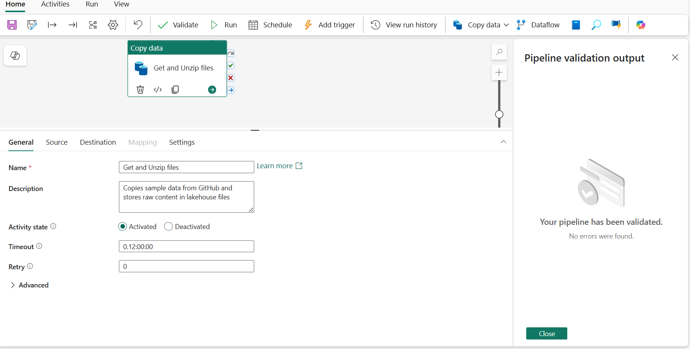

1. Once validated, select the **Save** option and then **Run** to start the ingestion from the data pipeline. Running the pipeline initiates the data transfer, allowing you to see the results of your configuration in action within the output window.

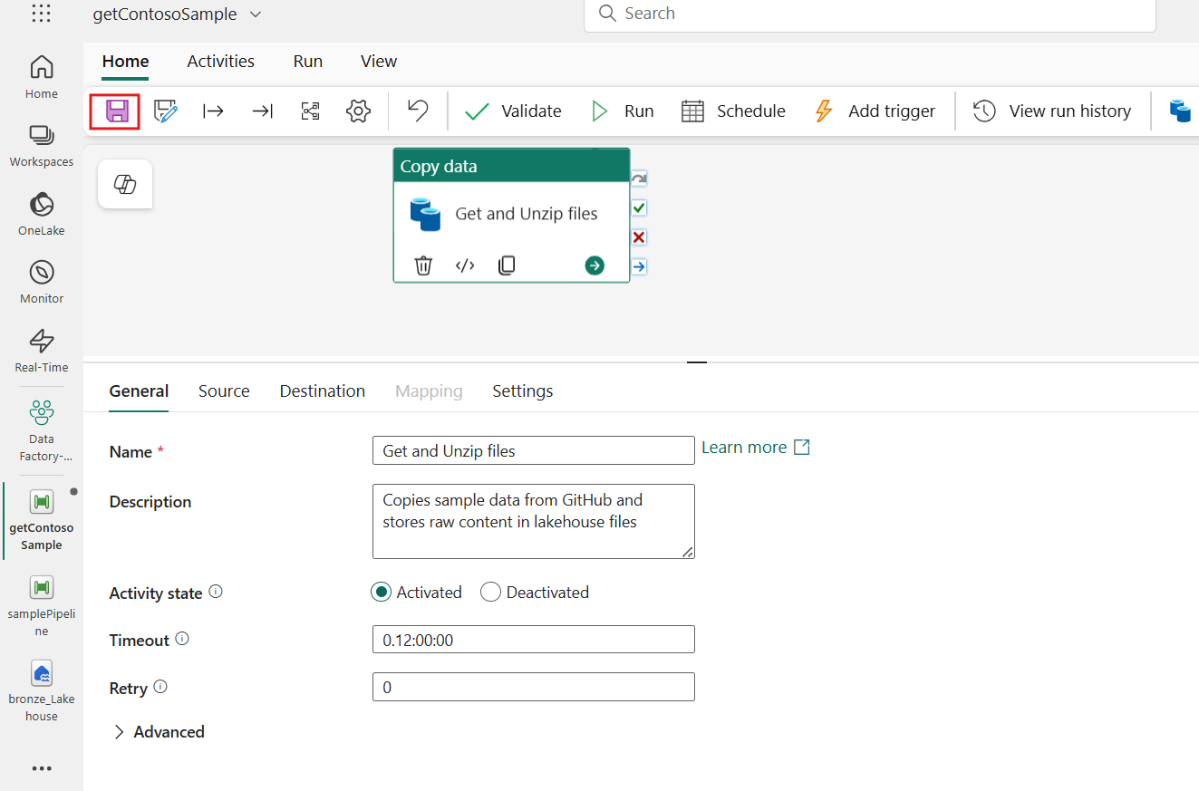

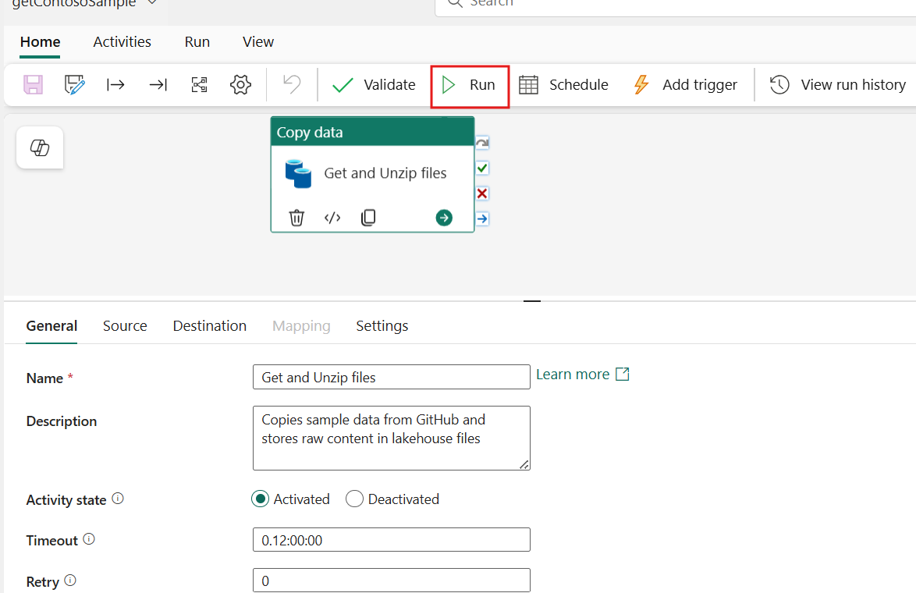

1. This action will make the global properties and **Output** view visible. After starting the run of your pipeline, both the Pipeline status and any individual Activity statuses should show a **Succeeded** status. This indicates that everything ran as intended, confirming that your data ingestion process was successful.

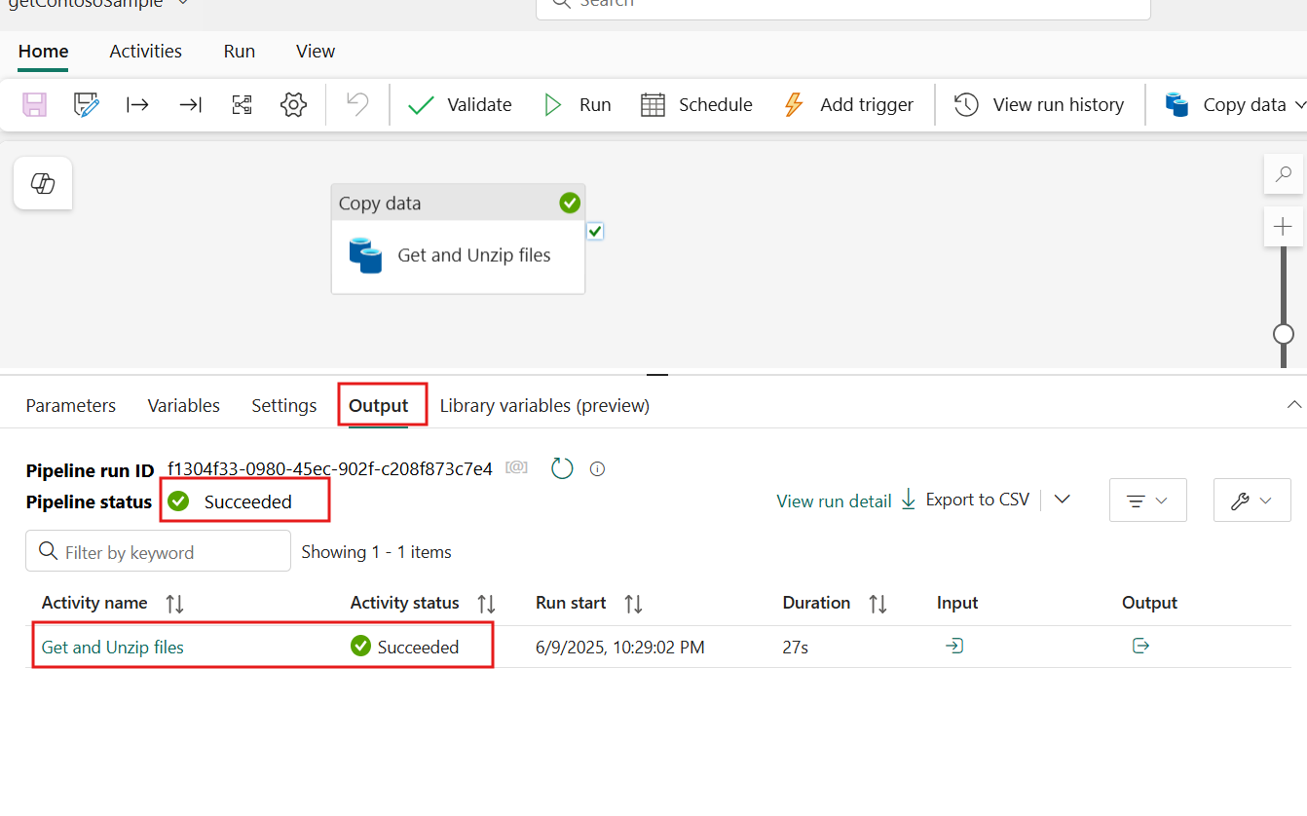

1. In the left-sided navigation menu, navigate and click on **bronze_Lakehouse lakehouse**

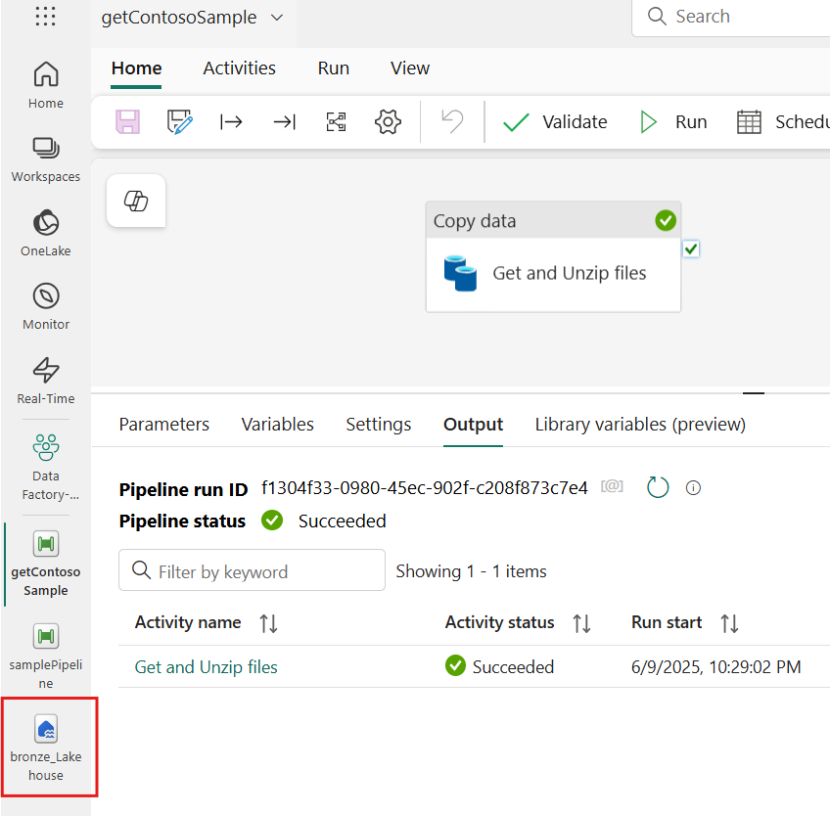

1. The contents of the **zip file** have been successfully added to the **Files** section, organized in a nested folder structure based on the data source title, year, month, and date of the pipeline run.

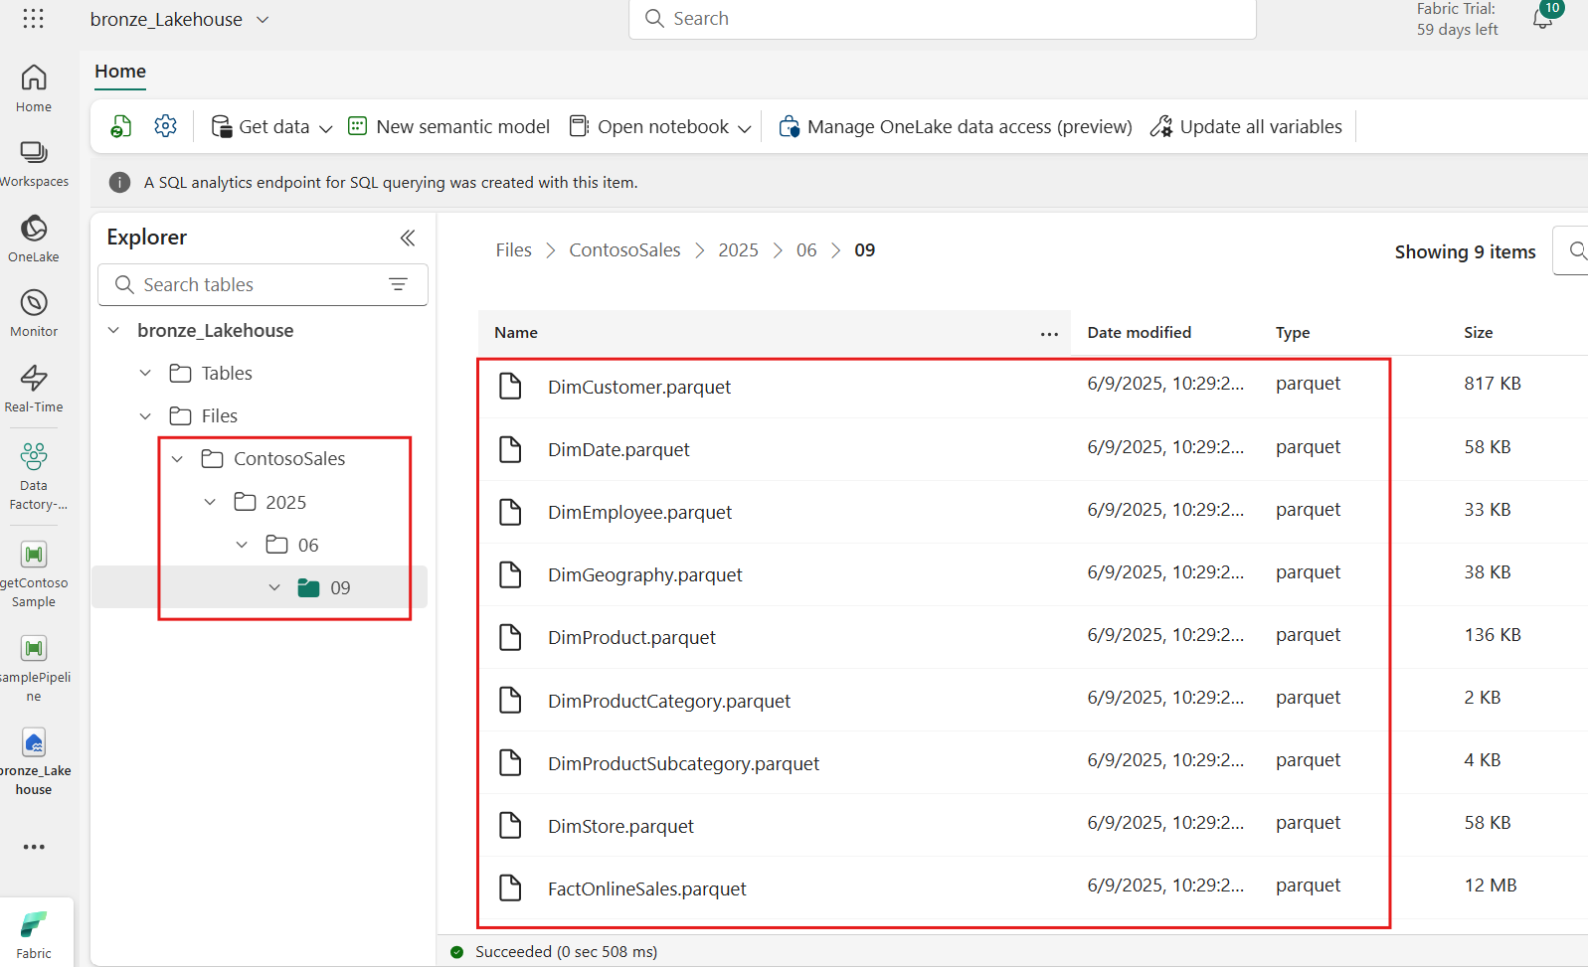

Task 4: Enriching raw data

1. In the left-sided navigation menu, navigate and click on **Data Factory-MedallionXX**, as shown in the below image.

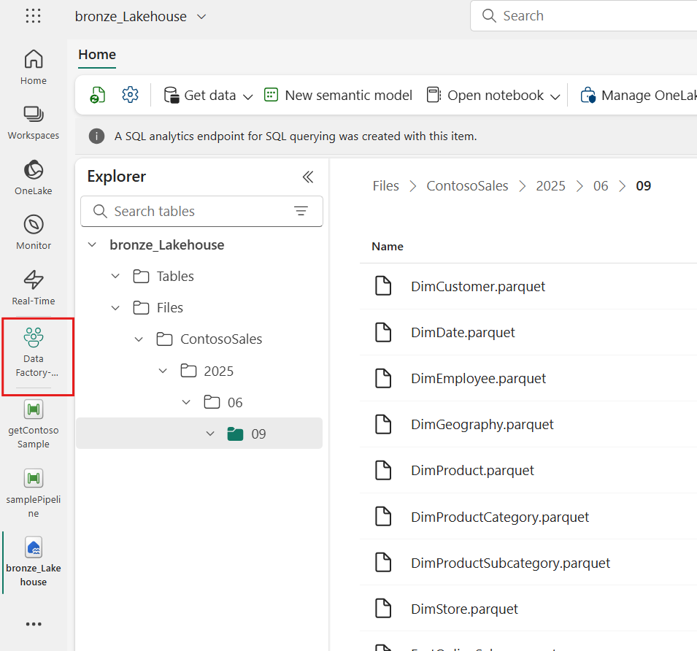

1. Select the **New item** option on the **Silver data** from your task flow to add another storage item to project. Within the **Item type** selection, select **Lakehouse**.

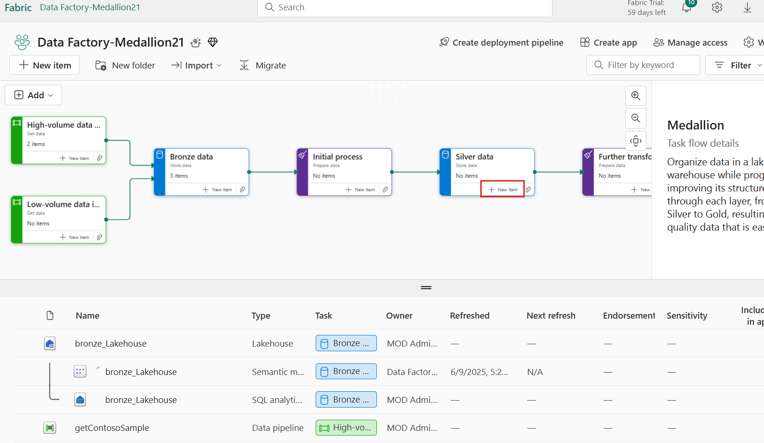

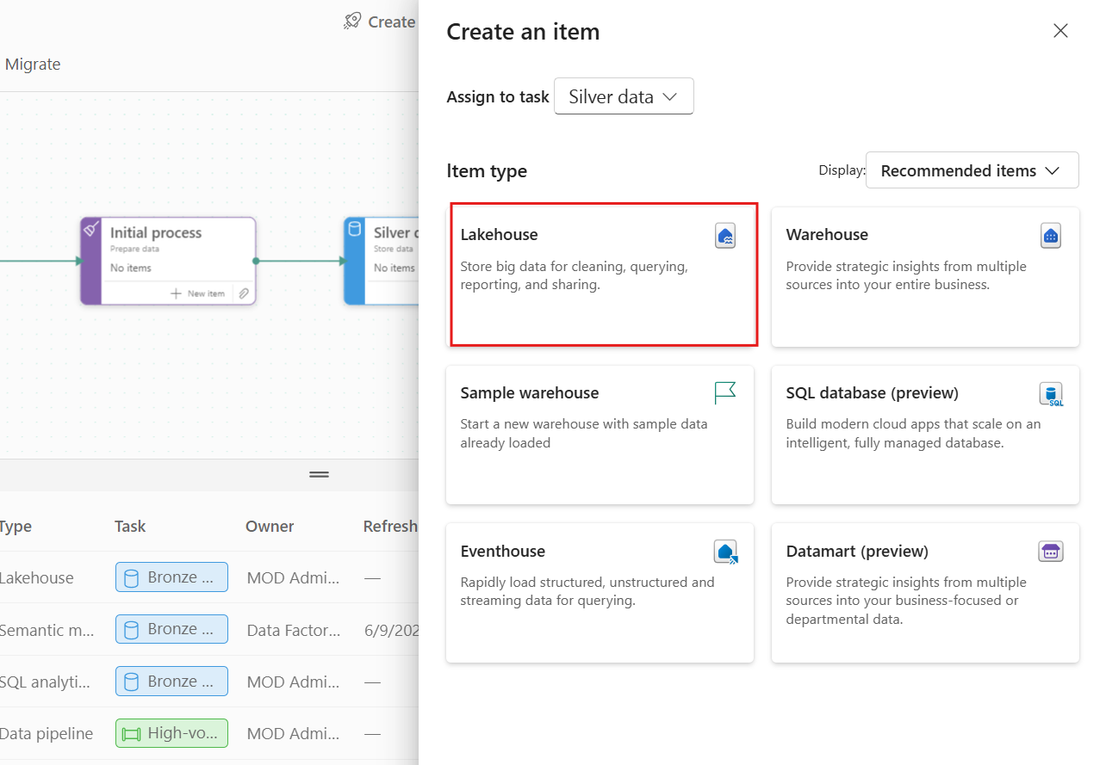

1. In the New lakehouse window, set the lakehouse name to **silver_Lakehouse** and then select **Create**.

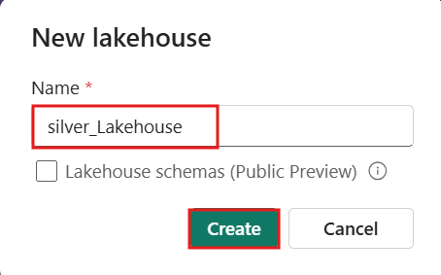

1. Within the lakehouse item from the **Home** tab select **Get data** from **New data pipeline**.

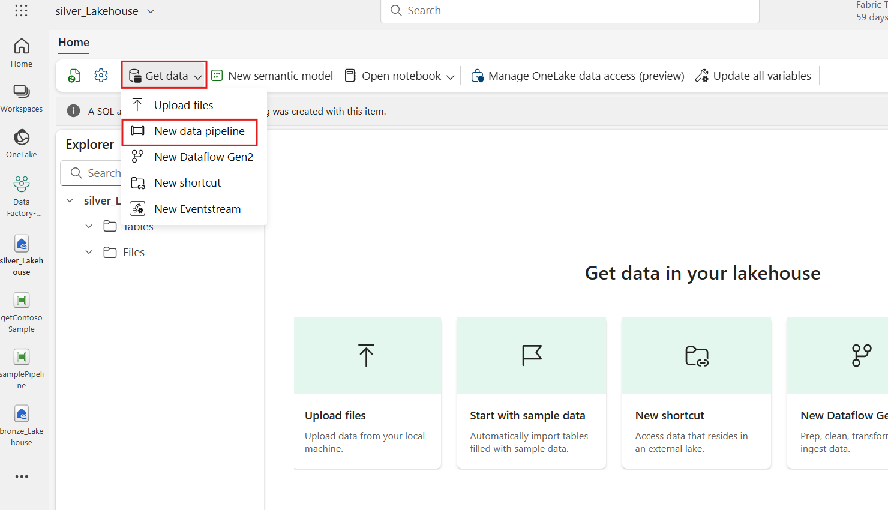

1. In the New pipeline window, set the data pipeline name to **createContosoTables** and then select **Create**

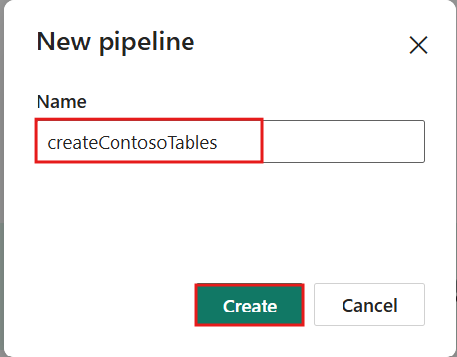

1. If prompted with the **Copy data assistant** window, select **X** in the top right corner to be taken into an empty authoring canvas. This ensures that start with a clean slate for pipeline configuration.

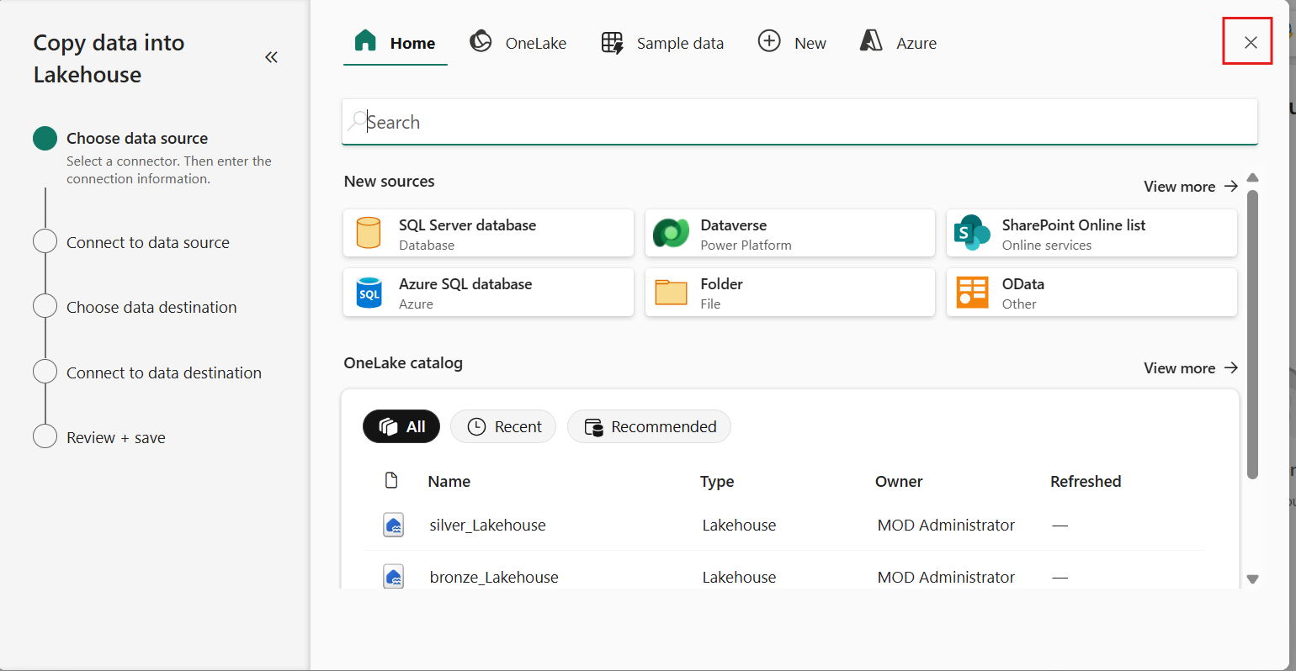

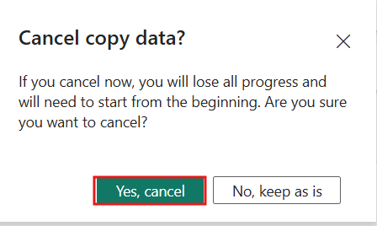

1. Select the **Activities** tab and then the **Set variable** activity to add this to your canvas. The Set variable activity allows to define and assign values to variables that can be used throughout pipeline.

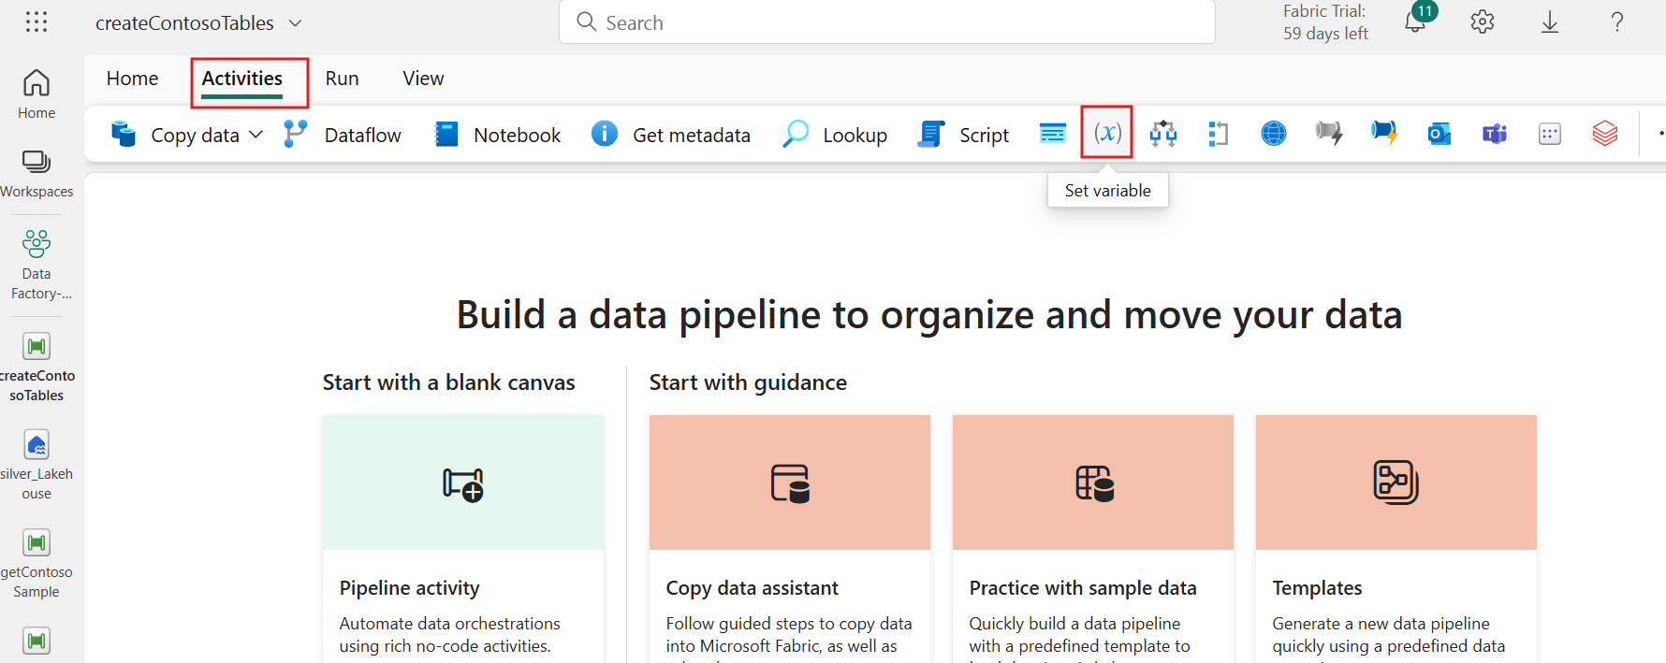

1. With the Set variable activity selected, navigate to the **Settings** tab. Next to the Name property, select '**New'** to create a variable that will be used within the pipeline.

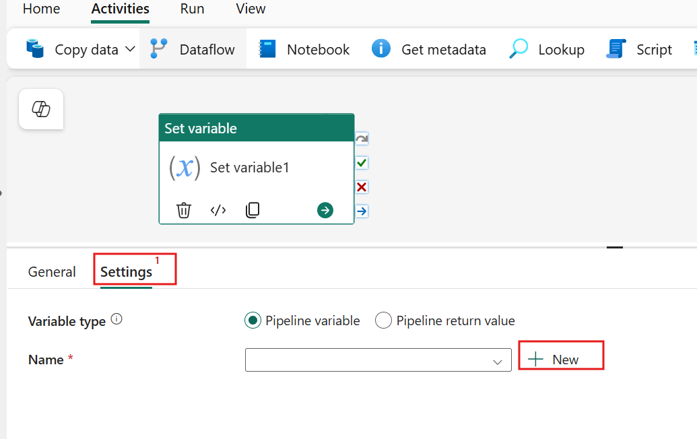

1. In the **Add new** **variable** window, set the **Name** value to **fileDirectory** and ensure the Type remains as a string before selecting **Confirm.**

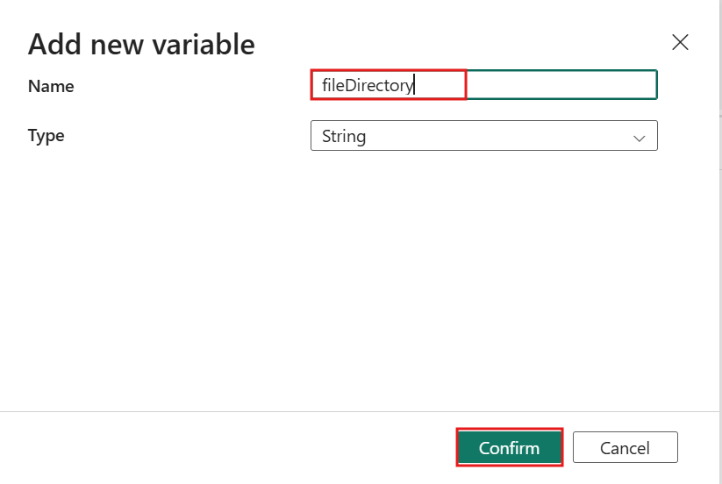

1. Select the **Value **text input box. This will display the **Add dynamic content** [Alt+Shift+D] property. Select this text to open the pipeline expression builder.

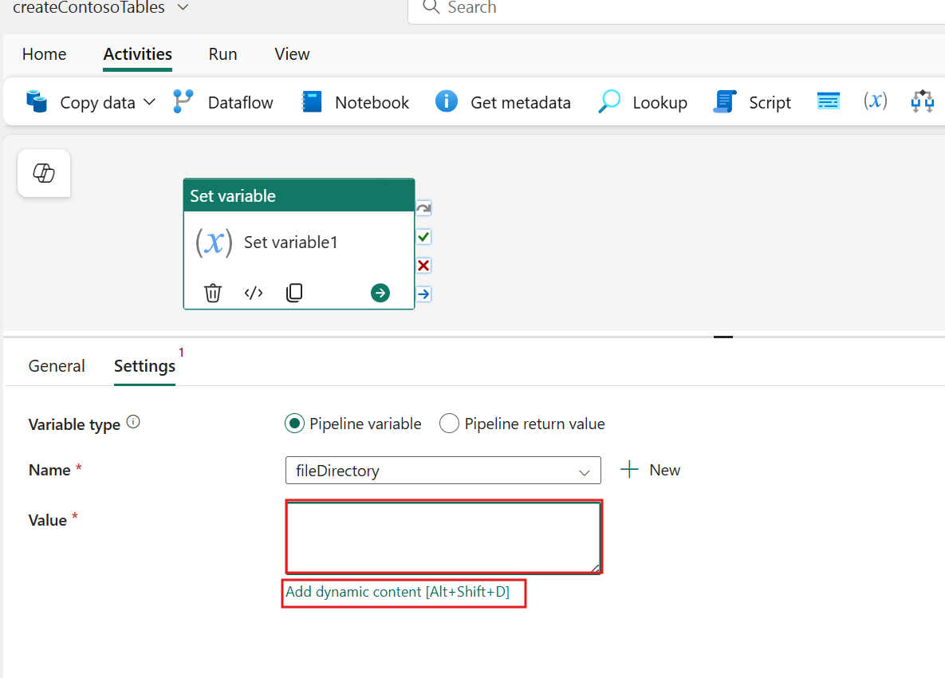

1. In the Pipeline expression builder window **copy and paste** the code block below into the expression input box. Press **Ok** when complete.
2. @concat(
3. 'ContosoSales\',
4. formatDateTime(
5. convertFromUtc(
6. utcnow(), 'Central Standard Time'
7. ),
8. 'yyyy/MM/dd'
9. )

)

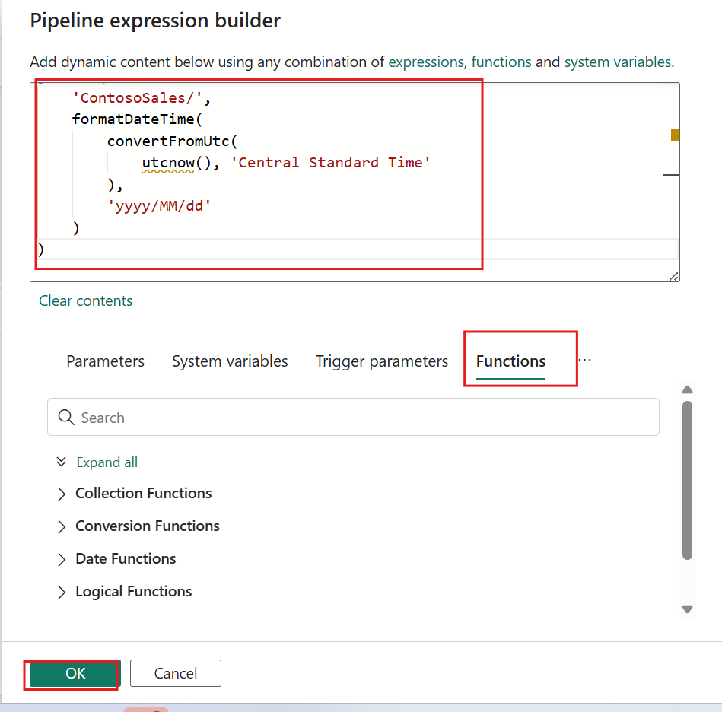

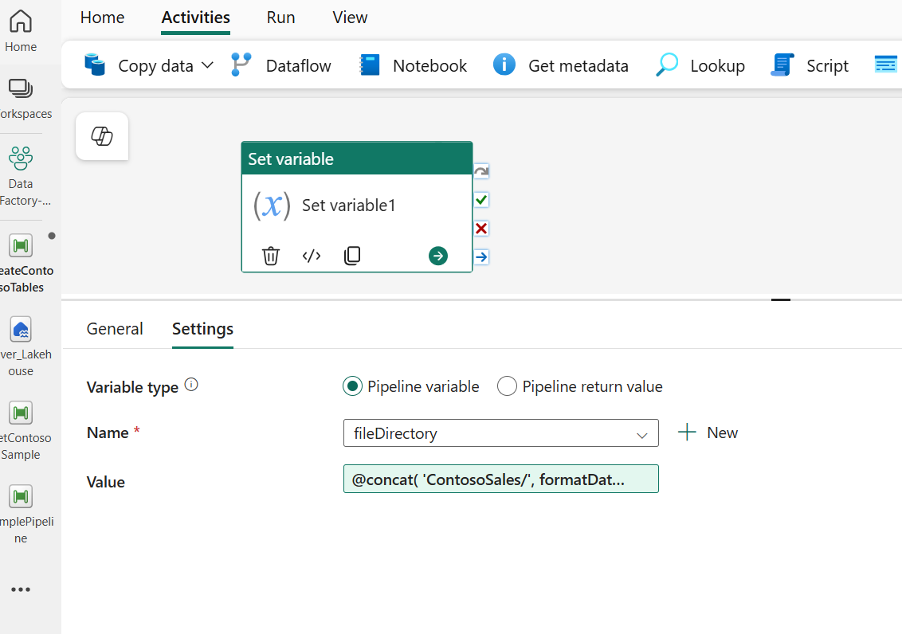

1. Navigate to the **General** tab with the Set variable activity selected. Update the **Name** field with the text **Set file directory**.

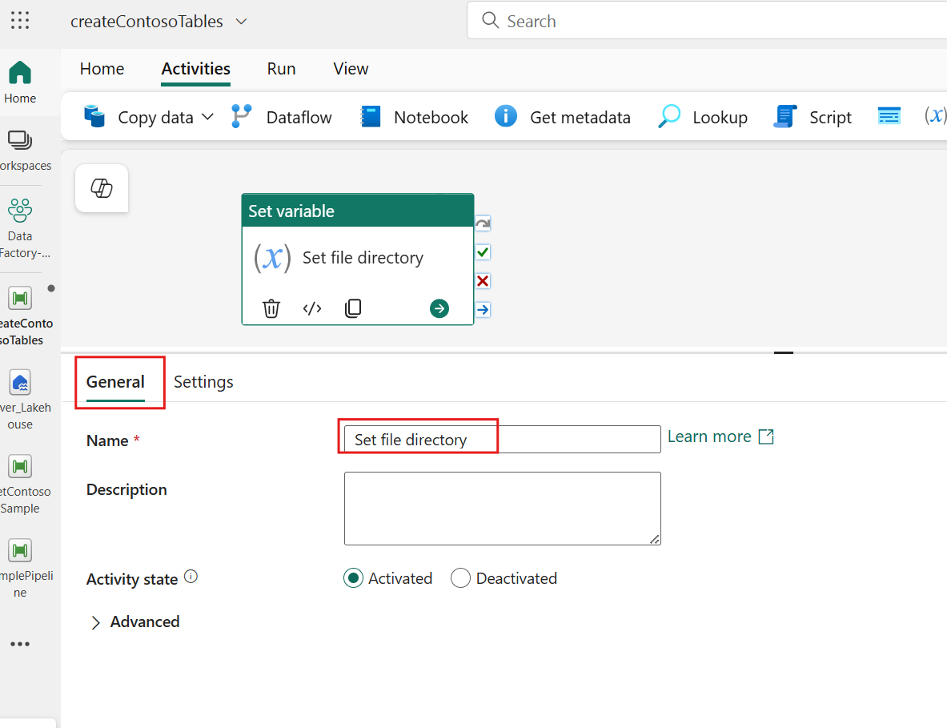

This step helps in identifying and managing the activity within your pipeline in subsequent steps, making it easier to understand its purpose and functionality.

1. Navigate to the **Activities** tab and select the **Get metadata** activity to add it to your canvas.

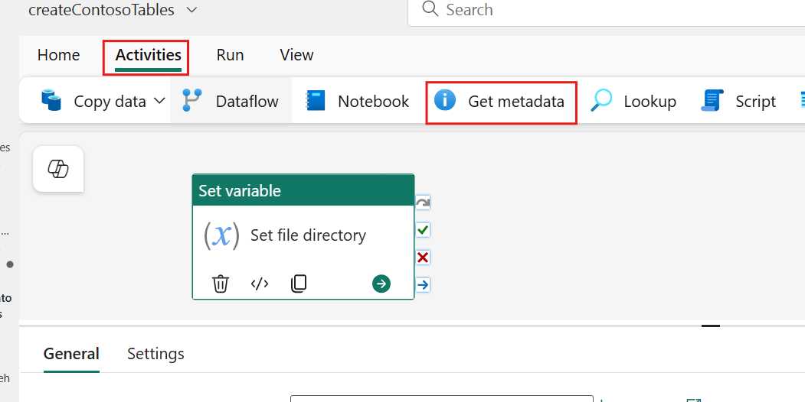

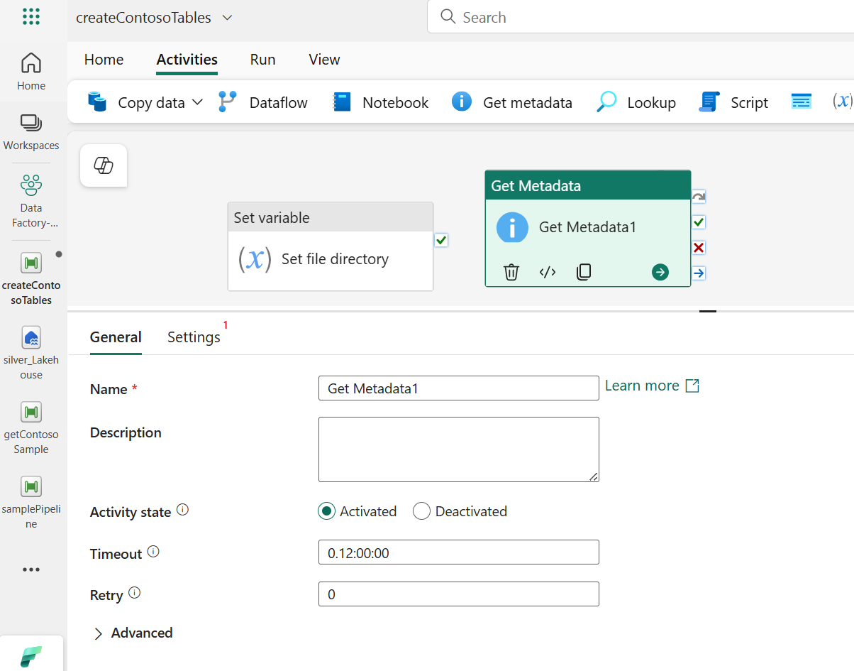

1. In the **Settings** options, set the **Connection** to **bronze_Lakehouse** from the available connection options.
2. Choose the **Files** option and then click on the **Directory** file path text input box. This will display the **Add dynamic content [Alt+Shift+D]**. Click on this text to open the pipeline expression builder.

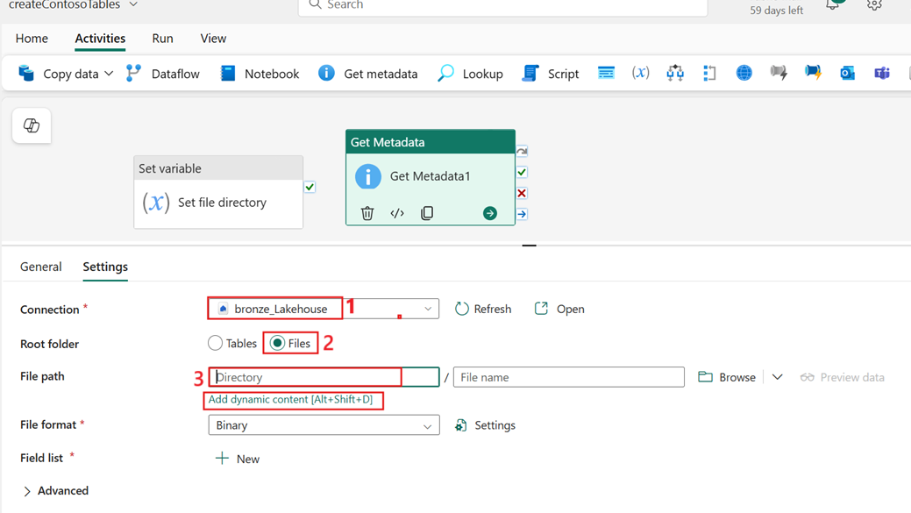

1. In the Pipeline expression builder window, select the **Variables** option. Within the available variable list, select **fileDirectory** and then **OK**.
2. This step ensures that the file path for the metadata retrieval is dynamically set based on the value of the fileDirectory variable.

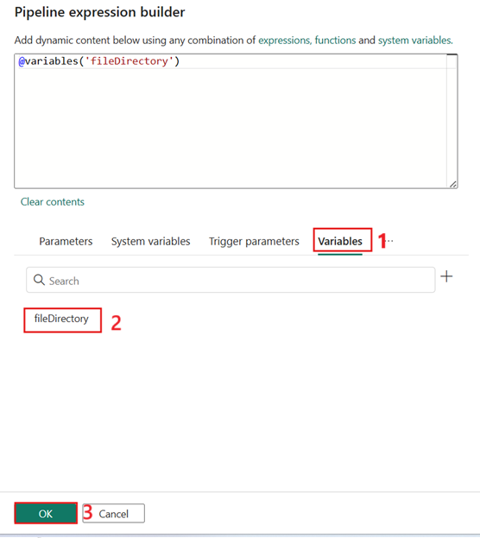

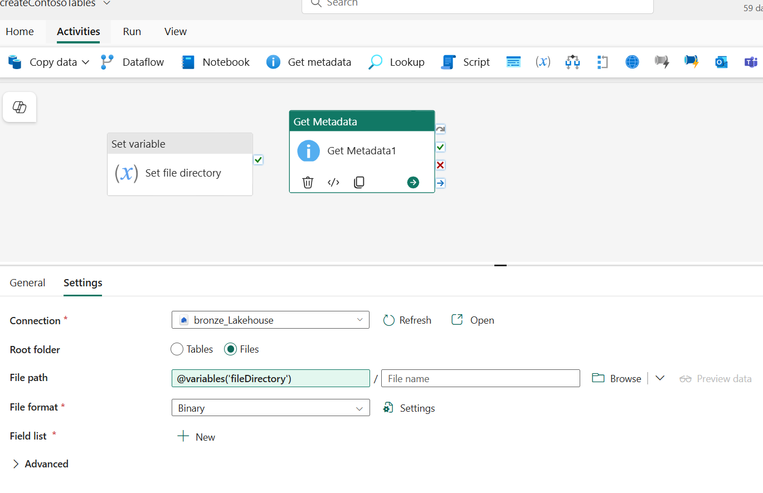

1. Select Get metadata activity, navigate to the **Settings** tab. From the **Field list** select **New**.

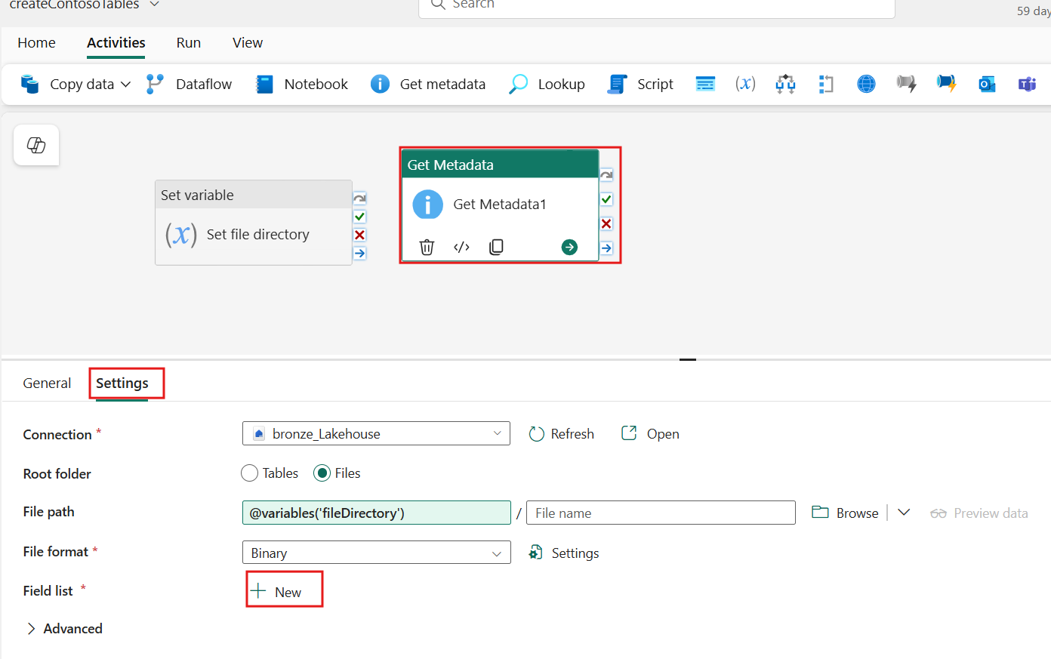

1. Within the drop-downs, configure the value as **Child items**. This ensures that the metadata activity retrieves information about the child items and their names within the specified directory.

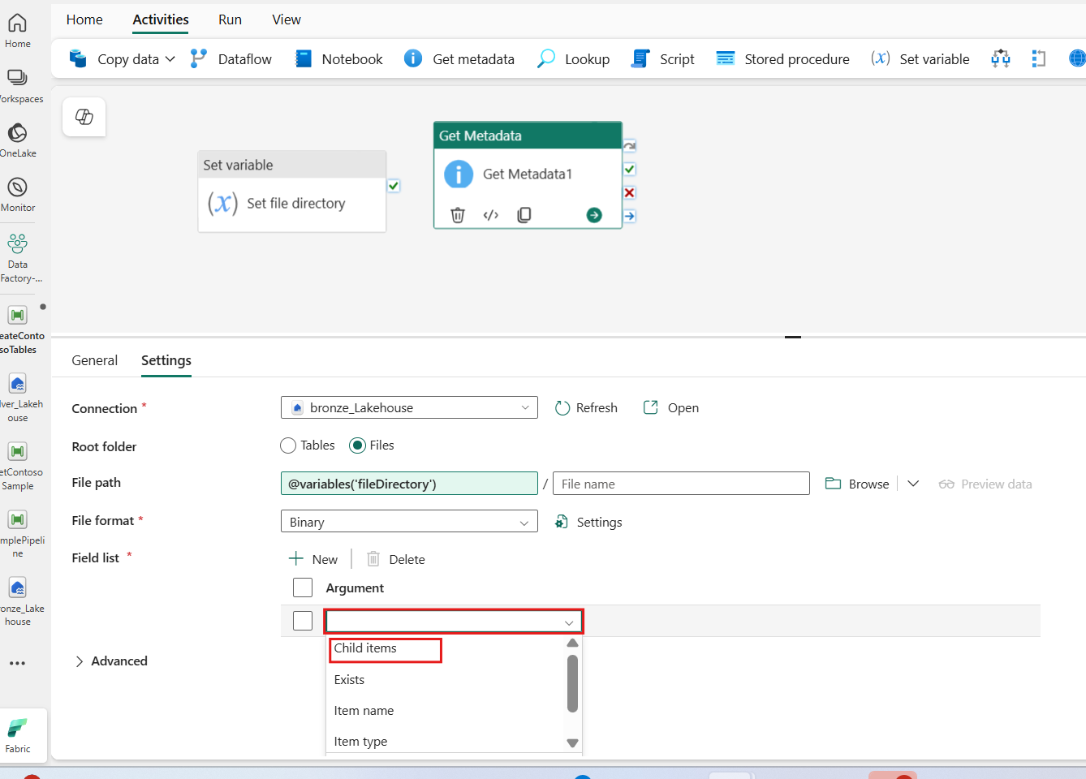

1. Select the **Get Metadata** activity and update the **Name** field with the text **Get items in folder**.
2. This naming step aids in identifying and managing the activity within the pipeline, enhancing clarity around its purpose and functionality. 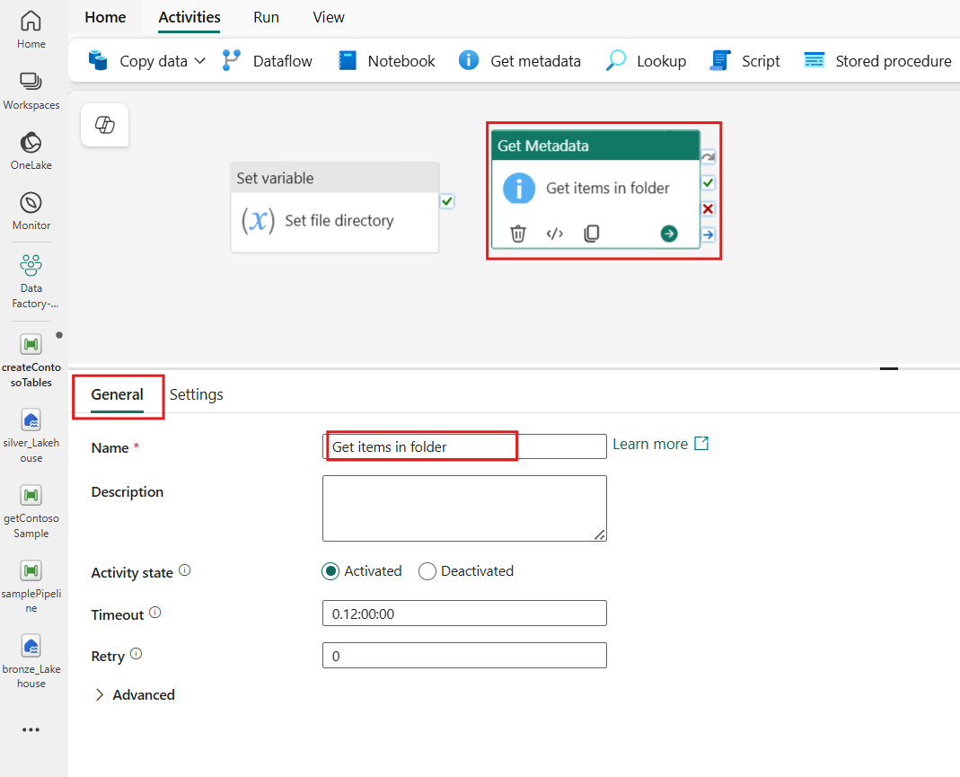
3. Create a conditional path by dragging and dropping the **On completion** option between the **Set file directory** activity and the **Get items in folder** activity.

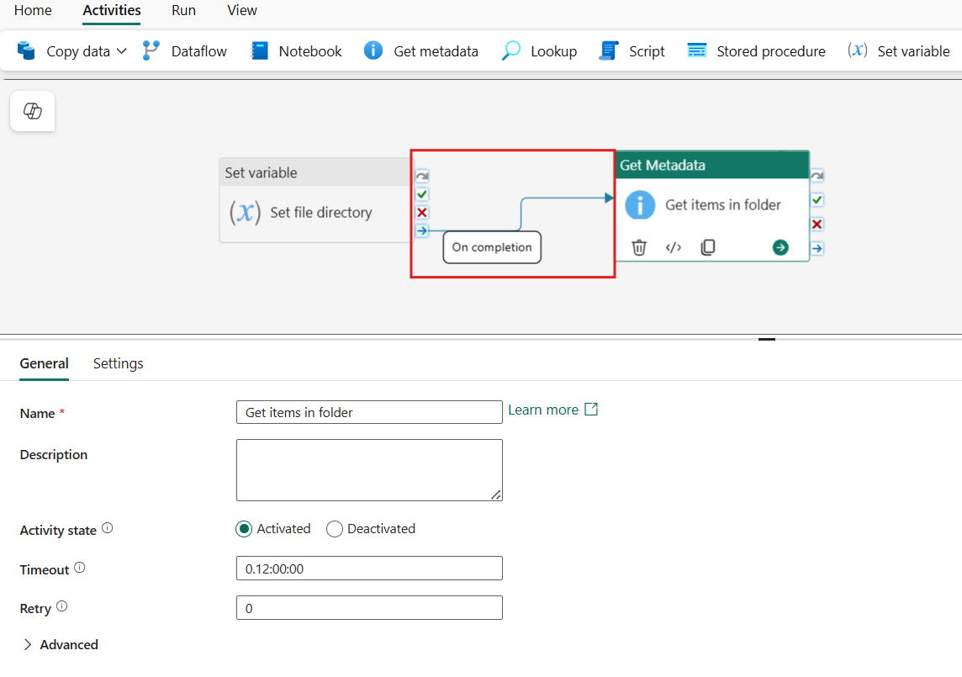

1. Select **Validate** on the **Home** tab to ensure there are no errors within the pipeline.

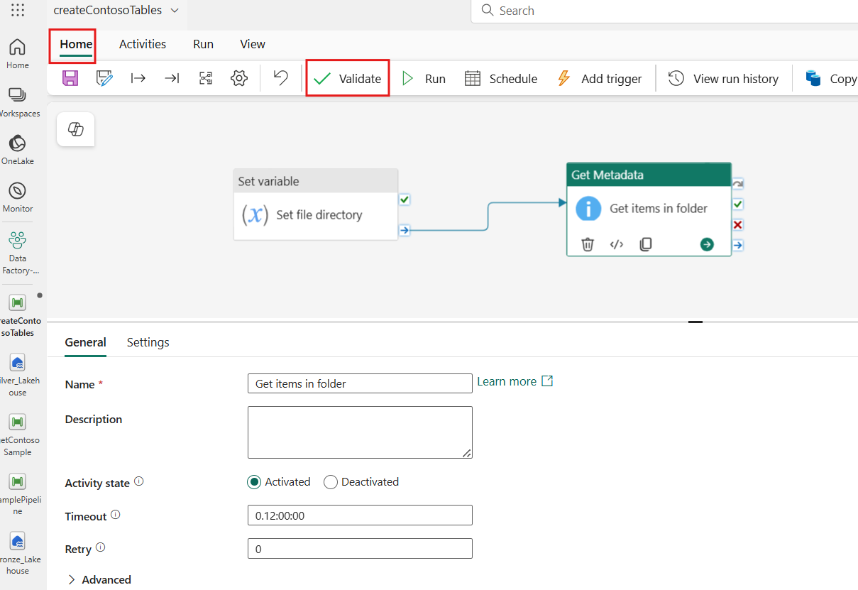

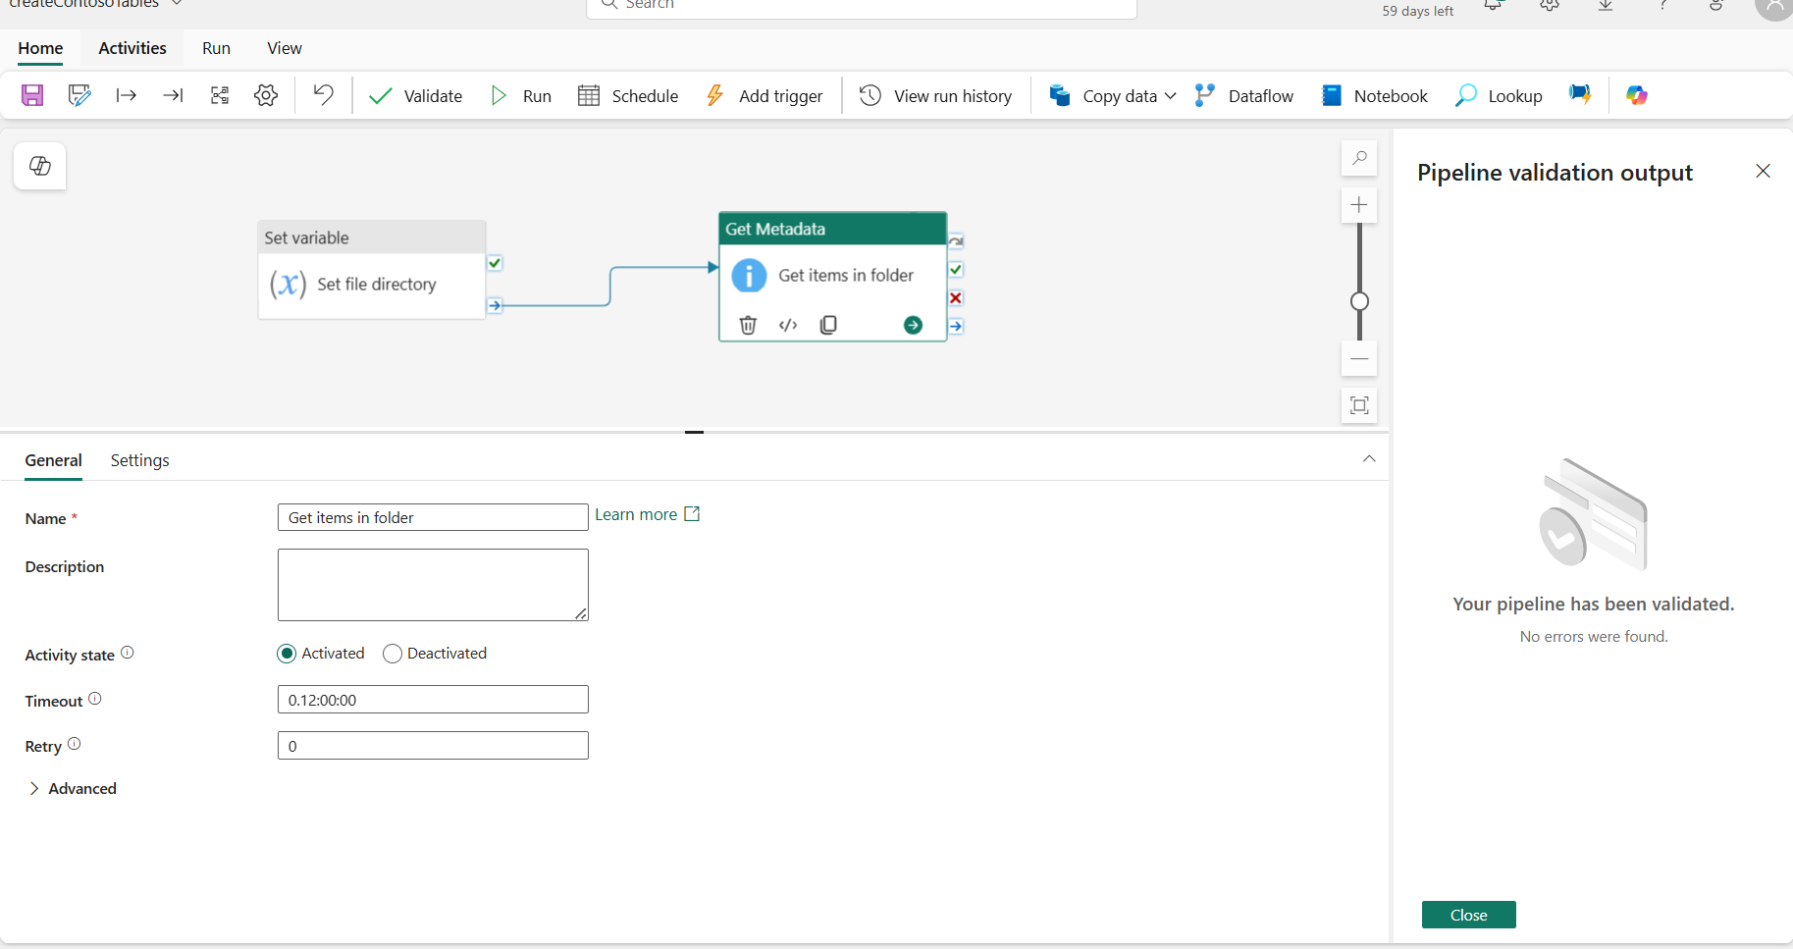

1. After validation, select **Run** to start the pipeline.

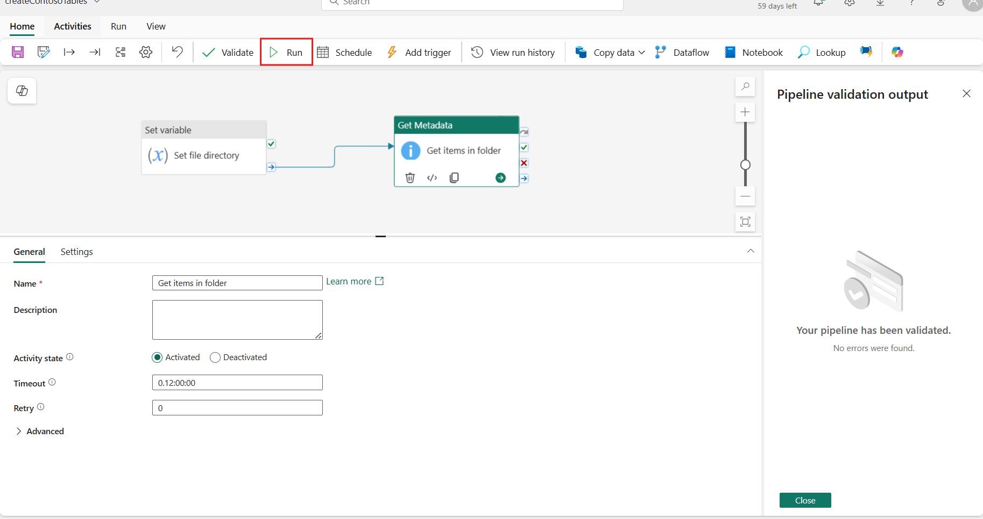

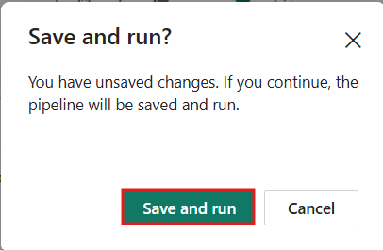

1. Both the Pipeline status and the Activity status should display a '**Succeeded**' status, indicating that the execution completed successfully.

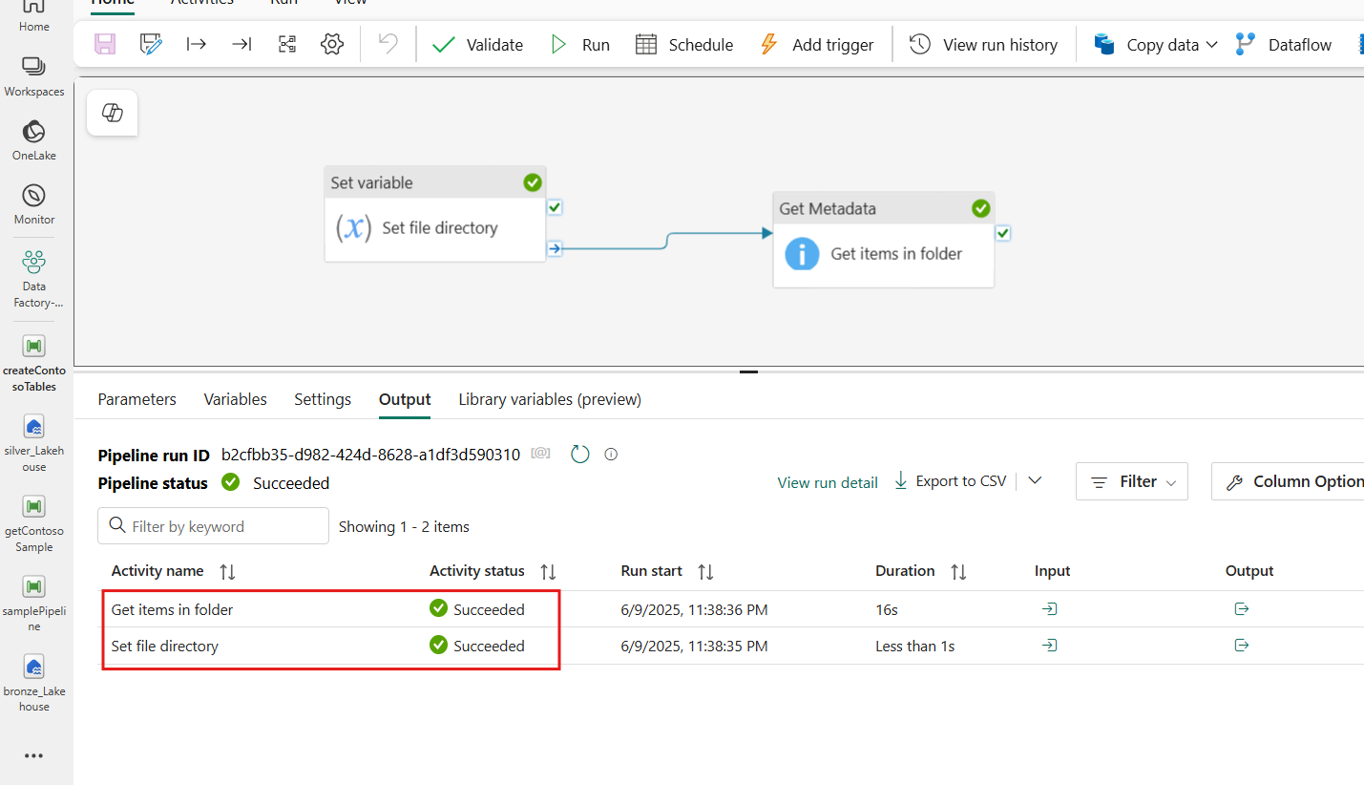

1. From the **'Get items in fo**lder' activity, select the last column labeled '**Output**' to review the activity's contents. This step verifies that the filenames from the directory have been correctly retrieved and included in the output. 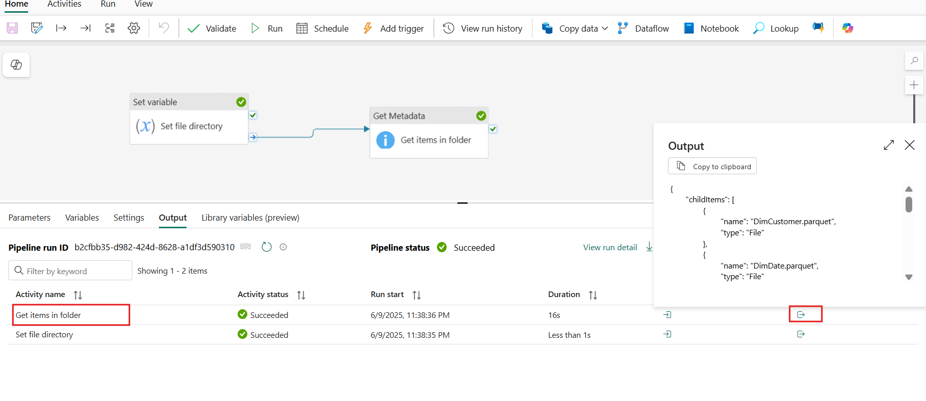

Task 5: ForEach loop and conditional branches

1. Select the **Activities** tab and then the **ForEach** activity to add this to your canvas. This activity allows you to iterate over a collection of items, performing a set of actions for each item in the collection.

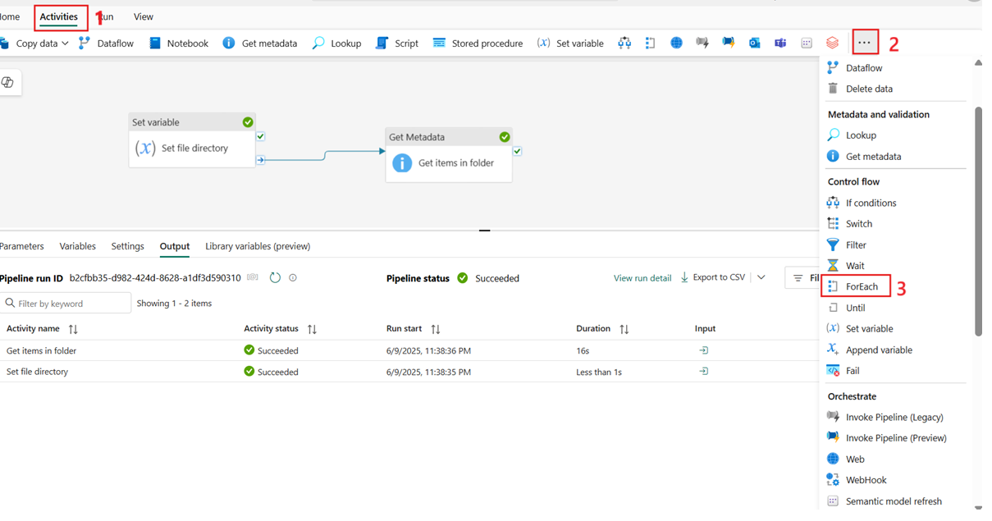

1. With the **ForEach** activity selected, navigate to the **General** tab and update the **Name** field with the text **For each file**.

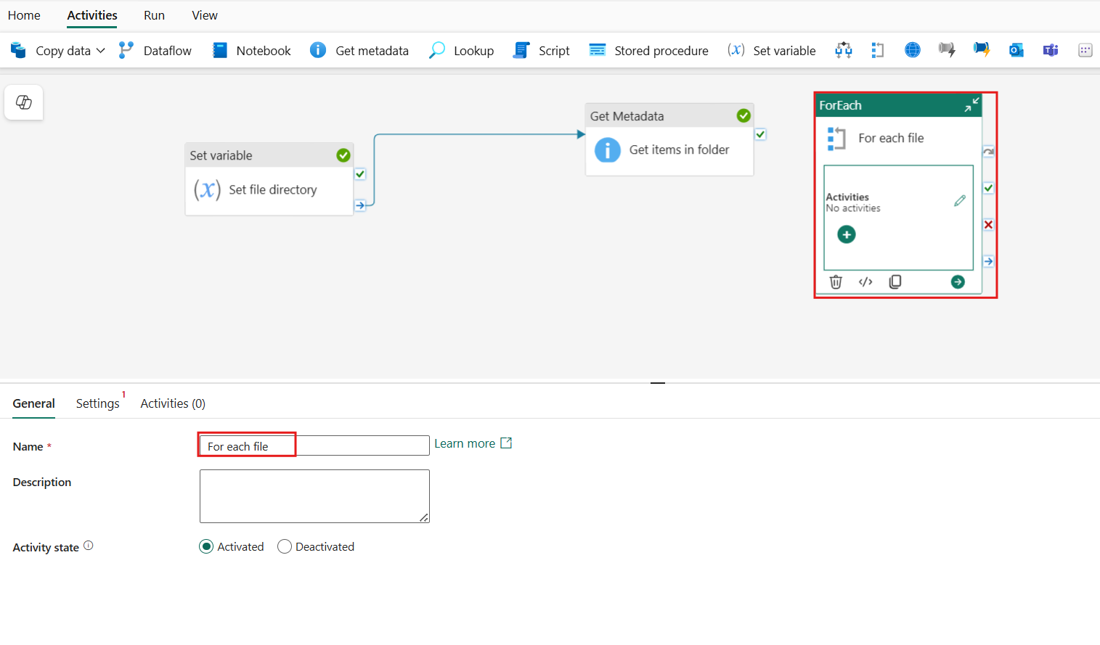

1. Next, create a conditional path by dragging and dropping the **On success** option between the **Get items in folder activity** and the **For each file activity**.

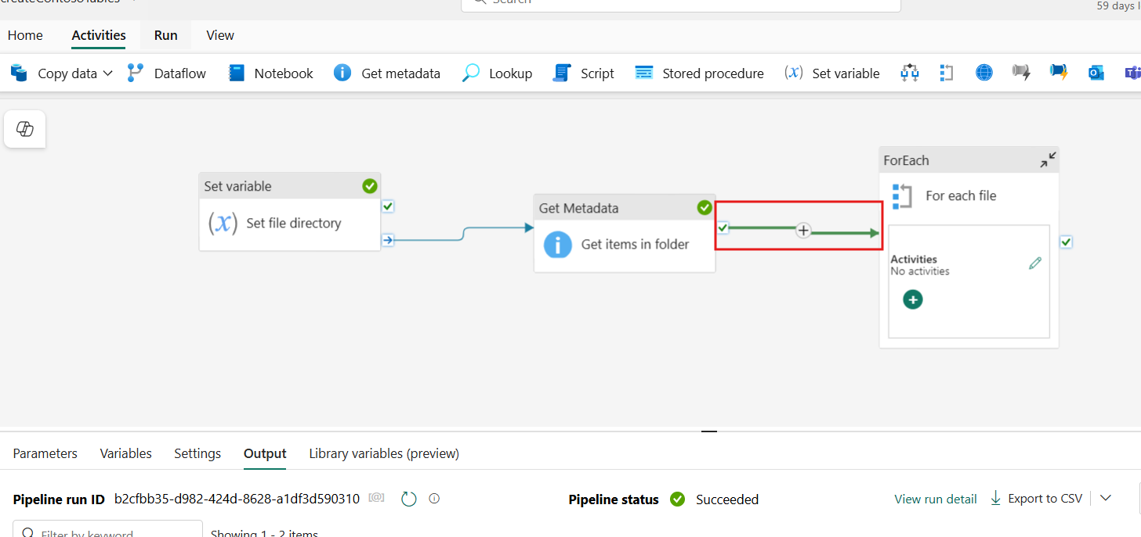

1. Select **For each file activity**, navigate to the **Settings** tab. Select the **Items** text input box. This will display the **Add dynamic content [Alt+Shift+D]** property. Select this text to open the pipeline expression builder. The sequential order ensures that the items are processed one after another, maintaining the order of execution.

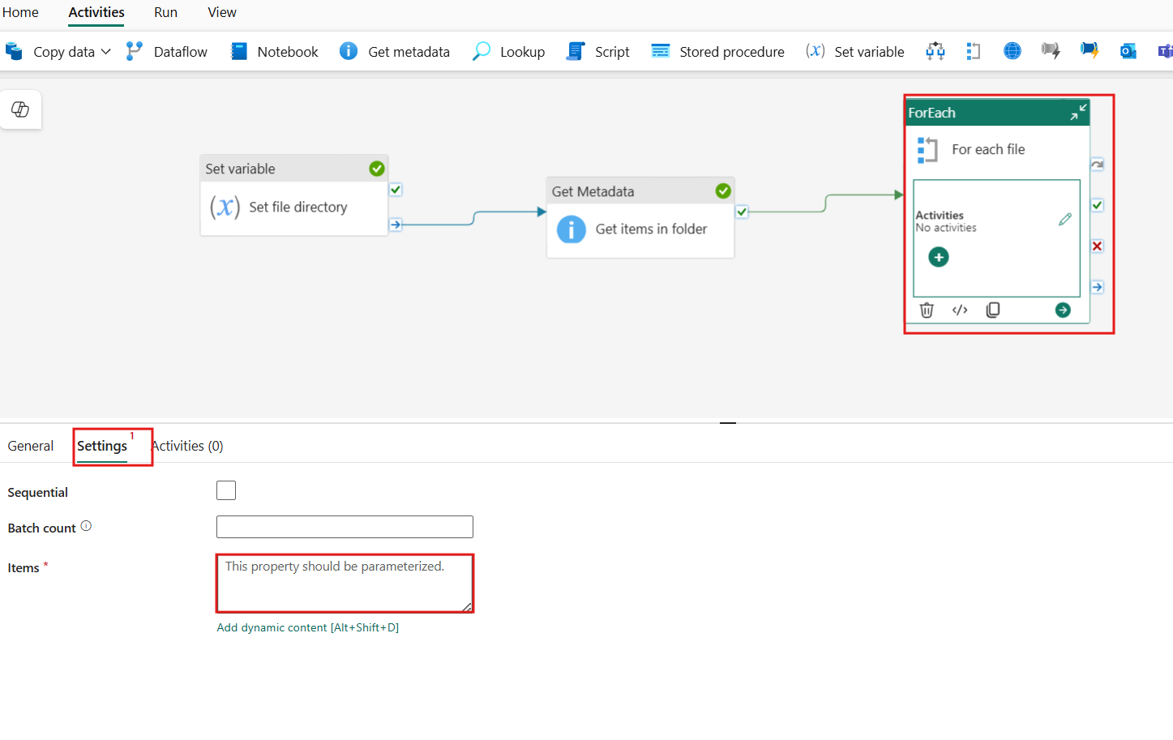

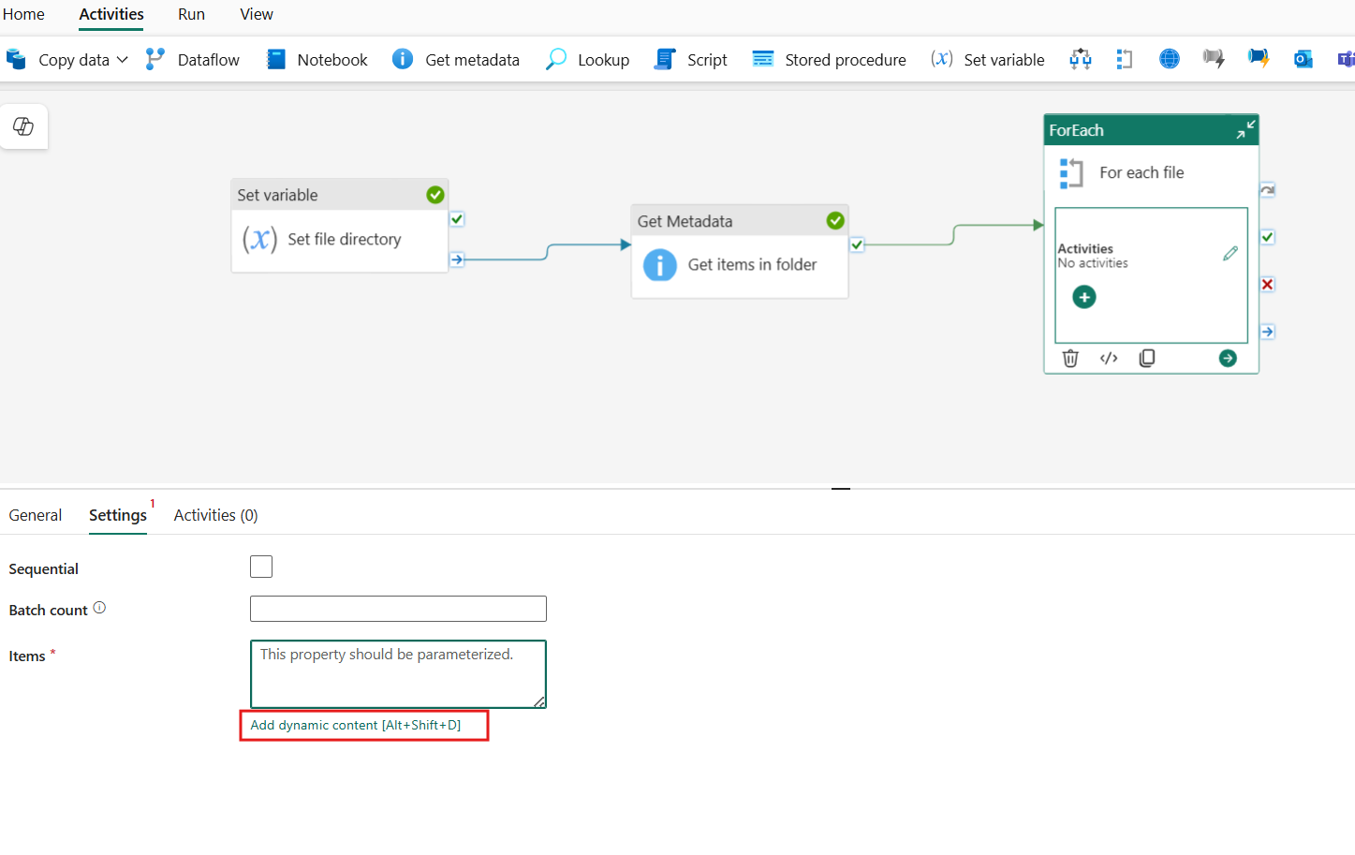

1. Within the Pipeline expression builder window, select the **Activity outputs** section. Then, choose the **Get items in folder** output of **childItems**. The full option title is **Get items in folder childItems**. This step ensures that the ForEach activity iterates over the child items retrieved from the specified directory.

@activity('Get items in folder').output.childItems

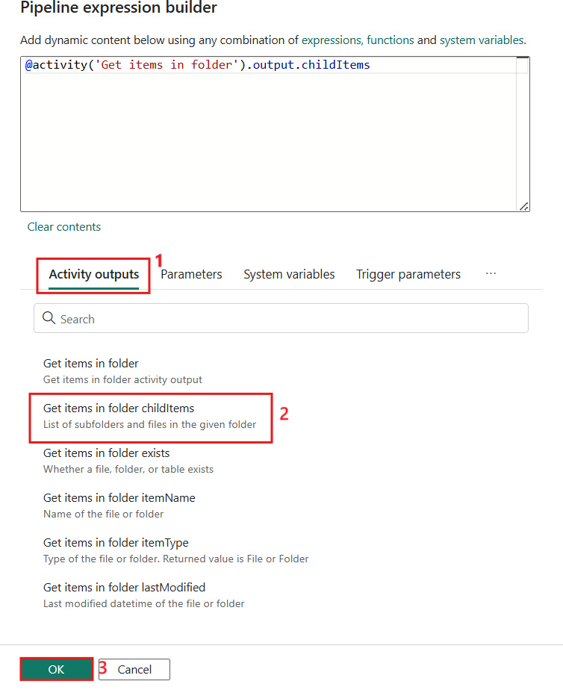

1. Select the **add** option on the **For each activity** and then select **Copy data**. This step will allow us to repeatedly execute the copy data activity for each item in the array.

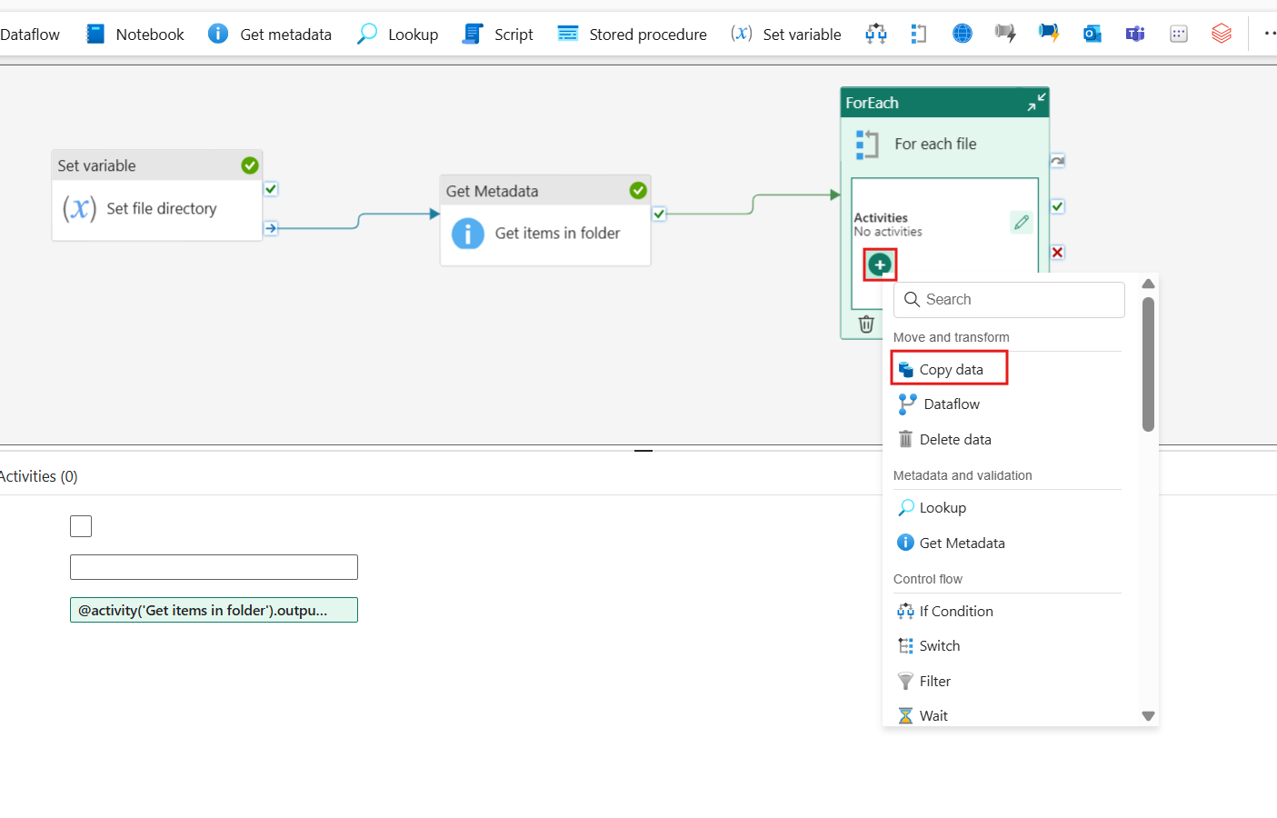

1. Select the **Edit** option on the **For each activity** to drill into the nested authoring canvas. This step allows you to configure the activities that will be executed for each item in the collection.

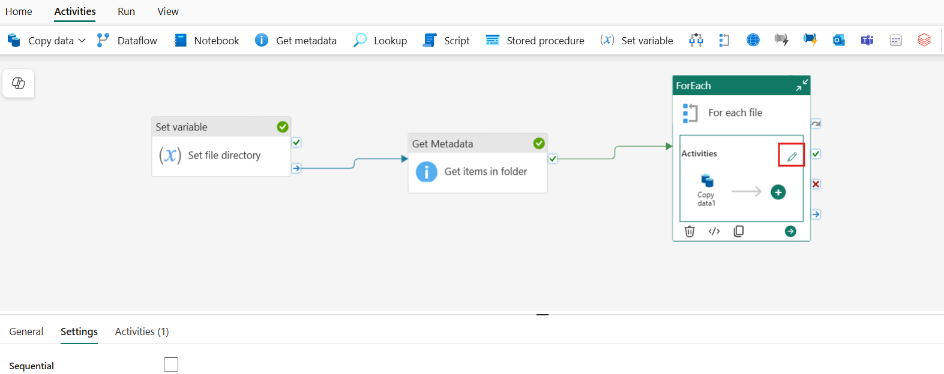

1. Navigate to the **General** tab with the **Copy data activity** selected. Update the **Name** field with the text **Copy tables**.

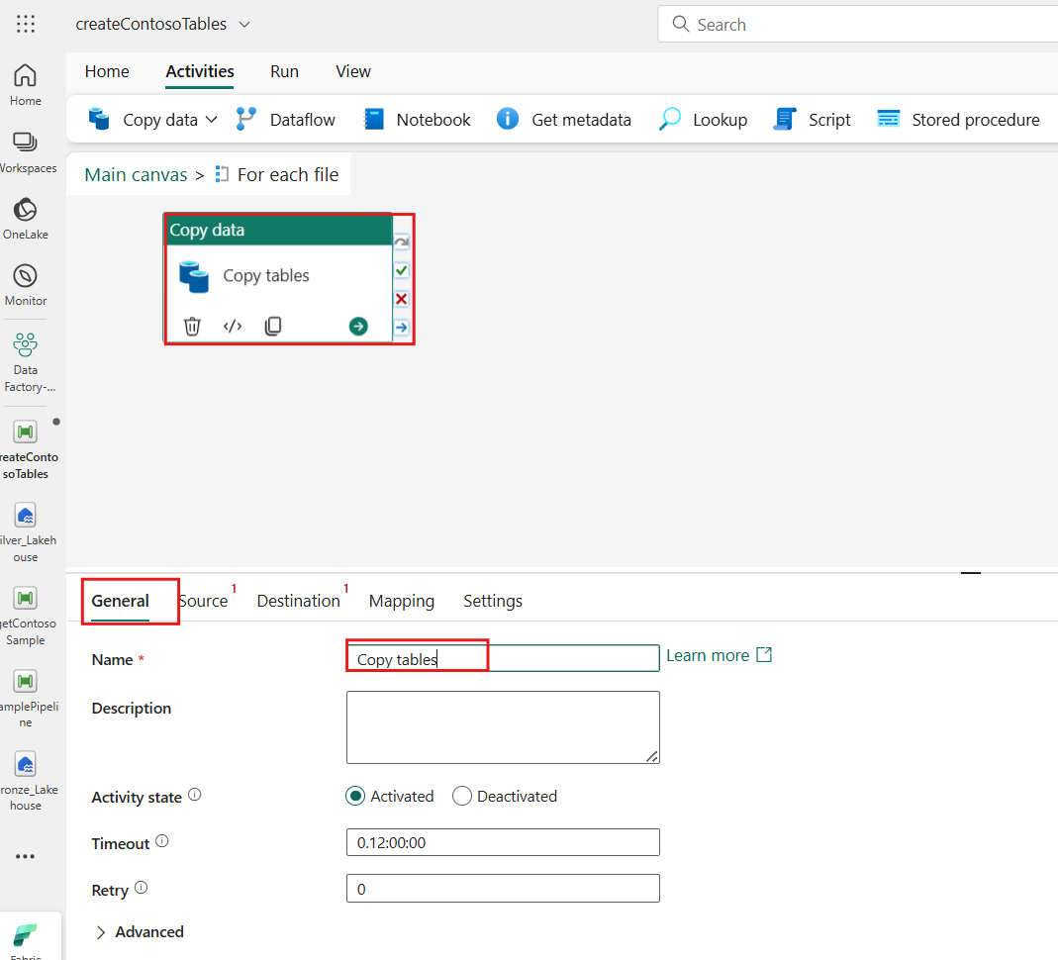

1. With the **Copy data** activity still selected, configure the following options in the **Source** tab. Once complete select the **Directory** text input box. This will display the **Add dynamic content [Alt+Shift+D]** property.

| **Property** | **Value** |
| --- | --- |
| Source | Select the previously configured **bronze_Lakehouse** lakehouse. |
| Root folder | Files |
| File path | File path |
| File format | Parquet |

1. 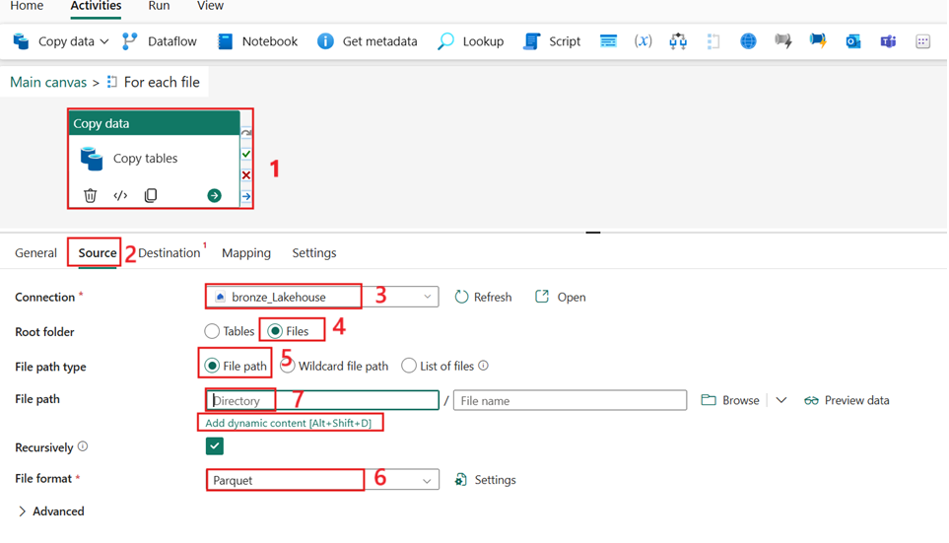
2. Select this text to open the pipeline **Add dynamic content [Alt+Shift+D]** property expression builder.

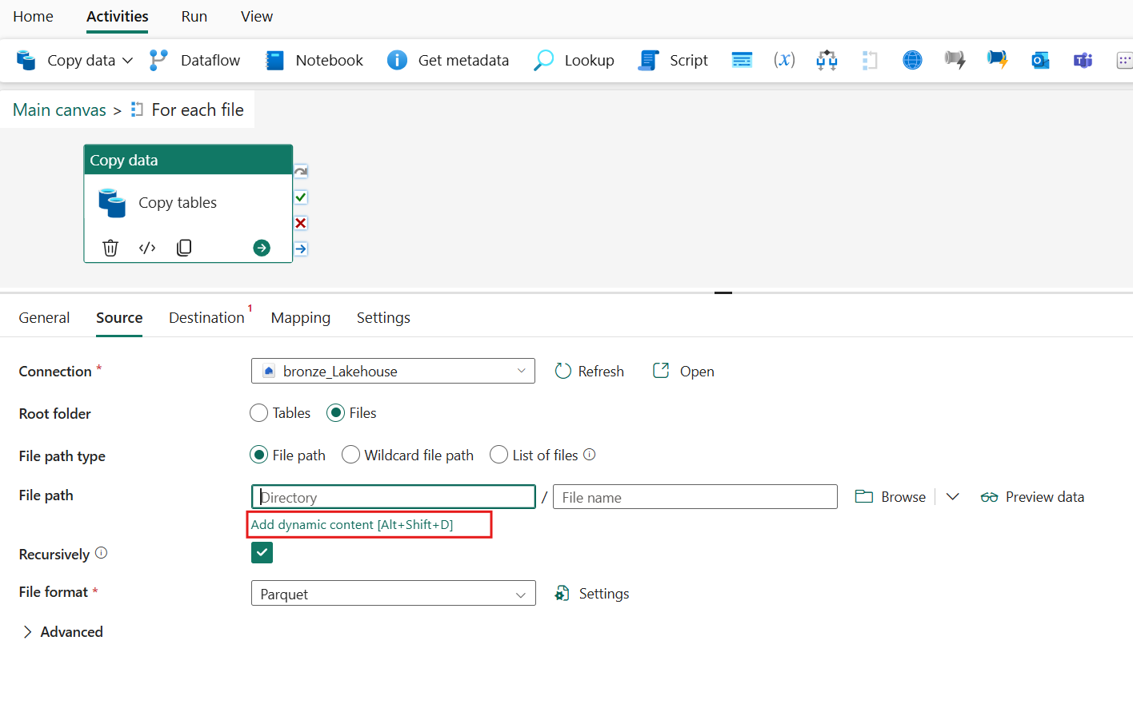

1. Select the variable **fileDirectory** within the expression builder's **Variables** section and **OK** to continue.

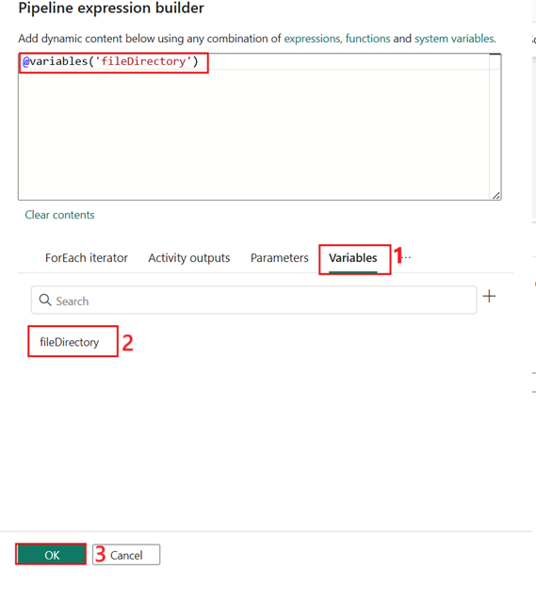

1. Select the **File name** text input box. This will display the **Add dynamic content [Alt+Shift+D]** property. Select this text to open the pipeline expression builder.

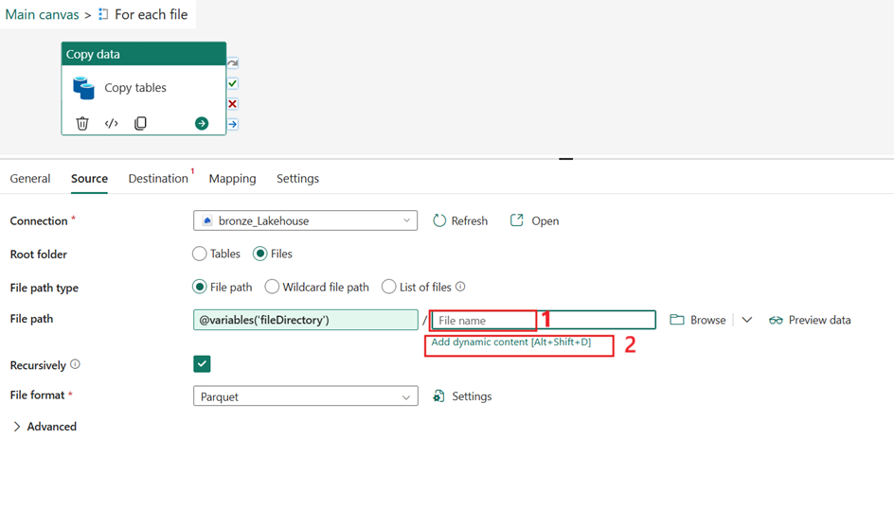

1. Select the item **For each file** within the expression builder's **ForEach iterator** section. Within the expression builder, add the suffix ".name" to access the name property of the current items array and then **OK** to continue once complete.
2. Copy and paste the code block below into the expression input box.

**@item().name**

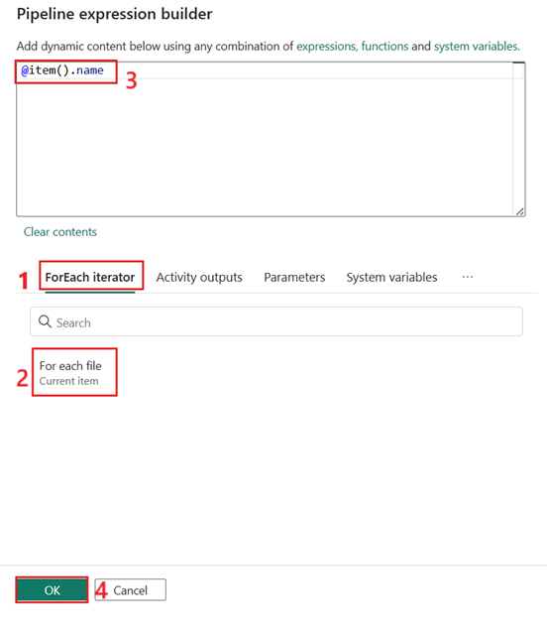

1. With the **Copy data activity** selected, configure the following options in the **Destination** tab. Once complete select the Table text input box. This will display the Add dynamic content [Alt+Shift+D] property. Select this text to open the pipeline expression builder.

| **Property** | **Value** |
| --- | --- |
| Destination | Select the previously configured **silver_Lakehouse** lakehouse. |
| Root folder | Tables |

1. 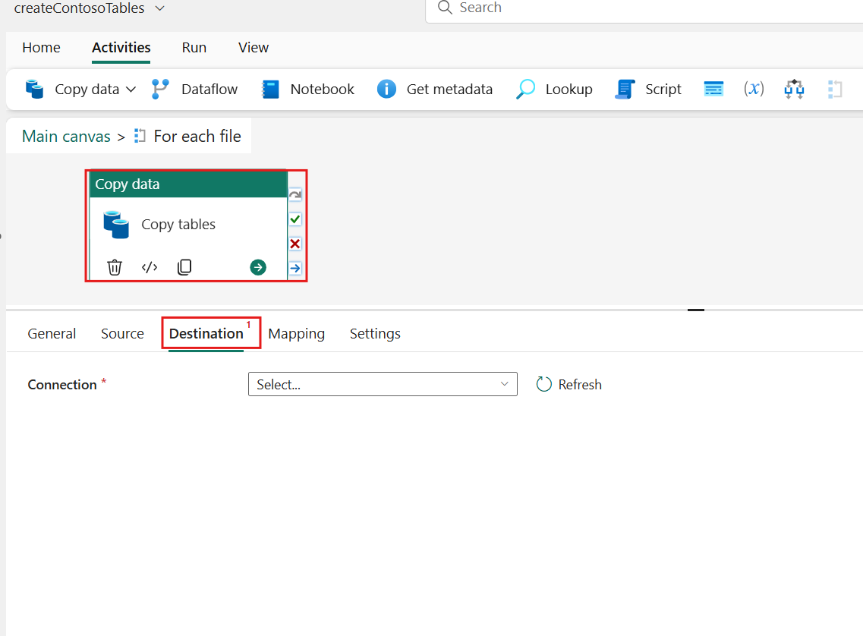
2. 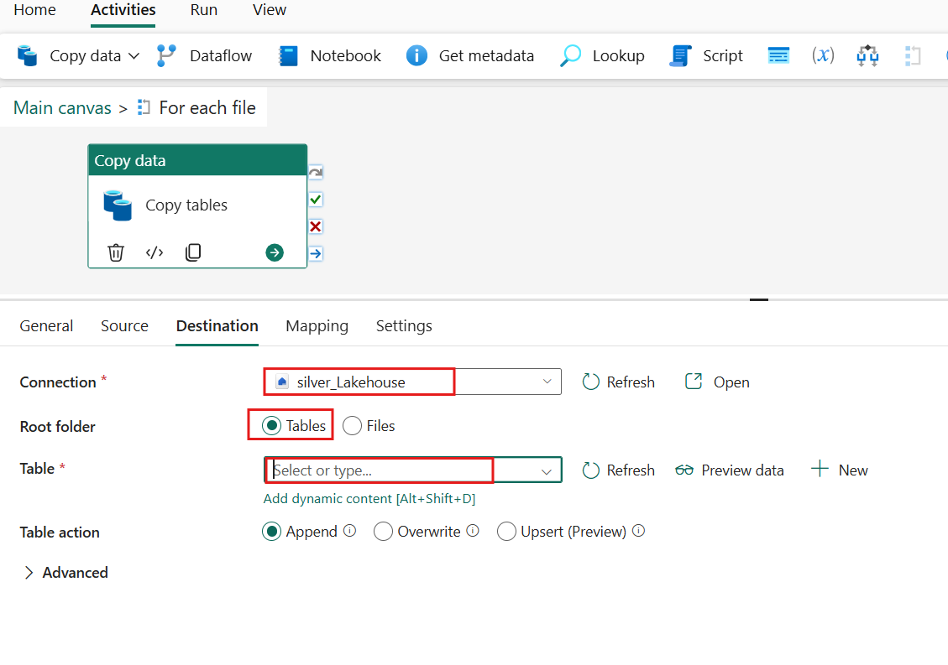
3. In the **Pipeline expression builder**, select **Functions** and then choose **split** from the **String functions group** to divide each item name using the period delimiter **'.' .** From the resulting array, select the first item. Once complete, select '**OK**' to proceed
4. Copy and paste the code block below into the expression input box.

**@split(item().name, '.')[0]**

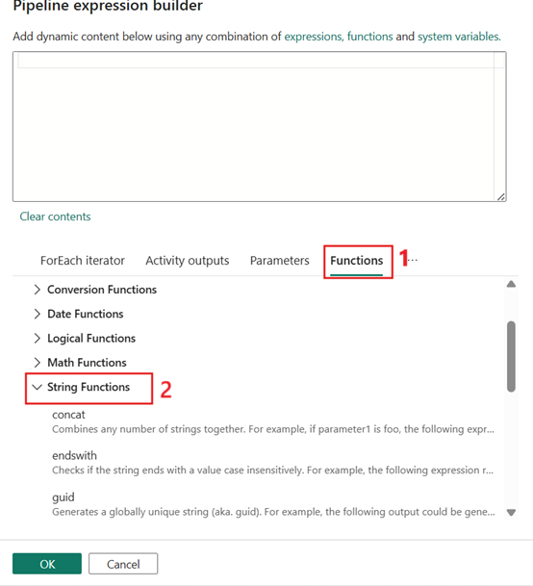

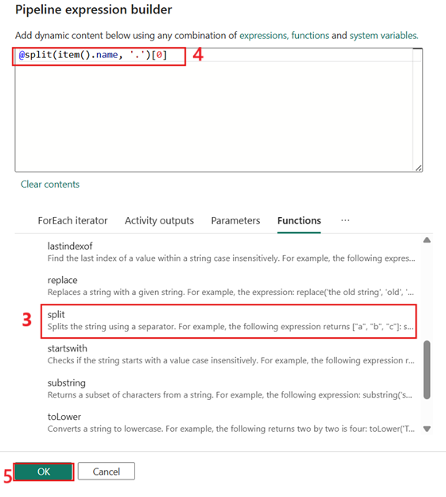

1. In the **Source** tab, select '**Append**' from the **Table action** values to display the **'Add dynamic content [Alt+Shift+D]' property**. Select this text to open **the Pipeline Expression Builder.**

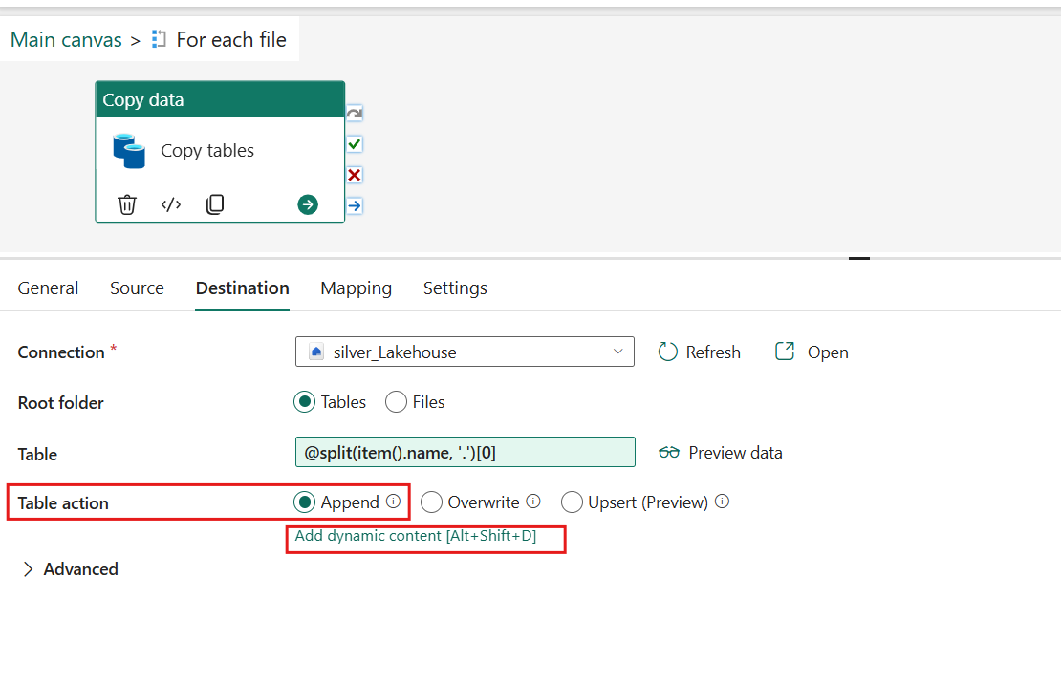

1. Within the expression builder, we'll use the if condition from the logical **functions** group and the startswith function from the string functions group to determine if the string starts with the prefix of **Dim** for our dimension tables. If true, we'll set the value to **Overwrite**, if false **Append**. Once complete select **OK** to continue.
2. Copy and paste the code block below into the expression input box.
3. @if(
4. startswith(item().name, 'Dim'),
5. 'Overwrite',
6. 'Append'

)

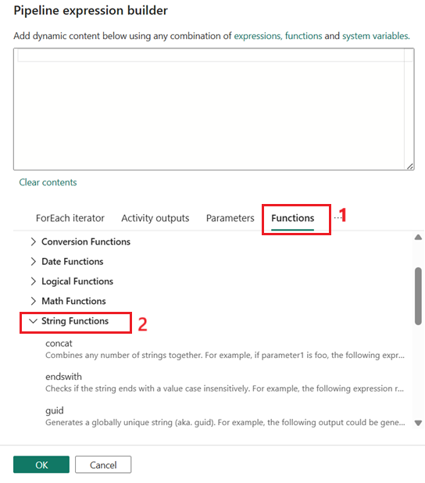

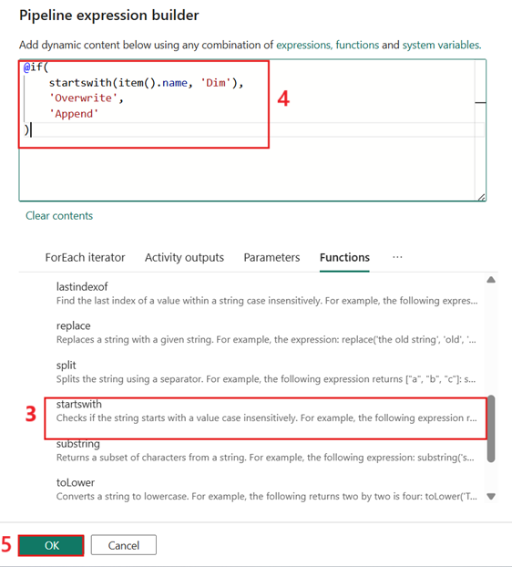

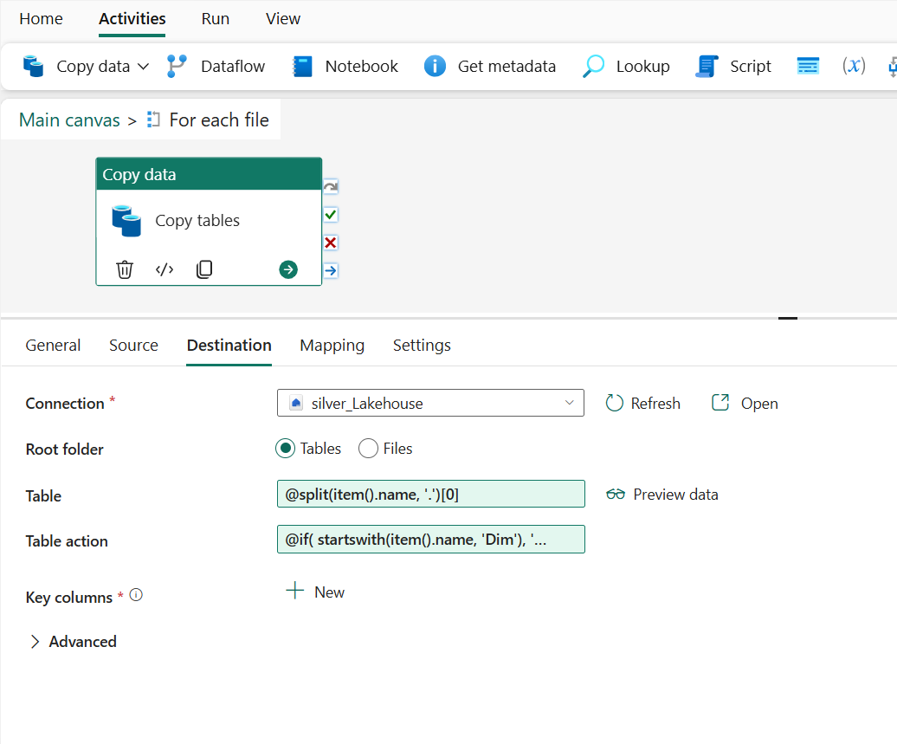

1. Select the **Main canvas** option from the breadcrumb trail to return to the top level of pipeline.

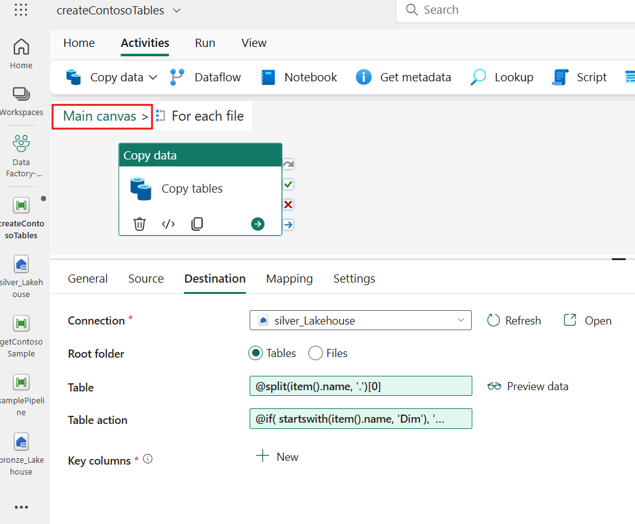

1. From the **Home** tab, select the **Validate** option to first confirm that there are no issues with in the pipeline.

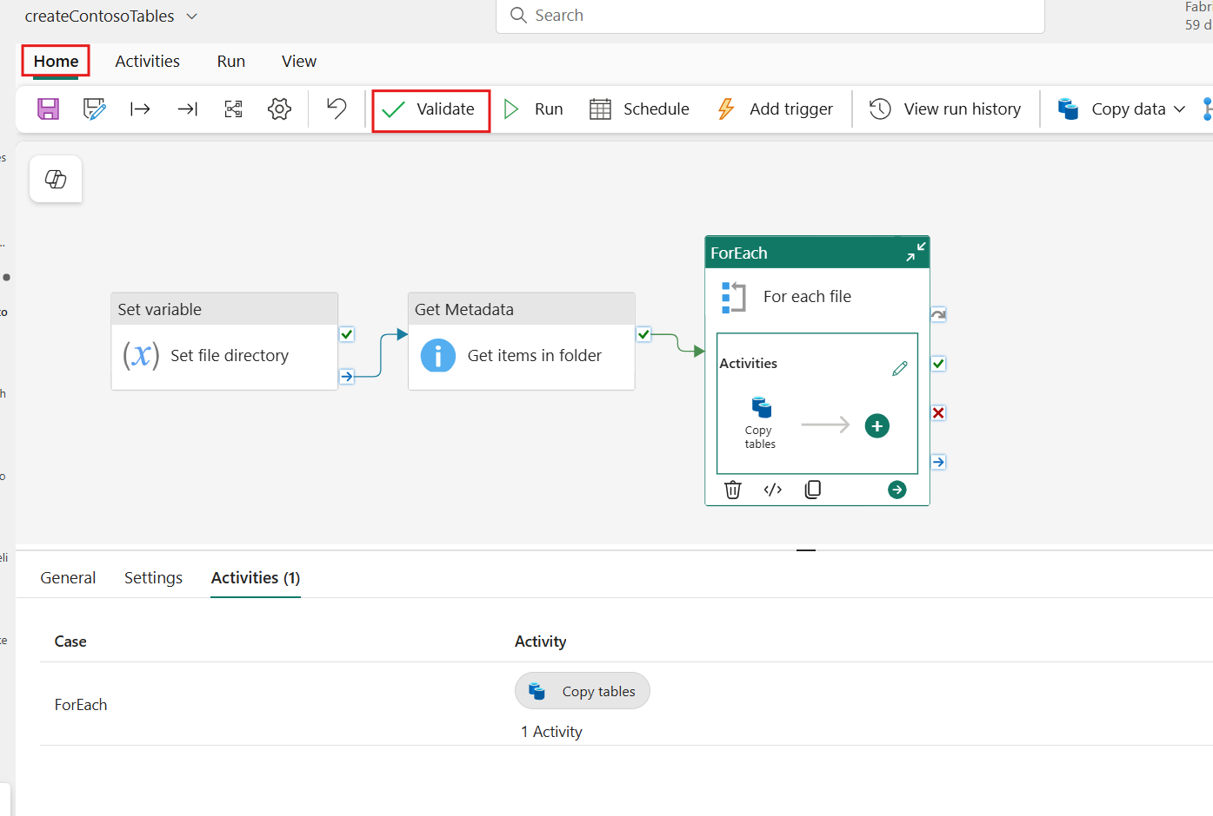

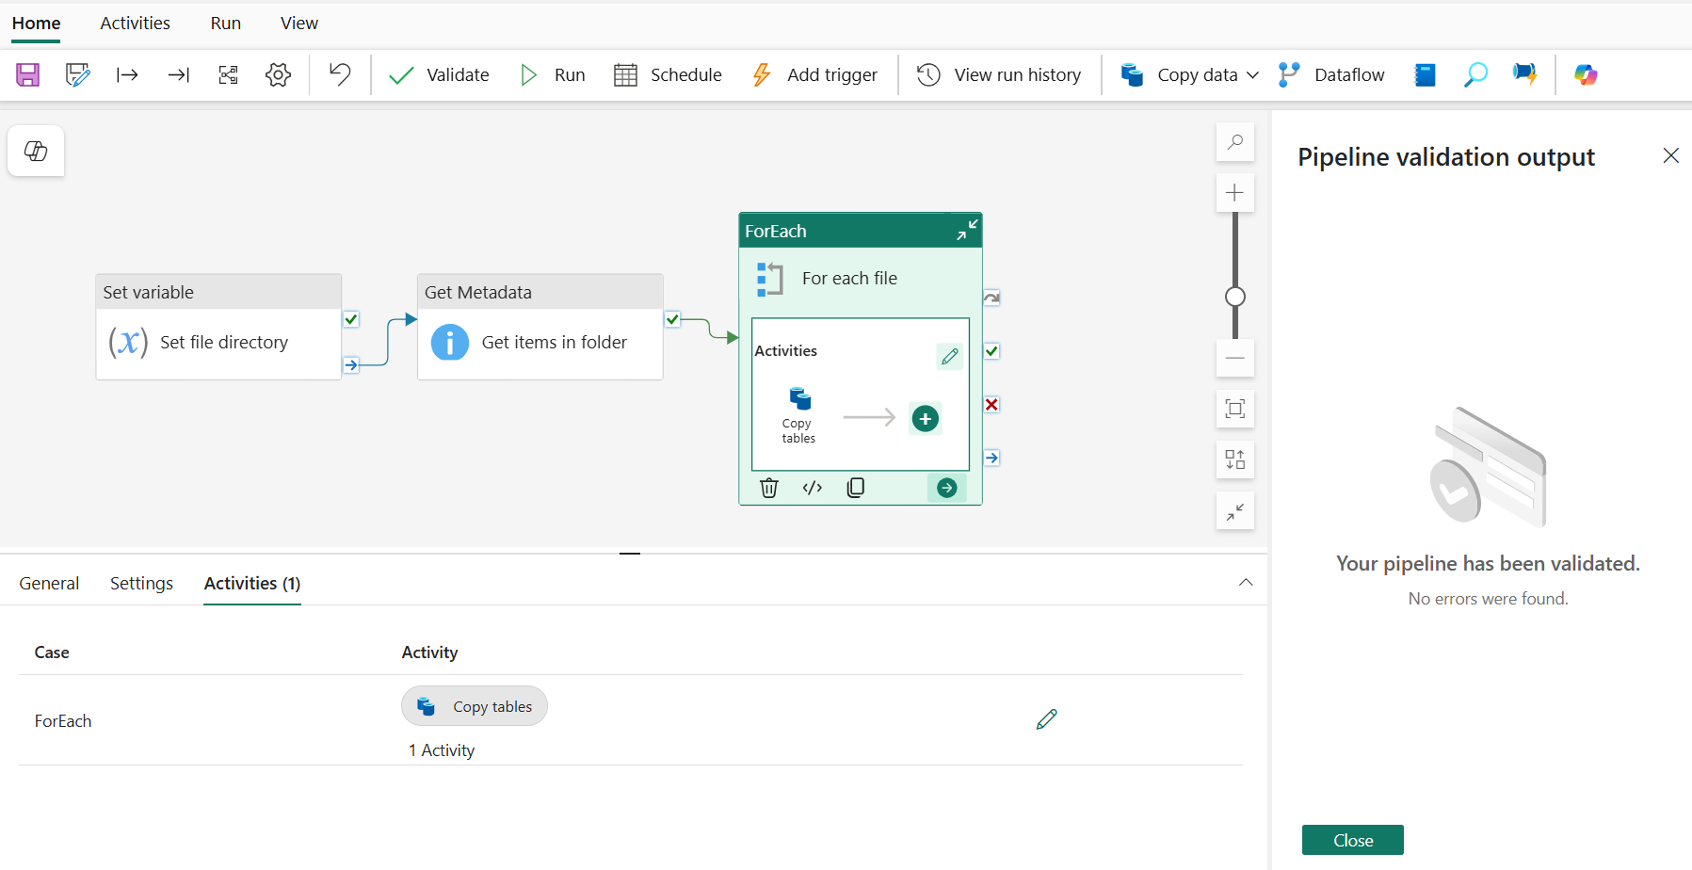

1. Once validated, select the **Run** to start the ingestion from the data pipeline.

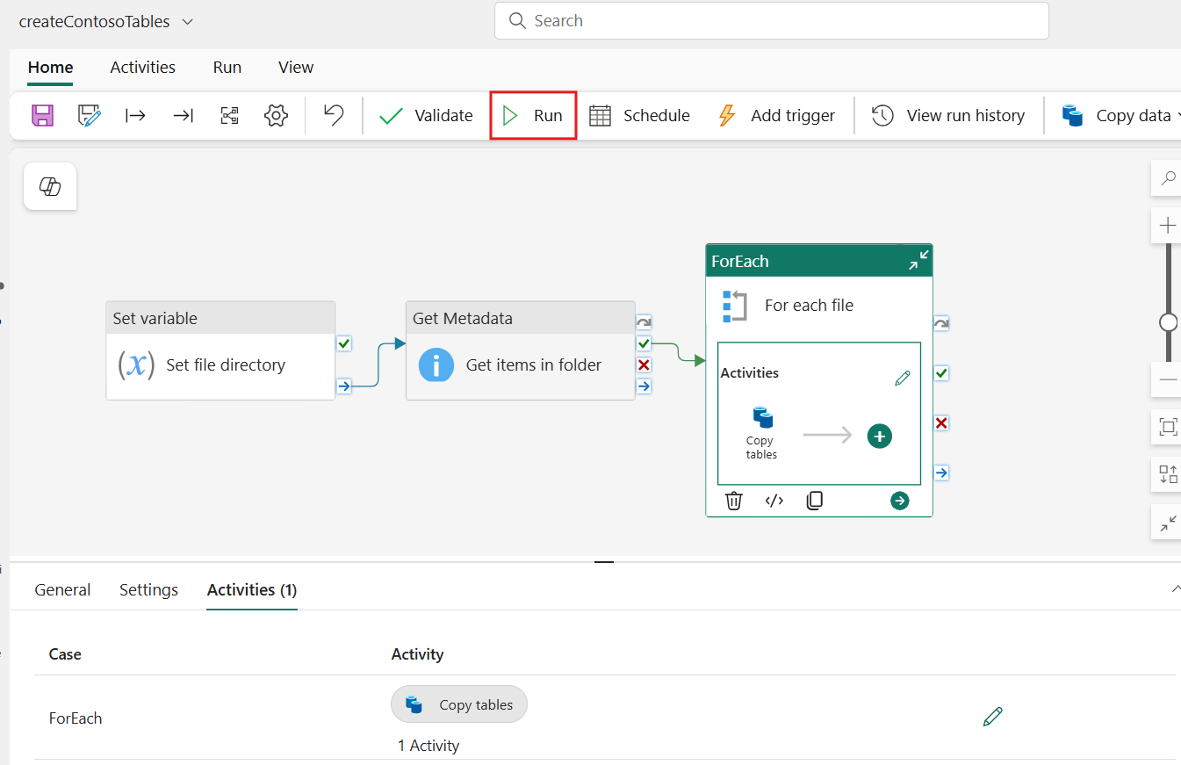

1. If a save window is prompted, confirm by selecting **Save and run**.

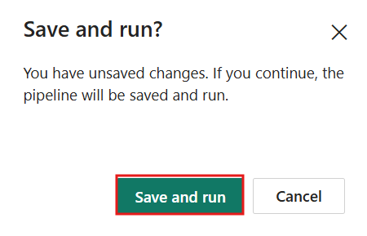

1. Running the pipeline initiates the data transfer, allowing you to see the results of your configuration in action within the output window.

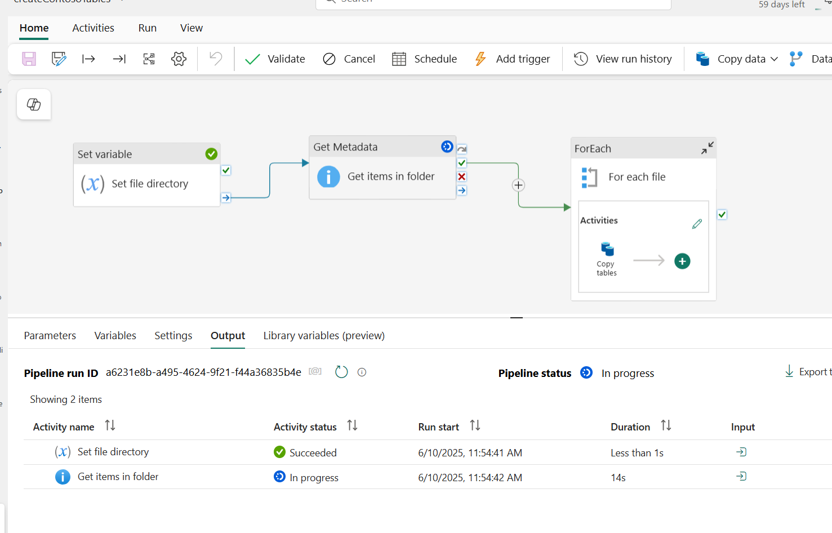

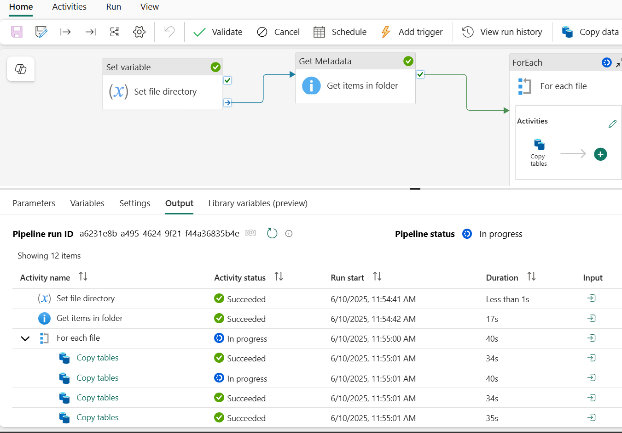

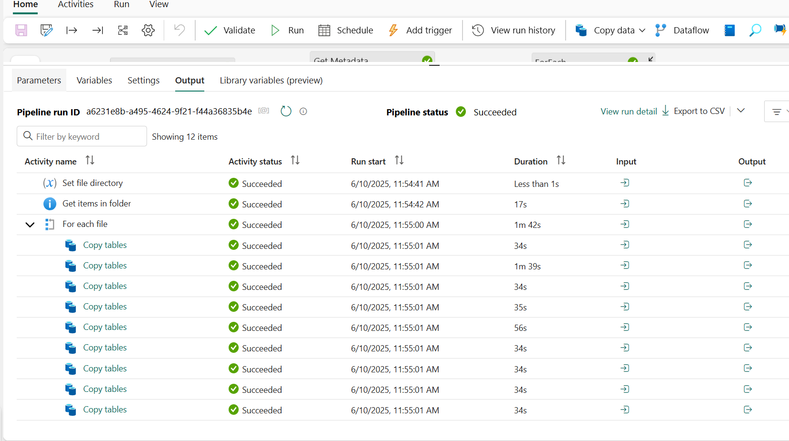

1. The data pipeline runs multiple activities sequentially, writing to the Silver data layer as delta parquet tables. v-Order optimized tables enhance performance, reduce storage costs, and support efficient querying and data updates-ideal for analytical workloads in Microsoft Fabric.

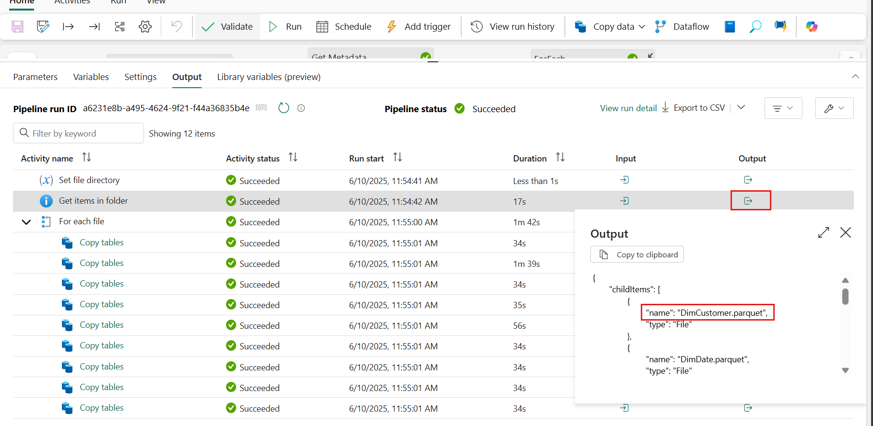

Task 6: Attach data pipeline to task flow

1. In the left-sided navigation menu, navigate and click on **Data Factory-MedallionXX** as shown in the below image.

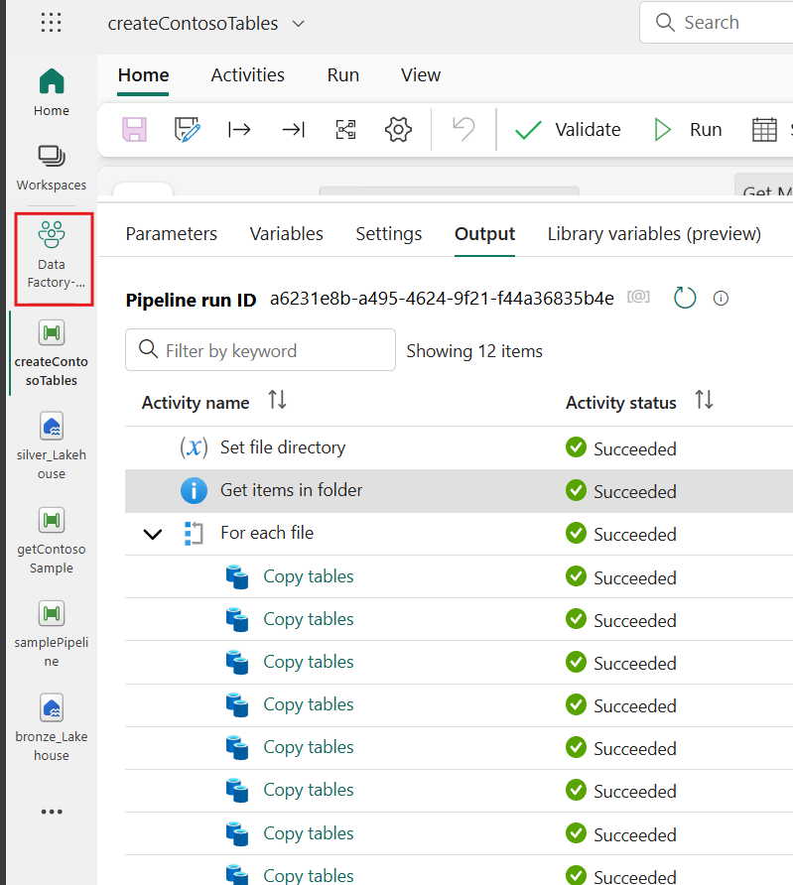

1. From the task flow select the **Initial process** task and the paper clip to assign a previously created item.

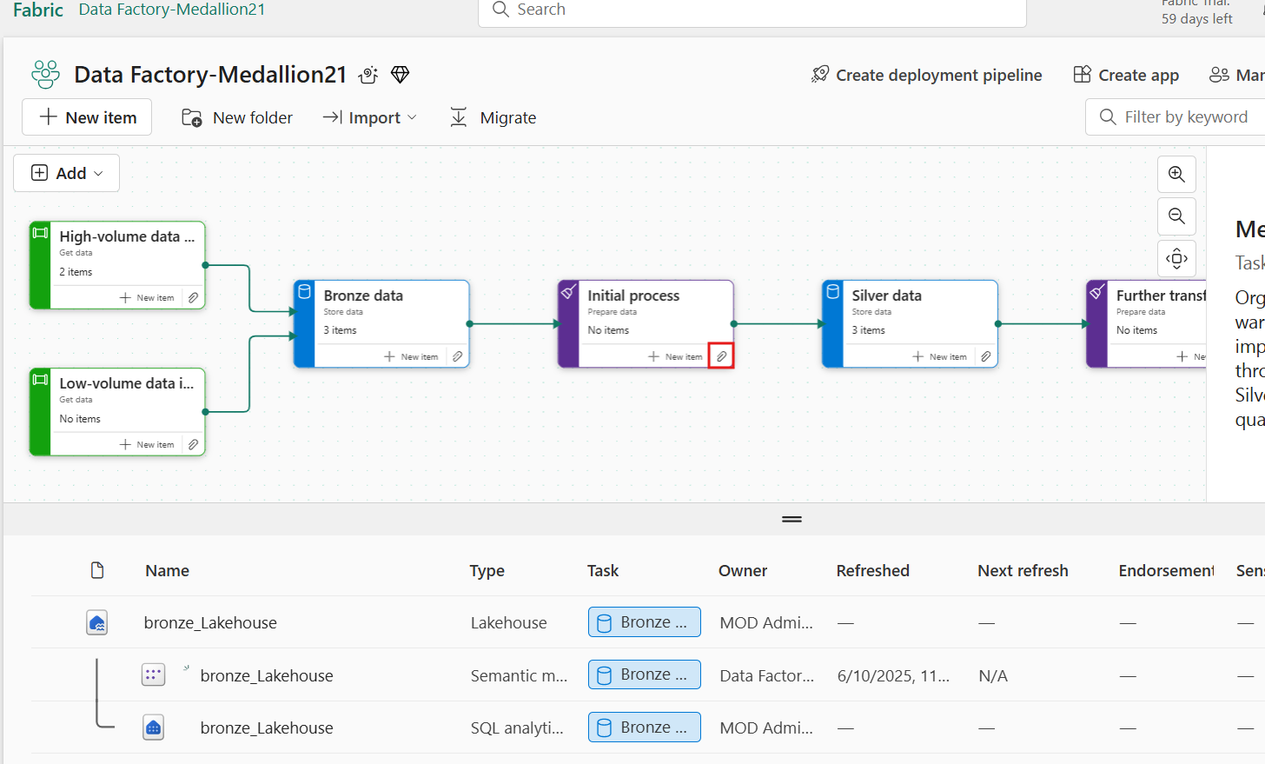

1. Select the **createContosoTables** item and then press **Select**.

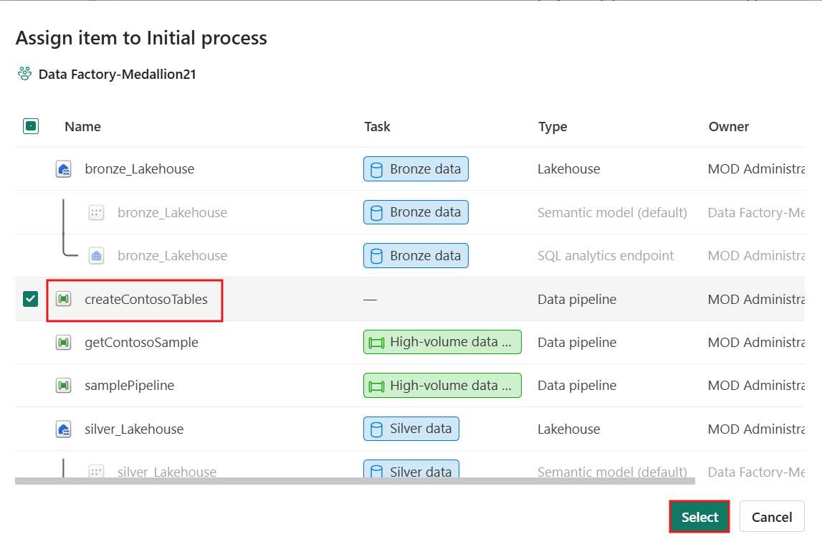

Exercise 3: Transforming and copying data

In this exercise, you will learn how to transform and copy data using Data Factory experiences. You'll start by creating a Dataflow Gen2 to prepare and load data with Power Query Online, allowing for efficient data shaping and transformation. The exercise will also guide you through understanding the storage and compute staging architecture, which supports large-scale data transformations. Next, you will configure data destination outputs to ensure that the transformed data is correctly routed. Finally, you'll create and configure a Copy job to enable a streamlined and user-friendly data ingestion process from source to destination.

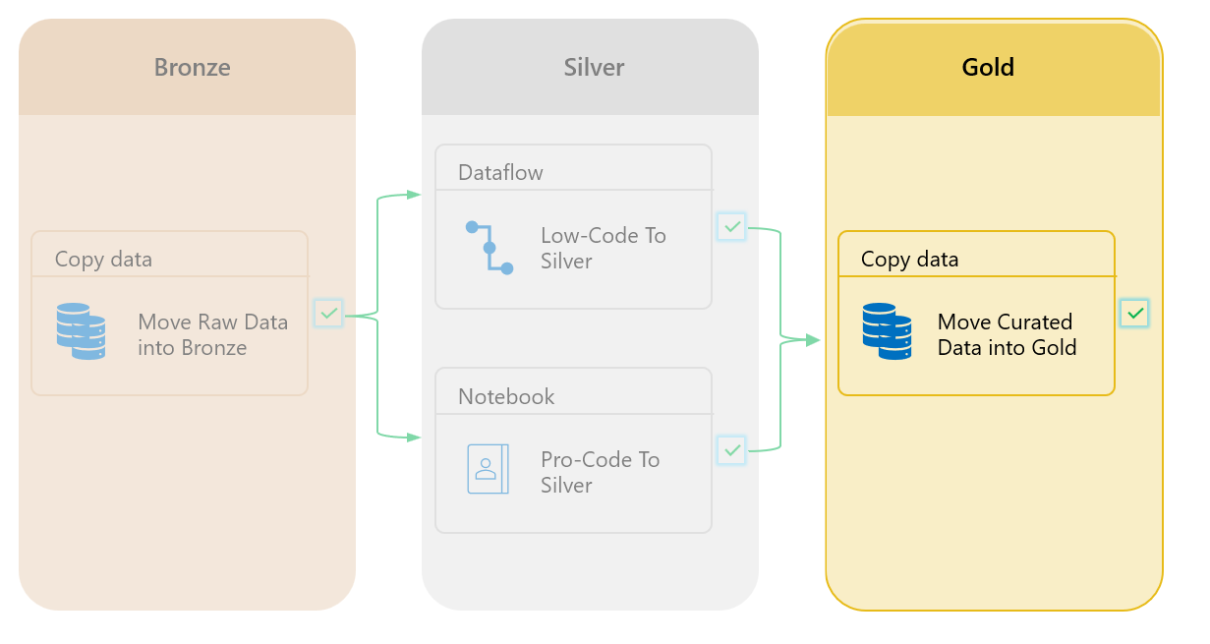

Task 1: Creating Golden data storage and a Dataflow Gen2

1. Select the **New item** option on the **Gold data** from task flow to add another storage item.

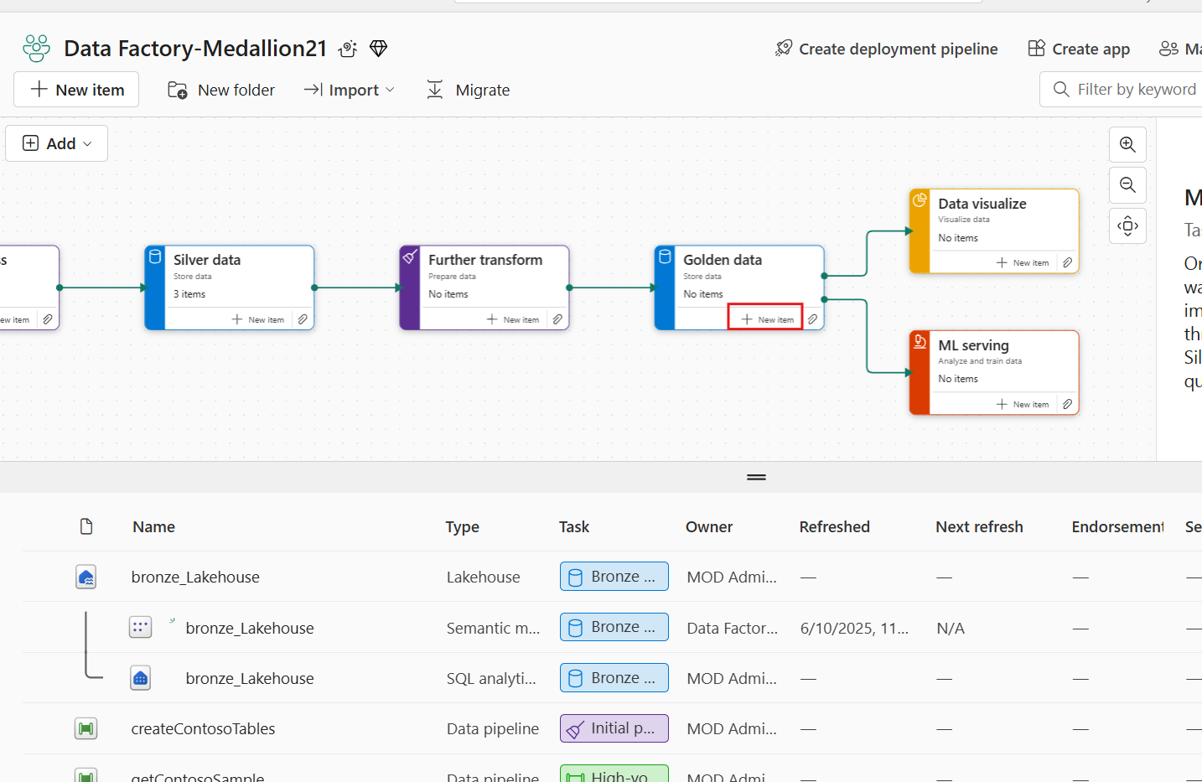

1. In the Create an item tab, select **Warehouse**.

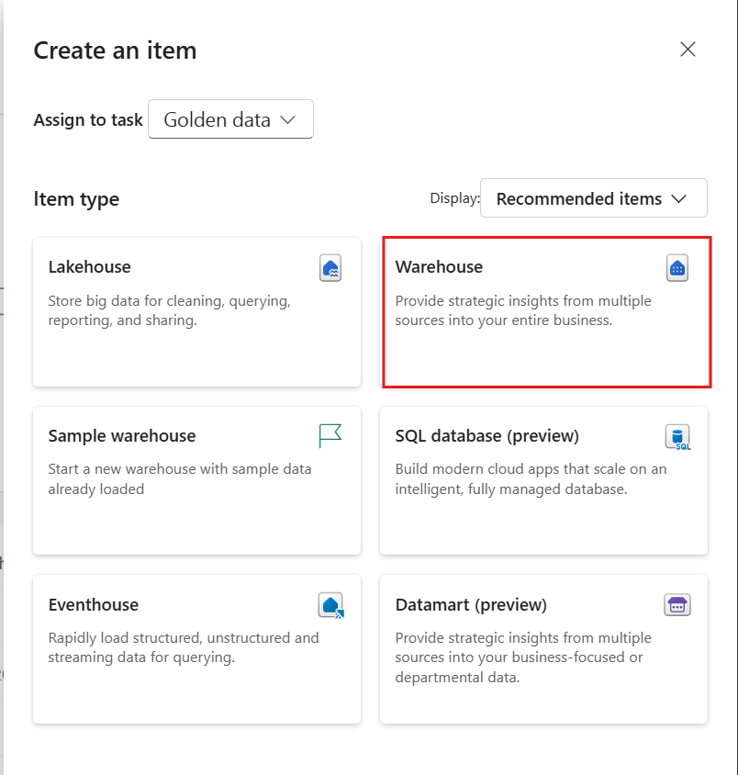

1. In the New **warehouse** window, set the warehouse name to **gold_Warehouse** and then select **Create**.

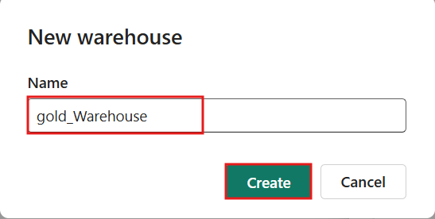

1. Within the warehouse item from the **Home** tab select **Get data** from **New Dataflow Gen2**.

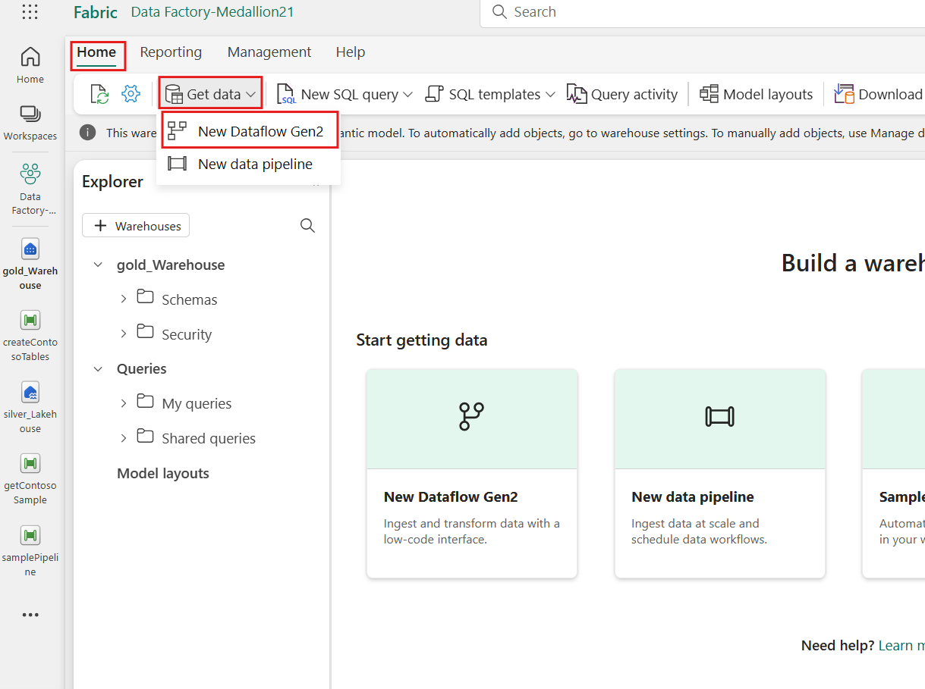

1. In the **New Dataflow Gen2** window, click on **Dataflow1** and rename it to **PrepContoso**

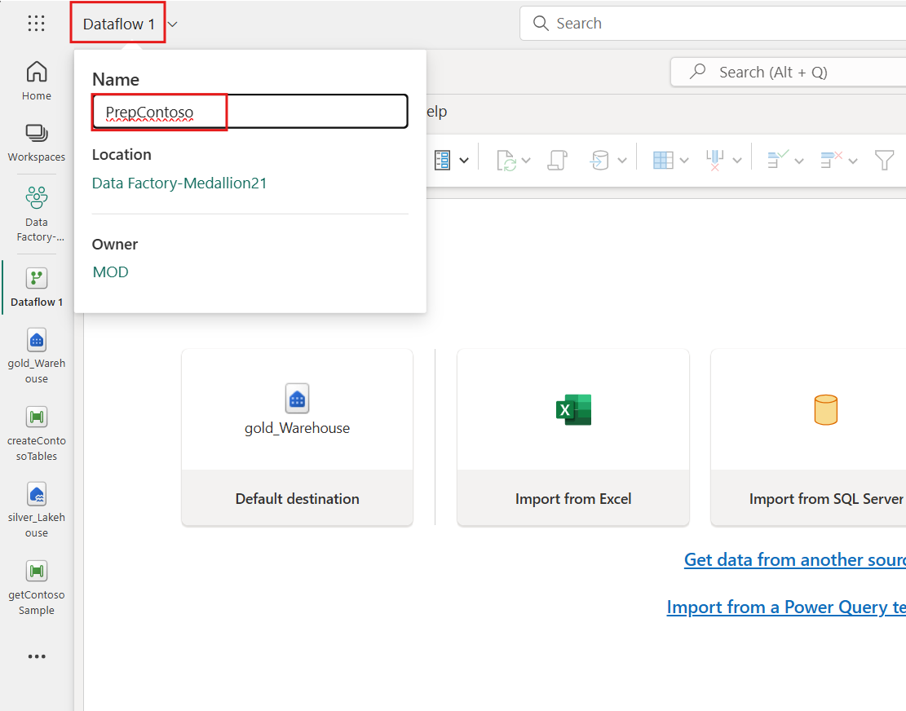

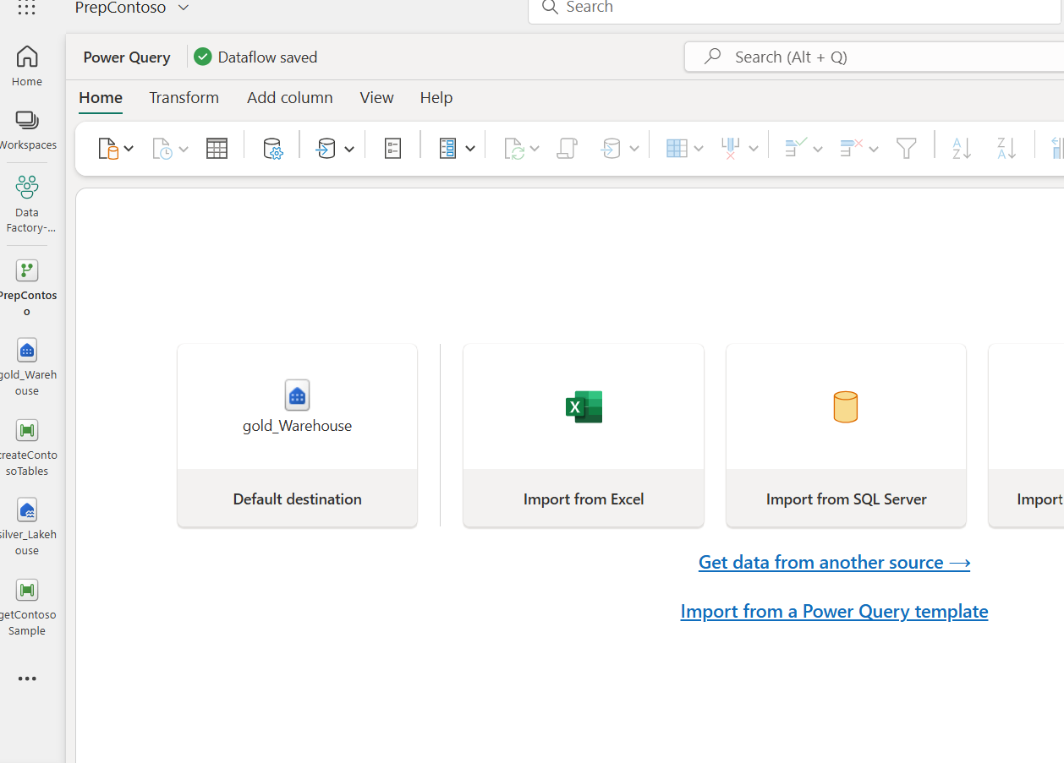

Task 2: Connecting to lakehouse tables

1. From the **Home** tab, select **Get data** and then the **More…** option.

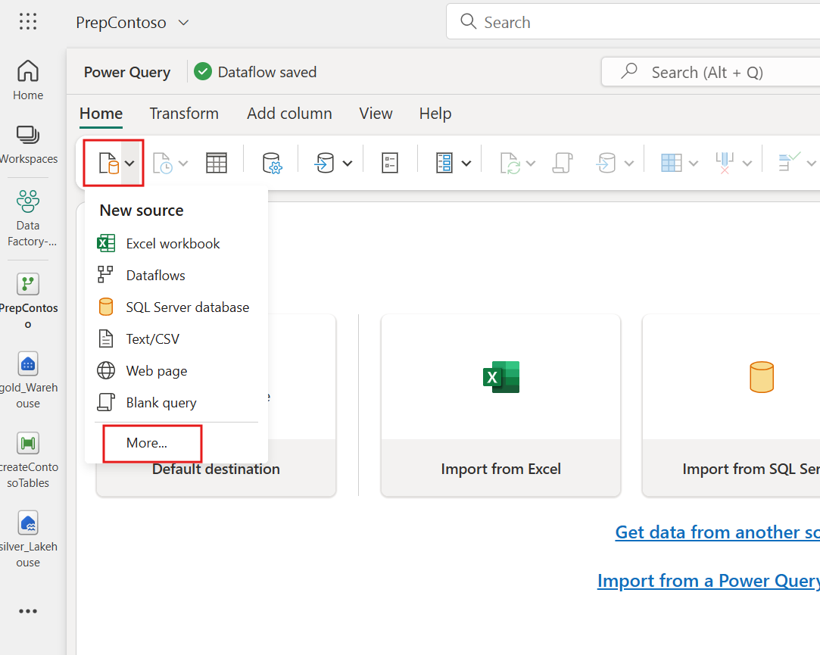

1. Within the **Get data** explorer's search bar, type **silver_Lakehouse** to locate the silver lakehouse item. Select the **silver_Lakehouse** item within the OneLake catalog's returned results.

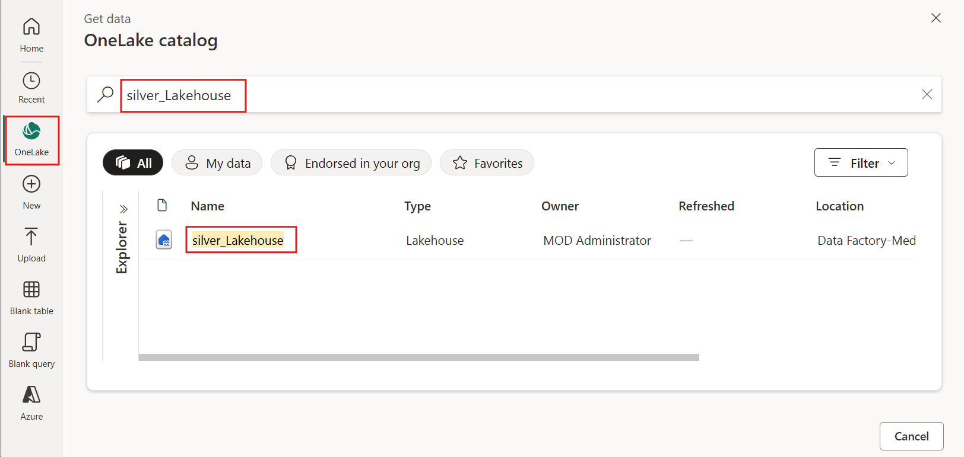

1. From the Get data table navigator, select the tables listed below to perform data transformation operations and merge the tables for our downstream business intelligence projects.

| **Table Name** |
| --- |
| DimCustomer |
| DimGeography |
| DimProduct |
| DimProductCategory |
| DimProductSubcategory |
| FactOnlineSales |

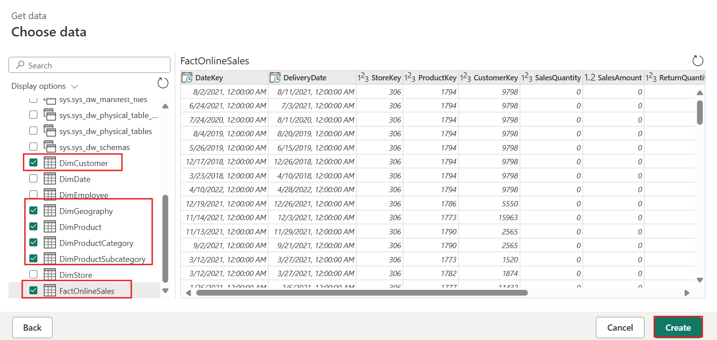

Task 3: Preparing data using Power Query Online

1. Select the **DimCustomer** table and from the **Home** tab, click on the **Combine** dropdown, navigate to **Merge Queries**, and choose **Merge Queries as New** to create a new merged query.

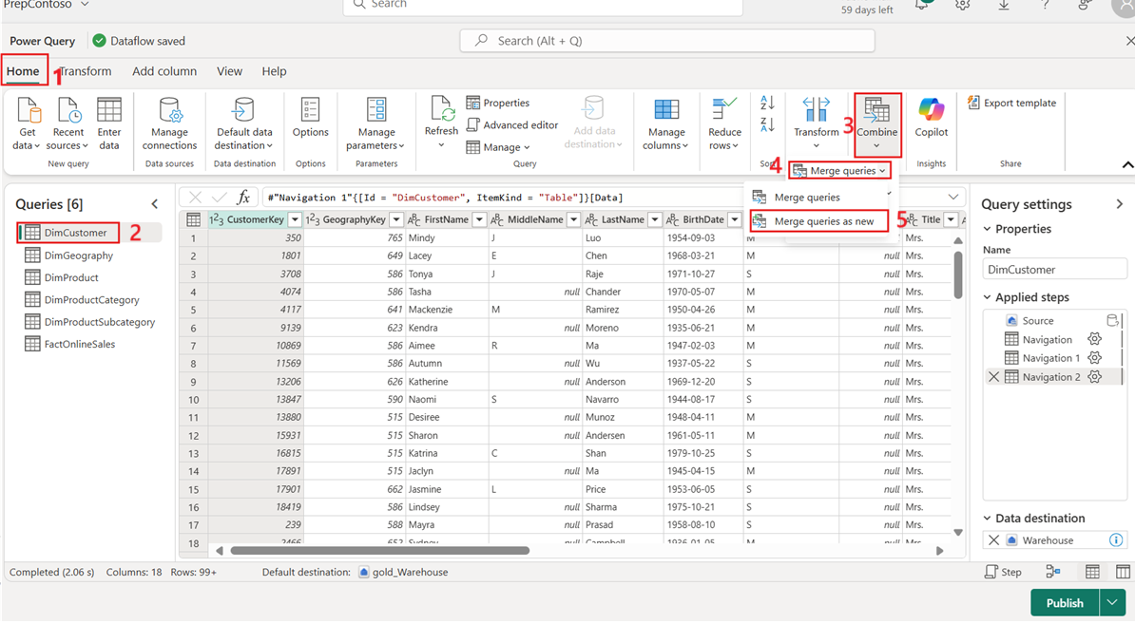

1. From the **Merge query** window, set the **Right table for merge** to **DimGeography**. In the top right corner, select the lightbulb which has detected a possible column match

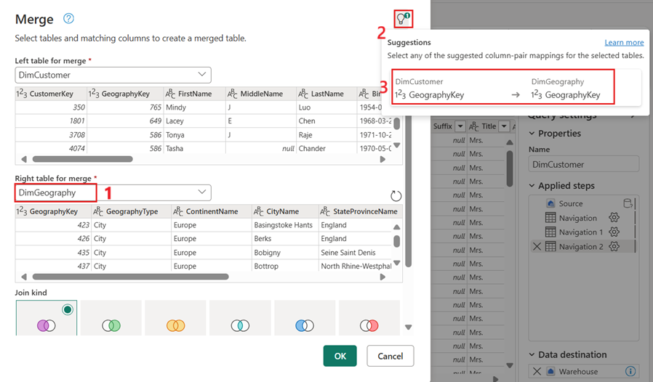

1. In this example, both tables contain a column titled **GeographyKey**. Select this option to set the columns to be merged on. For the join kind, select **Inner** and then **OK** to proceed. This activity ensures that the data is accurately combined based on matching columns.

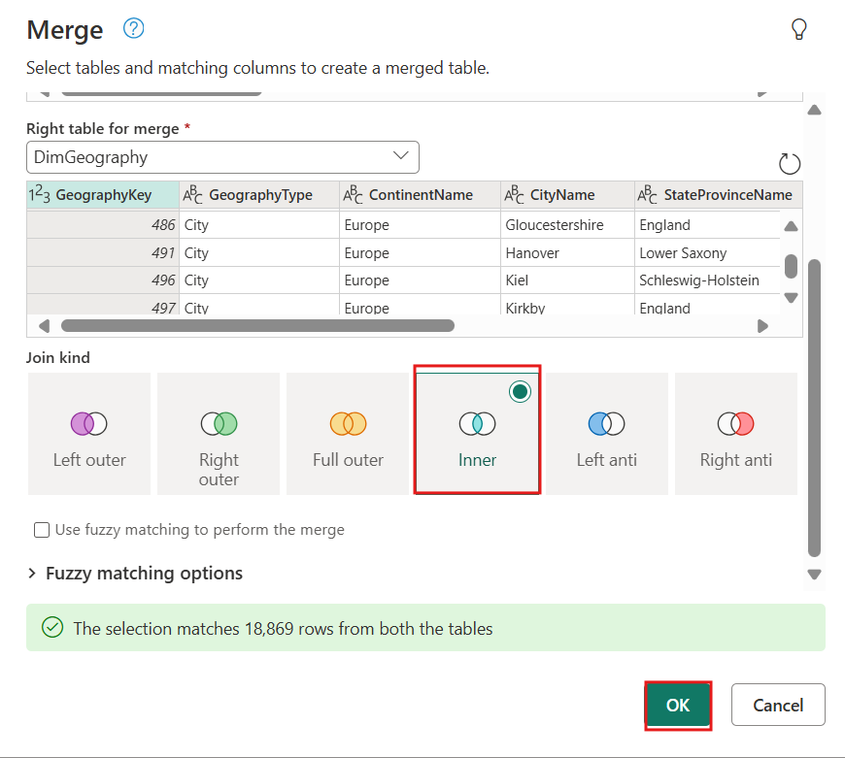

1. Navigate to the far right fo the **DimCustomer** table and select the joined **DimGeography** table column's top right corner to expand the table, from the avaialble column selections deselect **GeographyKey** since this column is what we used to merge on and already exists in the dataset before selecting **OK** to continue.

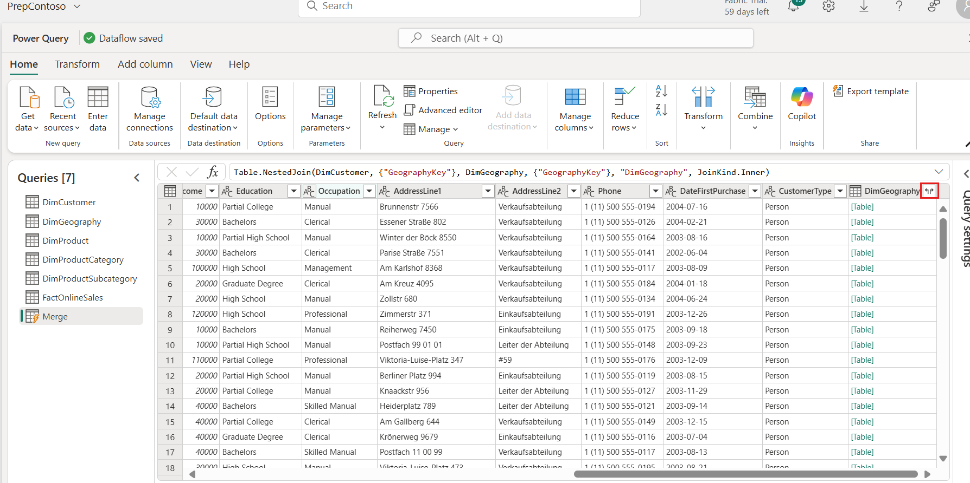

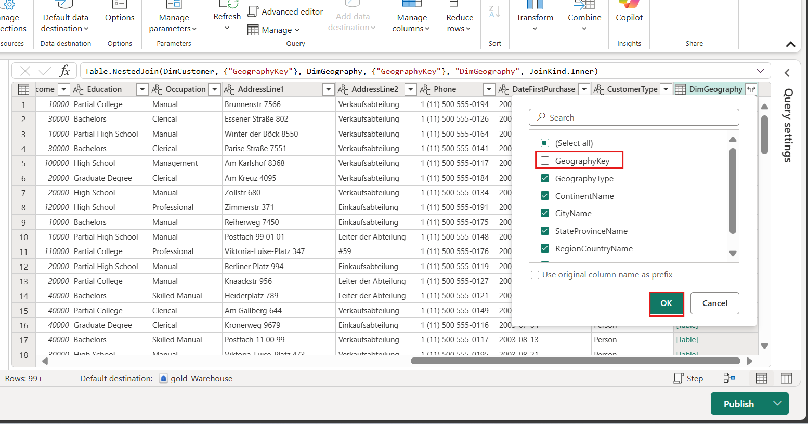

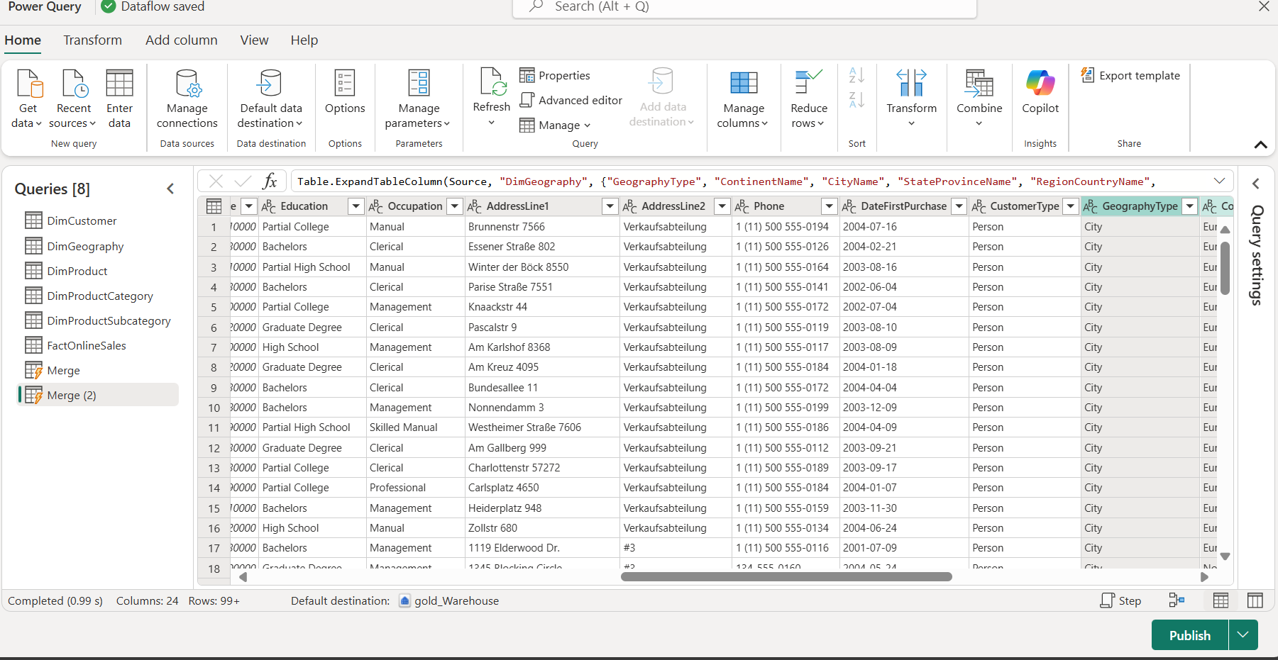

1. On the right-hand side in the **Query settings** pane, update the **Name** of the query to be **DimCustomers**.

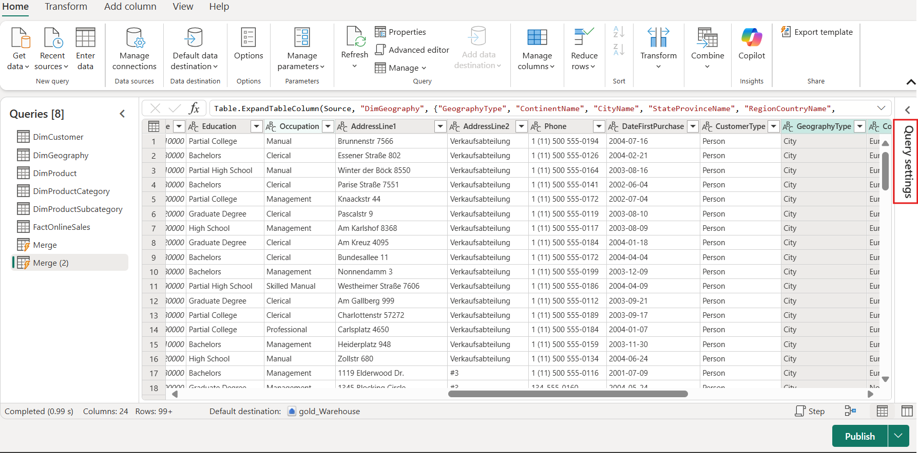

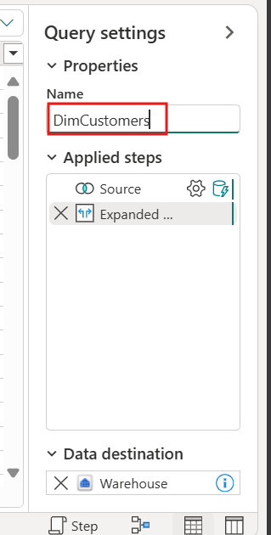

1. Within the **Query settings** pane, review the Applied steps list, which records the steps of your transformations. In this example, query folding indicators highlight that our queries are successfully folding back to the lakehouse's SQL endpoint for large-scale transformations.

Additionally, the options to View data source query and View query plan allow you to review the generated SQL or the execution plan for the query. This step ensures that the data transformations are applied correctly and efficiently, maintaining the integrity and performance of your dataflow.

1. Select the **DimProduct** table and from the **Home** tab, navigate to the **Merge queries** group and select **Merge queries as new**.

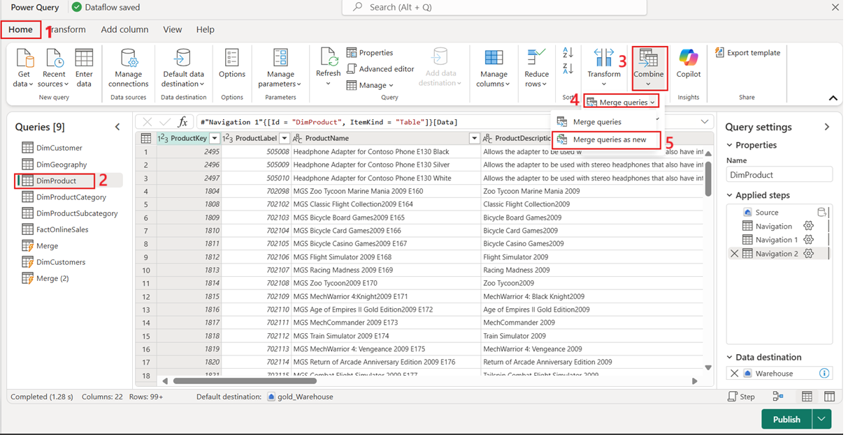

1. From the **Merge query** window, set the Right table for merge to **DimProductSubcategory.**
2. In the top right corner, select the lightbulb which has detected a possible column match. In this example, both tables contain a column titled **ProductSubcategoryKey**. Select this option to set the columns to be merged on. For the join kind, select **Inner** and then **OK** to proceed.

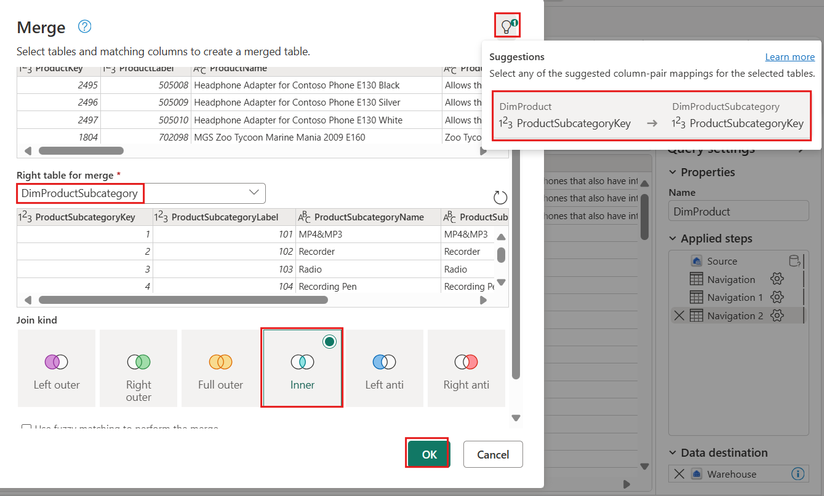

1. Navigate to the far right fo the **DimProduct** table and select the joined **DimProductSubcategory** table column's top right corner to expand the table, from the avaialble column selections deselect **ProductSubCategoryKey** since this column is what we used to merge on and already exists in the dataset before selecting **OK** to continue.

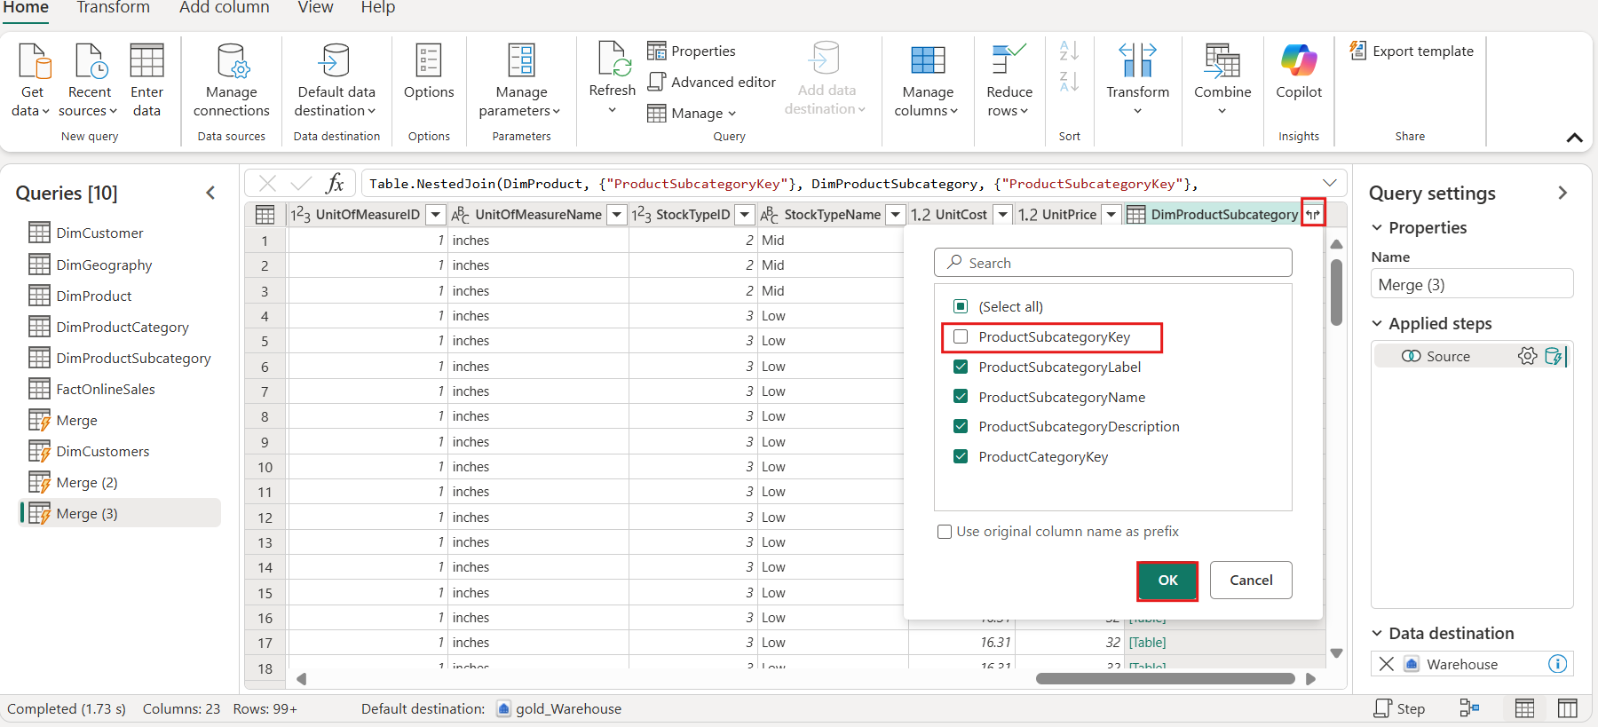

1. Select the **Merge** query and from the **Home** tab, navigate to the **Merge queries** group and select **Merge queries**.

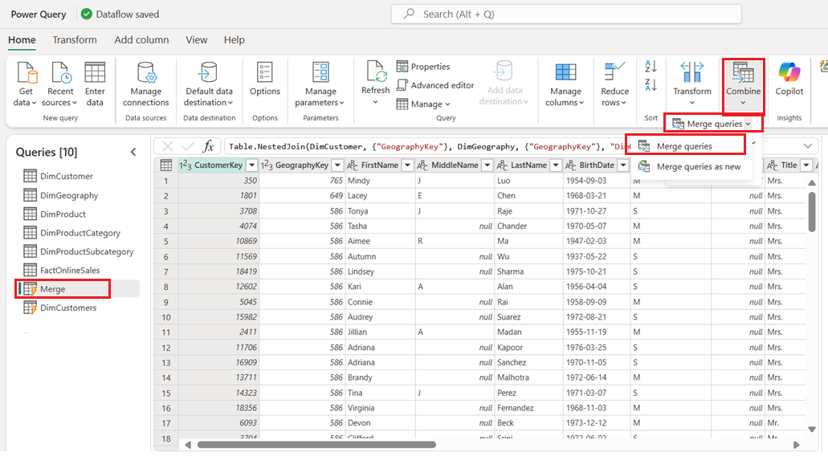

1. From the Merge query window, set the **Right table for merge** to **DimProductCategory**. In the top right corner, select the lightbulb which has detected a possible column match. In this example, both tables contain a column titled **ProductCategoryKey**. Select this option to set the columns to be merged on. For the join kind, select **Inner** and then **OK** to proceed.

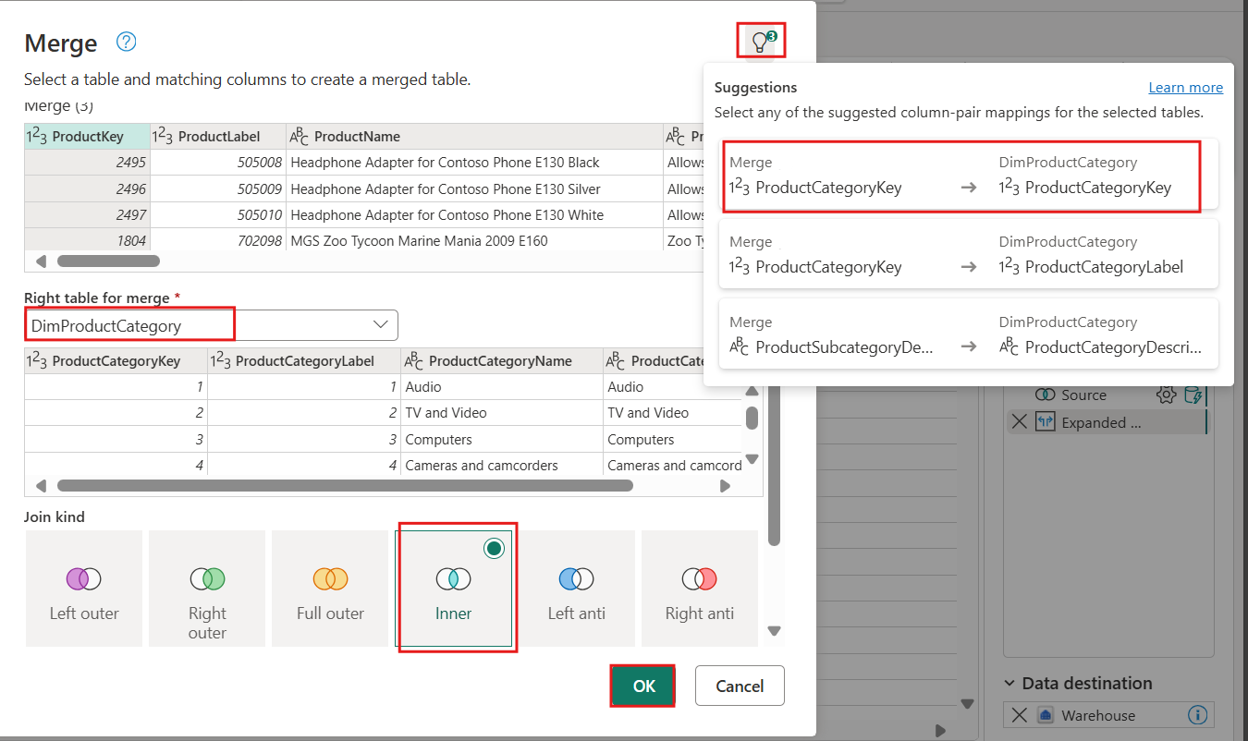

1. Navigate to the far right fo the **DimProduct** table and select the joined **DimProductCategory** table column's top right corner to expand the table, from the avaialble column selections deselect **ProductCategoryKey** since this column is what we used to merge on and already exists in the dataset before selecting **OK** to continue.

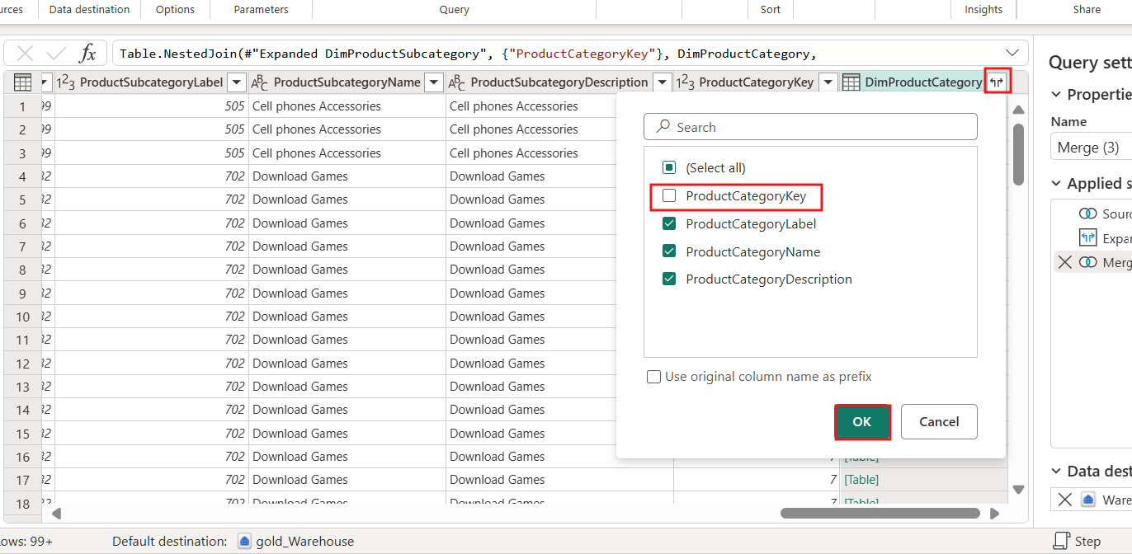

1. On the right-hand side in the Query settings pane, update the **Name** of the query to be **DimProducts**.

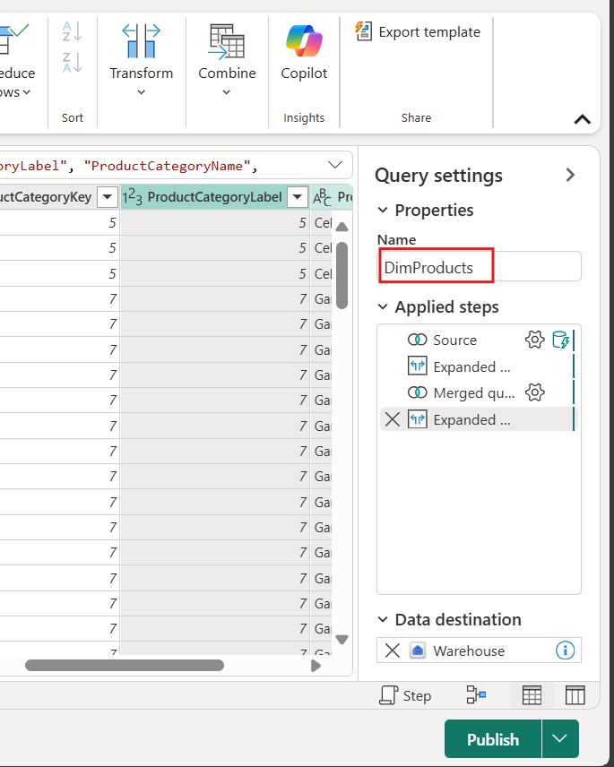

Task 4:Group queries and save

1. Select the **DimCustomer**, **DimGeography**, **DimProduct**, **DimProductCategory** and **DimProductSubcategory** queries by holding the shift key, as they are all adjacent to each other. Right-click and select **Move group**, then select **New group**.

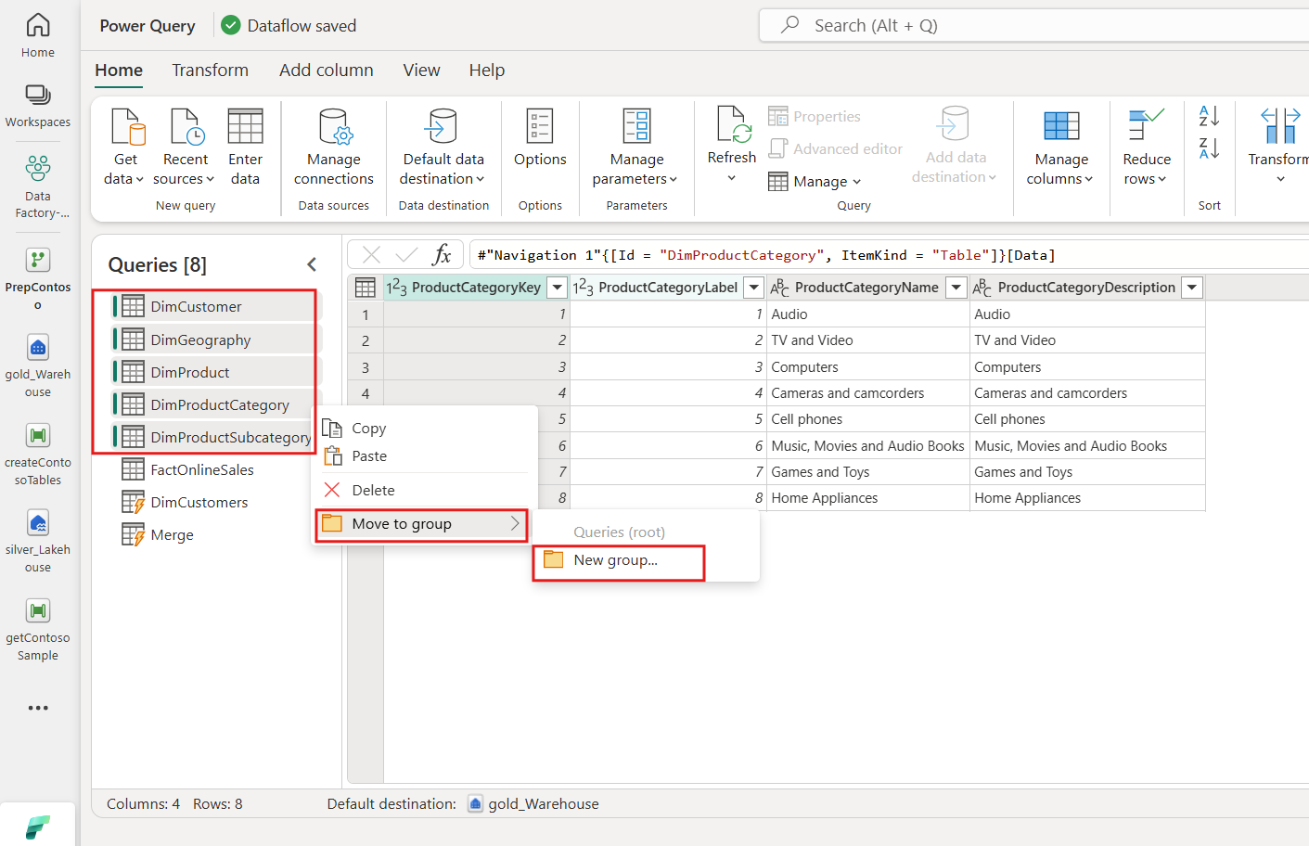

1. In the New group window, set the properties as needed below and select **OK**.

|  |  |
| --- | --- |
| Name | **Description** |
| Data reference | **Data used only as a source from the silver lakehouse** |

1. 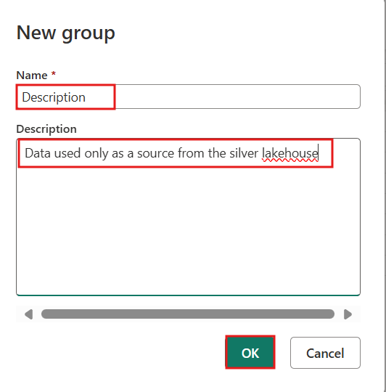
2. Select the **FactOnlineSales**, **DimCustomers** and **DimProducts** queries by holding the control key. Right-click and choose **Move group**, then select **New group**.

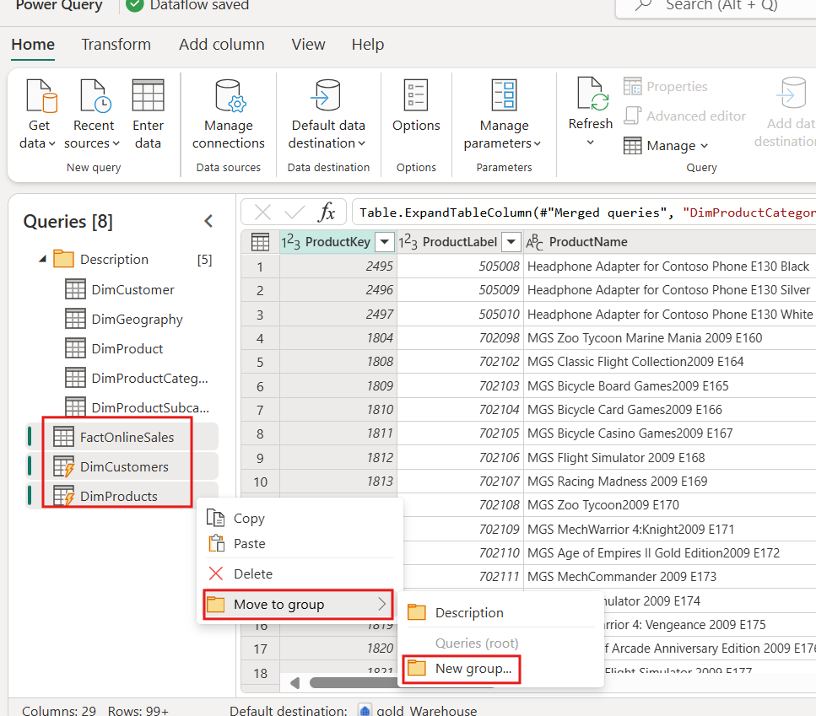

1. In the New group window, set the properties as needed below and select **OK**. This step helps in organizing your queries into logical groups, making it easier to manage and navigate your data.

|  |  |
| --- | --- |
| Name | **Data load** |
| Data load | **Data loaded to the gold warehouse** |

1. 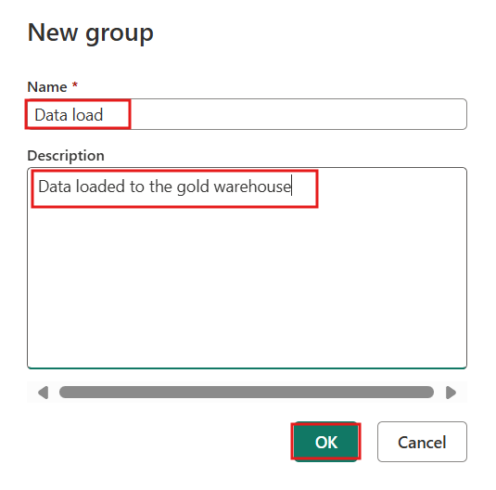
2. 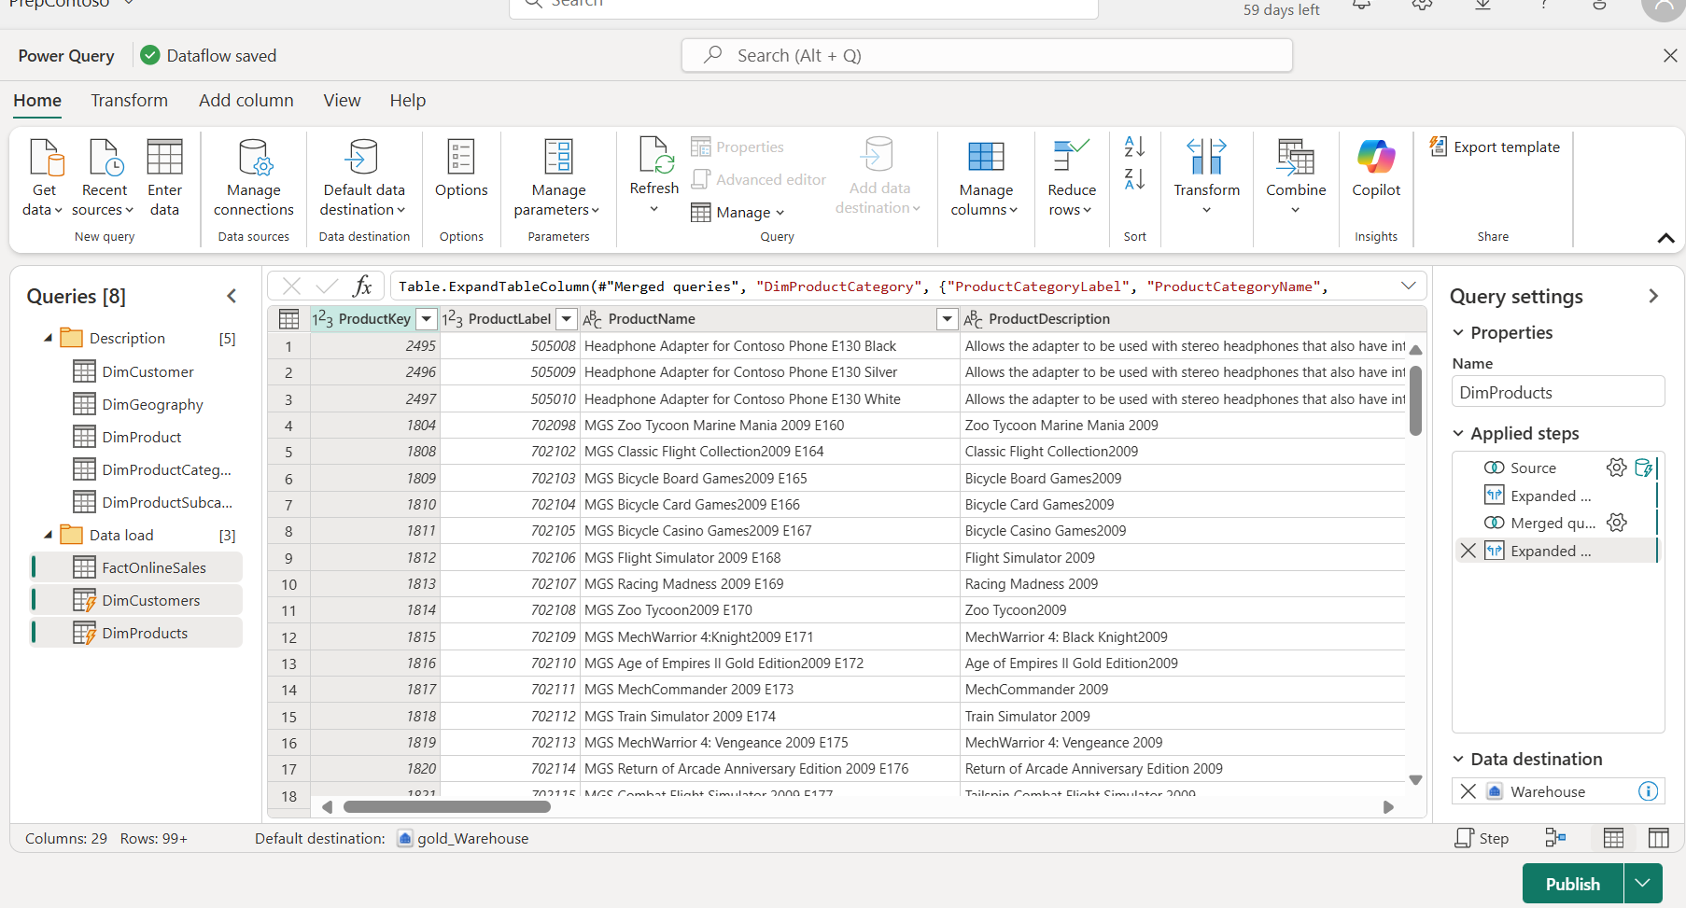
3. In the main editor window, confirm that you see your output destination on the **Query settings** pane for the **Output** table, and then select **Publish**.

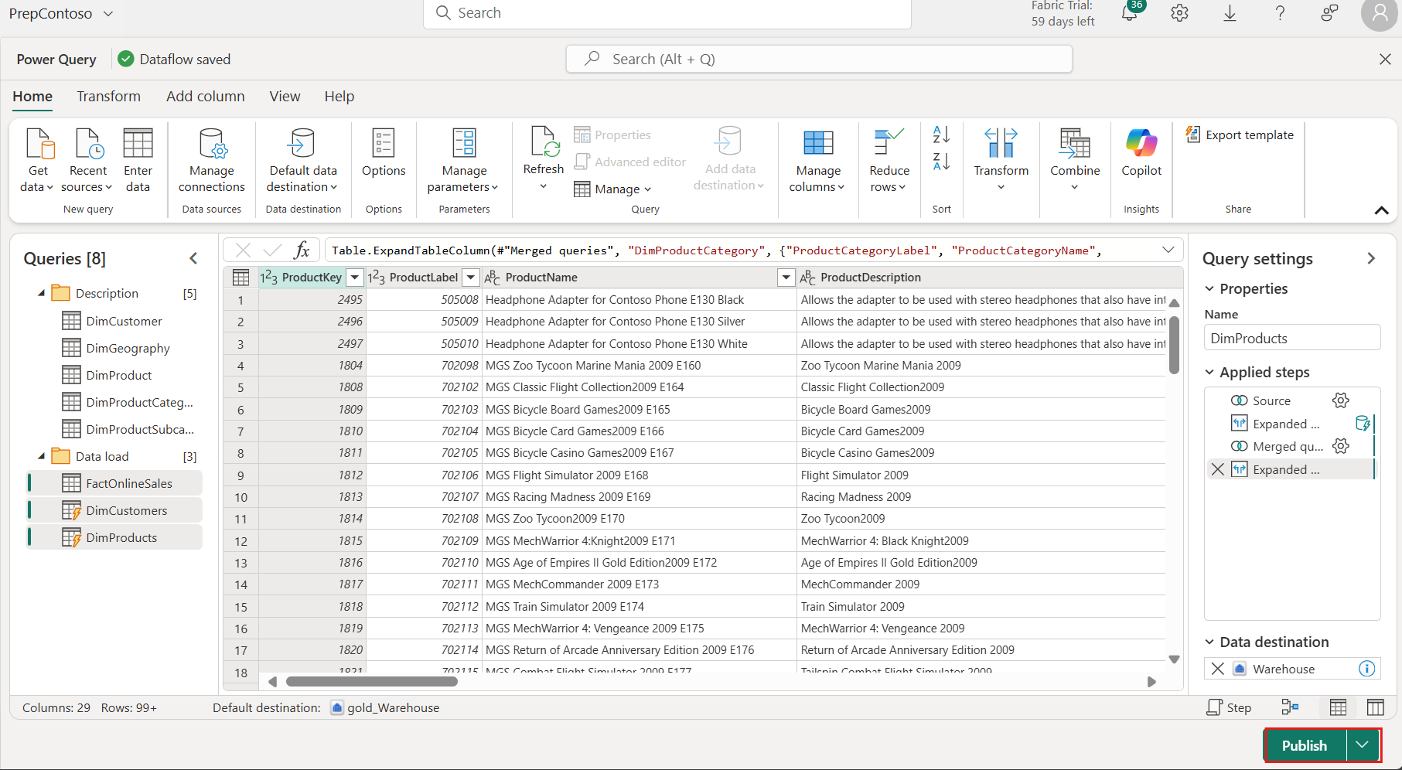

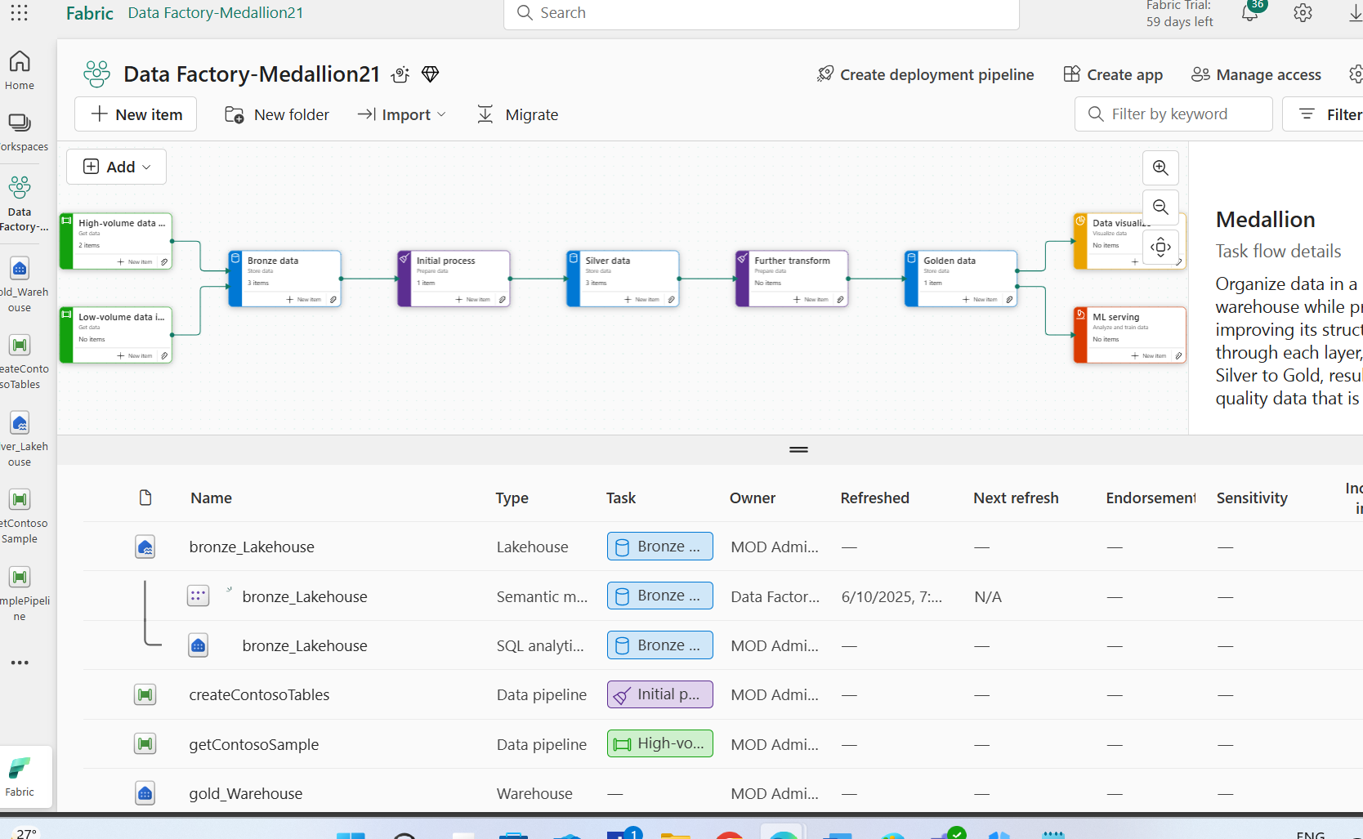

Task 5: Further transform task flow

1. From the task flow, select the **Further transform** task and click on the paper clip icon to assign a previously created item.

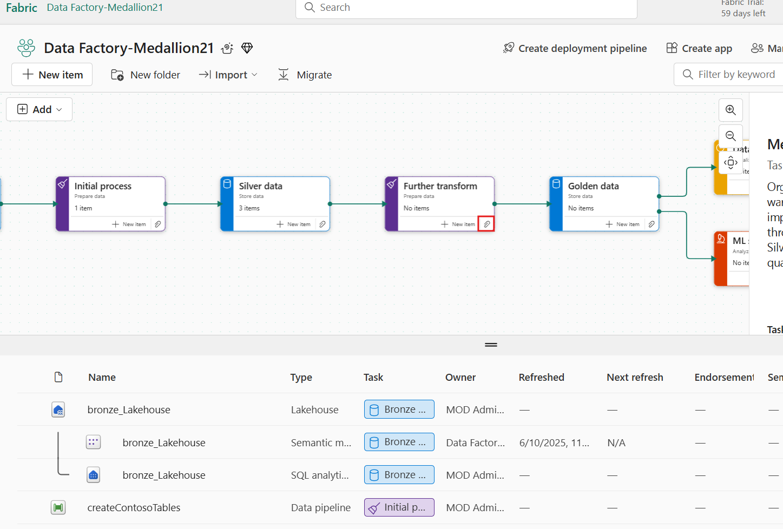

1. Select the **PrepContoso** item and then press **Select**.

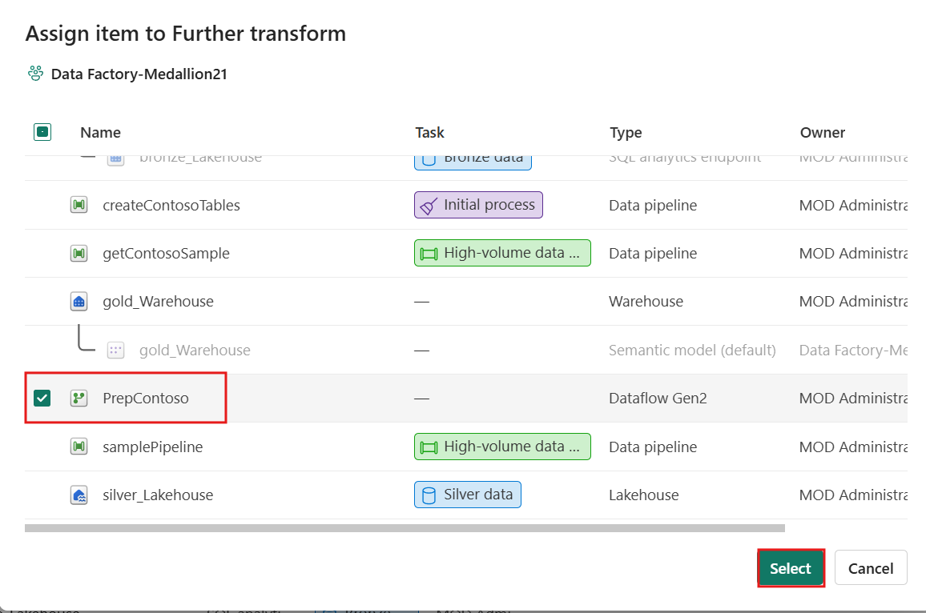

1. From the task flow, select the **Further transform** task and click on the **New item** option. Within the Create an item pane display properties, change the toggle to the **All items** option.

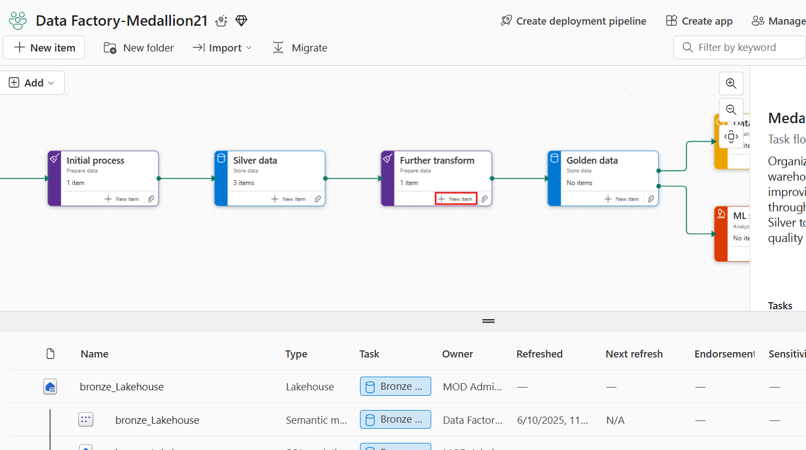

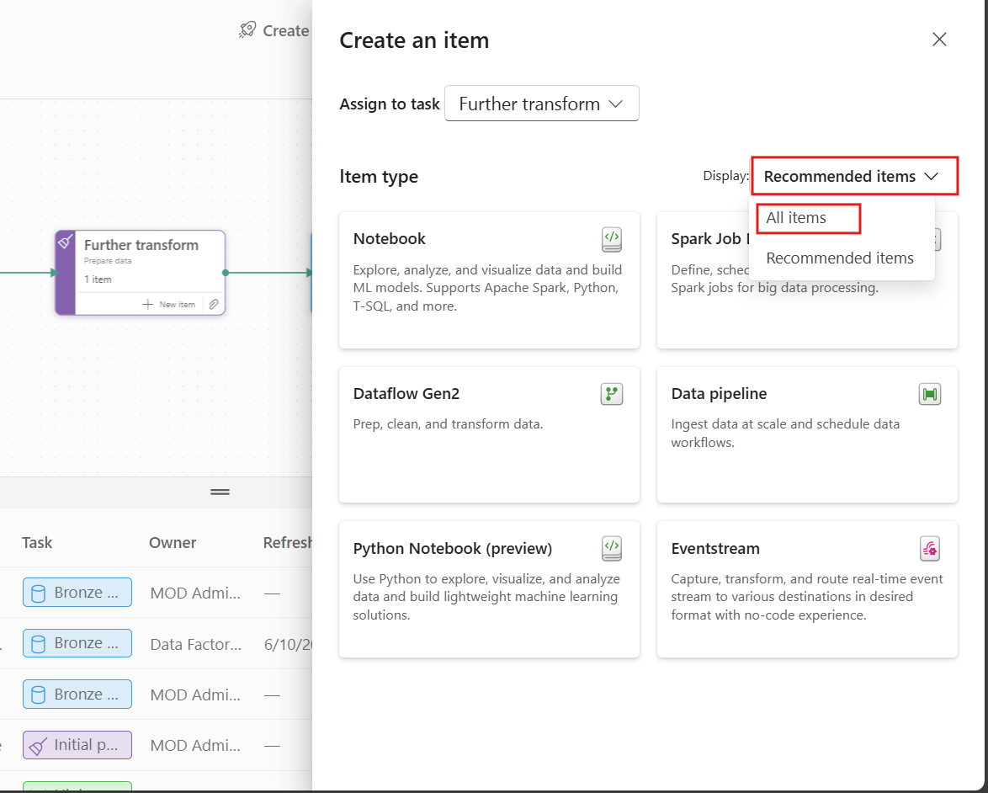

1. From the list of available items, navigate to the Data Factory section and select the **Copy job** item.

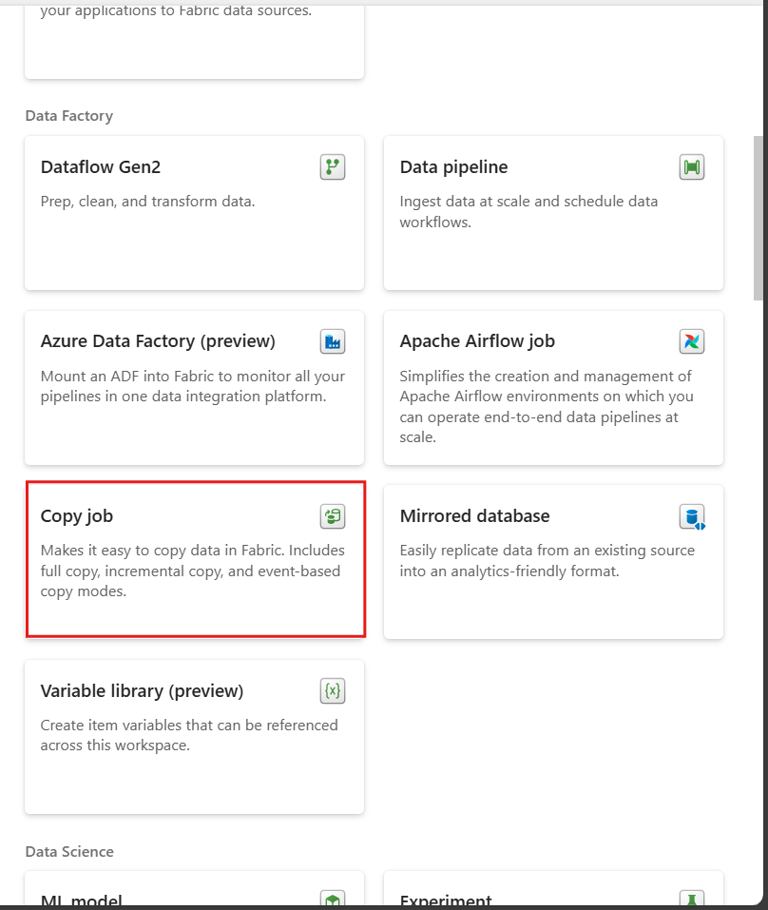

Task 6: Copy data into the warehouse

1. In the New copy job window, set the copy job name to **CopyContoso** and then select **Create**.

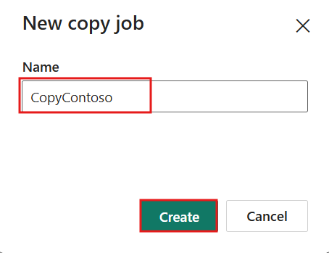

1. From the Copy job window, search for the data source starting with **silver_Lakehouse** in the search bar and then select **silver_Lakehouse** from the OneLake catalog list.

You can also use the OneLake tab at the top if you want to set additional criteria such as filters or item types.

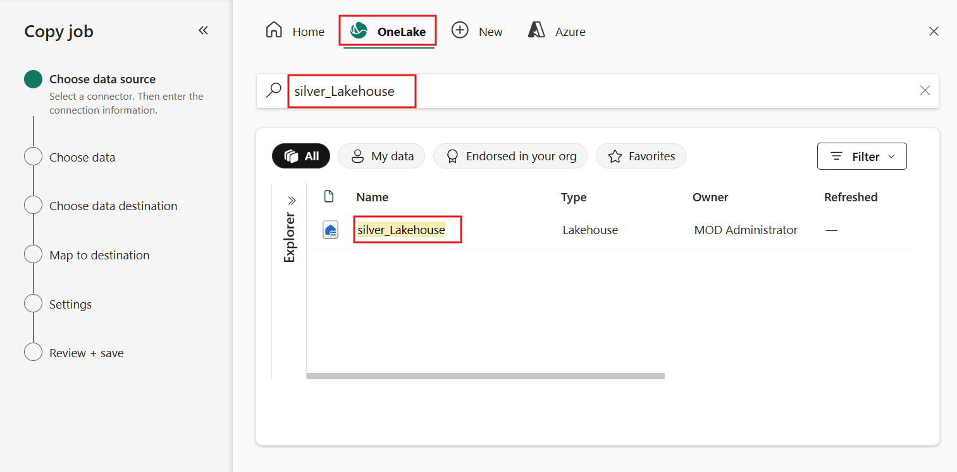

1. Now that you're on the **Choose data** step, select the following tables:
   * **DimDate**
   * **DimEmployee**
   * **DimStore**

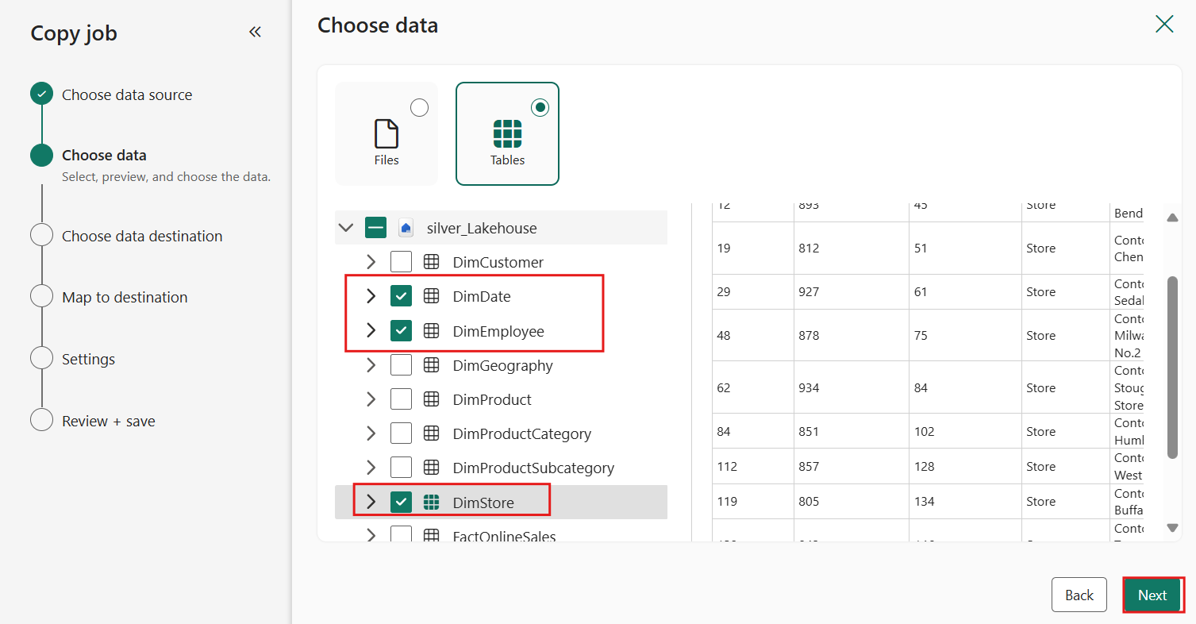

1. The copy job also supports a limited set of transformations such as column mapping, setting schema names, and renaming tables. Expand the **DimStore** table and then deselect the **GeoLocation** and **Geometry** columns. Once done, select **Next** to continue.

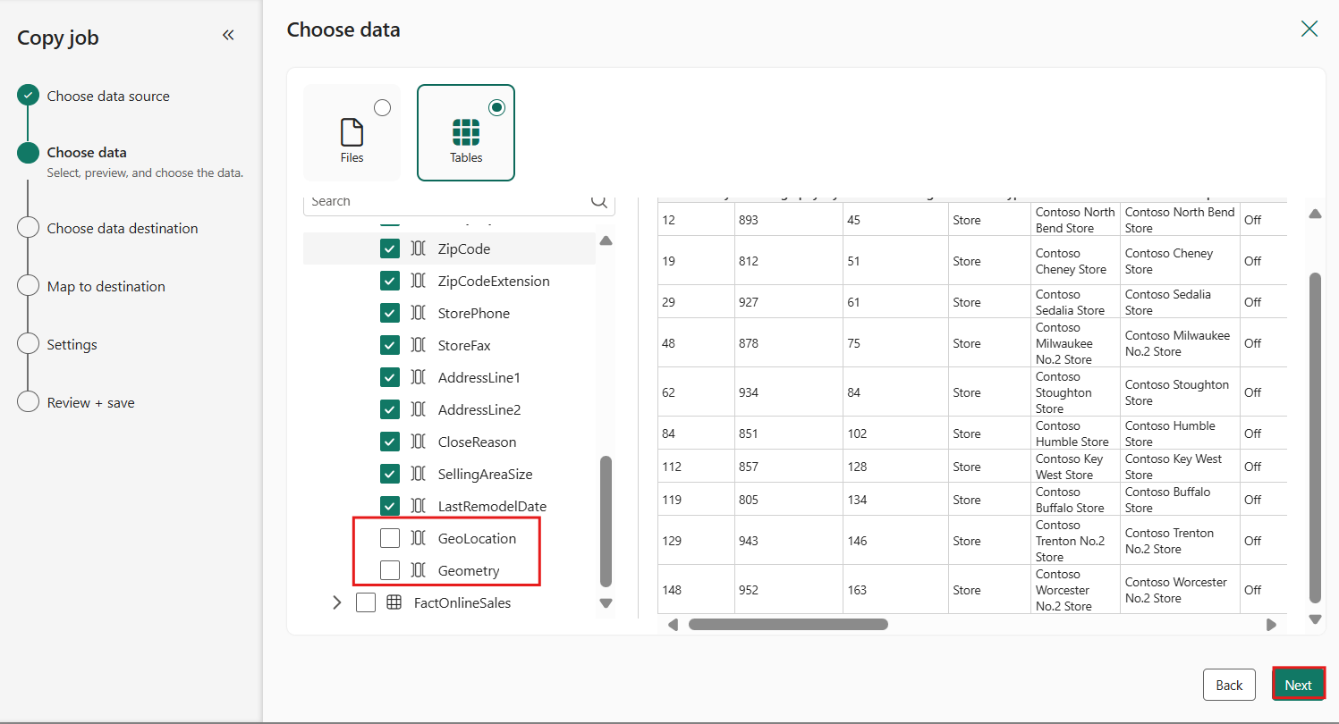

1. Within the Choose data destination step, search for the data source starting with **gold_Warehouse** in the search bar and then select **gold_Warehouse** from the OneLake catalog list.

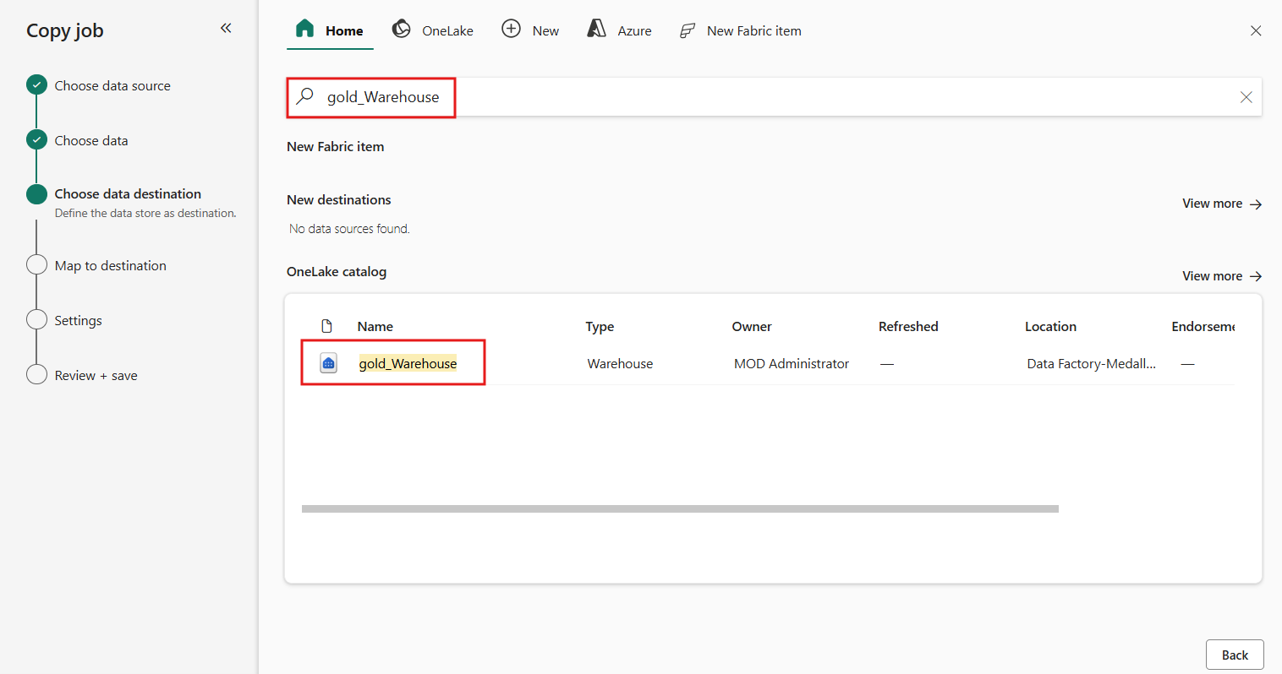

1. Within the **Map to destination** step, you can review the added tables and update the schema or table names. Once done reviewing, select **Next** to continue.

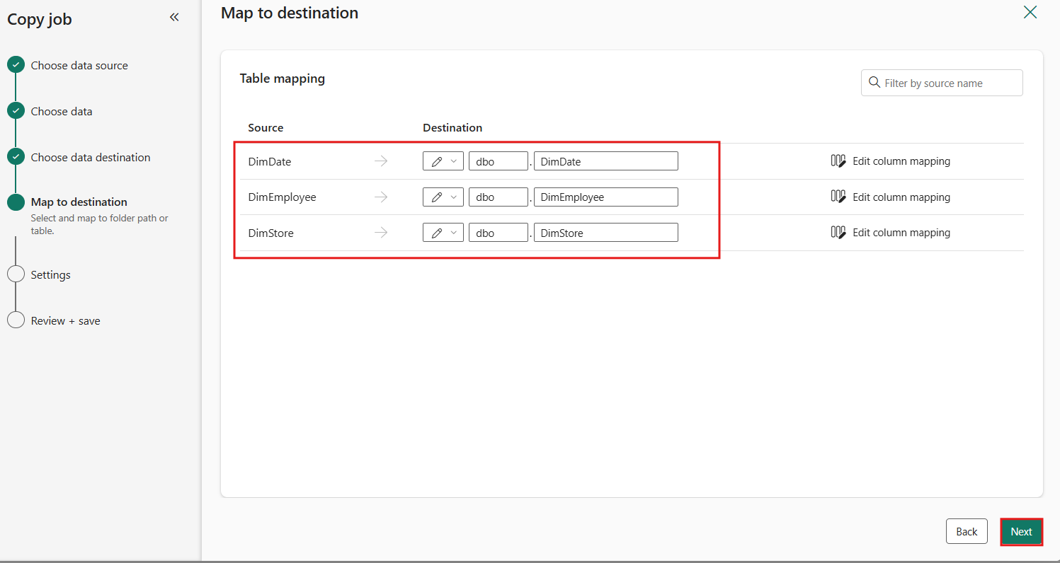

1. On the **Settings** step, review the Copy job mode options and then select **Next** to continue.

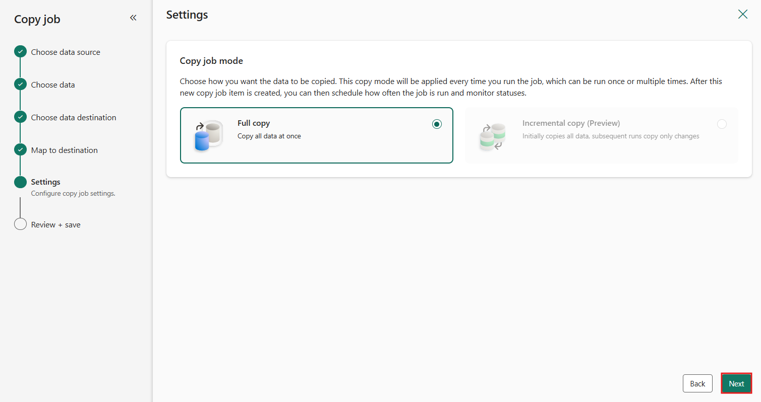

1. On the Review + save step, deselect the **Start data transfer immediately** option and then select **Save** to continue.

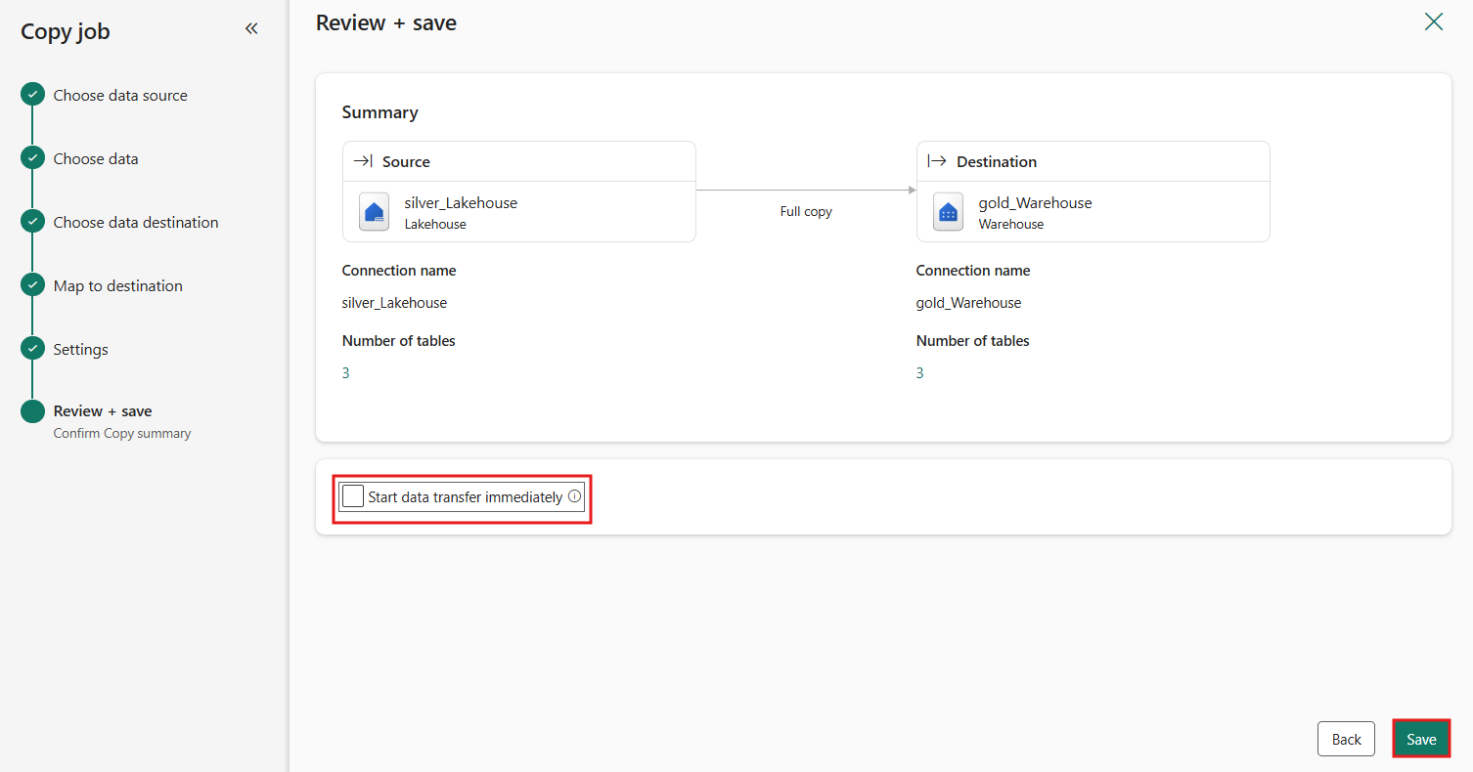

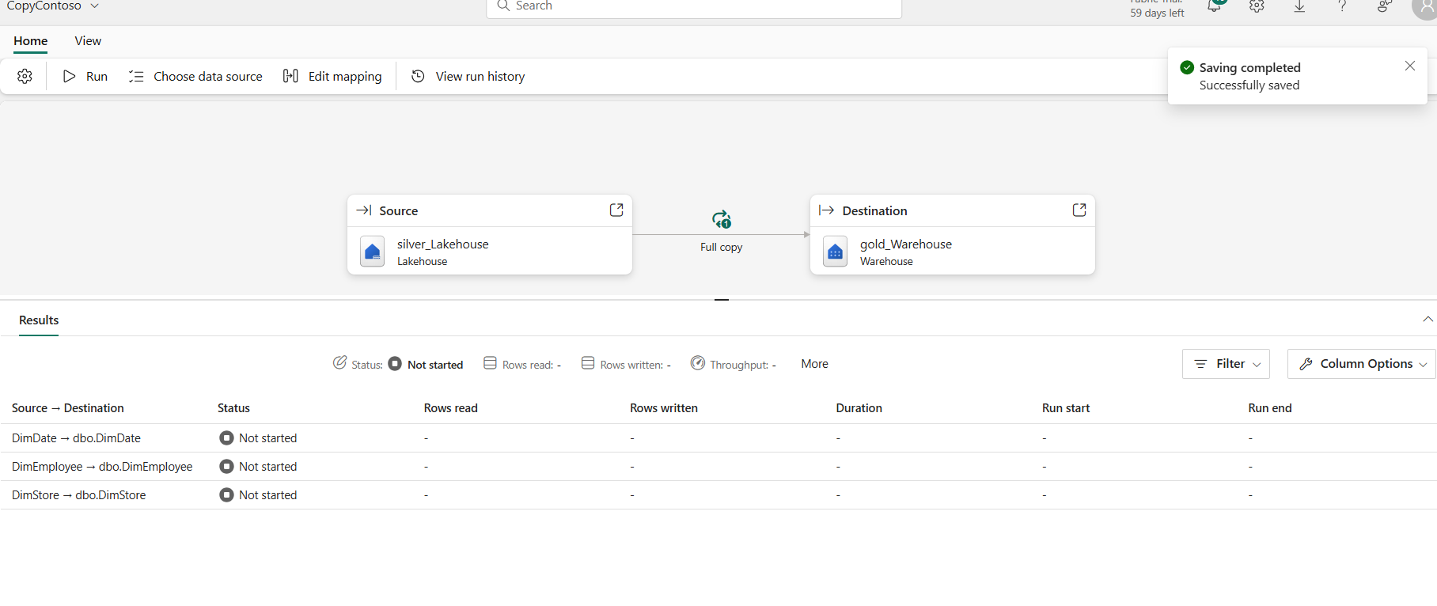

1. Now that you've reviewed the configuration, from the **Home** tab, select the **Run** option to begin copying data from the lakehouse into the warehouse.

To configure the copy job items' name, description, refresh schedule, or other properties, you can select the settings icon (cog) to edit.

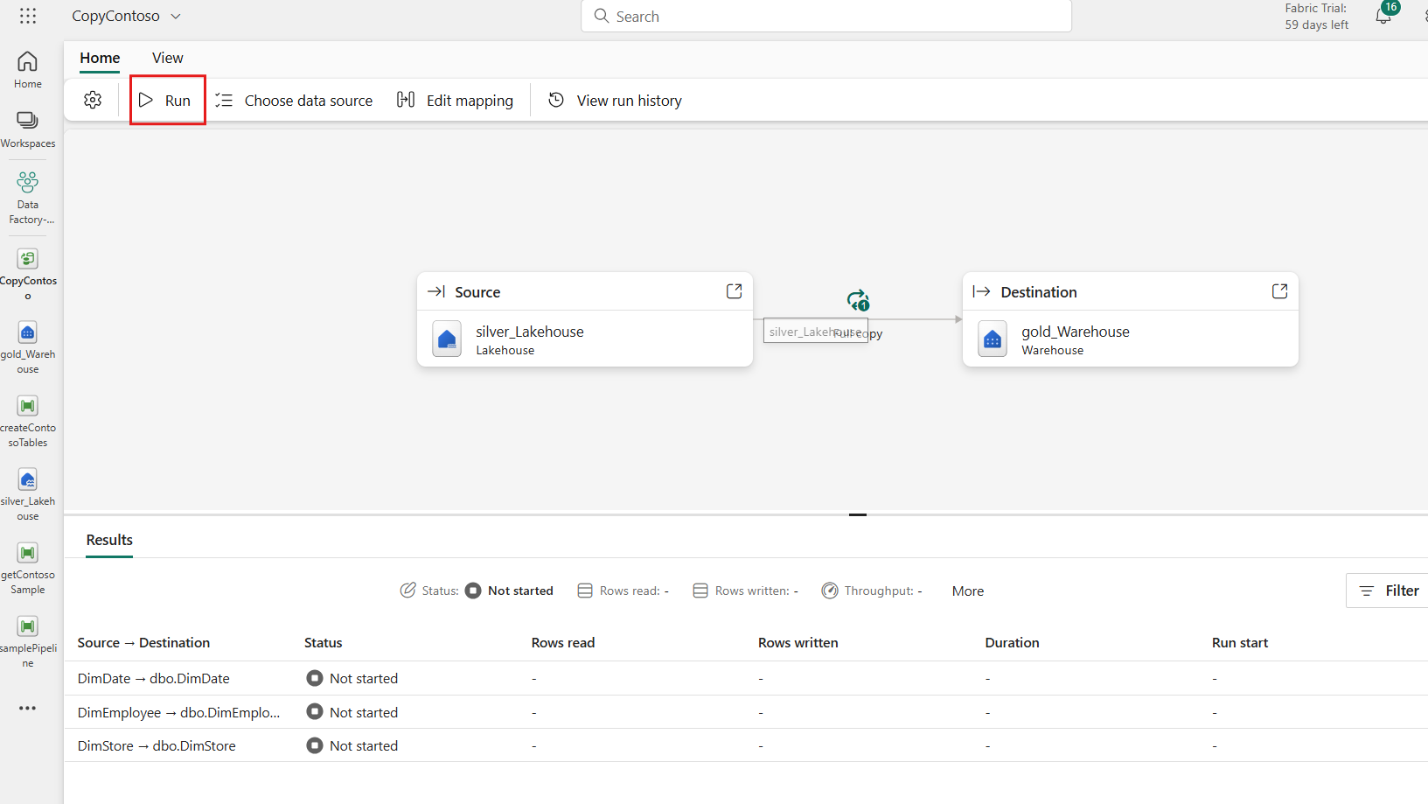

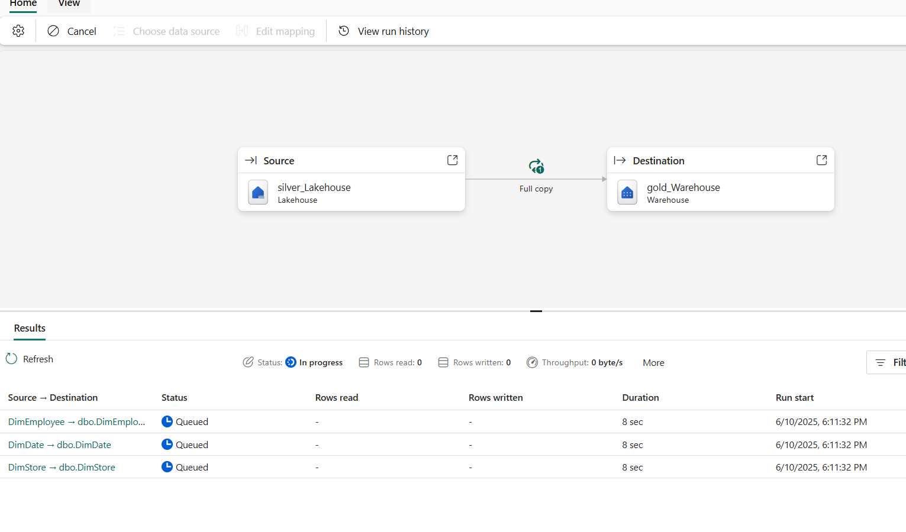

1. You can monitor the copy job in the **Results** tab at the bottom to confirm that it has successfully completed.

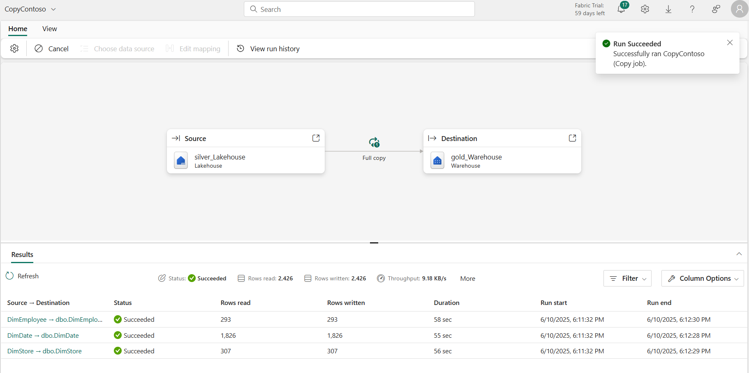

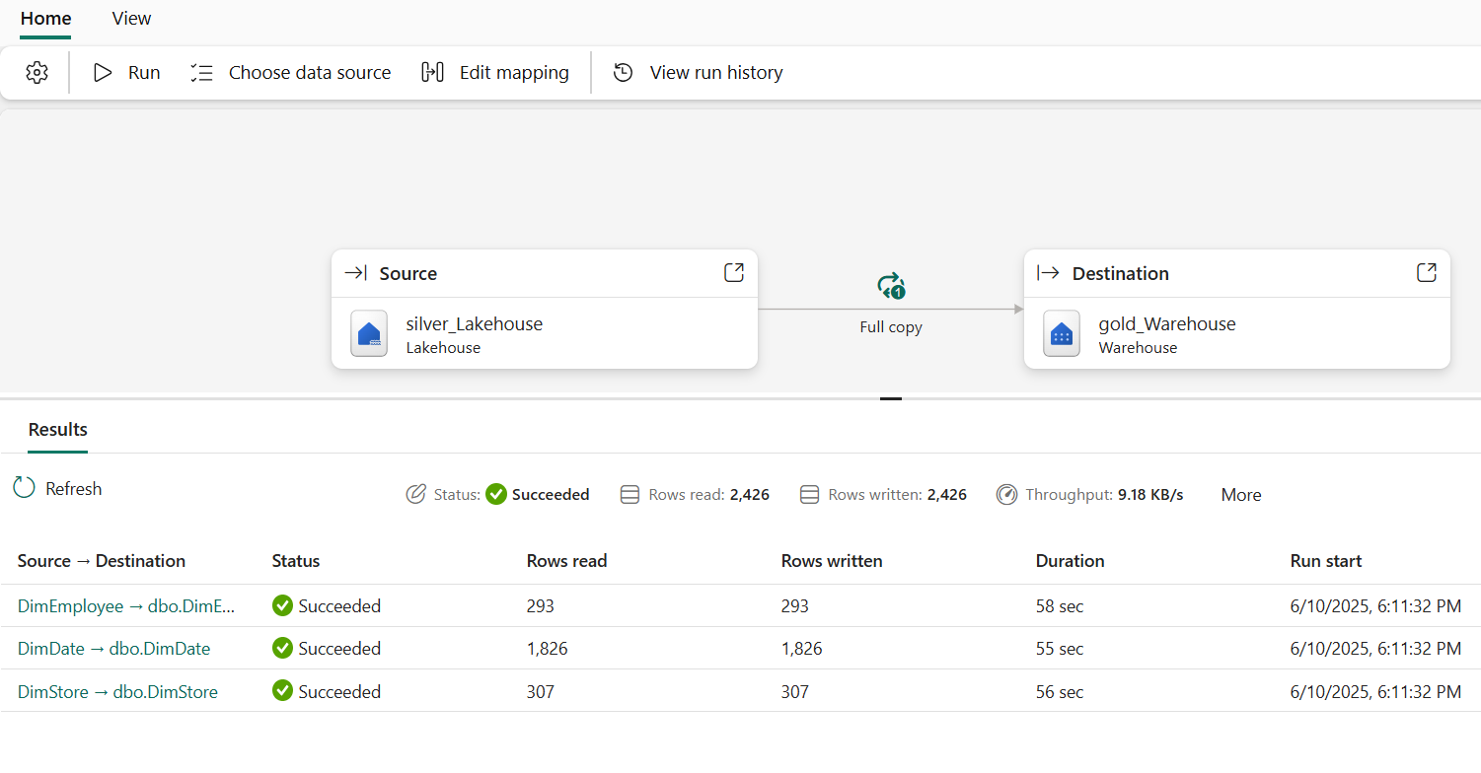

1. Hover over the copy job on the left side-rail and select the **X** to close it.

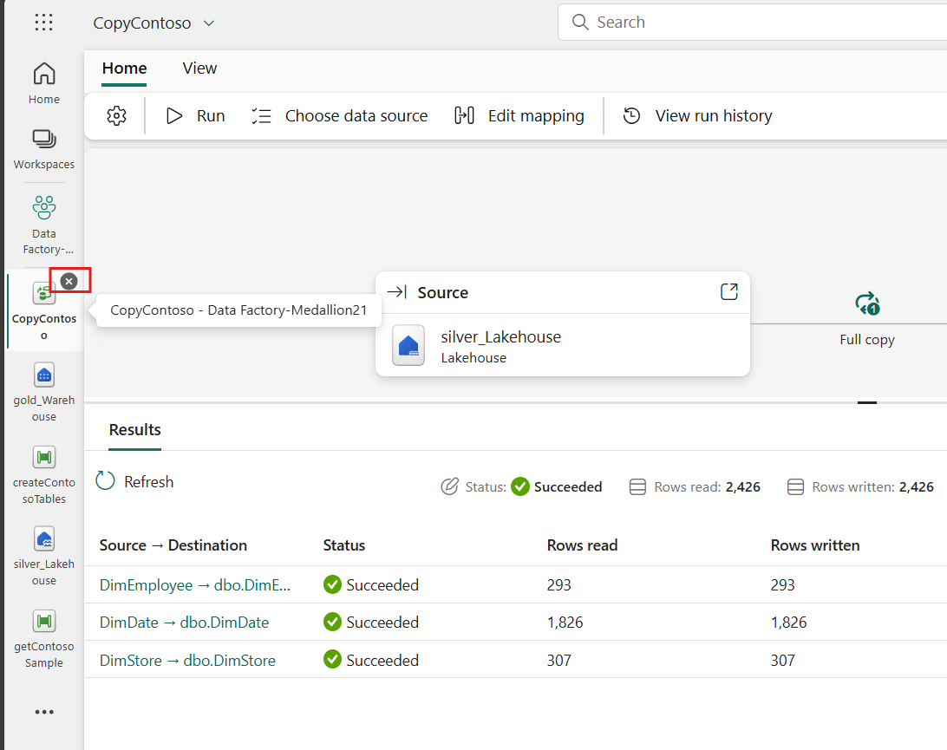

Task 7: End-to-end orchestration with pipelines

1. In the left-sided navigation menu, navigate and click on **Data Factory-MedallionXX**, as shown in the below image.

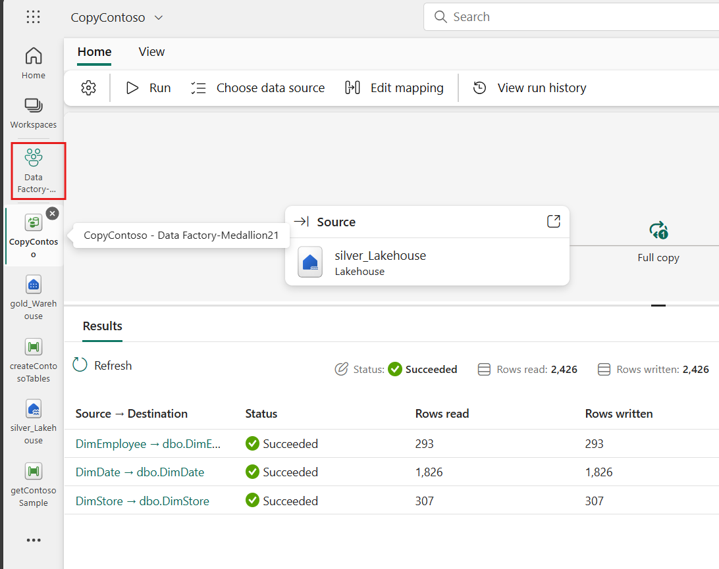

1. Within the workspace, select the **Initial process** task flow item and from the filtered list, select the **createContosoTables** pipeline.

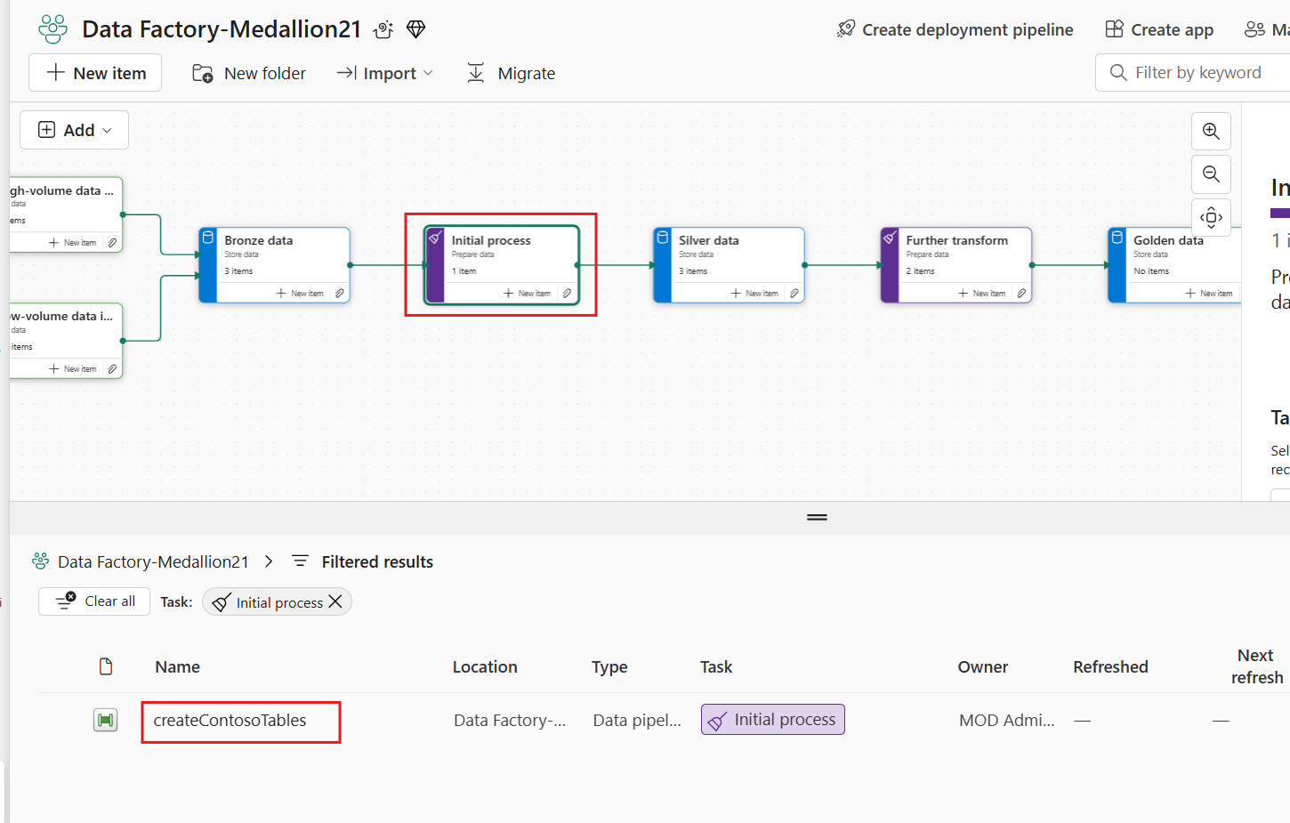

1. From the **Home** tab, add a new **Dataflow** activity to the pipeline.

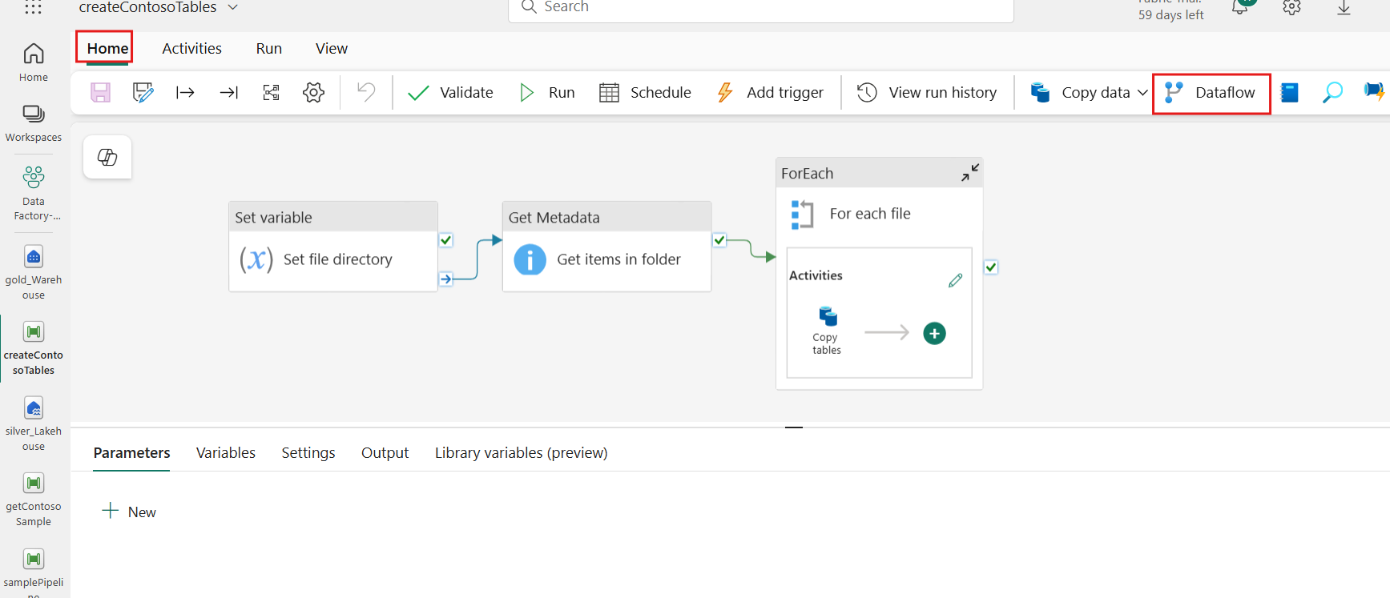

1. Drag the **On success** conditional path between the **For each file** activity and the new **Dataflow1** activity.

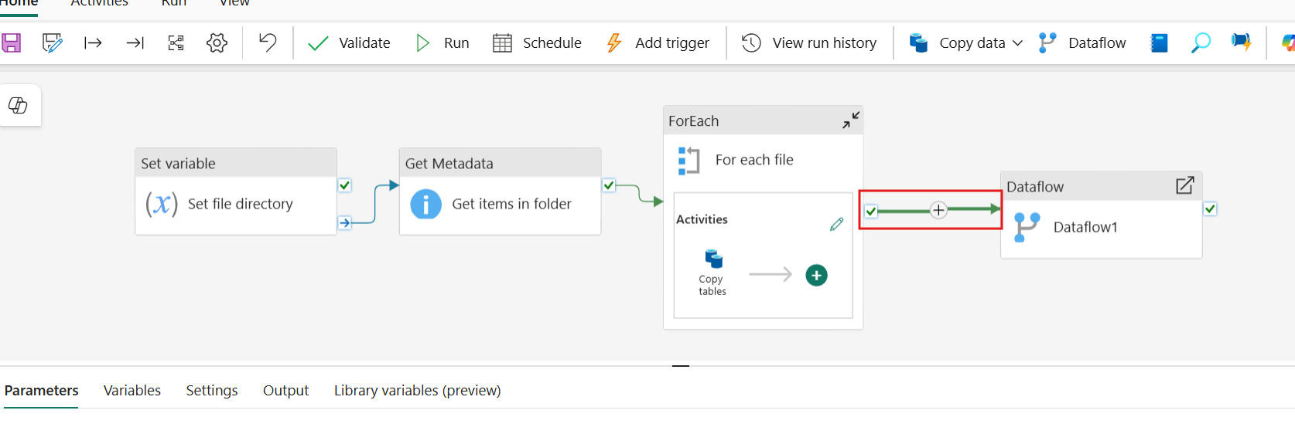

1. Select **Dataflow**, select **Settings** section and within the Dataflow drop-down, select the **PrepContoso** dataflow.

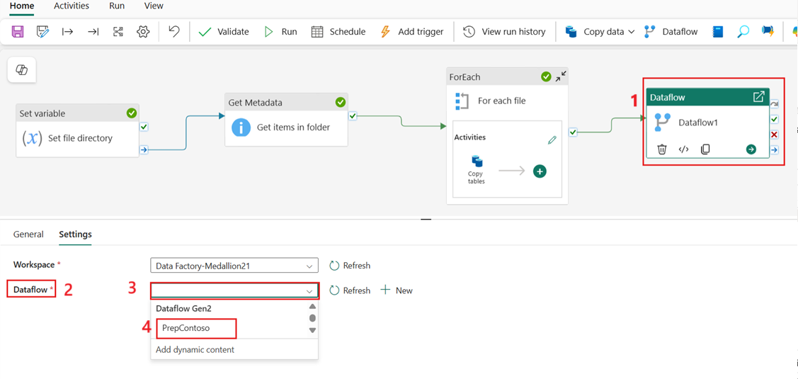

1. With the dataflow activity still selected, go to the **General** tab and update the activity name to **PrepContoso**.

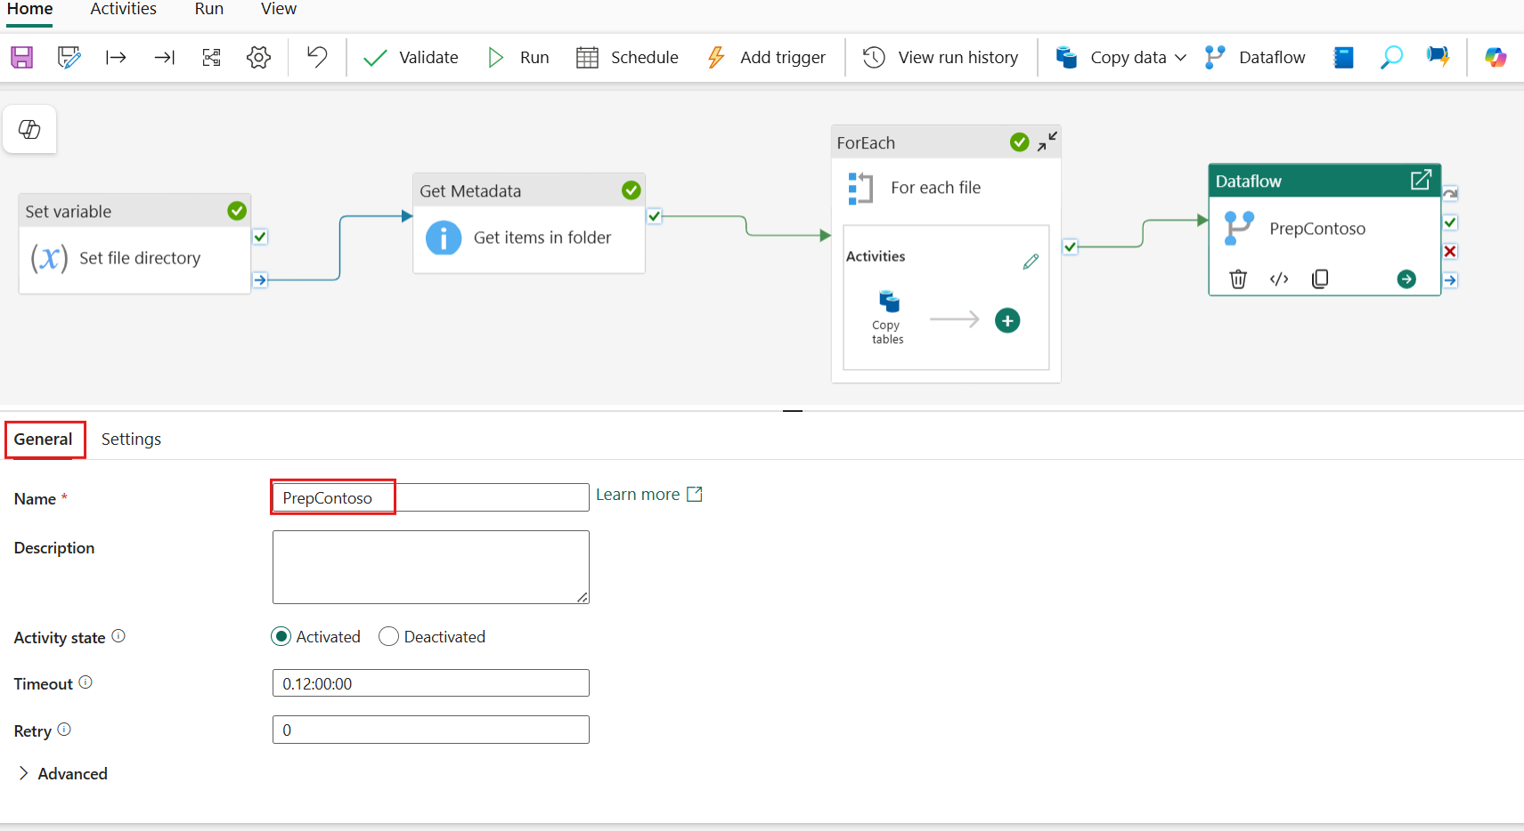

1. Once complete, select the **Save** icon.

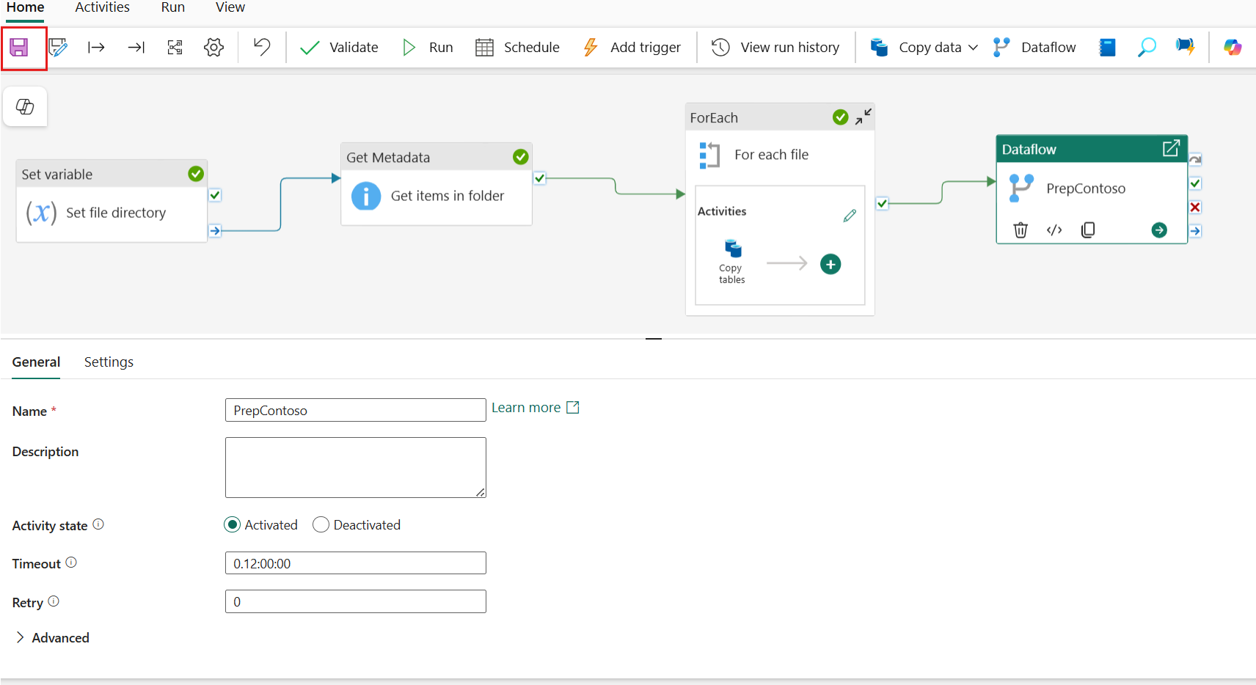

1. In the left-sided navigation menu, navigate and click on **Data Factory-MedallionXX**, as shown in the below image.

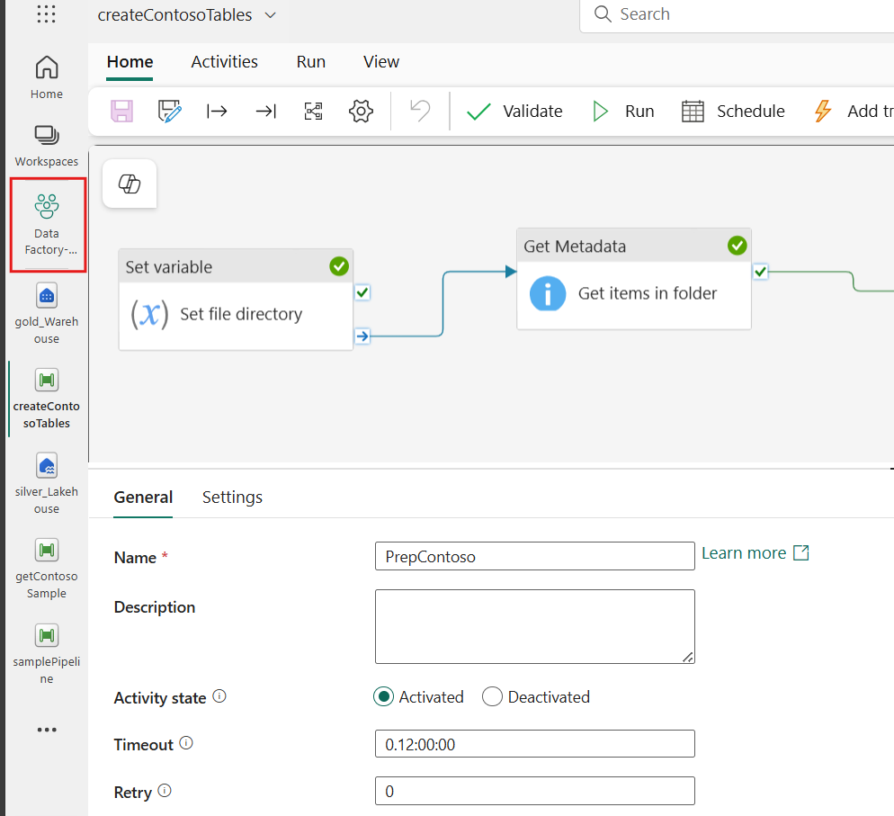

1. Within the workspace, select the **High-volume data ingest** task flow item and from the filtered list, select the **getContosoSample** pipeline.

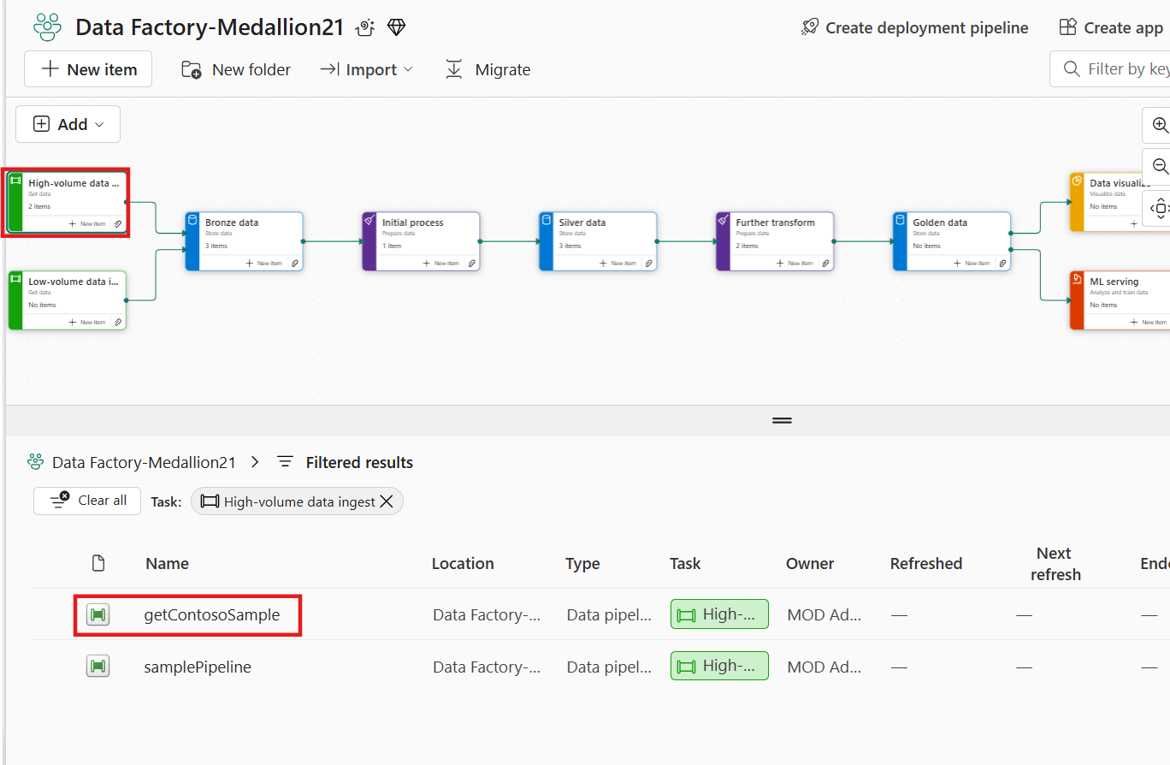

1. From the **Home** tab, add the **Invoke Pipeline(Preview)** activity.

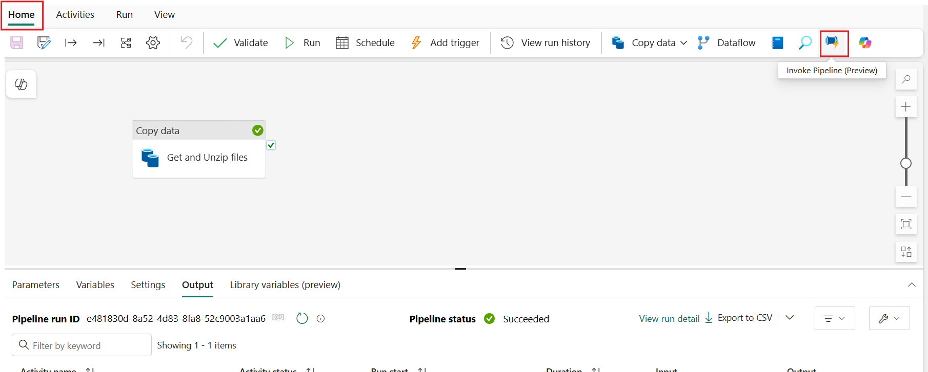

1. Create a conditional **On success** path between the **Get and Unzip files** activity and the **Invoke pipeline1** activity.

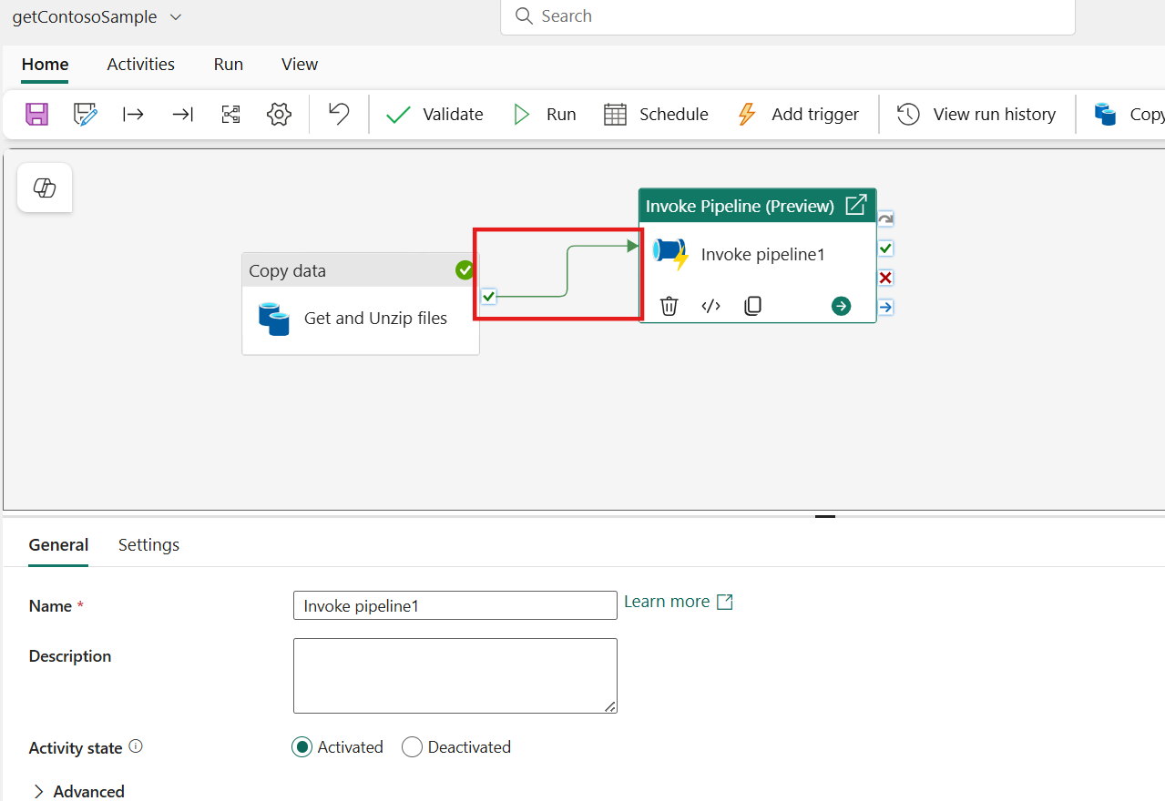

1. Select the **Invoke Pipeline** activity, then expand the **Connection** field under the **Settings** tab.

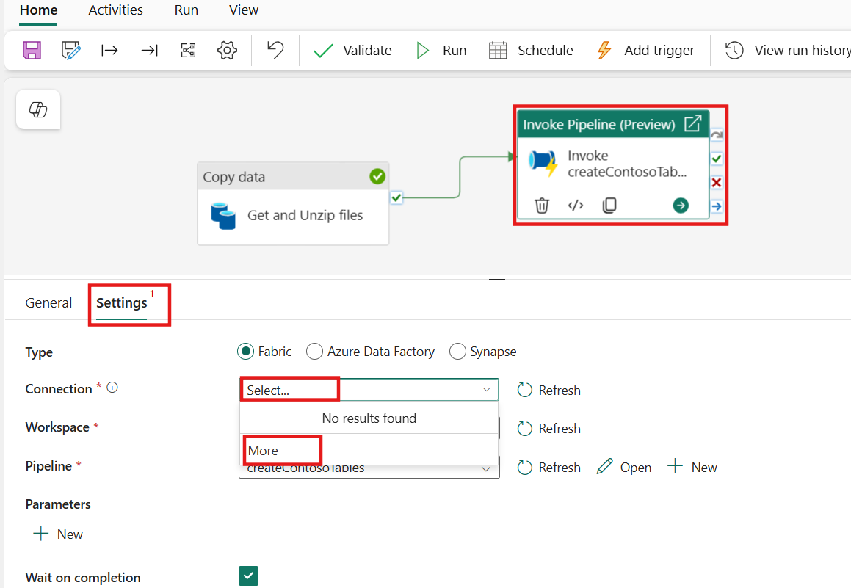

1. In the Get data tab, type **Fabric Data Pipelines** and Select it.

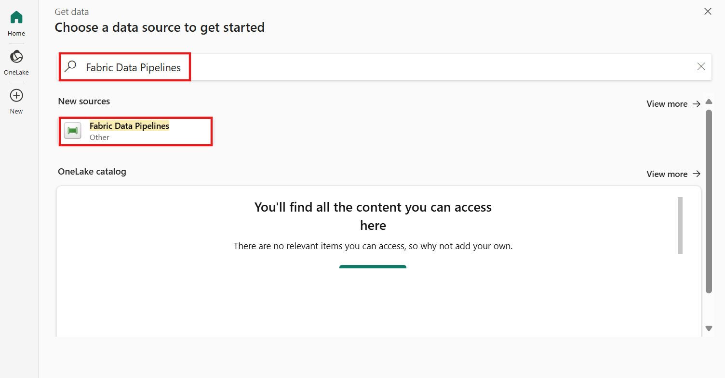

1. Select **Sign in** button and select the credentials

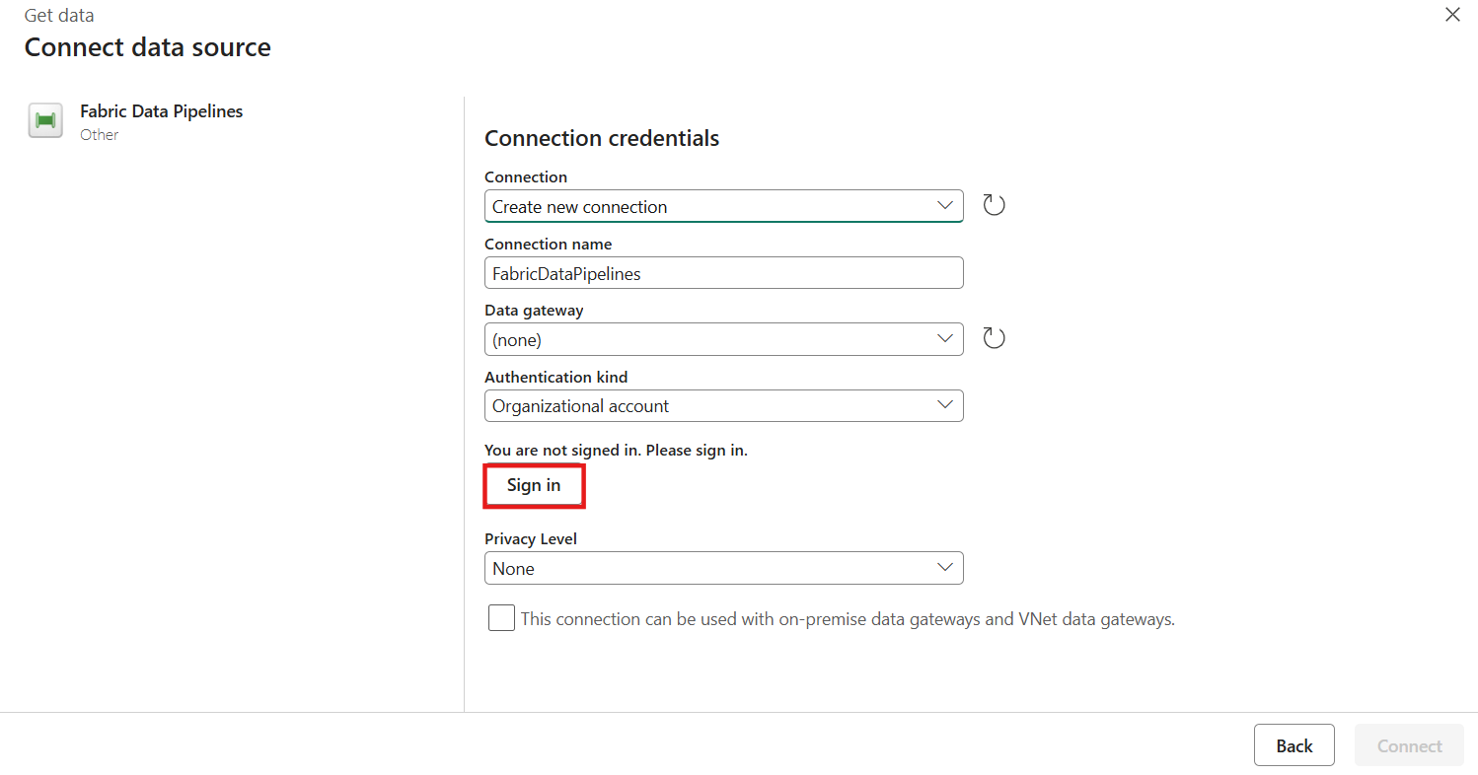

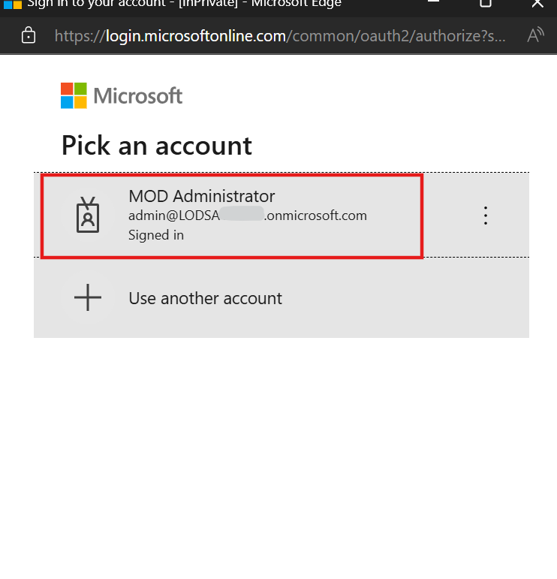

1. In the **Connect data source** tab, select **Connect**

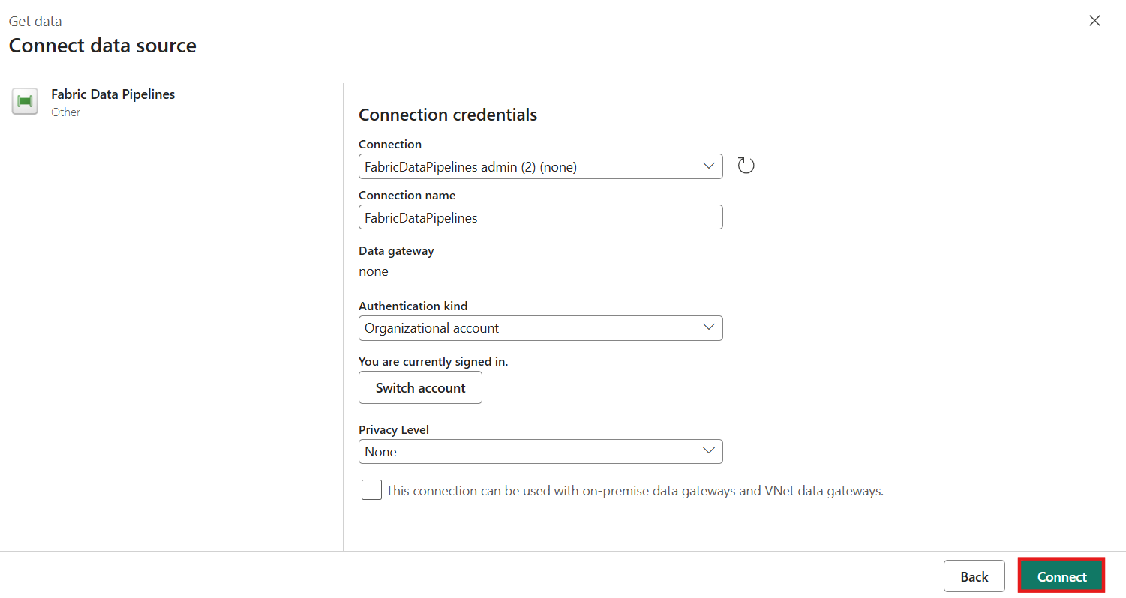

1. From the **activity** settings **Pipeline** option, select the **createContosoTables** pipeline.

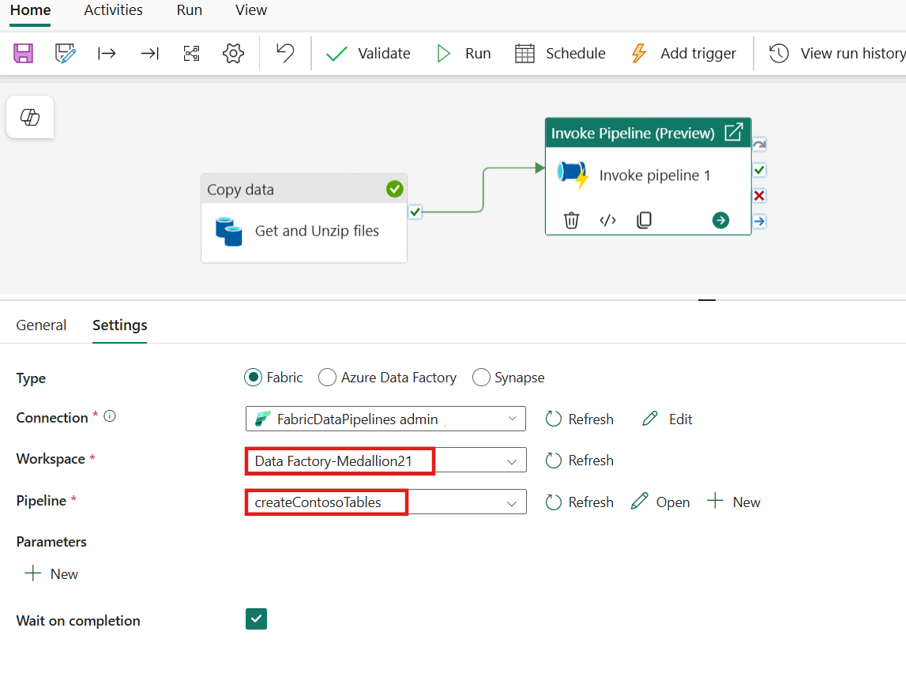

1. With the invoke pipeline activity still selected, go to the **General** tab and update the activity **Name** to **Invoke createContosoTables**.

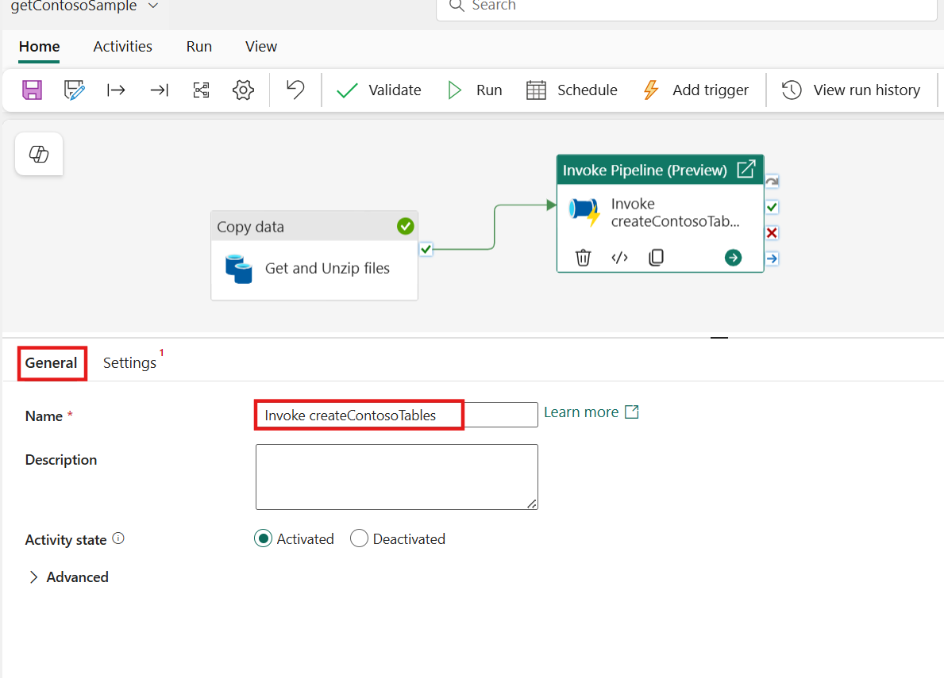

1. Once complete, select the **Save** icon and then **Run**.

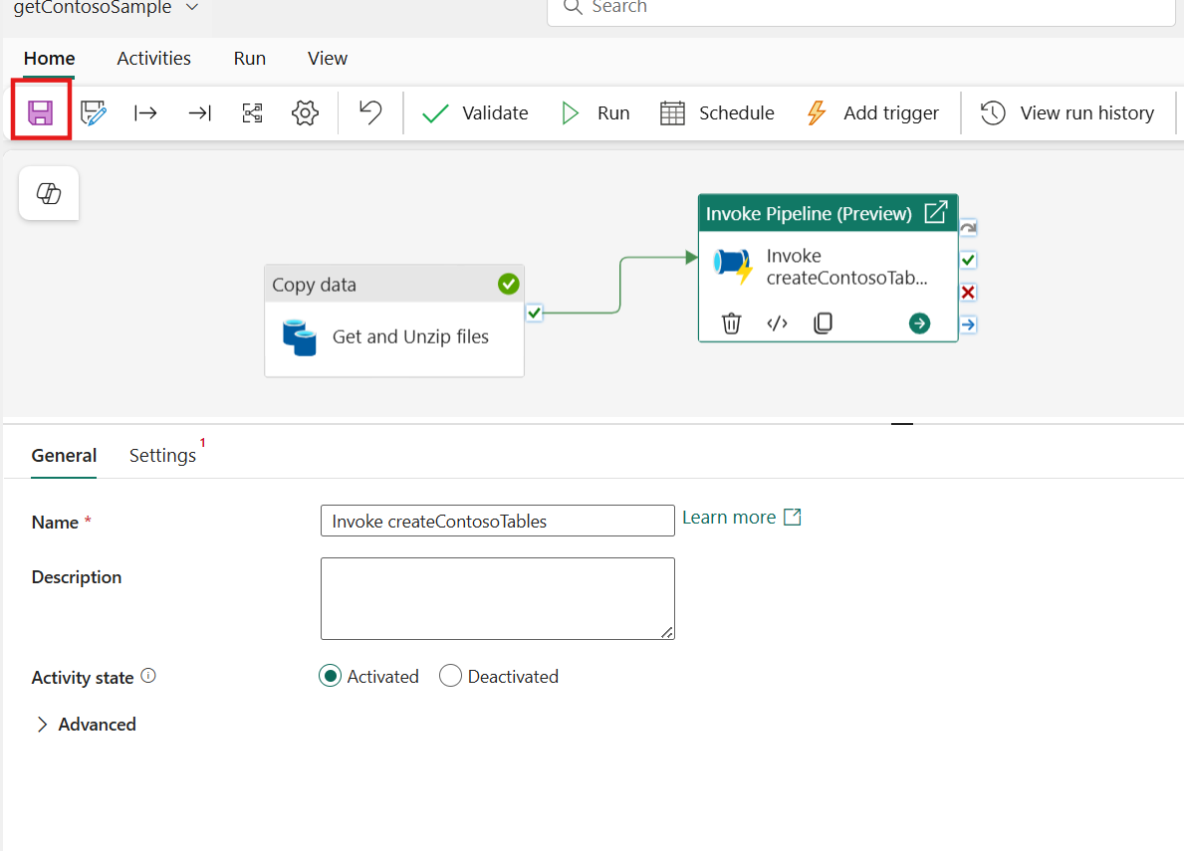

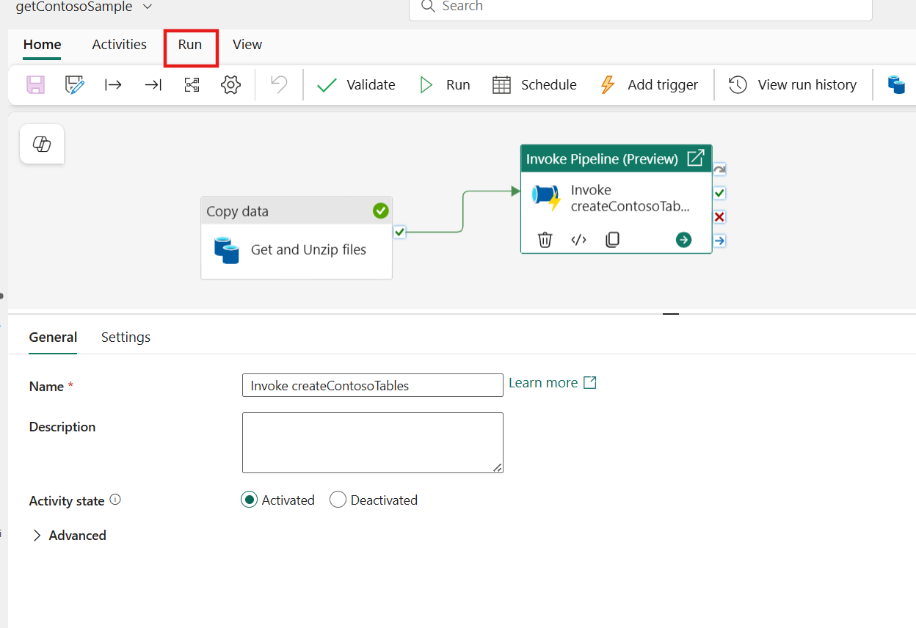

**Note:** You can set a schedule from this first pipeline, and it will call the subsequent pipelines and its dataflow upon successful completion or have the pipeline triggered by events like when new files are added to the lakehouse.

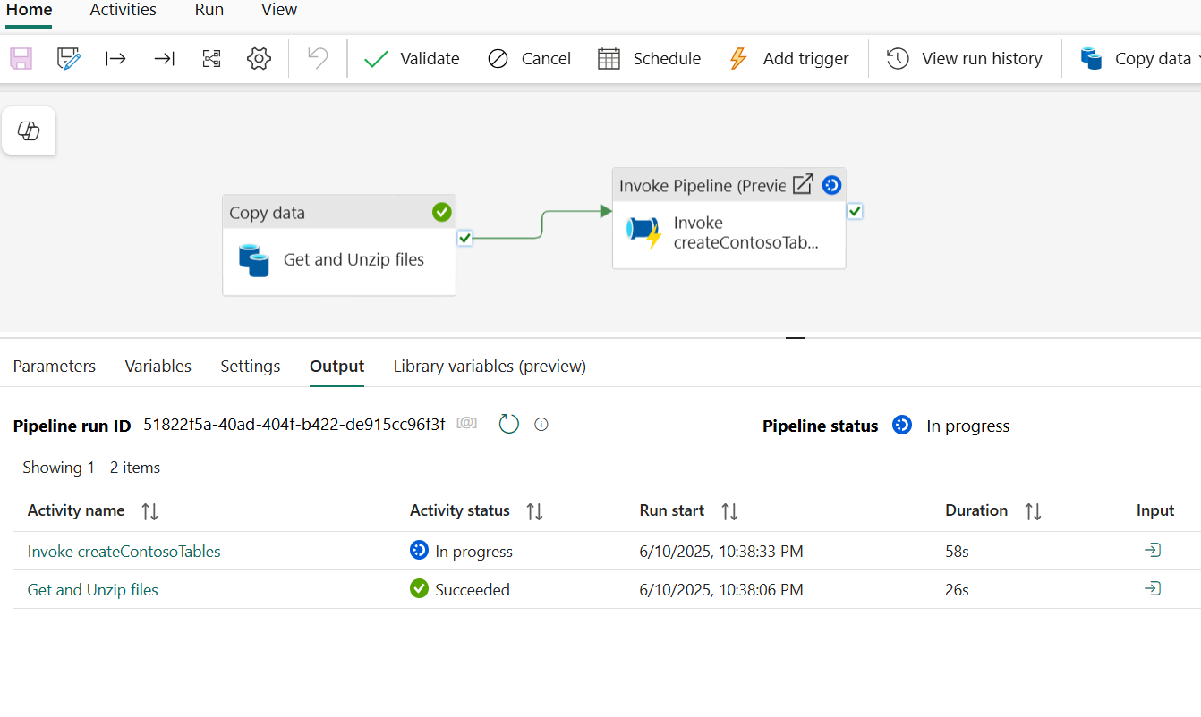

**Important:** Designing modular pipelines makes development, testing, and maintenance easier. They are also portable, allowing components to be reused across different projects. This approach is particularly beneficial in large-scale data processing environments, where reusability and modularization are key to efficient data integration workflows.

1. From the **Output** pane monitor that the activities and **Succeedded** and once done close the pipeline by selecting the **X** on the left side-rail to return to the workspace.

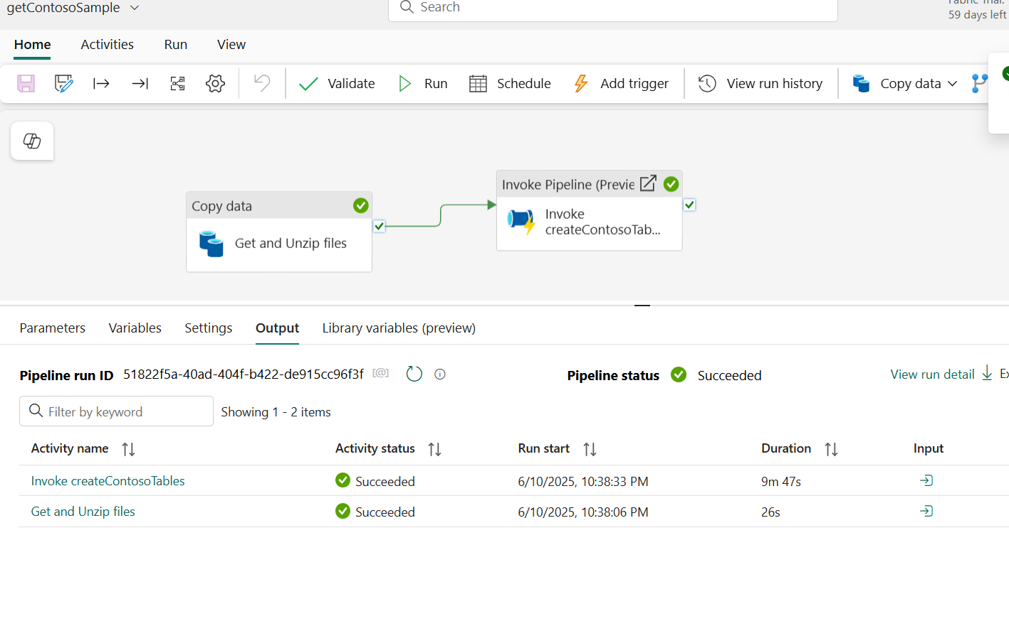

1. In the left-sided navigation menu, navigate and click on **Data Factory-MedallionXX**, as shown in the below image.

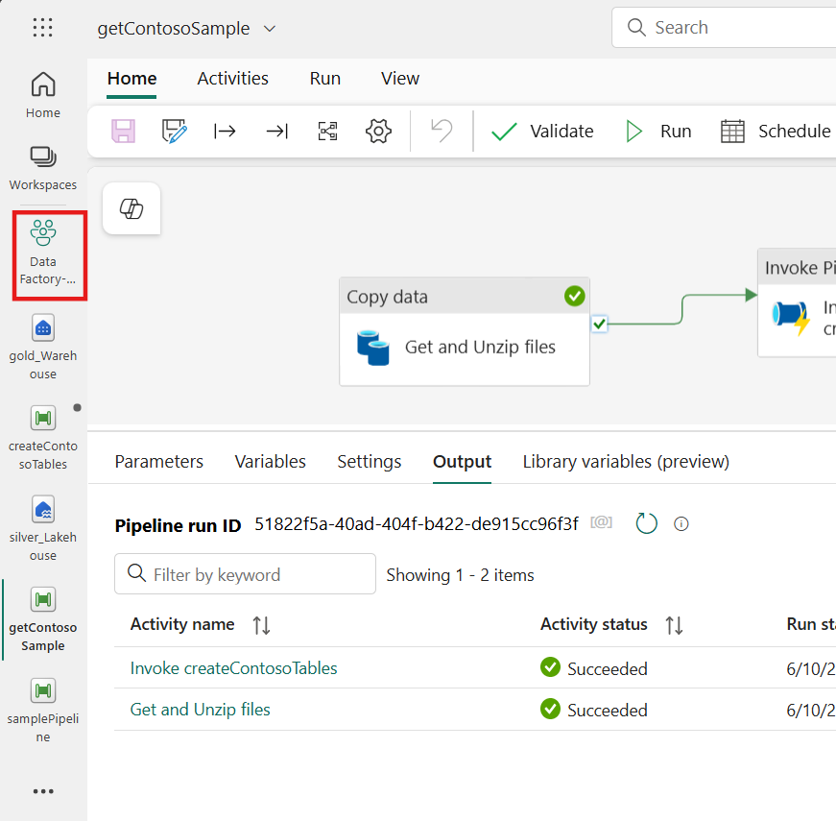

Task 8: Create a semantic model and build a report

1. Within the workspace, select the **Golden data** task flow item and from the filtered list, select the **gold_Warehouse** Warehouse.

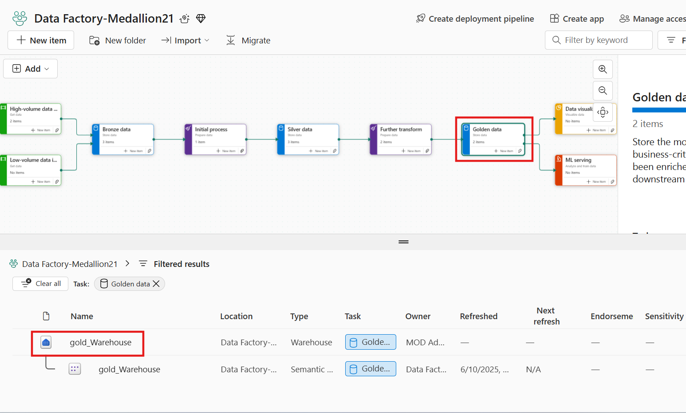

1. On the **gold_Warehouse** page, expand the Table under the dbo, right-click on the **'DimCustomer'** table, select **'New SQL Query',** and then click on **'Select Top 100'.**

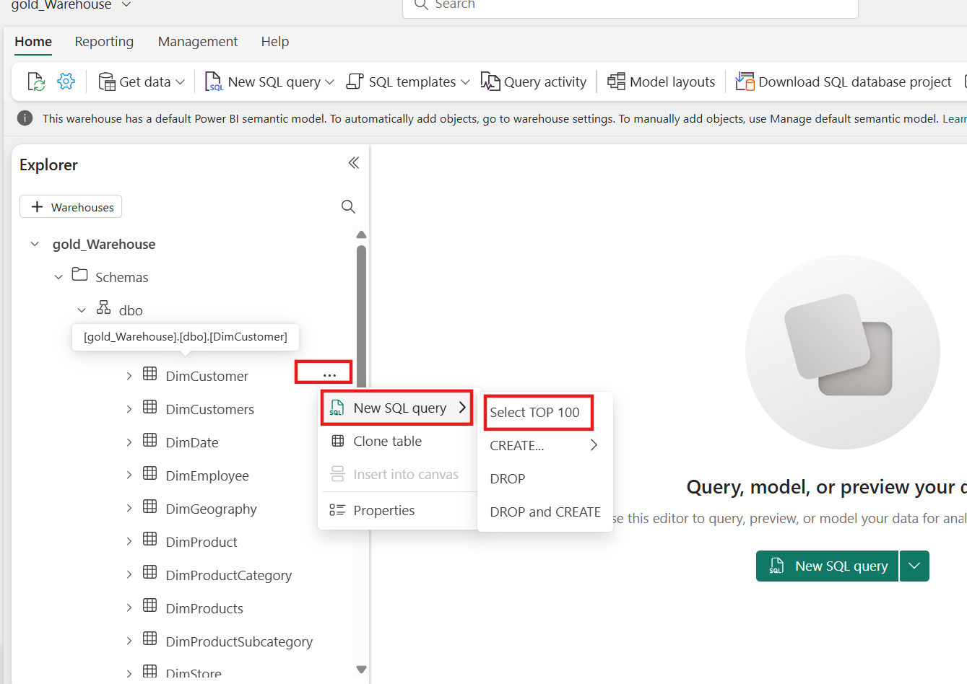

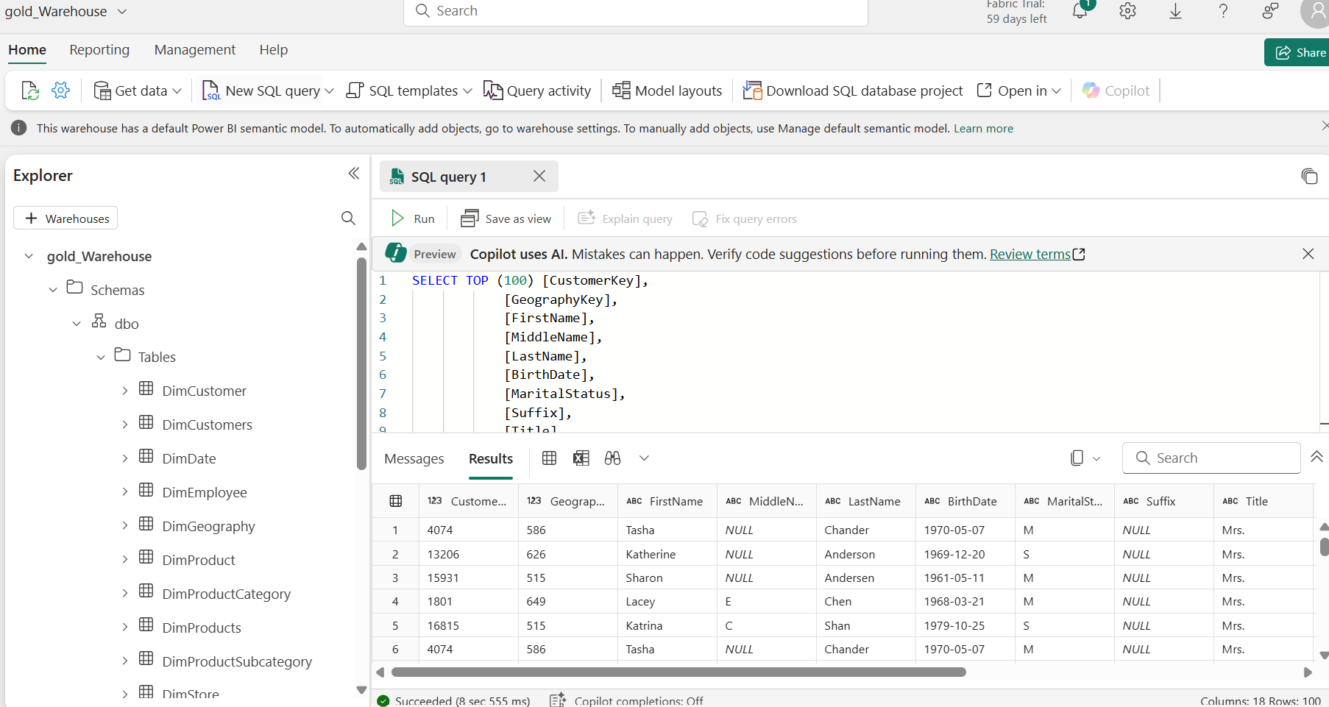

1. In gold_Warehouse page, select the ***Reporting* **tab and then select ***New semantic model***.

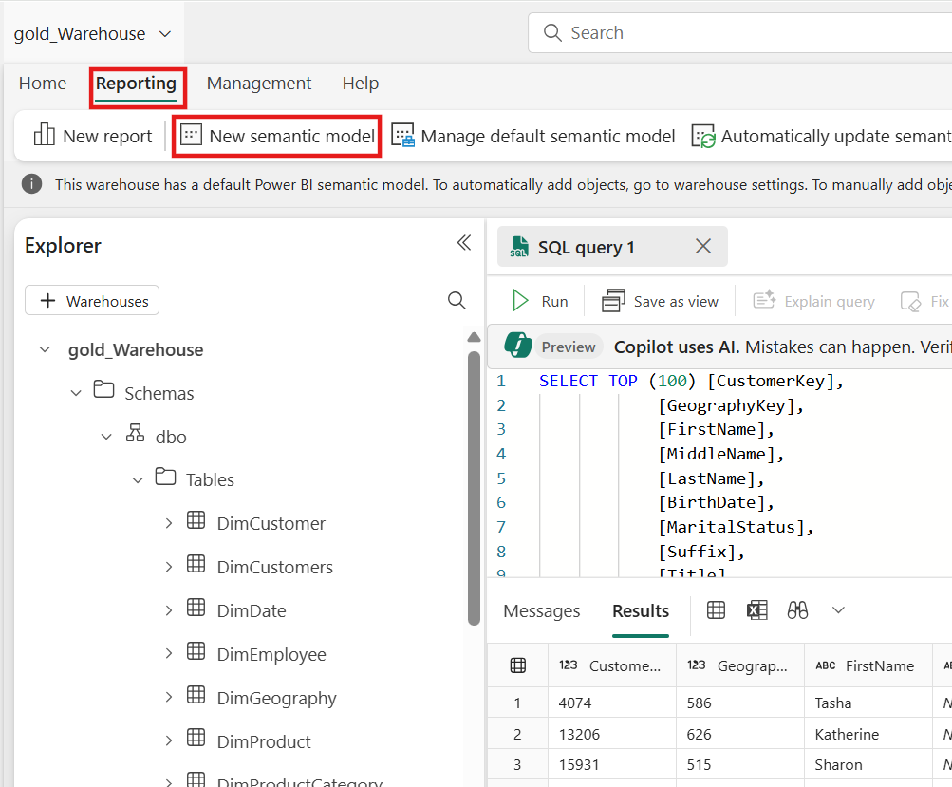

1. In the New semantic model tab, enter the name as **Sample model**, and select **dbo**. Click on the **Confirm** button.

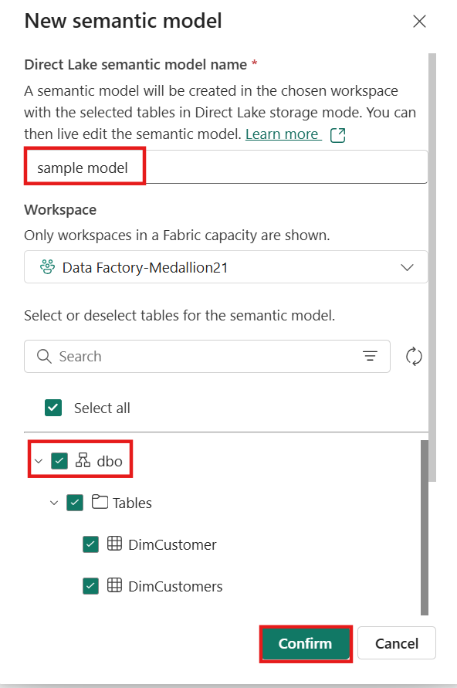

1. In the left-sided navigation menu, navigate and click on **Data Factory-MedallionXX**, as shown in the below image.

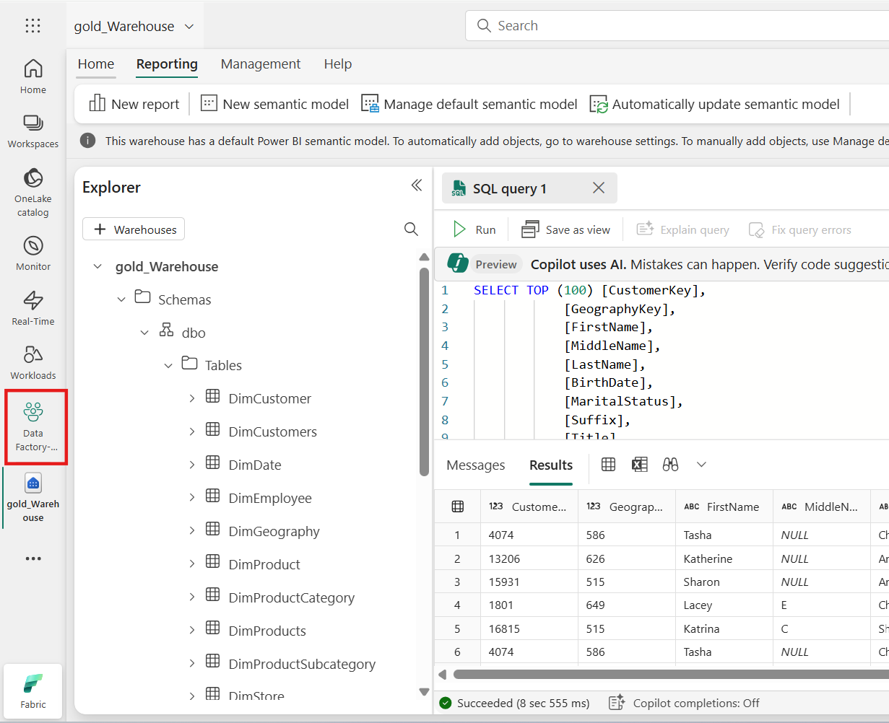

1. Select ***Sample model***

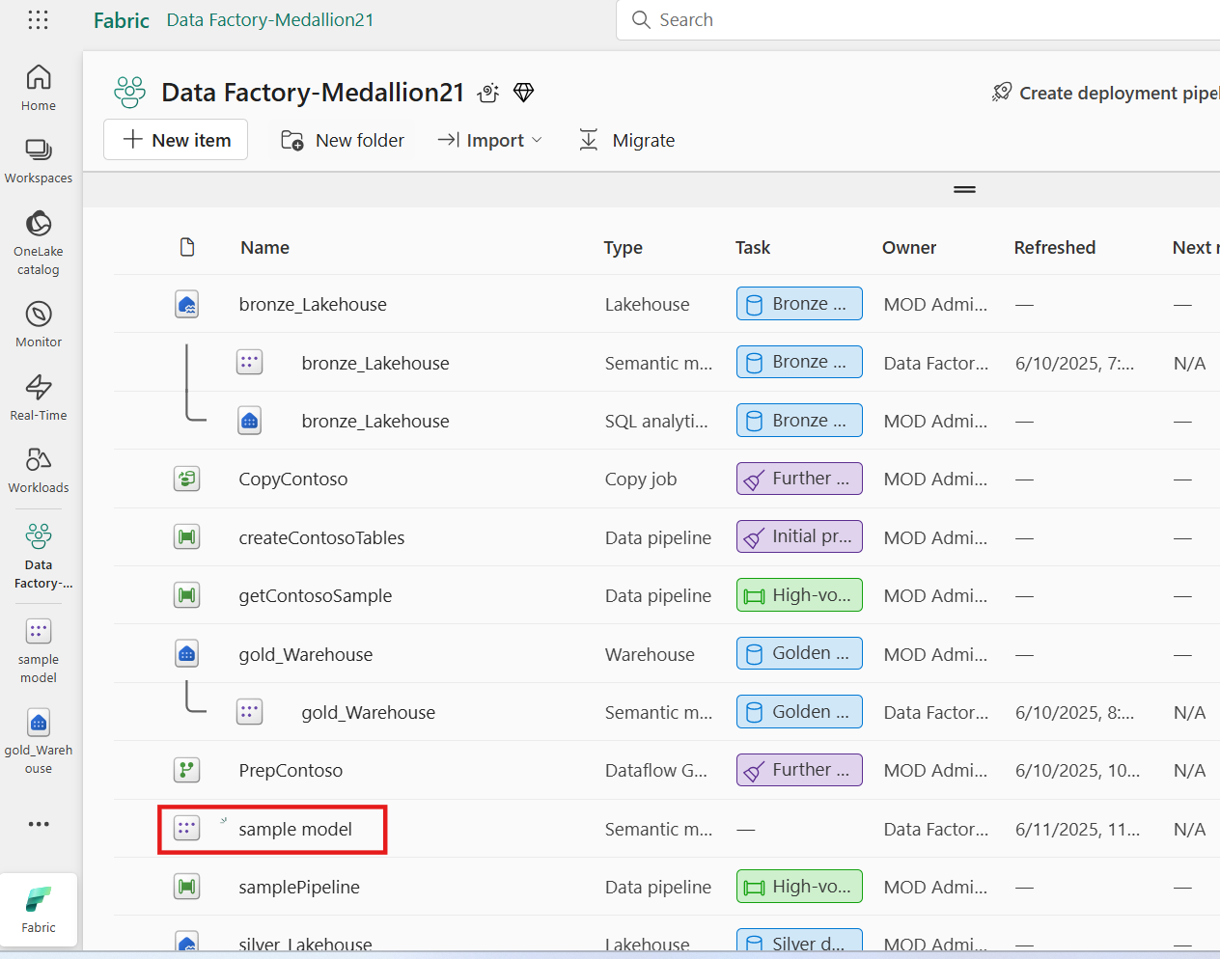

1. From the semantic model pane, you can view all the tables. You have options to create reports either from scratch, paginated report, or let Power BI automatically create a report based on your data. For this tutorial, under **Explore this data**, select **Auto-create a report** as shown in the below image.

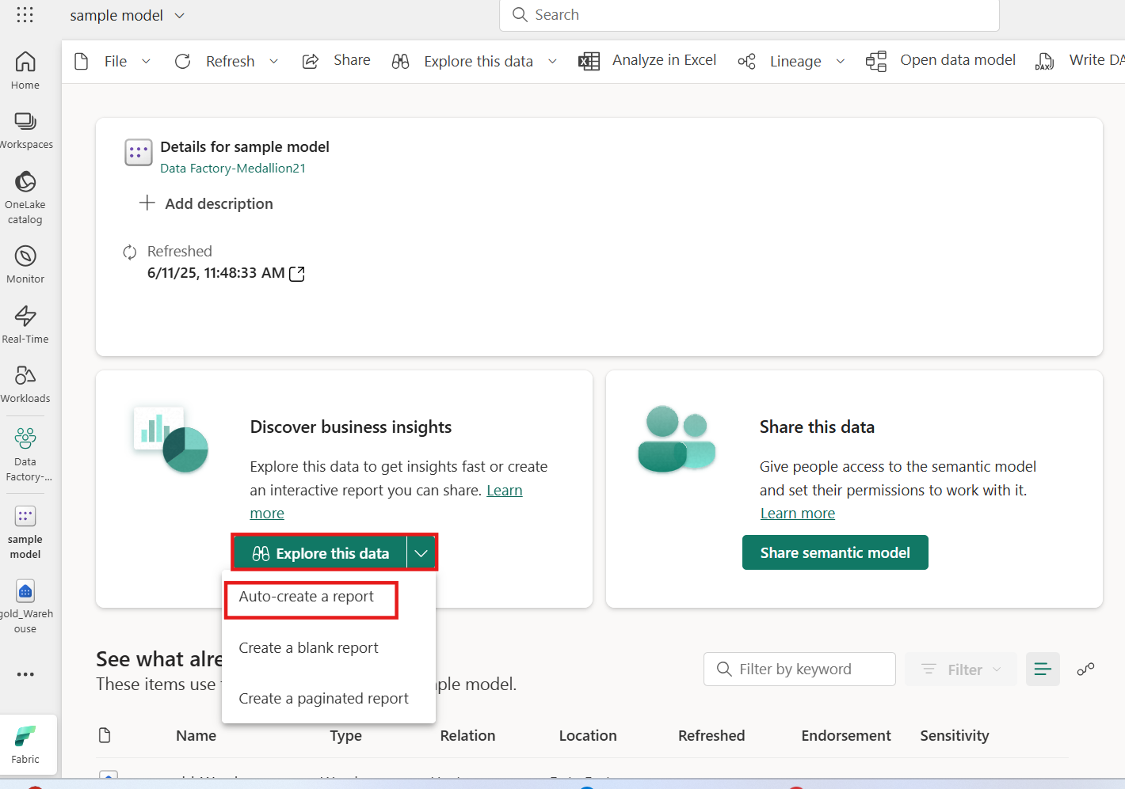

1. Click on the View report now

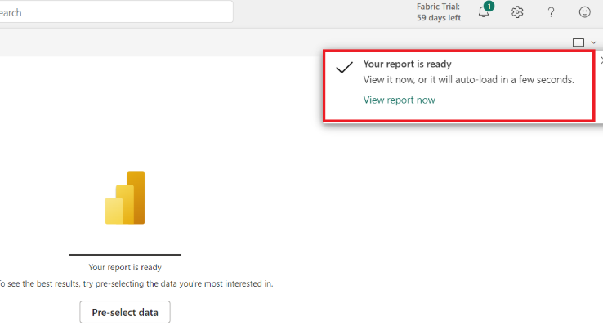

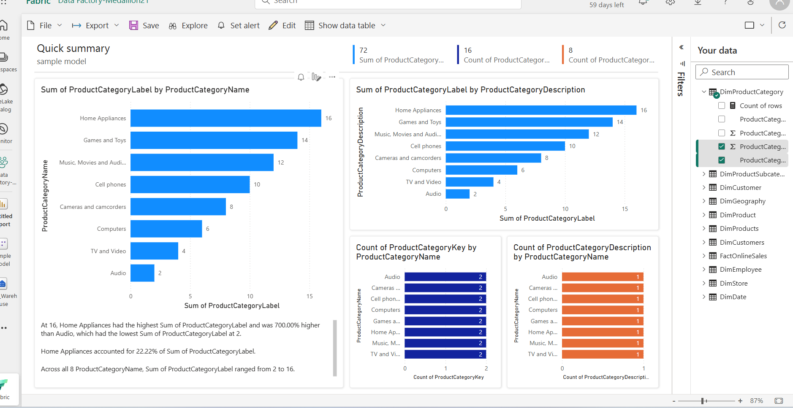

1. In **PowerBI** page, select **File** and click on **Save**

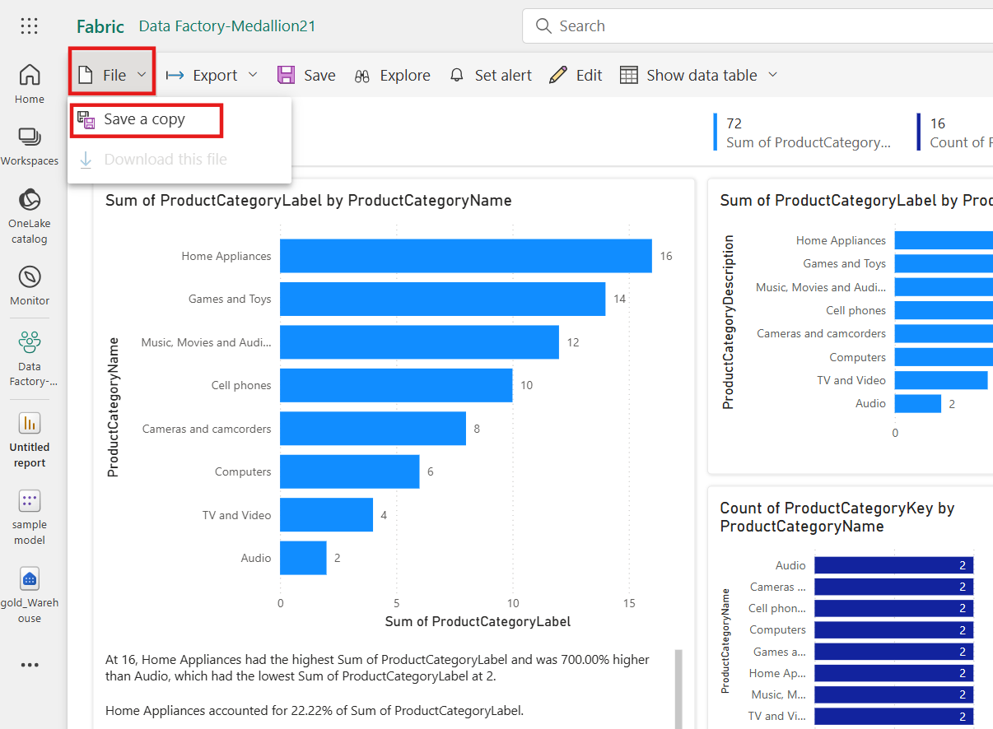

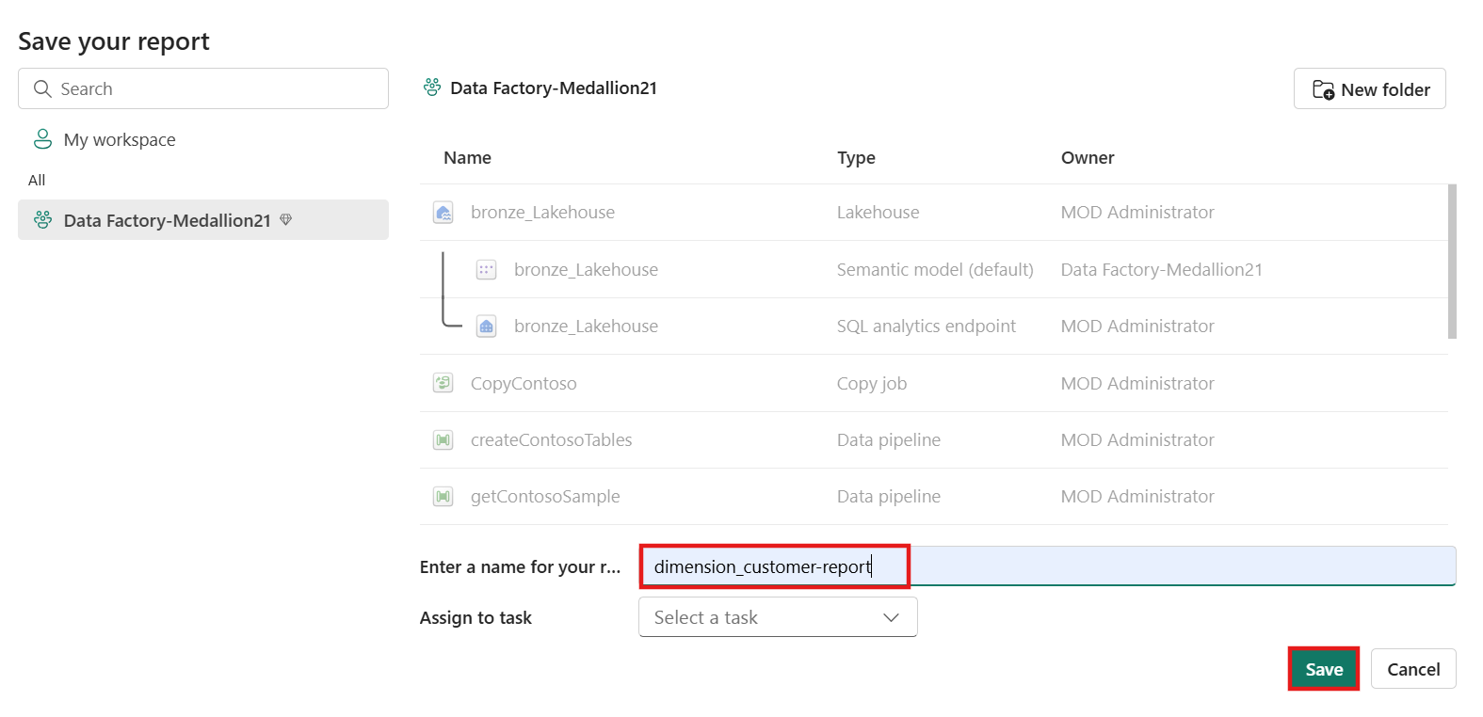

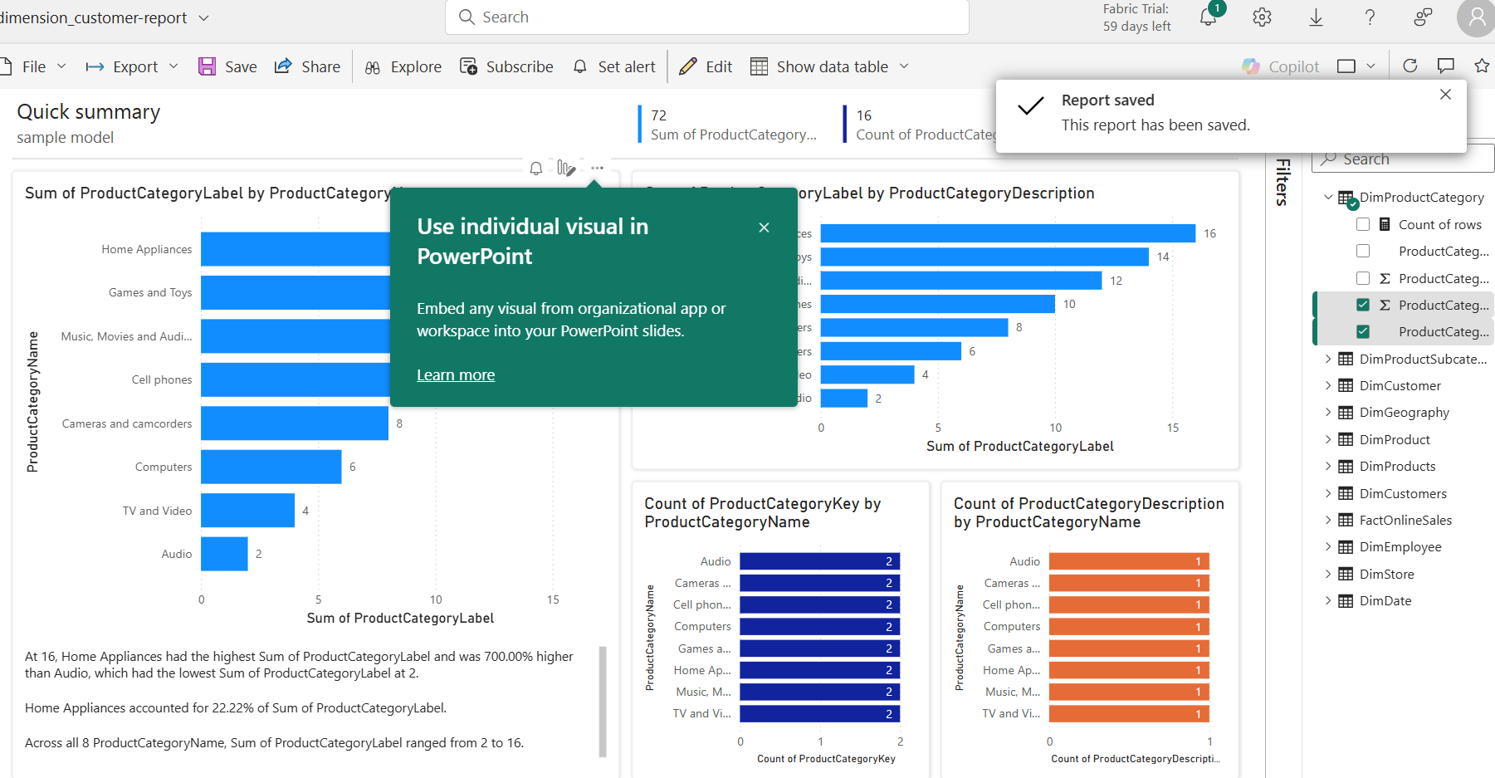 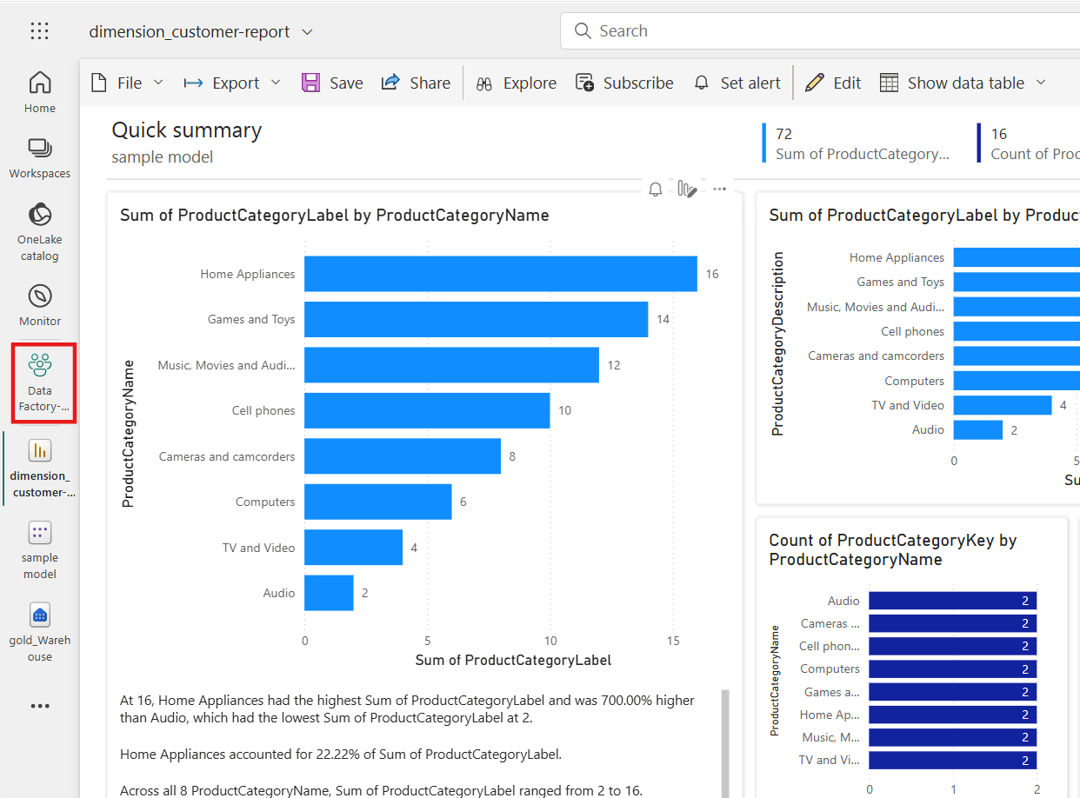 

Task 9: Clean up resources

1. In the **…** menu on the toolbar, select **Workspace settings**.

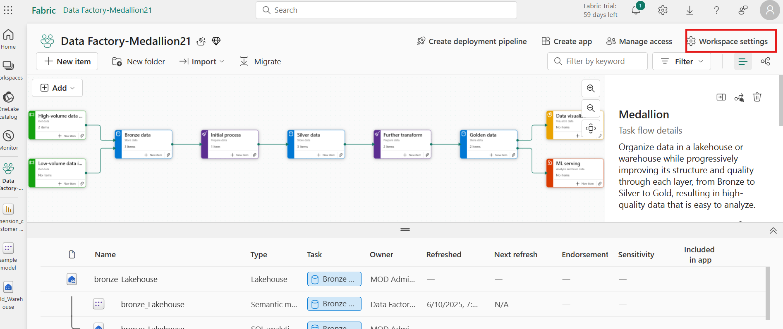

1. In the **General** section, select **Remove this workspace**.

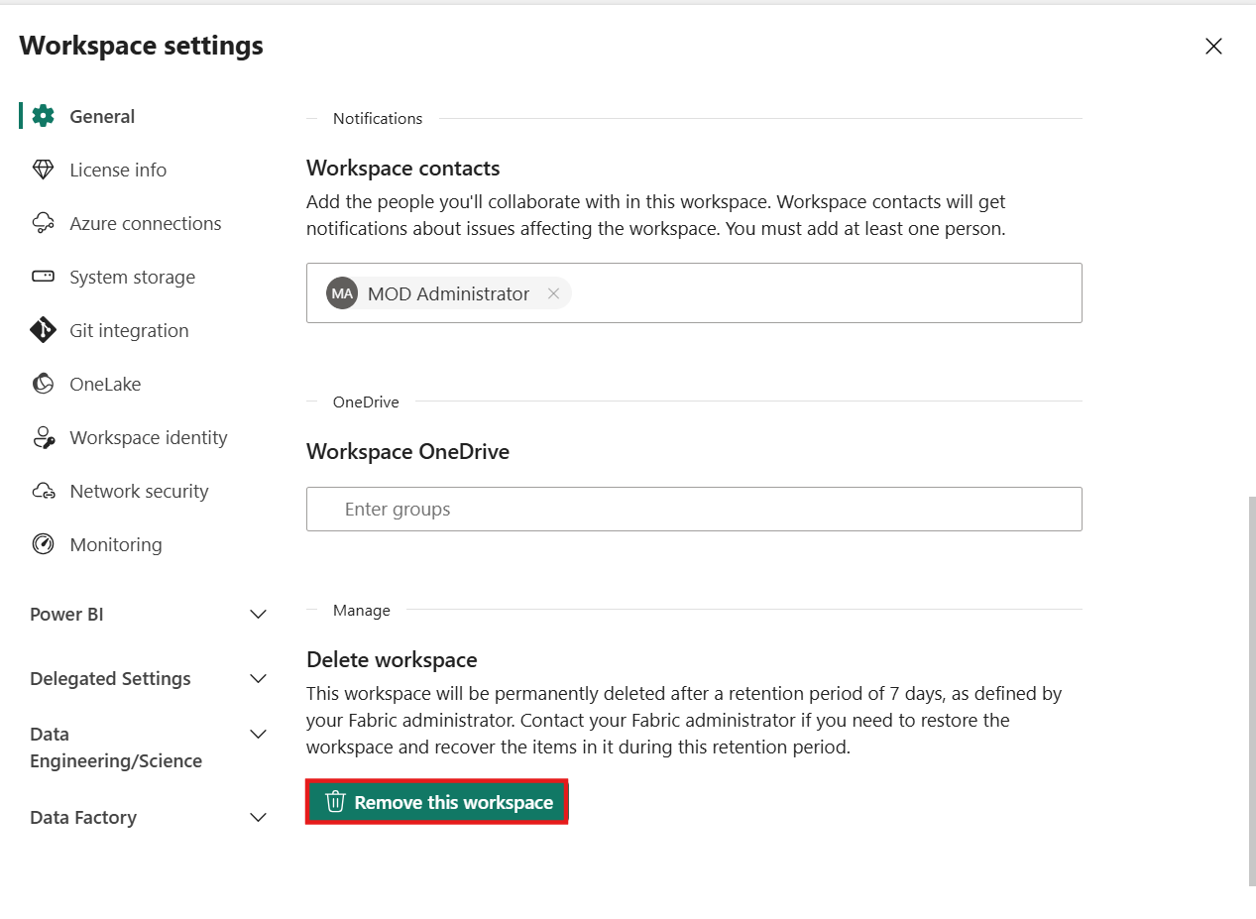

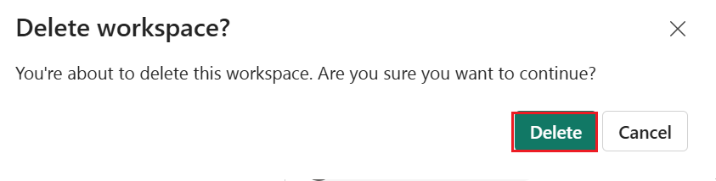

**Summary:**

This use case implementation of the Medallion Architecture using Microsoft Fabric tools. Beginning with workspace setup, users define a task flow that separates data processing into modular components. Data is ingested into the Bronze layer using pipelines and dynamic folder structures. From there, metadata-driven loops and conditional logic are used to enrich data into the Silver layer. The Gold layer is populated via Dataflow Gen2 transformations and Copy Jobs. Pipelines are orchestrated end-to-end with dynamic expressions, and integration points with Power BI and SQL interfaces are established. This structured approach improves data quality, traceability, and analytical readiness-making it ideal for enterprise-scale analytics solutions.